saqarTvelos teqnikuri universisteti

Ggaremos dacva da sainJinro ekologia


Ddamtkicebulia saredaqcio - sagamomcemlo
sabWos mier

Tbilisi 2015

Semdgenlebi: rusudan alasania, dimitri erisTavi, aza danelia,
lera qaSakaSvili, leila gverdwiTeli, marina demetraZe.

recenzenti: prof. Salva andRulaZe

kompiuteruli uzrunvelyofa e. zariZe

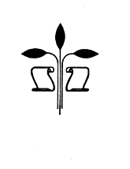
Verba voland
scripta manent
© sagamomcemlo saxli `teqnikuri universiteti~, 2015
ISBN
http://www.gtu.ge/publishinghouse/

yvela ufleba daculia. am wignis arc erTi nawili (iqneba es teqsti, foto, ilustracia Tu sxva) aranairi formiT da saSualebiT (iqneba es eleqtronuli Tu meqanikuri), ar SeiZleba gamoyenebul iqnes gamomcemlis werilobiTi nebarTvis gareSe.

saavtoro uflebebis darRveva isjeba kanoniT.

s a r C e v i

I. samecniero-teqnikuri progresi da garemos dacvis problemebi........................ 5
ekologiuri krizisis masStabebi........................................................................................................ 6
biosferos biotis danakargebi............................................................................................................... 7
qimizacia da atmosferos gaWuWyianeba........................................................................................... 9
klimatis globaluri cvlilebebi.................................................................................................... 10
ozonis Sris rRveva........................................................................................................................................... 10
myari da saSiSi narCenebi............................................................................................................................ 10
wylis gaWuWyianeba.............................................................................................................................................. 10
energetikuli problemebi............................................................................................................................ 11
mosaxleobis mateba............................................................................................................................................ 11
garemo da adamianis jamrTeloba........................................................................................................ 12
II. ekologiis mecnieruli safuZvlebi da misi ZiriTadi ganyofilebebi......... 14
nivTierebaTa wrebrunva da maTi rRveva garemoSi............................................................. 18
wylis wrebrunva.................................................................................................................................................... 19
Jangbadis wrebrunva........................................................................................................................................... 20
naxSirbadis wrebrunva.................................................................................................................................... 21
gogirdis wrebrunva........................................................................................................................................... 23
azotis wrebrunva................................................................................................................................................. 24
fosforis wrebrunva......................................................................................................................................... 27
III. bunebrivi resursebi, maTi klasifikacia da racionaluri gamoyeneba........ 29
IV. atmosferos Sedgeniloba. ozonis roli da misi rRvevis Sedegebi...............33
V. atmosferos bunebrivi da anTropogenuri gaWuWyianebis wyaroebi.................. 38
VI. transporti-atmosferuli haeris mniSvnelovani gamabinZurebeli.................. 42
VII. samrewvelo gamavali airebis gasufTaveba mtvris nawilakebisagan............ 45
VIII. hidrosfero. misi roli bunebaSi................................................................................................... 49
IX. Camdinare wylebi. maTi klasifikacia............................................................................................. 51
X. Camdinare wylebis gawmendis meTodebi........................................................................................... 56
samrewvelo Camdinare wylebis meqanikuri gawmenda......................................................... 57
samrewvelo Camdinare wylebis fizikori gawmenda........................................................... 58
samrewvelo Camdinare wylebis fiziko-qimiuri gawmenda............................................ 58
samrewvelo Camdinare wylebis qimiuri gawmenda................................................................ 60
Camdinare wylebis biologiuri gawmenda.................................................................................... 62
XI. niadagis dacva........................................................................................................................................................ 64.
XII. klimatur cvlilebaze bunebrivi da anTropogenuri faqtorebis
gavlena......................................................................................................................................................................... 69

XIII.unarCeno da mcire narCeniani teqnologiebis Seqmnis safuZvlebi da
ZiriTadi mimarTulebebi........................................................................................................................... 73
myari narCenebis likvidaciis ZiriTadi mimarTulebebi.......................................... 74
myari komunaluri narCenebis (mkn) gadamuSavebis da likvidaciis
gzebi................................................................................................................................................................................75
Txevadi narCenebis likvidaciis ZiriTadi mimarTulebebi....................................76
airadi gamonabolqvis likvidaciis gzebi...............................................................................77
XIV. ekologiuri monitoringis roli garemos dacvis sferoSi............................. 79
zogadi cnobebi ekologiuri monitoringis Sesaxeb................................................... 79
damabinZurebeli wyaroebis monitoringi................................................................................. 79
damabinZurebeli wyaroebis daxasiaTeba................................................................................... 80
emisiebis Semadgenloba............................................................................................................................... 80
mavne nivTierebaTa emisiebi da maTi koncentracia gamonatyorcnSi........... 83
emisiis kontroli...............................................................................................................................................84.
impaqturi monitoringi..................................................................................................................................84
fonuri monitoringi........................................................................................................................................86
XV. flora da fauna.................................................................................................................................................89
literatura........................................................................................................................................................................94

- samecniero-teqnikuri progresi da garemos dacvis problemebi
adamianTa sazogadoebis istoria – es bunebaTsargeblobis, e.i. adamianis komfortisa da keTildReobisaTvis bunebrivi resursebis gamoyenebis istoriaa. jer kidev XX saukunis dasawyisSi adamiani sunTqavda sufTa haeriT, svamda sufTa wyals. samyaro arsebobda ukideganod, bunebrivi resursebi ki gamoulevad. ramdenime aTeul weliwadSi ki es samyaro dadga yvelaze saSiSi xelTqmnili katastrofis – ekologiuri katastrofis winaSe. Tu kacobrioba gaagrZelebs am gziT svlas, misi daRupva gardauvalia araugvianes erTi-ori Taobisa _ ase Tvlian cnobili ekologebi.
adamianis damokidebuleba bunebisadmi da adamianisa da bunebis urTierTdamokidebuleba gaxda Taviseburi sakvanZo sakiTxi adamianis cxovrebis sxvadasxva – ekonomikur, kulturul da sazogadoebriv aspeqtSi. xdeba yvela faseulobis gadafaseba da sabolood, albaT, SevignebT, rom bunebaSi da kosmosSi ar arsebobs privilegirebuli adgili adamianisaTvis, rom dedamiwaze iarsebebs mxolod is sazogadoeba, romelic cxovrobs bunebriv garemosTan SezRudul erTianobaSi.
termini ekologia 1866 wels SemoiRo germanelma bunebismetyvelma e. hekelma biologiis erTi ganyofilebis – organizmebis saarsebo garemosTan urTierTobis – Seswavlis aRsaniSnavad.
Cvens droSi cneba `ekologiam~ farTod daimkvidra adgili – SemoRebulia terminebi ekologiuri politika, ekologiuri msoflmxedveloba, warmoebis ekologizacia da a.S. dRes saubroben msoflio ekologiur fazaze.
naTeli xdeba, rom Tu yvela ara, Zalian bevri problema Tavisi arsiT ekologiuria – esenia SimSilis, energetikis, msoflio okeaneebis aTvisebis da sxva problemebi.
kacobriobam ekologiuri problemebis seriozuloba da mniSvneloba gaacnobiera maSin, rodesac adamianis materialuri saqmianobis masStabebma da intensivobam miaRwia iseT zRvars, rom planetis bunebrivi garemo veRar axerxebs warmoebis, transportisa da yofis narCenebis STanTqmas, aRar aris nedleulisa da energiis ulevi wyaro da gaCnda dedamiwaze sicocxlis saarsebo areSi – biosferoSi, Seuqcevadi degradaciuli procesebis niSnebi.
ram ganapiroba e.w. ekologiuri krizisi, gansakuTrebiT XX saukunis bolosTvis? amis ori ZiriTadi mizezi arsebobs: demografiuli Zvra da samecniero-teqnikuri revolucia.
gasul saukuneSi planetis mosaxleoba gaoTxmagda da 1,5 miliardidan 6 miliards miaRwia, Tumca mravali ekologi Tvlis, rom misi racionaluri raodenoba 1-1,5 miliards unda Seadgendes.
samecniero-tenqikuri revoluciis Sedegia sxvadasxva dargebis ganviTareba. maT Soris aRsaniSnavia saaviacio da saavtomobilo transporti, atomuri energetika, qimiuri industria da sxv., romlebic ara marto saSiSia garemosTvis, aramed iwveven bunebrivi resursebis gamolevas. maTi mizeziT XX saukuneSi masalebisa da energiis xarji bevrad uswrebda mosaxleobis zrdas – energiis moxmareba gaizarda 10-jer, masalebis – 9-jer. rac ufro mdidaria qveyana, miT met resurss moixmars igi; mag., aSS mosaxleoba msoflio mosaxleobis mxolod 5%-ia, msoflio resursebis moxmareba ki 40% Seadgens.
`ekologiuri krizisis” cneba xmarebaSi SemoRebuli iqna 1972 w. `romis klubis~ moxsenebaSi, romlis daskvnebSi naTqvamia, rom Tu SenarCundeba ekonomikis ganviTarebis zrdis tempebi, kacobrioba 2100 wlisTvis miva katastrofamde da daiRupeba.
winaaRmdegoba kacobriobis mizansa (cxovrebis pirobebis gaumjobeseba) da bunebis SesaZleblobebs Soris, bunebriv procesebSi adamianis masStaburi CarTva safrTxes uqmnis bunebas da, Sesabamisad, kacobriobis arsebobas.

ekologiuri krizisis masStabebi
XX saukune kacobriobisaTvis iyo yvelaze boboqari da SfoTiani, saocari socialuri, ekonomikuri da ekologiuri cvlilebebiT aRsavse. mis dasawyisSi saerTo msoflio produqtis moculoba 60 mlrd dolars Seadgenda, xolo XX saukunis dasasruls ki am moculobis produqti erT dReSi iqmneboda (cxr. 1).
cxrili 1. sameurneo saqmianobisa da globaluri ekosistemebis cvlilebis masStabebi
maCvenebeli | XX s. dasasruli | XX s. bolo
saerTo msoflio produqti, mlrd dolari | 60 | 20000
mosaxleobis raodenoba, mlrd adamiani | 1.5 | 6.0
mtknari wylis moxmareba, mlrd m³ | 360 | 4000
sufTa bioturi produqtebis gamoyeneba, % da  saxeobiTi Semcireba, % | 1  - | 40  20
sameurneo saqmianobiT dazianebuli farTobebi, % | 20 | 60
energiis gamoyeneba, kjouli | 1 | gaizarda 12-jer (gaor-magdeba yovel 25 wl-Si)

XX saukunis ZiriTadi tendenciebia:
_ ekosistemis farTis Semcireba – 1% weliwadSi, SenarCunebulia ~40% xelSeuxebeli farTi;
_ saTburis efeqtis gamomwvevi ZiriTadi airis (CO₂) koncentraciis cvlileba atmosferoSi – gaizarda 32%-iT;
_ ozonis Sris gaTxeleba – 1-2%-iT weliwadSi, ozonis xvrelebis warmoqmna;
_ tyeebis, gansakuTrebiT tropikulis, farTis Semcireba _ 200 aTasi km²/weli;
_ udabnoebis farTis zrda _ 60 aTasi km²/weli;
_ miwebis degradacia (niadagis damlaSeba, erozia, nayofierebis Semcireba);
_ okeanis donis mateba _ 2-3 mm/weli;
_ teqnogenuri avariebisa da katastrofebis zrda (msxverplisa da dazarale-bulebis mateba) _ 5-10%/weli;
_ biologiuri saxeobebis gaqroba: ~20 mln-dan wliurad qreba 5-150 aTasi saxeoba;
_ mavne nivTierebebis dagroveba wyalSi, niadagSi, haerSi;
_ mtknari wylis moxmarebis zrda;
_ mavne fizikuri velebis warmoqmna da zrda (xmauri, infrabgera, eleqtro-magnituri veli);
_ klimatis cvlileba _ globaluri daTboba gasul saukuneSi 0,7°C-iT;
_ cxovrebis pirobebis gauareseba naklebad ganviTarebul qveynebSi _ geneti-kuri da axali daavadebebi, imunuri statusis Semcireba.
samwuxarod, es tendencia SenarCundeba XXI saukuneSi, SesaZloa cvlilebis tempebis zrda.
ekologiuri destabilizaciis centrebi. adamianis sameurneo saqmianobis ZiriTadi Sedegebia bunebrivi ekosistemebis rRveva xmeleTze.
ekosistemebis rRvevis xarisxis mixedviT asxvaveben Semdeg teritoriebs:
_ daurRveveli – bunebrivi mcenareuli safari ucvlelia da mosaxleobis simWidrove ar aRemateba 10 adamians 1 km²-ze;
_ nawilobriv darRveuli _ meoradi dazianebis, magram bunebrivad aRdgenadi mcenareuli safaris arseboba, tyeebis Cexva;
_ darRveuli – mudvimi sasoflo-sameurneo miwebi da qalaqis dasaxlebebi, sadac bunebrivi mcenareuli safari ar aris, xdeba miwebis degradacia, mag. udabnoebis gafarToeba.
Sesabamisi teritoriebis miaxloebiTi farTobebi mocemulia cxrilSi 2.

cxrili 2. dazianebuli ekosistemebis farTobebi
kontinenti | saerTo farTi  mln km² | teritoria
kontinenti | saerTo farTi  mln km² | daurRveveli |  | nawilobriv  darRveuli |  | darRveuli
kontinenti | saerTo farTi  mln km² | % | mln. km² | % | mln. km² | % | mln. km²
evropa | 9 | 15 | 1,4 | 20 | 1,8 | 65 | 5,9
azia | 53 | 43 | 22,8 | 27 | 14,3 | 30 | 15,9
afrika | 34 | 50 | 17,0 | 35 | 11,9 | 15 | 5,1
Crd. amerika | 26 | 56 | 14,6 | 18 | 4,7 | 25 | 6,5
samx. amerika | 30 | 62,5 | 18,8 | 22,5 | 6,8 | 15 | 4,5
avstralia | 8,5 | 62 | 5,3 | 26 | 2,2 | 12 | 1,0
sul | 160,5 |  | 79,9 |  | 41,7 |  | 38,9

am cxrilidan Cans, rom nawilobriv da mTlianad darRveuli ekosistemis farTobi mTlianobaSi kontinentebis saerTo farTobis 50,2% utoldeba.

biosferos biotis danakargebi
biota Tavisi arsebobisaTvis iRebs energias mzisagan. mTeli organikis 89%-s moixmars mikroorganizmebi, 10%-ze naklebs mwerebi da patara cxovelebi, didi cxovelebi da adamianebi ki moixmars mxolod 1%-s. ukanaskneli 100 wlis manZilze adamianma gaanadgura wiaRiseuli sawvavis saxiT arsebuli, milioni wlebis ganmavlobaSi warmoqmnili organuli produqciis umetesi nawili. adamiani moixmars fotosinTezirebuli produqciis 30%-s, rac iwvevs biosferos ganadgurebas, gaudabnoebas, amis Sedegad – cxovelebis saarsebo arealisa da sakvebis Semcirebas. arsebuli monacemebiT ekologiuri sivrcis 50%-is dakargviT qreba saxeobebis 10% (nax. 1).
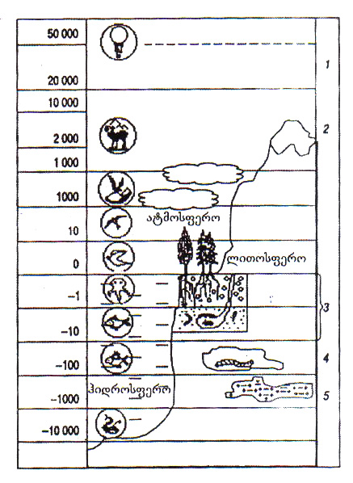
nax. 1. cocxali organizmis ganawileba biosferoSi (metrebSi)
1. ozonis Sre; 2. Tovlis sazRvari; 3. niadagi;
4. gamoqvabulebis cxovelebi; 5. baqteriebi.

biotis ganadgurebis yvelaze naTeli magaliTia tyeebis Cexva, bunebrivi mcenareuli safaris gardaqmna sasoflo-sameurneo, maT Soris saxnav-saTes farTobebad. tyeebis ganadgurebis masStabebi grandiozulia – 10 aTasi wlis manZilze ganadgurebulia tyeebis 50%, amJamad tyeebis Cexva mimdinareobs 50ha/wT siCqariT.

qimizacia da atmosferos gaWuWyianeba
dRes masiurad iwarmoeba daaxloebiT 5 aTasi sinTezuri nivTiereba, romelTa 80% Seuswavlelia toqsikurobis da garemoze zemoqmedebis TvalsazrisiT.
garemos gaWuWyianebis saxeebi mocemulia naz. 2-ze.
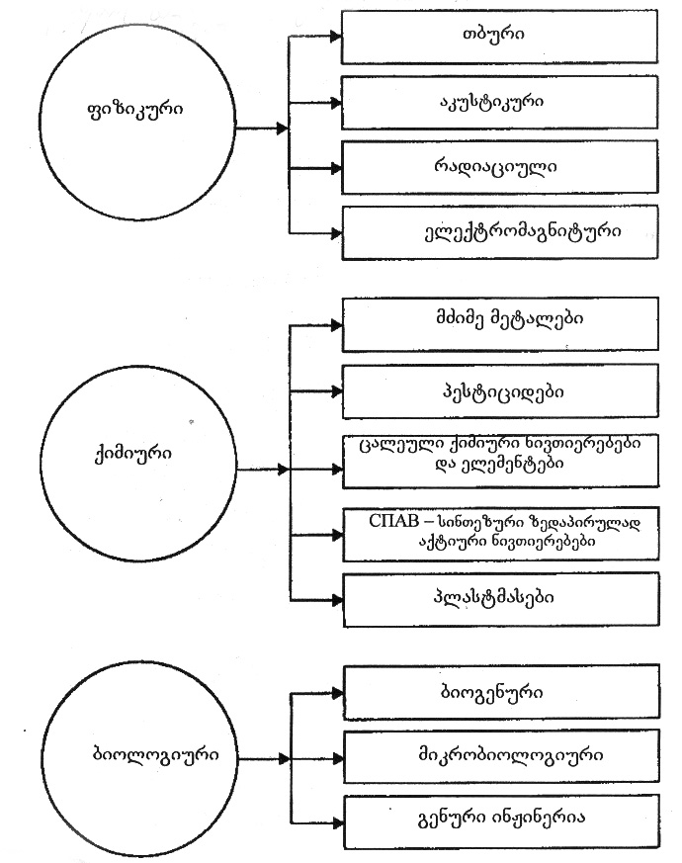
nax. 2. garemos gaWuWyianebis saxeebi

haeris ZiriTadi gamaWuWyianeblebia myari nawilakebi (mtveri, Wvartli), naxSirJangi (CO), azotis oqsidebi (NO, NO₂), naxSirwyalbadebi (C_{m}H_{m}), tyvia da sxva metalebi. am gaWuWyianebis wyaroebia energetika da transporti. atmosferoSi yovelwliurad gamoiyofa 150 mln t myari nivTierebebi, 400 mln t naxSirJangi, 100 mln t azotis oqsidebi. amJamad avtomanqanebze modis moxmarebuli sawvavis 25%, TiTo manqana Tavisi funqcionirebis manZilze gamoyofs saSualod 10 t CO₂-s (dReisaTvis msoflioSi 700 mln avtomanqanaa).

klimatis globaluri cvlileba
zemoT xsenebuli procesebis Sedegad XX saukunis dasawyisidan SeimCneva saTburis airebis, pirvel rigSi CO₂-is koncentraciis zrda atmosferoSi, ris Sedegadac haeris globalurma saSualo temperaturam ukve moimata 0,7°C-iT. es tendencia SenarCunebulia da XXI saukuneSi daTboba kidev 3°C-iT aris navaraudevi. mosalodnelia, agreTve, taifunebisa da wyaldidobebis gaxSireba, Tu ar iqna miRebuli saTanado zomebi, XXII saukuneSi ki daTbobam SesaZlebelia 5-10°C-s miaRwios, rac gamoiwvevs dedamiwis yinulovani safaris gadnobasa da okeanis donis 7 metriT awevas.

ozonis Sris rRveva
ozonis Sris maqsimaluri koncentracia 20-45 km-is simaRlezea. misi sisqis 1%-iT Semcireba zrdis mzis ultraiisferi radiaciis intensivobas 2%-iT, ris Sedegadac daavadebaTa sixSire matulobs 3-6%-iT.

myari da saSiSi narCenebi
XX saukunis bolos planetaze yovelwliurad xdeboda 3.5 mlrd t navTobis, 5,5 mlrd t naxSiris, 2,5 mlrd t metalis, 3 mlrd m³ xe-tyis utilizacia.
ZiriTadi momxmareblebi ganviTarebuli qveynebia, romelTa mosaxleoba daaxloebiT 1 mlrd Seadgens, magram isini iyeneben energiis 50%, metalebis 70% da warmoqmnian narCenebis 75%-s. am narCenebis ZiriTadi nawili rCeba nedleulis mimwodebel qveynebSi. mag., msoflioSi 1 adamianze yovelwliurad saSualod modis 50 t/weli narCeni, germaniaSi 10 t, iaponiaSi 4 t. evropaSi narCenebis is raodenobaa, romelic mis teritorias 10 sm-iani SriT dafaravda.
qimiuri narCenebi – es Senelebuli moqmedebis bombebia. planetaze am tipis narCenebi weliwadSi 500 mln t warmoiqmneba, maTgan 50% - aSS-Si.
gansakuTrebiT saSiSia radiaciuli narCenebi. pirveli atomuri bombis afeTqebis Semdeg (1945w.) 2 aTasi afeTqeba moxda, ramac dedamiwis radiaciuli foni 2%-iT gazarda. amJamad dagrovilia daaxloebiT 10 mln m³ radiaciuli narCeni.

wylebis gaWuWyianeba
dedamiwis hidrosferoSi mtknari wyali mxolod 2%-ia, aqedan 99% Seadgens yinulovani safari. mdinareebSi da tbebSi Tavmoyrilia 90 aTasi km³ mtknari wyali. misi wliuri moxmareba 4 aTasi km³-ia (70% _ soflis meurneoba, 30% – mrewveloba da komunaluri meurneoba).
mtknari wylebi TiTqmis yvelgan dabinZurebulia, gamaWuWyianeblebis raodenoba weliwadSi 150 mlrd tonas aRwevs. ZiriTadi saSiSi gamaWuWyianeblebia mZime metalebi, fenolebi, pesticidebi, zedapirulad aqtiuri nivTierebebi, navTob-produqtebi.

energetikuli problemebi
garemoze udides gavlenas axdens energetika, misi ganviTareba iwvevs bunebrivi resursebis gamolevas. aseve garemoze uaryofiT gavlenas axdens sawvavis wvis produqtebi.

cxrili 3. Tanamedrove energetikis struqtura da ekologiuri Sedegebi
energetikuli  teqnologia | wili msoflio  warmoebaSi, % | ekologiuri Sedegebi
wiaRiseuli saTbobis wva | 78 | mtvris, CO₂-is gamoyofa, rezervebis gamoleva
atomuri energetika | 15 | radiaciuli gaWuWyianebis saSiSroeba, narCenebis problema
hidroenergetika | 7 | bunebrivi teritoriebis datborva
helioenergetika | 0,1 | ekologiurad sufTa, ar saWiroebs did teritoriebs
qaris energia | 0,2-0,3 | xmauri, infrabgera

mosaxleobis mateba
adamians aTvisebuli aqvs xmeleTis 3/4 (~100 mln km²). yvelaze mWidrod dasaxlebul raionebSi (xmeleTis 7%) Tavmoyrilia mosaxleobis 70%. mosaxleobis saSualo simWidrove aris 55 adamiani 1 km²-ze (avstralia – 2, dasavleT evropa – 100).
gansakuTrebiT eqstremaluri da araekologiuri niSa Tanamedrove adamianisaTvis aris qalaqi. qalaqebSi cxovrobs mosaxleobis 50%. bolo 50 weliwadSi qalaqebis mosaxleoba 3,5-jer gaizarda.
cxrili 4. msoflios mosaxleobis raodenobis cvlileba
dro | raodenoba
~100 aTasi wlis win | 2 mln
~50 aTasi wlis win | 10 mln
~2 aTasi wlis win | 100 mln-ze meti
1500w. | 450 mln
1800w. | 900 mln
1900w. | 1 mlrd
1950w. | 2,5 mlrd
1975w. | 4 mlrd
2000w. | 6 mlrd

cxrili 5. mosaxleobis zrda (mlrd)
mosaxleoba | 1950 | 1970 | 1990
dedamiwaze | 2,5 | 3,7 | 5,3
qalaqSi | 0,7 | 1,4 | 2,3
maTi Tanafardoba, % | 28 | 38 | 43
garemo da adamianis janmrTeloba
adamianis janmrTelobaze mravali ekologiuri faqtori moqmedebs – wylebis, haeris, miwis gaWuWyianeba, kveba, anTropogenuri, fizikuri velebis done (xmauri, vibracia, infrabgera, eleqtromagnituri gaWuWyianeba). nax. 3-ze mocemulia xmauris wyaroebi da misi gavlena adamianze.
qveynis civilizaciis done ganisazRvreba, pirvel rigSi, ara teqnikis ganviTarebiT, aramed sicocxlis xangrZlivobiT.
civilizaciis ganviTarebasTan erTad mosaxleobis sicocxlis xangrZlivoba izrdeba. amis mizezia is, rom mosaxleobis cxovreba gaumjobesda, gansakuTrebiT ekonomikurad ganviTarebul qveynebSi, rasac ganapirobebs medicinis miRwevebi, kvebis gaumjobeseba (cxr. 6). marTalia, mravali daavadeba medicinis miRwevebis Sedegad Semcirda an moispo, magram SeimCneva axali daavadebebi, romelTa winaSe medicina jerjerobiT uZluria.
msoflios mosaxleobis 30% avadmyofia, xolo 60 wlis zeviT – 80%.
bunebis mxridan adamianze ganzogadebuli Sexeduleba aseTia: adamiani gansakuTrebiT mravalricxovani, Zlieri, daundobeli, xarbi da binZuri, mtacebeli, romelic anadgurebs ufro mets, vidre SeuZlia SeWamos, riTac sasikvdilod swiravs Tavs.
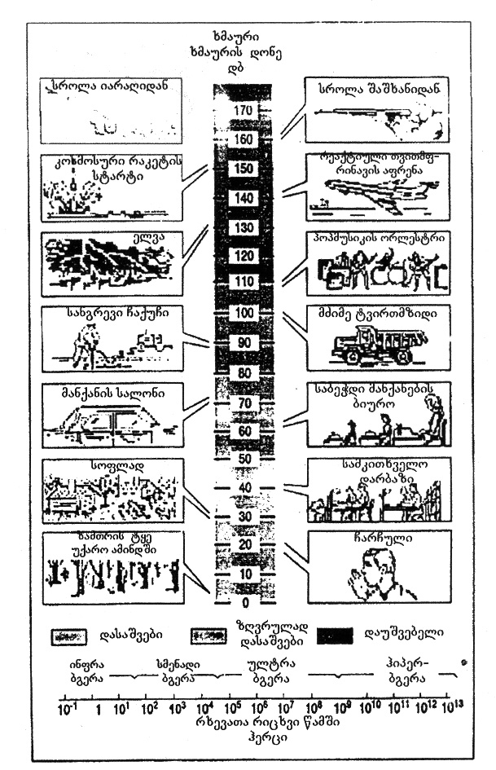
nax. 3. xmis Zalis Skala
cxrili 6. sicocxlis saSualo xangrZlivoba sxvadasxva qveynebSi
qveyana | sicocxlis saSualo xangrZlivoba,  wlebi
iaponia | 80
safrangeTi, germania | 74-78
aSS | 72
ruseTi | 65
CineTi | 64
indoeTi | 44
angola | 41

EII. ekologiis mecnieruli safuZvlebi da misi ZiriTadi ganyofilebebi

dRes adamianis cnobierebaSi ekologia asocirdeba im problemebTan, romlebic naTlad gamoikveTa bolo saukuneSi anTropogenuri zemoqmedebiT bunebis radikaluri gardaqmnis Sedegad. Eekologiis mecnieruli safuZvlebi da misi ZiriTadi ganyofilebebi
albaT, sworia erTi Tanamedrove filosofosis mtkiceba, rom ekologia ara imdenad mecnierebaa, ramdenadac azrovnebis meTodi, midgomis principi. ekologiur problemebTan mimarTebaSi naTlad Cans adamianisa da bunebis kavSiri.
mecnierebs, filosofosebs, astrologebs, RvTis msaxurebs ara aqvT erTiani azri kacobriobis momavalze, icxovrebs is bednierad Tu gainadgurebs Tavs.
XX saukunis Sua wlebamde kacobrioba cxovrobda bunebis gamoulevadobisa da civilizaciis TandaTanobiTi ganviTarebis bednieri rwmeniT. magram iyvnen mecnierebic, romlebic ara mxolod amCnevdnen Cveni ganviTarebis winaaRmdegobebs, aramed winaswarmetyvelebdnen kacobriobis daRupvas, saSinel katastrofebs, civilizaciis mospobas.
amJamad saerTo katastrofis SegrZneba imdenad Zlieria, rom TiToeuli adamiani eWviT uyurebs samyaros momavals. rogori iqneba igi – amis pasuxi amqveynad aravis aqvs.
`ekologiuri usafrTxoeba~ gulisxmobs garemos SenarCunebas teqnogenuri saqmianobis procesSi. adamianis nebismieri praqtikuli saqmianoba dakavSirebulia garemos gardaqmnasTan, bunebrivi resursebis gamoyenebasTan. amitomac ekologiuri usafrTxoebis cnebasTan erTad gamoiyeneba bunebis dacvisa da bunebrivi resursebis racionaluri gamoyenebis cnebebic.
ekologiuri usafrTxoeba miiRweva finansuri, sakanonmdeblo da teqnikuri RonisZiebebiT: ekologiuri kanonebisa da normatiuli dokumentebis SemuSavebiT, garemoze naklebad mavne zemoqmedebis teqnikuri sistemebisa da axali bunebisdacviTi teqnologiebis SeqmniT. garemos dacvis problema, pirvel rigSi, ekonomikuria. garemos dacviTi RonisZiebebis efeqturoba damokidebulia sazogadoebis SesaZleblobebze da mzadyofnaze gaiRos xarjebi garemos SenarCunebis mizniT.
ganviTarebuli qveynebis umetesoba ekologiuri mdgomareobis xelisSewyobisa da stabilizaciisTvis xarjavs saerTo nacionaluri produqtis 2-3%-s, Tumca ekologiuri situaciis gasaumjobeseblad saWiroa aranakleb 5%-isa.
Tanamedrove civilizaciis ZiriTadi amocanaa gazardos es cifri randemjerme, raTa ara mxolod Seamciros, aramed Tavidan aicilos garemosTvis miyenebuli zarali.
ekologia ewodeba mecnierebas, romelic Seiswavlis cocxali organizmebis arsebobis pirobebs, aseve organizmebsa da maT saarsebo garemos Soris urTierTkavSirs misi cocxali da aracocxali komponentebiT.
garemos faqtorebs, romlebic moqmedeben organizmebze, uwodeben ekologiur faqtorebs. isini iyofa sam jgufad – abiotur, biotur da anTropogenur jgufebad (nax. 4).
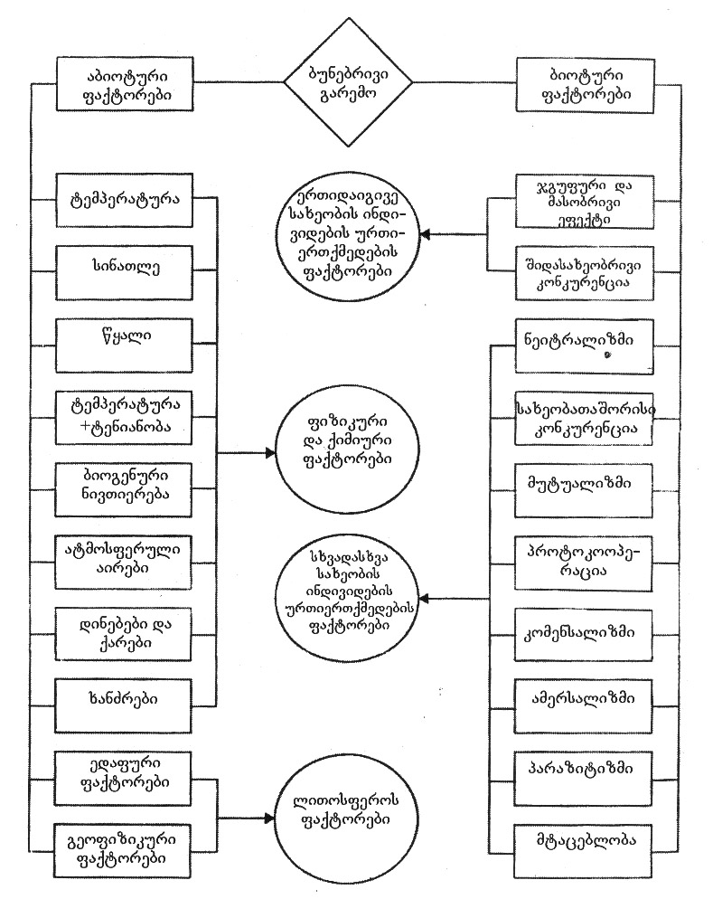
nax. 4. ekologiuri faqtorebis klasifikacia

abioturi ewodeba araorganul faqtorTa erTobliobas. esenia temperatura, sinaTle, sinotive, naleqebi, qari da a.S. yvela es aracocxali bunebis faqtori pirdapir da arapirdapir moqmedebs cocxal organizmebze da gansazRvravs maTi arsebobis pirobebs.
bioturi ewodeba yvela zemoqmedebas, romelsac ganicdis organizmi mis garSemo myofi sxva organizmebisagan (nax. 5).
anTropogenuri faqtorebi aris adamianis moqmedebis formebi: pirdapiri da arapirdapiri. pirdapiri moqmedeba xdeba uSualod cocxal organizmebze, arapirdapiri ki – maT saarsebo garemoze.
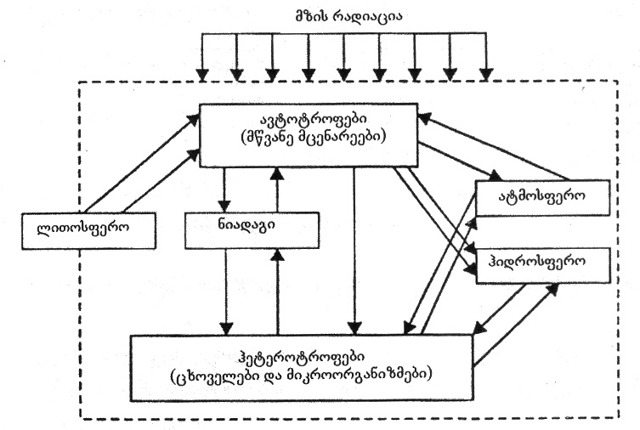
nax. 5. cocxali organizmebis urTierTkavSiri biosferos komponentebTan

garemos cocxal da aracocxal – biotur da abiotur komponentebs Soris kavSiri xorcieldeba nivTierebaTa cvlisa da energiis gardaqmnis gziT, xolo biotur komponentebs Soris – kvebis jaWviT (nax. 6).
kvebis formis mixedviT ganasxvaveben avtotrofebsa da heterotrofebs.
avtotrofebi – es is organizmebia, romlebic araorganuli nivTierebebisagan mzis energiis gamoyenebiT axdenen organuli nivTierebebis sinTezs – kerZod, mcenareebi, fotosinTezis gziT, an qimiuri reaqciebis energiis xarjze – qemosinTezis gziT.
fotosinTezirebadi avtotrofebia wylisa da xmeleTis mwvane – qlorofilis Semcveli mcenareebi.
qemosinTezirebadi avtotrofebia mikroorganizmebi, romlebic organuli nivTierebebis sinTezs axdenen naxSirorJangisagan, amiakis, gogirdwyalbadisa da sxva nivTierebaTa daJangvis energiis xarjze.
heterotrofebi iyofa or jgufad – konsumentebad da reducentebad.
konsumentebi momxmarebuli heterotrofebia, romelic ikvebeba organuli nivTierebebiT; maT miekuTvneba cxovelebi, zogierTi mikroorganizmi, aseve paraziti da mweriWamia mcenareebi.
reducentebi ki damSleli heterotrofebia, maT miekuTvneba baqteriebi da sokoebi, isini ikvebebian cxovelebiT an maTi naSTiT, mcenareuli narCenebiT da organul nivTierebebs gardaqmnian sawyis araorganul nivTierebebad.
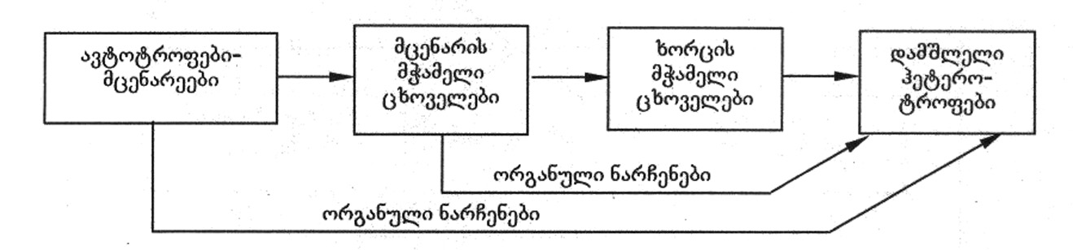
nax. 6. kvebis jaWvis sqema

amJamad ekologias yofen sam ganyofilebad _ faqtorialur, populaciur ekologiad da biocenologiad.
faqtorialuri, anu avtoekologia Seiswavlis calkeul saxeobaTa kavSirs garemosTan, anu ekologiuri faqtorebis erTobliv moqmedebas calkeul saxeobaze da maT reaqcias am zemoqmedebaze.
populaciuri ekologia Seiswavlis erTi da imave saxeobebis – populaciebis calkeul jiSTa bunebrivi jgufebis struqturisa da dinamikis formirebis pirobebs, sxvadasxva saxeobebis raodenobriv cvlilebebs da ikvlevs am movlenebis mizezebs.
biogeocenologia Seiswavlis cocxali da aracocxali bunebis urTierTkavSirsa da urToerTqmedebas biogeocenozSi.
biogeocenozis sqema ase SeiZleba warmovadginoT.
biogeocenozi aris biosferos modeli (nax. 7). biosfero, v.i. vernadskis ganmartebiT, aris `cocxali nivTierebis arsebobis are~. misi sazRvrebia – liTosferos zeda nawili ~3-5 km siRrmeze, hidrosfero mTlianad da atmosferos qveda fena 11-12km simaRlemde. es is area, sadac arseboben cocxali organizmebi an maTi arsebobis kvali Cans.
noosfero – sityvasityviT `moazrovne garsi~, es is area, sadac adamianis gonieri moqmedeba Cans, sadac adamianis gonieri moRvaweoba xdeba ganviTarebis ZiriTadi ganmsazRvreli faqtori.
dResdReobiT Cveni sazogadoebis keTildReoba didad aris damokidebuli ekologiuri problemebis gacnobierebasa da gadawyvetaze. es problemebi Semdegia:
1. raodenobrivi regulacia;
2. produqtiuloba;
3. adaptacia;
4. monitoringi;
5. indikacia.
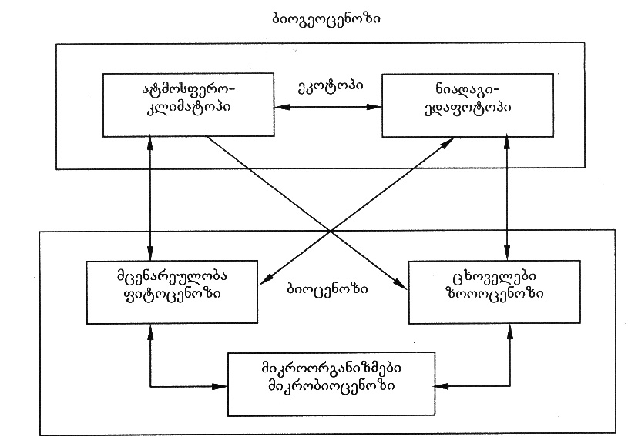
nax. 7.

raodenobrivi regulaciis problema gulisxmobs bunebaSi arsebuli cxovelTa ricxobrivi regulaciis meqanizmis Seswavlas da mis gamoyenebas mosaxleobis cxoveluri produqtebiT momaragebis uzrunvelsayofad da warmoebisaTvis cxoveluri warmoSobis nedleuliT momaragebisaTvis.
produqtiulobis problema gulisxmobs mcenareuli safaris mosavlianobis gazrdis sakiTxebis Seswavlasa da ganxorcielebas.
adaptaciis problema – es aris cocxali organizmebis eqstremaluri pirobebisadmi Seguebis meqanizmebis Seswavla, rac gvexmareba Cveulebrivi saarsebo garemosagan eqstremalurad gansxvavebuli teritoriebis aTvisebaSi, mag., Crdilo-yinulovani zona, kosmosi da a.S.
monitoringis problema emyareba garemoze ganmeorebiTi, winaswarganzraxuli dakvirvebebis sistemis Seqmnas, rac gvexmareba bunebrivi movlenebis gacnobierebasa da gamoyenebaSi.
indikaciis problema moicavs saxalxo meurneobis arsebuli dargebis gafarToebiTa da axali dargebis Seqmnis Sedegad garemoze uaryofiTi gavlenis dadgenas, rac gvexmareba ekonomikis dagegmarebaSi.

nivTierebaTa wrebrunvebi da maTi rRveva garemoSi
ukanaskneli aseuli milioni wlis manZilze nivTierebaTa wrebrunva bunebaSi xorcieldeba biologiuri da geofizikuri faqtorebis zemoqmedebiT. SemoRebulia terminebi – biogeoqimiuri wrebrunva da bioqimiuri ciklebi.
normalur, daurRvevel biogeoqimiur ciklebs aqvs TiTqmis Caketili xasiaTi, rac ganapirobebs biosferos Semadgenlobis mudmivobasa da wonasworobas, komponentTa raodenobisa da koncentraciis SenarCunebas.
swored biogeoqimiuri wrebrunvebi da masTan dakavSirebuli energiis gardaqmnis procesebia biosferos mdgradobisa da dinamiuri wonasworobis safuZveli.
cnobilia wylis, Jangbadis, naxSirbadis, azotis, fosforis, mikroelementebis wrebrunvebi. ganasxvaveben did (geologiur) da mcire (biologiur) wrebrunvebs. didi wrebrunvebis arsi Semdegia – mTis qanebi ganicdis daSlas, gamofitvas. gamofitvis produqtebi, maT Soris wyalSi xsnadi mkvebavi nivTierebebi, wylis nakadiT Cadis okeaneSi da warmoqmnis zRvis danaleqs (danaSrevs). qanebi xmeleTze mxolod nawilobriv brundeba naleqebTan da zRvebidan adamianis mier amoRebul organizmebTan erTad.
mcire wrebrunvebi didis nawilia da mimdinareobs biocenozis doneze – niadagis mkvebavi nivTierebebi, wyali, CO₂ da atmosferos sxva nivTierebebi fotosinTezis xarjze akumulirdeba producentebSi (mcenareebi, zogierTi baqteriebi) da ixarjeba producentebisa da konsumentebis aRnagobasa da cxovrebiseuli (gacvliTi) procesebisTvis. SemdgomSi, ZiriTadad reducentebis xarjze, organuli nivTiereba iSleba, nawili mineralizdeba da kvlav erTveba nivTierebaTa nakadSi (wrebrunvaSi).
nivTierebaTa gadaadgileba biologiuri wrebrunvisas gacilebiT swrafad xdeba, vidre geologiuri wrebrunvisas. qimiuri nivTierebebis wrebrunvas araorganuli aredan mcenareTa da cxovelTa organizmebis gavliT kvlav araorganul areSi mzis energiis gamoyenebiT mimdinare bioqimiuri reaqciebiT biogeoqimiur cikls uwodeben.
yovelwliurad am cikliT moZraobaSi modis daaxloebiT 480 mlrd t nivTiereba, ZiriTadad biofiluri elementebi – naxSirbadi, azoti, wyalbadi, Jangbadi da sxv.

wylis wrebrunva
wylis wrebrunva _ es aris wylis cirkulacia dedamiwaze, igi mimdinareobs Semdegi pirobiTi sqemiT: zRvebidan, xmeleTidan, mdinareebidan da mcenareebidan aorTqleba, wylis orTqlis gadatana atmosferoSi, wylis orTqlis cirkulacia, naleqebi.
okeanis zedapiridan yovelwliurad orTqldeba wylis mniSvelovani raodenoba. okeanis zedapiris wylebsa da SedarebiT Rrma zonebis wylis masas Soris Camoyalibebulia regularuli mimocvla, lokaluri droebiTi wonasworoba. wylis orTqli atmosferoSi kondensirdeba, waritacebs airebs, vulkanur gazebsa da aerozolebs, anTropogenuri warmoSobis mavne nivTierebebs da gamoiyofa naleqebis saxiT. nawili dedamiwis qerqis gavliT Cadis mis siRrmeSi. iq maRali wnevisa da temperaturis gavleniT isev amodis cxeli wyaroebis – geizerebis saxiT. wylis mniSvnelovani nawili Slis liTosferos qanebs, xsnadi naerTebi amoaqvs zedapirze da mdinareebis saxiT Cadis okeaneebSi. advilad xsnadi nivTierebebi rCeba da grovdeba okeanis wyalSi, Znelad xsnadi ki ileqeba okeanis fskerze.
wylis wrebrunvis rRvevas iwvevs tyeebis ganadgureba, intensiuri irigacia, mtvrisa da CO₂-is Semcvelobis cvlileba atmosferoSi, ozonis Sris rRveva, zRvebisa da okeaneebis gabinZureba, gansakuTrebiT navTobproduqtebiT – navTobis afskis warmoqmna iwvevs aorTqlebis intensivobis Semcirebas da, Sesabamisad, naleqebis raodenobis klebas, zedapiruli da miwisqveSa Canadenis Semcirebas, gruntis wylebis donis dawevas, soflis meurneobis produqtebis, dedamiwis mcenareuli safaris klebas, es unakaskneli ki amcirebs transpiraciis (mcenareebidan wylis aorTqleba) process.
zemoT CamoTvlili procesebi TiTqmis wonasworulia, amitom wyali bunebaSi raodenobrivad ar klebulobs, igi gamoulevad resursebs miekuTvneba.
gamoTvlilia, rom dedamiwis zedapiridan 1 wuTSi orTqldeba ~1 mlrd. t wyali. okeaneebidan aorTqlebuli wyali bevrad aRemateba xmeleTidan aorTqlebuls (tbebi, mdinareebi, mcenareebi). samagierod, naleqebi xmeleTze meti gamoiyofa, vidre okeanis zedapirze.
1 grami wylis aorTqlebaze ixarjeba 2250 jouli (537 kal) siTbo, romelic SemdegSi gamoiyofa naleqebis warmoqmnisas.
atmosferoSi arsebuli wylis ganaxleba daaxloebiT 10 dRe-RameSi xdeba, mdinareebis wylisa – 11 dRe-RameSi, niadagisa da zedapiruli wylebis – 1 weliwadSi. SedarebiT nela mimdinareobs tbebis, Waobebis da myinvarebis hidrologiuri cikli. wylis wrebrunvis sqema mocemulia nax. 8-ze.
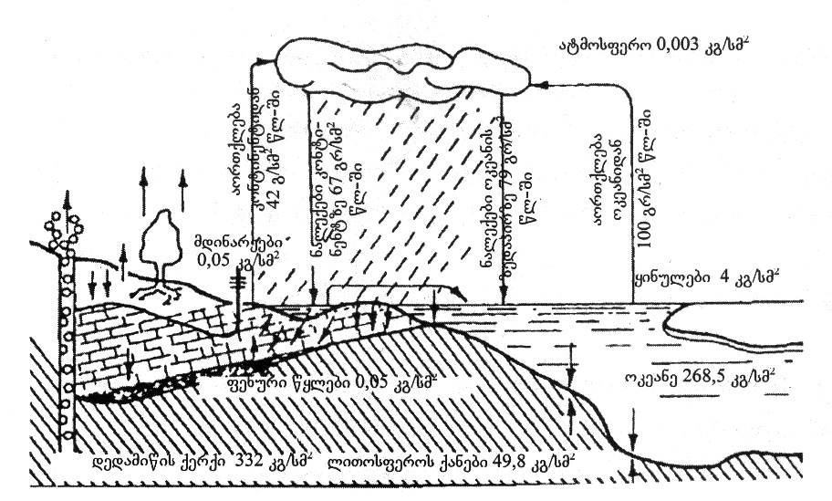
nax. 8. wylis wrebrunva

Jangbadis wrebrunva
Jangbadis wrebrunva erT-erTi urTulesi procesia, radgan Jangbadi reaqciaSi Sedis rogorc araorganul, ise organul mravalricxovan nivTierebebTan, aseve wyalbadTan (nax. 9).
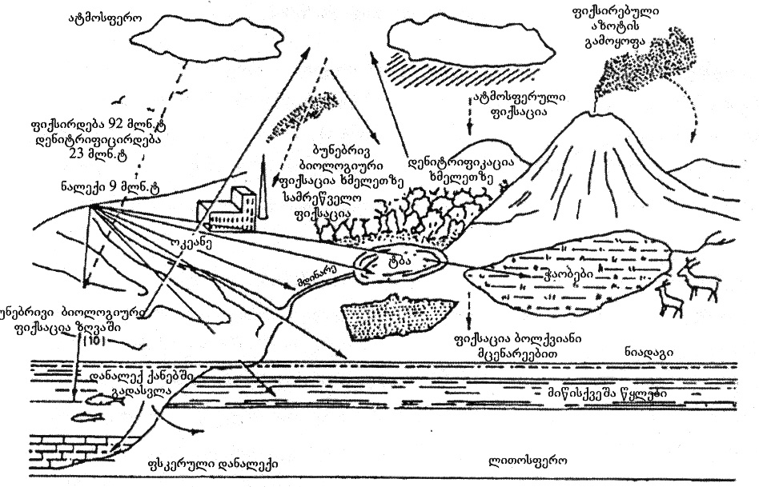
nax. 9. Jangbadis wrebrunva
Tavisufali saxiT Jangbadi aris zedapirul wylebSi, niadagSi, igi atmosferos makrokomponentia, aseve aris ozonis saxiT stratosferoSi.
bmuli saxiT igi mineralebisa da mTis qanebis ZiriTadi elementia, aseve oqsidebis saxiT aris atmosferoSi da hidrosferoSi. wyali – H₂O yvelaze gavrcelebuli nivTierebaa planetaze. Jangbadi nebismier cocxal organizmSia rogorc wylis Semadgeneli nawili.
atmosfero Seicavs daaxloebiT 1,1·10²¹ t Jangbads, rac haeris moculobis 21%-s Seadgens. dedamiwis qerqSi misi woniTi wili ~49%-s aRwevs.
atmosferoSi Jangbadi Semdegi procesebis Sedegad gamoiyofa: zeda SreebSi maRali temperaturis gamo ultraiisferi sxivebiT wylis orTqli iSleba Jangbadad (O₂) da wyalbadad (H₂):
_ xmeleTisa da wyalmcenareebidan fotosinTezis gziT;
_ endogenuri procesebiT – xmeleTisa da okeanis fskeridan bazaltis qanebis daSliT.
Jangbadis momxmarebelia yvela cocxali organizmi sunTqvis procesis dros.
iseve rogorc wylis wrebrunvis, O₂-is ciklis darRvevas iwvevs mcenareuli safaris ganadgureba, zRvebisa da okeaneebis navTobproduqtebiT gaWuWyianeba, radganac zedapiruli gamyofi afskis warmoqmnis gamo Zneldeba aeracia atmosferosa da okeanes Soris.
naxSirbadis wrebrunva
naxSirbadis wrebrunva biosferoSi gacilebiT martivia, vidre Jangbadis, masSi monawileoben mxolod organuli naerTebi da naxSirorJangi. fotosinTezis procesSi asimilirebuli mTeli naxSirbadi gardaiqmneba organul naerTebad, xolo sunTqvis procesSi organul naerTebSi arsebuli naxSirbadi gardaiqmneba CO₂-ad. mcenareebi yovelwliurad asimilireben ~105·10¹⁵ g C-s, xolo sunTqviT gamoiyofa 32·10¹⁵ g C.
organuli sawvavis wvisas gamoiyofa naxSirorJangi da naxSirJangi. naxSirorJangi gamoiyofa aseve niadagis qanebis daSliT, rac Seqcevadi procesia. naxSirbadis wrebrunva xorcieldeba rogorc didi, aseve mcire cikliT. es ciklebi SeiZleba gamovsaxoT sqematurad (nax. 10, 11).
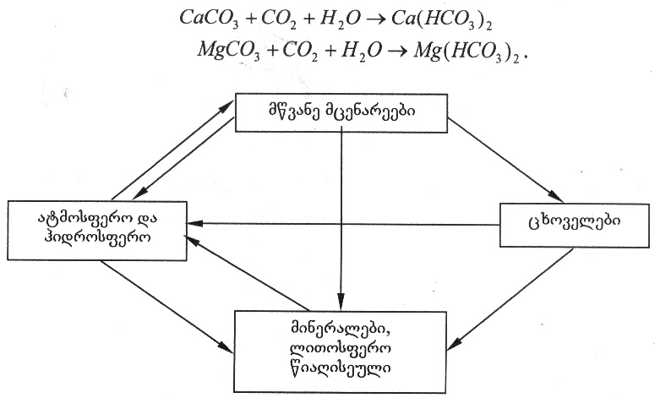
atmosferoSi da wyalSi aris naxSirorJangi CO₂, romlis gavleniT qarTan da wyalTan erTad icvleba mTis qanebis Sedgeniloba, mag., karbonatebis: kirqvis (CaCO₃), magnezitis (MgCO₃), dolomitis (CaCO₃, MgCO₃).

nax. 10. naxSirbadis wrebrunvis mcire cikli
warmoqmnili xsnadi marilebi (hidrokarbonatebi) gamoirecxeba da Cadis okeaneebSi; nawili ixsneba wyalSi, nawili ki araorganuli pirobebis zemoqmedebiT, aseve wylis organizmebiT (mag., moluskebiT) ifiltreba da ileqeba okeanis fskerze. danaleqi qanebi metamorfozis Sedegad, aseve teqtonuri procesebiT gadaadgildeba dedamiwis qerqis siRrmeSi, xangrZlivi periodis Semdeg nawili isev amodis zeviT. ufro swrafad midis procesi vulkanebis amofrqvevisas. am dros gamoiyofa rogorc CO₂, aseve CO, romelic SemdgomSi gardaiqmneba CO₂-ad.
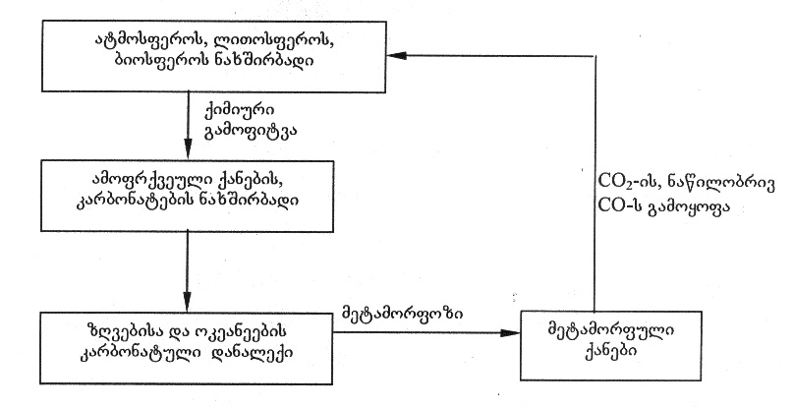
nax. 11. naxSirbadis didi (geologiuri) wrebrunva

atmosferoSi CO₂-is saxiT arsebuli naxSirbadis maragi 23,5·10¹¹ tonaa. mwvane mcenareebi mzis energiis xarjze CO₂-sa da H₂O-sagan fotosinTeziT qmnian organul nivTierebebs. es procesi endoTermulia.
6CO₂ + 6H₂O = C₆H₁₂O₆ + 6O₂ _ 674 kkal
atmosferoSi CO₂-is Semcvelobis maregulirebeli faqtori ZiriTadad okeanea. Tu atmosferoSi matulobs CO₂-is Semcveloba, is ixsneba wyalSi, Sedis reaqciaSi Ca(HCO₃)₂-is warmoqmniT, xolo CO₂-is Semcirebisas atmosferoSi, hidrokarbonatebi iSleba karbonatebis warmoqmniT, romlis nawils iyeneben cocxali organizmebi ConCxis, niJarebis asagebad, maTi kvdomis Semdeg ki ileqeba fskerze.
bunebaSi naxSirbadis mimoqcevis gamartivebuli sqema mocemulia naxazze 12.
naxSirorJangis, Sesabamisad naxSirbadis wrebrunvis rRvevas iwvevs anTropogenuri faqtorebi, kerZod, mrewvelobis mravali dargi – metalurgiuli, qimiuri, navTobqimiuri, samSeneblo masalebis sawarmoebi, transporti, aseve mcenareuli safaris ganadgureba da zRvebisa da okeaneebis navTobproduqtebiT gaWuWyianeba. gamoyofili naxSirorJangi atmosferoSi rom kavdebodes, misi koncentraciis mkveTri zrda katastroful Sedegebs gamoiwvevda, sabednierod es ar xdeba, radgan CO₂-is zrdasTan erTad izrdeba msoflio okeaneSi misi gaxsnis procesi.
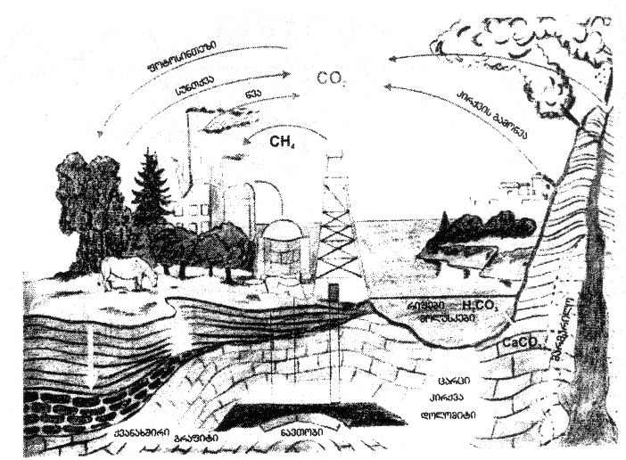
nax. 12. naxSirbadis mimoqceva bunebaSi

gogirdis wrebrunva
arsebobs hipoTeza, rom adreul geologiur epoqebSi O₂-is ukmarisoba ganapirobebda gogirdis arsebobas ZiriTadad H₂S da marilebis (sulfidebis) saxiT, mg. FeS. O₂-is formirebiT iwyeba JangviTi procesebi. amJamad, gogirdi bunebaSi warmodgenilia H₂SO₄-is, H₂S-is da maTi marilebis saxiT – sulfatebiTa da sulfidebiT, aseve Tavisufali formiT, SO₂-is da cocxal organizmebSi organuli nivTierebebis saxiT (nax. 13).
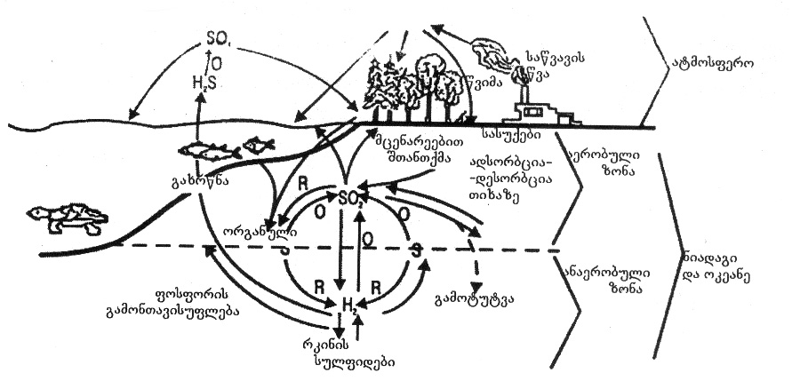
nax. 13. gogirdis wrebrunva bunebaSi

gogirdis wrebrunvaSi udides rols asruleben baqteriebi, romelTagan zogierTi qemosinTezis gziT warmoqmnis organul nivTierebebs.
gansakuTrebuli baqteriebis (gogirdbaqteriebis) moqmedebiT xdeba gogird-wyalbadis H₂S-is Jangva S-mde:
2H₂S + O₂  2H₂O + 2S + 127 kkal
es ar aris sruli Jangvis procesi, igi ufro Rrmad midis haeris Jangbadis moqmedebiT:
H₂S + 2O₂  H₂SO₄ + 189 kkal
gogirdi iJangeba rogorc haerze, aseve gogirdbaqteriebis organizmSi, Tu ar aris gogirdwyalbadis are:
2S + SO₂ + 2H₂O  2H₂SO₄ + 251 kkal
SO₂ da H₂SO₃-is praqtikulad ar warmoiqmneba:
2S + O₂ + 2H₂O  2H₂SO₃ + 157 kkal
2H₂SO₃ + 2H₂O + O₂  2H₂SO₄ + 94 kkal
H₂SO₄ Tavisufali saxiT bunebaSi ar gvxvdeba, igi aqtiuria, amitom moqmedebs wyalsa da niadagSi arsebul nivTierebebTan an mTis qanebTan, magaliTad:
CaCO₃ + H₂SO₄  CaSO₄ + CO₂ + 2H₂O
vulkanebis amofrqvevisas gamoiyofa H₂S da SO₂, maTi maRali koncentraciisas mimdinareobs reaqcia:
2H₂S + SO₂  3S + 2H₂O
gogirdwyalbadi icavs gogirds Semdgomi Jangvisagan da igi liTonsferos garkveul siRrmeze SeiZleba iyos Sreebis an marcvlebis saxiT. gogirdi Sedis wiaRiseuli saTbobis SemadgenlobaSic. am sawvavis gamoyenebisas, atmosferoSi gamotyorcna ufro myar sagans Seefereba, gamoifrqveva H₂S da SO₂, romlebic iJangebian haerze H₂SO₄-mde da dedamiwas ubrundebian mJave wvimebis saxiT. amiT gogirdis wrebrunva ikvreba.
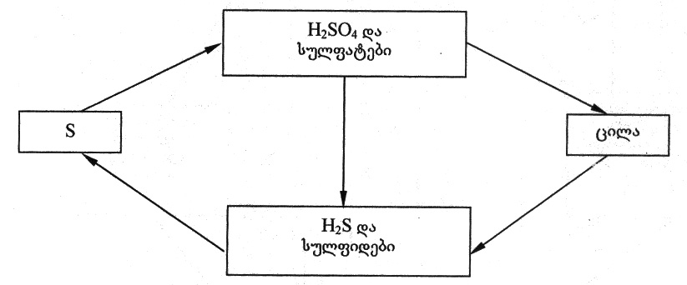
nax. 14. gogirdis wrebrunvis gamartivebuli sqema

azotis wrebrunva
azotis wrebrunva erT-erTi rTuli da, amave dros, idealuri wrebrunvaa. masSi monawileobs organizmebis didi ricxvi, organuli naerTebis daSla xdeba etapebad, sabolood azoti gadadis nitratul formaSi.
atmosferos 78%-s Seadgens azoti, igi aris niadagSi, wyalSi araorganuli naerTebis saxiT (amoniumis marilebi, nitritebi, nitratebi), aseve organuli nivTierebebis saxiT Sedis mcenareebis da cxovelebis cilebsa da aminomJavebSi.
azotis fiqsacia xdeba mcenareebis mier, esaa biologiuri asimilacia. igi yovelwliurad Seadgens 86·10¹⁴ g N₂, rac misi aqtiuri fondis 1%-ia.
naerTebSi Semavali azoti iSleba aminofikaciisa da nitrofikaciis gziT, xolo nitritebisa da nitratebis aRdgena molekulur azotamde xdeba denitraciis Sedegad da gamoiyofa atmosferoSi.
azotis wrebrunvis gamartivebuli sqema mocemulia naxazze 15.
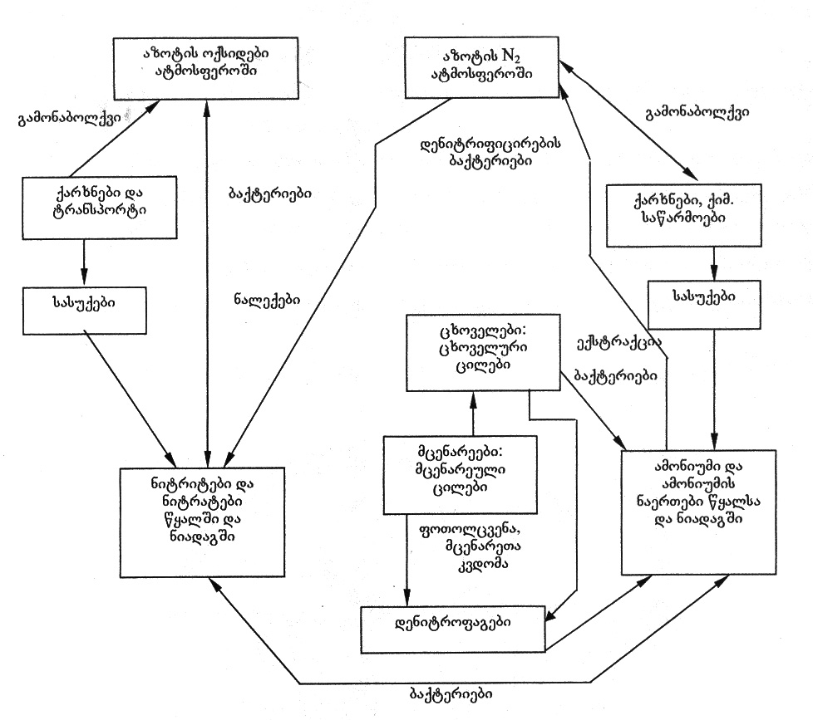

nax. 15. azotis wrebrunvis gamartivebuli sqema

Tavisufal azots N₂ mcenare ver iTvisebs, Tavis zrdisTvis igi iyenebs amiakis naerTebs an azotmJavas marilebs. azoti haeridan niadagSi bmuli saxiT gadadis azotmafiqsirebeli baqteriebiT da wyalsacavebSi lurj-mwvane wyalmcenareebiT. aseTi baqteriebis magaliTebia aerobuli azotbaqteriebi, anaerobuli pasteris klostridiumebi, bolqvebis baqteriebi, romlebic cxovroben da funqcionireben parkosani mcenareebis fesv-bolqvebze.
fiqsaciis procesi aseTia:
N₂ + 3H₂  2NH₃ + 615,63 kjouli
SemdgomSi nitrificirebadi baqteriebi Jangaven amiaks
2NH₃ + 3O₂  2HNO₂ + 2H₂O + 148 kkal
2HNO₂ + O₂  2HNO₃ + 48 kkal
es mJavebi niadagSi mimocvliTi reaqciebiT qmnian marilebs, romlebsac iTvisebs mcenare:
K₂CO₃ + 2HNO₃  2KNO₃ + H₂O + CO₂ ↑
igi axdens cilovani nivTierebebis sinTezs, romelsac iyenebs sxva cocxali organizmi Tavisi aminomJavebis sinTezisTvis.
nivTierebaTa cvlis produqtebi (eqskrumentebi) – Sardovana da sxva, mcenareebsa da cxovelebis mZori ganicdis destruqcias da mineralizdeba jer amiakad da amoniumis naerTebad baqteriebis, sokoebisa da wvimis Wiebis mier, xolo Semdeg azotmJavad. es ukanaskneli ki iSleba denitrificirebadi baqteriebiT – azotad N₂, romelic adis atmosferoSi da cikli ikvreba (nax. 16). es procesi SeiZleba gamoisaxos reaqciiT:

5C₆H₁₂O₆ + 24KNO₃  30CO₂ ↑ + 18H₂O + 24KOH + 12N₂ ↑ + 9388,3 kjouli
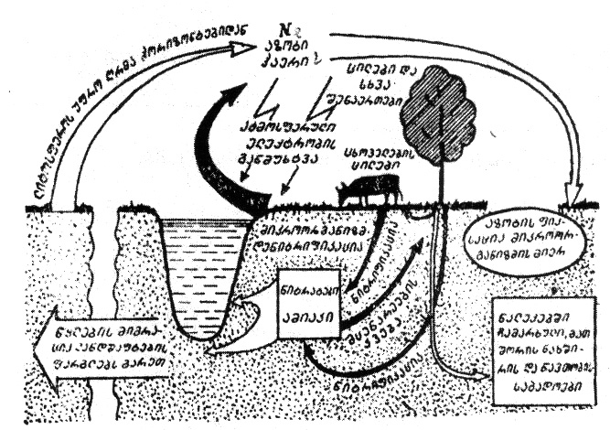
nax. 16. azotis wrebrunva bunebaSi

azotis wrebrunvis rRvevas iwvevs Semdegi faqtorebi – 1) warmoebebi. maTi sawarmoo narCenebi Seicavs azotis oqsidebs, romelic adis atmosferoSi. 2) mosax-leobis matebis gamo saWiroa meti mosavlis miReba, risTvisac iyeneben azotovan sasuqebs – nitratebs. maTi wyalSi xsnadobis gamo xdeba araorganuli naerTebis ~50%-is gamorecxva niadagidan, saidanac isini Cadis mdinareebSi, tbebSi, iwvevs wyalmcenareebis intensiur zrdas da evTrofikaciis process.

fosforis wrebrunva
fosforis wrebrunva sakmaod rTulia, risTvisac ganvixiloT igi gamartivebuli saxiT. fosfori metad mniSvnelovani biogenuri elementia, igi Sedis nukleinmJavas, Zvlovani qsovilis, ujredis membranis, energiis gadamtani sistemis (АТФ) da sxvaTa SemadgenlobaSi (nax. 17).

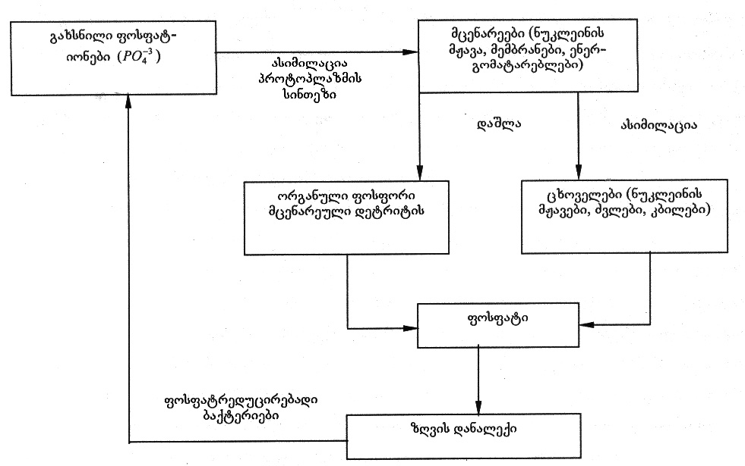

nax. 17. fosforis biogenuri wrebrunvis gamartivebuli sqema

fosfori moZravi elementia da misi wrebrunva didad aris damokidebuli garemos faqtorebze, Cvens droSi ki _ gansakuTrebiT anTropogenur faqtorebze. fosfori wylebSi aRwevs sarecxi saSualebebis (detergentebis) saxiT, mindvrebidan fosforovani da kombinirebuli sasuqebis formiT, sawarmoo narCenebis (gansakuTrebiT apatitebisa da fosforitebis sawarmoebis) saxiT da sxv., riTac irRveva fosforis biogenuri wrebrunvis wonasworoba.
fosfori bunebaSi ZiriTadad fosfatebis saxiTaa gavrcelebuli. atmosferoSi igi mxolod mtvris saxiTaa warmodgenili, amitom wrebrunvaSi CarTulia wyali da niadagi.
xmeleTisa da wylis mcenareebi asimilireben fosfors xsnadi fosfationis saxiT. cxovelebis organizmidan fosfori gamoiyofa SardiT an uSualod organizmis daSliT, zogierTi baqteriebi organul fosfors gardaqmnis fosfatad (nax. 18).
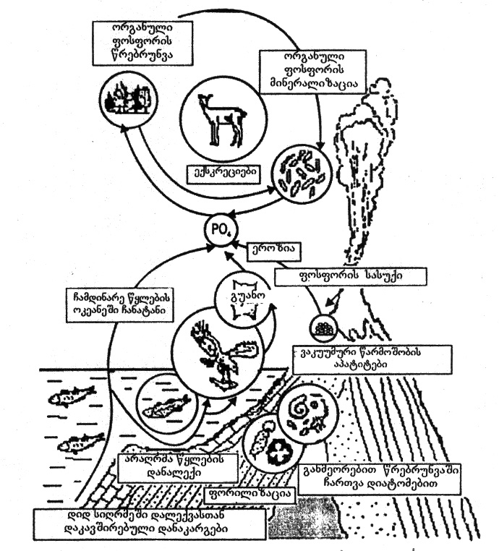

nax. 18. fosforis wrebrunva bunebaSi

fosforis wrebrunvis rRveva azotis analogiurad ganpirobebulia fosforovani sasuqebis warmoebis zrdiT, fosforiT mdidari sakvebis (Tevzi, moluskebi) gamoyenebiT, narCenebis dagrovebiT. am ukanaskneliT xdeba rogorc niadagis, aseve wyalsacavebis gaWuWyianeba, rac iwvevs evTrofikaciis process.

III. bunebrivi resursebi da maTi klasifikacia. racionaluri gamoyeneba

resursi (resources) _ franguli sityvaa da niSnavs saSualebebs, marags.
yovelive bunebaSi arsebuli _ haeri, wyali, flora, fauna, wiaRiseuli, mzis energia, meteoritebi, niadagi da a.S. warmoadgens bunebriv resurss.
buneba da bunebrivi resursebi _ es aris pirveladi wyaro adamianis materialuri da sulieri moTxovnilebis dasakmayofileblad. maT gareSe SeuZlebelia sazogadoebis arseboba da ganviTareba. bunebrivi resursebis CamonaTvalSi yvelas ara aqvs erTnairi mniSvneloba adamianisTvis. dasaSvebia, rom zogierT maTgans dRes saerTod ar hqondes `resursis~ funqcia, magram mas mainc miakuTvneben bunebriv resurss, radgan SesaZloa man momavalSi, Cveni codnis gafarToebis kvaldakval SeiZinos es funqcia. miT umetes, rom gvaqvs warsulis gamocdilebac, mag., navTobi, bunebrivi airi wiaRSi aTasi wlebis ganmavlobaSi arsebobda, maTi gamoyeneba ki bolo 2-3 saukunis periodSi moxda da umniSvnelovanesi resursis funqciac SeiZina.
bunebrivi resursebis swori gagebis, gamoyenebisa da dacvisTvis didi mniSvneloba aqvs maT klasifikacias (nax. 19).
literaturaSi gvxvdeba bunebrivi resursebis sxvadasxva klasifikacia. gavicnoT zogierTi maTgani.
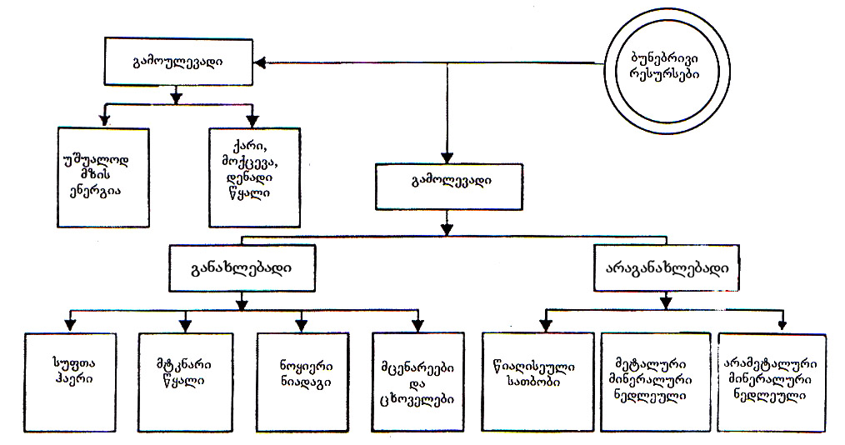

nax. 19. bunebrivi resursebis klasifikacia

I. warmoSobis mixedviTY(laptevis klasifikacia)
1. araorganuli resursebi.
a) kosmosuri _ mzis da kosmosuri radiacia; meteorituli nivTierebebi; kosmosuri radiotalRebi; zRvis miqcevisa da moqcevis energia.
b) planetaruli _ atmosferos eleqtroba, dedamiwis magnituri Zalebi, wneva, haeri, wyali, mTis qanebi, siTbo, klimati, qimiuri elementebi.
2. biologiuri resursebi - flora, fauna, mikroorganizmebi.
3. Sereuli resursebi - landSafti, wyalsacavebi, niadagi.

II. voroncovis klasifikacia
1. bunebrivi klasifikacia – wiaRiseuli, klimaturi, wyali, niadagi, haeri, flora, fauna da sxv.
2. ekonomikuri klasifikacia.
a) materialuri warmoebis resursebi _ samrewvelo, soflis meurneobis.
b) arasawarmoo sferos resursebi.
III. resursebis klasifikacia Zvradobis mixedviT
1. kosmosidan uwyvet migraciaSi myofi resursebi _ igi moicavs laptevis klasifikaciis kosmosuri resursebis jgufs.
2. dedamiwis farglebSi migrirebadi resursebi _ haeri, wyali, siTbo, qimiuri elementebi, cxovelebi.
3. pirobiTad uZravi, dedamiwasTan erTad moZravi resursebi – flora, wiaRiseuli
IV. resursebis klasifikacia Seucvladobis mixedviT
1. absoluturad aucilebeli, Seucvladi resursebi _ atmosfero, wyali, mzis radiacia, kulturuli mcenareebi, niadagi, moSenebadi cxovelebi.
am resursebidan romelimes ara Tu amoReba, aramed Tvisebebis gauareseba sazogadoebis yofna-aryofnis sakiTxs ayenebs.
2. SedarebiT aucilebeli da principulad Secvladi resursebi – maT miekuTvneba yvela danarCeni resursi.
V. bunebrivi resursebis klasifikacias gamolevadobis mixedviT
bunebrivi resursebis gamoyenebisa da dacvis organizaciisaTvis udidesi mniSvneloba aqvs resursebis klasifikacias gamolevadobis mixedviT. am niSniT resursebi iyofa:
1. gamolevad resursebad _ flora, fauna, wiaRiseuli, niadagi.
2. gamoulevadi resursebi _ yvela danarCeni resursi.
gamolevadi resursebi iyofa or jgufad:
a) aRdgenadi – flora, fauna, niadagi, zogierTi mineraluri resursebi _ mag., marilebi, romlebic ileqeba tbebSi, zRvis ubeebSi.
b) aRudgenadi – wiaRiseuli.
flora, fauna aRdgenadia maTi gamravlebis unaris gamo. Tu SevinarCunebT TiToeuli saxeobis 20% mainc, isini Tavis ricxovnobas aRidgenen garkveuli drois ganmavlobaSi. niadagi bunebrivi wrebrunvebiT inarCunebs Tavis noyierebas, magram adamianis uSualo an arapirdapiri zemoqmedebiT SesaZloa dairRves gamravlebis, zrdis, ganviTarebis pirobebi, rac gamoiwvevs cxovelebisa da mcenareTa garkveuli saxeobebis gadagvarebas, niadagis gamofitvas da a.S.
rac Seexeba gamolevad, araganaxlebad resurss _ wiaRiseuls, misi gamoyeneba aucileblad migviyvans mis gamolevamde, amitom udidesi mniSvneloba eniWeba maTi arsebobis gaxangrZlivebis RonisZiebebis gatarebas.
aRudgenadi resursebis – wiaRiseuli saTbobis, madnis, mineraluri resursebis arsebobis gaxangrZlivebis sami gza arsebobs:
1. maTi racionaluri, ekonomiuri gamoyeneba
2. maTi Semcvlelebis Zieba
3. mravaljeradi gamoyeneba.
ganvixiloT TiToeuli ufro vrclad.
wiaRiseuli saTbobis – qvanaxSiris, navTobis, bunebrivi airis racionaluri, ekonomiuri gamoyeneba gulisxmobs maTSi Tavmoyrili siTburi energiis maqsimalur amoRebas da daniSnulebisamebr gamoyenebas, wvis optimaluri reJimis srulad dacvas, siTbos gadacemis maqsimalur hermetulobas, rac minimumamde daiyvans yovelgvar danakargebs da Sesabamisad dazogavs pirvelad resurss.
rogorc cnobilia, Tavisufali, TviTnabadi saxiT wiaRSi mxolod keTilSobili liTonebi – oqro, vercxli da platina arsebobs, sxva liTonebi naerTebis saxiT, ZiriTadad sulfidebis saxiT moipoveba. amdenad, konkretul warmoebas amoRebuli madnis mTliani masiT, 100%-iT gamoyeneba ar SeuZlia. mag., Savi metalurgiis qarxnebi rkinis madnebidan Fe_{x}S_{y} saWiroeben mxolod rkinas da ara gogirds, an minarevebis saxiT am madnebSi arsebul ferad liTonebs, romlebic am warmoebisaTvis narCenebs warmoadgens.
Savi metalurgiuli warmoebis mier nedleulis racionaluri gamoyeneba gulisxmobs madanSi arsebuli rkinis maqsimalurad gadatanas produqtSi.
imave nedleulze muSaobs gogirdmJavas sawarmoebic, mxolod mas gogirdovani nawili sWirdeba da ara rkina, romelic misTvis narCens warmoadgens.
Tu moxdeba am or sawarmos Soris narCenebis urTierTgacvla, es dazogavs, Seamcirebs maT mier amoRebuli pirveladi nedleulis _ rkinis madnis moxmarebas.
amrigad, madnis racionaluri, ekonomiuri gamoyeneba niSnavs mis kompleqsur gadamuSavebas, anu yvela Semadgeneli nawilis saTanado warmoebis mier gamoyenebas, rac Seamcirebs calkeuli sawarmoebis narCenebs da Sesabamisad ekologiur sakiTxsac moagvarebs – naklebad moxdeba garemos gaWuWyianeba.
qvanaxSiris, navTobis, bunebrivi airis arsebobis gaxangrZlivebas xels Seuwyobs bunebaSi arsebuli, gamoulevadi energoresursebiT maTi Secvla. aseTi energoresursebia wylis, qaris, miqcevis da moqcevis, geizerebis, mzisa da sxva ganaxlebadi wyaroebis energia.
wylis, qaris energias adamiani uxsovari droidan iyenebda sxvadasxva meqanikuri samuSaoebis Sesasruleblad, amJamad ki am gamoulevadi energiis wyaroebidan xdeba universaluri energiis _ eleqtroenergiis miReba da gamoyeneba.
marTalia, dRes Tboeleqtrosadgurebis (qvanaxSirze, navTobze da bunebriv airze momuSave) wili bevrad sWarbobs sxva energiis wyaroebze momuSave eleqtrosadgurebis wils (~78% Tbosadgurebi, 16% hidroeleqtrosadgurebi), magram TandaTan es Tanafardoba Seicvleba.
msoflios TiTqmis yvela qveyanaSi funqcionirebs hidroeleqtrosadgurebi, CineTSi, safrangeTSi, ruseTSi (murmanskSi) aris zRvis miqcevisa da moqcevis energiaze momuSave eleqtrosadgurebi. iaponiaSi, italiaSi, islandiaSi, kamCatkaze da sxv. geizerebze – miwisqveSa cxeli wylebis energiaze momuSave eleqtrosadgurebi moqmedebs.
samxreT afrikaSi okeanis zedapirul da qveda fenebs Soris temperaturis sxvaobis gamoyenebiT muSaobs mZlavri eleqtrosadguri.
momavalSi gaizrdeba mzis energiaze momuSave helioeleqtrosadgurebis wili, rac didad Seuwyobs xels wiaRiseuli saTbobis dazogvas. mecnierebi muSaoben ori tipis kosmosuri helioeleqtrosadgurebis proeqtebze. erTi proeqtiT eleqtro-sadguri kosmosSive Sekrebs mzis energias, gardaqmnis eleqtroenergiad, romelsac mokle eleqtromagnituri talRebis saxiT miawvdis dedamiwis garkveul zonas da Semdeg moxdeba misi gadanawileba.
meore proeqtiT ki kosmosSi moxdeba mzis energiis, misi sxivebis viwro, mZlavr konebad Sekvra da dedamiwaze miwodeba, aq ki sxivuri energia eleqtroenergiad gardaiqmneba da gadanawildeba. es proeqtebi jerjerobiT aRiqmeba, rogorc fantastikuri, magram mravali fantastikuri proeqtis msgavsad, romelTac sainJinro ganxorcieleba hpoves, isic realurad iqceva.
dResdReobiT msoflio energetikaSi daaxloebiT 4% modis atomur eleqtro-sadgurebze, romlebic muSaoben radiaqtiuli, Zlier energotevadi nivTierebebis xarjze, magram es nivTierebebic gamolevad, araganaxlebad wiaRiseul energoresursebs miekuTvnebian da amdenad, qvanaxSiris, navTobisa da bunebrivi airis farTomasStabian Semcvlelad ver CaiTvleba. garda amisa, maTi qselis Semcireba xdeba ekologiuri saSiSroebis gamo.
rac Seexeba madnebs, dResdReobiT mxolod aluminis, aviaciisaTvis metad mniSvnelovani metalis (misi simsubuqisa da simtkicis gamo) Secvla xdeba plastikuri masalebiT (TiTqmis 40%-iT), xolo sxva liTonebis Semcvleli xelovnuri masalebis miReba momavlis saqmea.
wiaRiseuli resursebis arsebobis vadebis gaxangrZliveba maTi mravaljeradi gamoyenebiT SesaZlebelia mxolod madnebisa da mineraluri resursebisaTvis da ara saTbobisaTvis.
liTonis nakeTobebi amortizaciis vadis amowurvis Semdeg rogorc nakeToba uvargisia, magram nedleulad isev rCeba, amitom xdeba maTi jarTis saxiT Segroveba da xelaxali gadamuSaveba, jarTis gamoyeneba, madnis garda, energoresursebis dazogvasac uwyobs xels, radgan madnis pirveladi damuSavebisas meorad damuSavebasTan SedarebiT adgili aqvs energiis mniSvnelovan xarjs, aseve garemos gaWuWyianebasac. amitom rogorc Savi, aseve feradi liTonebis mravaljeradi gamoyeneba ekonomiur efeqtTan erTad sagrZnob ekologiur efeqtsac iZleva.
rogorc saTbobis, aseve mineraluri resursebis dazogvas xels uwyobs minis warmoebaSi, e.w. lewis (uvargisi an damtvreuli minis nawarmis) xelaxali gamoyeneba. aseTive efeqts vRebulobT makulaturis xelaxali gadamuSavebisas.

IV. atmosferos Sedgeniloba. ozonis roli da misi rRvevis Sedegebi

atmosfero haeris garsia, romelic gars akravs dedamiwas. igi gamoulevadi, amave dros Seucvladi resursia, romlis gareSe dedamiwaze sicocxle SeuZlebelia.
atmosferos airadi Sedgeniloba, misi gamWvirvaloba, tenianoba, atmosferuli wneva, dedamiwis damcveli garsi _ ai, is maxasiaTeblebi, romlebic ganapirobebs mis Seucvladobas.
atmosfero milevadi simkvriviT grZeldeba 2000 km simaRlemde. masSi gamoyofen ramdenime Sres – troposferos, stratosferos, mezosferos, Termosferos da egzosferos. am Sreobriv dayofas safuZvlad udevs temperaturis cvlilebis reJimi, zog SreSi igi matulobs, zogSi klebulobs, Sreebs Soris ki adgili aqvs temperaturis cvlilebis SeCerebas – pauzas, maTi saxelebic aqedan warmosdgeba (nax. 20).
gavecnoT calkeuli Sreebis ZiriTad Tvisebebs.
troposfero uSualod akravs dedamiwas, igi saSualod 10-11 km-mde vrceldeba, ekvatorTan 17 km-mdea. polusebTan ki troposfero ufro SemWidroebulia 7-8 km-mde. am SreSi simaRlis yovel kilometrze temperatura klebulobs ~6-7°C-iT. atmosferoSi arsebuli haeris TiTqmis 4/5 Tavmoyrilia troposferoSi, mxolod am SreSi warmoiqmneba naleqebi.
troposferosa da stratosferos gamyof fenas – tropopauzas mosdevs stratosfero. igi daaxloebiT 55 km-mde grZeldeba da masSi yovel km-ze temperatura 2-3°C-iT matulobs. haeris darCenili masa (1/5) TiTqmis am SreSia moqceuli; aq warmoiqmneba sadafisferi Rrublebi, naleqebi ki – ara. stratosferos udidesi dacviTi funqcia akisria. igi dedamiwas icavs mzis ultraiisferi gamosxivebisagan, rasac uzrunvelyofs 20-45 km simaRleebze Tavmoyrili ozoni (O₃). ozoni atarebs ultraiisferi gamosxivebis mxolod biologiuri procesebisaTvis aucilebel dozas. ozonis saerTo raodenoba Zalian mcirea, igi erTiani Sris saxiT rom SemovakraT dedamiwas, misi sisqe 3 mm-mde iqneba.
dResdReobiT mwvaved dgas ozonis problema. mis Semcirebas iwvevs atmosferoSi ozondamSleli airebis, e.w. freonebis (ftor-, qlor-Semcveli, advilad aqroladi naxSirwyalbadebi) raodenobis zrda.
ozoni aramdgradi airia, igi advilad iSleba atomuri Jangbadis (O) gamoyofiT, magram am ukanasknelis maRali reaqciis unarianobis gamo xdeba ukuprocesic – ozonis warmoqmna da myardeba wonasworoba.
O₃  O₂ + O.
freonebi boWaven atomur Jangbads, wonasworobis aRsadgenad saWiroa meti O₃-is daSla da es procesi jaWvurad midis da mcirdeba ozonis raodenoba. ozonis 1%-iT Semcireba zrdis mzis radiaciis SemoRwevadobas 2%-iT da kanis simsivnur daavadebebs 3-6%-iT.
ozonis Sris gaTxeleba aZnelebs misi bunebrivi da xelovnuri warmoSobis xvrelebis Sevsebis process.
ozonis xvrelebi pirvelad dafiqsirda 1978 wels antarqtidis Tavze amerikuli polaruli sadguris mecnierTa mier.
am xvrelebze Semdgomma dakvirvebebma aCvena, rom wlis manZilze xdeba xvrelebis farTis zrda da kleba. xvrelis farTi maqsimaluria polaruli gazafxulis (oqtomberi) dros. amis axsna aseTia – gazafxulze atmosferos sxvadasxva simaRleze temperaturis didi sxvaobaa. es mZlavri vertikaluri grigalis warmoqmnis mizezia, ris Sedegadac xdeba ozonis Sris rRveva da xvrelebis warmoqmna.
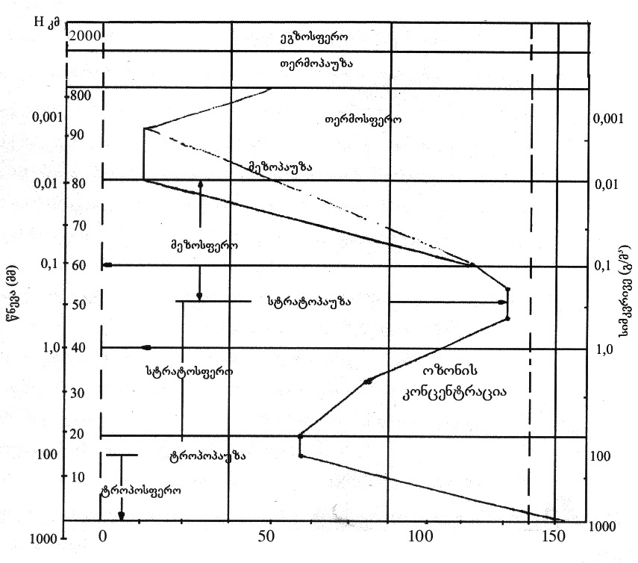
nax. 20. atmosferos vertikaluri struqtura

xvrelebi saSiSia imdenad, ramdenadac maTi gavliT xdeba mzis radiaciis daubrkoleblad SemoRweva dedamiwis zedapirze, rac arasasurvelia.
es procesi atmosferoSi xdeba mTeli misi arsebobis manZilze, magram polarul zonaSi es naklebad saSiSia, radgan aq mzis sxivebi maxvili kuTxiT ecema zedapirs da amdenad, mzis radiaciis SemoRweva da, Sesabamisad, uaryofiTi Sedegebic naklebia. magram, rac ufro vuaxlovdebiT ekvators, mzis sxivebis dacemis kuTxe izrdeba da bolos aRwevs 90°-s, e.i. xdeba mzis sxivebis pirdapiri SemoRweva.
am zonaSi ozonis xvrelebis warmoqmnis mizezi anTropogenuri faqtorebia _ zeswrafi TviTmfrinavebis frena da kosmonavtika.
unda aRvniSnoT, rom ozonis xvrelebs wliur ciklTan erTad mzis ciklebis Tanxvedrili 12-wliani ciklic axasiaTebs. am periodSi xdeba xvrelebis Sesabamisi farTis zrda da kleba.
ozoni garkveuli koncentraciiT gvxvdeba troposferoSic, misi Semcveloba matulobs gazafxulze – Weqa-quxilis dros azotis oqsidebis daSliT warmoqmnili O-s xarjze.
ozons gamoyofen wiwviani mcenareebic, rac gamoiyeneba klimatoTerapiisTvis (mag., abasTumani – filtvebiT daavadebulTaTvis). stratopauzas mosdevs mezosfero, romelic grZeldeba daaxloebiT 80 km-mde. es aris meore Sre, tropopauzis Semdeg, romelSic temperatura mcirdeba (daaxloebiT 1-2 gradusiT yovel kilometrze). mezopauzas mosdevs Termosfero, igi grZeldeba daaxloebiT 800 km-mde. rogorc saxelwodeba gviCvenebs, aq maRali temperaturaa. marTlac, 100 km-ze igi Seadgens 400-500°C, xolo 400 km-ze aRwevs 1600°C. aseTi maRali temperatura iwvevs aq maRali gaiSviaTebis gamo mcire raodenobiT arsebuli airebis ionizacias, amitom am Sres ionosferosac uwodeben. ionizirebuli are xels uwyobs mzis sxivebis gafantvas da Sesabamisad, dedamiwis dacvas Warbi radiaciisagan.
Termopauzas mosdevs egzosfero, e.w. gafantvis Sre da igi grZeldeba 2000 km-mde.
ufro detalurad SevCerdeT troposferoze, Cveni arsebobis areze.
rogorc aRvniSneT, am SreSi simaRlis mixedviT temperatura klebulobs, es umniSvnelovanesi faqtoria, radgan winaaRmdeg SemTxvevaSi dedamiwa gaexveoda namwvi airebis saburvelSi, warmoiqmneboda `smogi~ da safrTxe Seeqmneboda adamianis sicocxles. `smogi~ _ momwamvleli nislia, romlis wyaroc warmoebis mavne airebi da transportis gamonabolqvia.
mavne nivTiereba adamianisaTvis saSiSia, rodesac misi Semcveloba atmosferos garkveul moculobaSi (C _ nivTierebis koncentracia) aRwevs saSiS zRvars. es procesi mosalodnelia did qalaqebSi, samrewvelo raionebSi smogisTvis xelsayreli faqtorebis arsebobisas. es faqtorebia – maRali nislianoba, qvaburebSi moqceuli teritoriebis ganiavebis naklebi albaToba da temperaturuli inversiis movlena – e.i. yvela is faqtori, romlebic xels uSlian dedamiwis zedapiris bunebriv ganiavebas (zedapiris bunebriv ganiavebas ganapirobebs troposferoSi simaRlis mixedviT temperaturis kleba. uSualod dedamiwis siaxloves arsebuli Tbili, gaWuWyianebuli haeris masa, simsubuqis gamo adis zeviT, zeviT arsebuli sufTa civi, mZime haeris masa ki Camodis Zirs _ e.i. xdeba cirkulacia).
bunebrivi nislis (siTxis wveTebi Sewonil mdgomareobaSi) saburveli aZnelebs airebis gadaadgilebas simaRleze da mavne airebis koncentracia izrdeba uSualod dedamiwis siaxloves. igive procesi xdeba qvaburebSi airTa nakadebis umoZraobis gamo.
temperaturuli inversiis (inversia niSnavs Sebrunebas) arsi mdgomareobs SemdegSi. rodesac smogis wyaroebis Tavmoyris adgilebSi atmosferos zeda fenebSi xdeba Tbili haeris nakadebis Semosvla, irRveva simaRlis mixedviT temperaturis klebis reJimi, rac xels uSlis dedamiwis bunebriv ganiavebas da Sesabamisad, zrdis smogis albaTobas.
meteorologiuri samsaxuri akvirdeba garemos da zemoT CamoTvlili smogis xelSemwyobi faqtorebis dafiqsirebis SemTxvevaSi afrTxilebs qalaqis xelisuflebas. es ukanaskneli atarebs organizaciul RonisZiebebs – sawarmoebis simZlavris Semcirebas an gaCerebas, transportis muSaobis SezRudvas normaluri klimaturi pirobebis aRdgenamde, raTa ar moxdes adamianebis janmrTelobis gauareseba.
atmosfero rTuli sistemaa. faqtobrivad igi aerozolia, romelic airad, myar (mtveri, mlaSe wylebis Sxefebis aorTqlebis Sedegad marilTa kristalebi) da Txevad (siTxis wveTebi, orTqli) komponentebs Seicavs.
Tu myar da Txevad nawils movacilebT, airadi nawilis makrokomponentebis Semcveloba aseTia: N₂ ~ 78%, O₂ ~21%, inertuli airebi ~ 0,9% da СO₂ ~0,04%. es Tanafardoba SenarCunebulia TiTqmis 100 km-is simaRlemde.
gavecnoT am airTa cvlilebis dinamikas da mis Sedegebs. dresdReobiT arsebobs azotis Semcvelobis klebis tendencia, rac gamowveulia azotovani warmoebis zrdis masStabebiT. am warmoebis erTaderTi nedleuli haeris azotia (gaTxevadebuli haeris fraqciuli gamoxdisas, -196°С-ze duRils iwyebs azoti). Tumca, adamianis mier gamoyenebuli azotis wili bunebaSi mis saerTo raodenobasTan SedarebiT umniSvneloa, amitom mis koncentraciaze anTropogenuri zemoqmedeba problemas ar qmnis.
rac Seexeba Jangbads (O₂), misi moxmareba gasuli saukunis manZilze mkveTrad gaizarda mosaxleobis matebis (gaoTxmagda), warmoebis, transportis ganviTarebis gamo (dRes msoflioSi daaxloebiT 700 milioni avtomanqanaa, TiToeuli msubuqi avtomanqana 1000 km gavlisas wvavs mZRolisTvis saWiro O₂-is wliur normas).
miuxedavad O₂-is aseTi intensiuri moxmarebisa, misi Semcveloba atmosferoSi XX saukunis ganmavlobaSi mxolod 0,02%-iT Seicvala, e.i. atmosferos Sevseba O₂-iT misi moxmarebis TiTqmis tolfasia.
atmosferos O₂-iT pirveladi Semavseneli mwvane mcenareebia rogorc xmeleTis, aseve wylis, romlebic fotosinTezis gziT gamoyofen Jangbads.
magram momavalSi O₂-is stabilurobis garanti mcenareebi ver iqnebian, radganac xmeleTis mcenareuli safari yovelwliurad mcirdeba araswori rewvis, bunebrivi xanZrebis, qimizaciis Sedegad. aseve zRvebisa da okeaneebis dabinZureba, gansakuTrebiT navTobproduqtebiT, aZnelebs wylis aeracias wyalsa da haers Soris gamyofi afskis warmoqmnis gamo, rac zRudavs wyalmcenareebSi fotosinTezis process. isic unda aRiniSnos, rom mcenareebi mxolod mzis sinaTleze gamoyofen O₂-s, sibneleSi ki isinic sunTqaven da umniSvnelod, magram mainc moixmaren maT mierve gamoyofil Jangbads.
amrigad, wonasworobis SesanarCuneblad bunebaSi arsebobs atmosferos JangbadiT Semavsebeli sxva wyaroc. dResdReobiT aseTad iTvleba endogenuri procesebi anu siRrmuli procesebi. dedamiwis siRrmeSi arsebuli maRali temperatura iwvevs sxvadasxva qanebis daSlas, O₂-is gamoTavisuflebas da amoRwevas dedamiwis forovani qerqidan.
am procesebis realobis dasabuTeba SesaZlebelia zRvebisa da okeaneebis qveda Sreebis SeswavliT.
dadginda, rom zRvebisa da okeanis fskerze aris O₂-iT gadajerebuli adgilebi. okeanis wylebis cirkulaciisas wylis zedapirze siRrmesTan SedarebiT maRali temperaturis gamo O₂ gamoiyofa atmosferoSi (airTa xsnadobasa da temperaturas Soris ukuproporciuli damokidebulebis gamo).
inertuli airebis gamoyeneba imdenad umniSvneloa, rom es maT Semcvelobaze TiTqmis ar moqmedebs.
O₂-is moxmarebis zrdis Sedegia atmosferoSi meoTxe makrokomponentis _ CO₂-is zrda. rogorc sunTqvis, aseve nebismieri wvis procesis dros gamoiyoda CO (arasruli wva) an CO₂ (sruli wva).
CO-sgan gansxvavebiT CO₂ ar aris adamianis janmrTelobisaTvis saSiSi airi Tu misi koncentracia ar aWarbebs zdk. 052mg/m³ (СО advilad uerTdeba filtvis alveolebSi sisxlis wiTel burTulebs, methemoglobins O₂-s veRar ierTebs da Jangbadis deficitis gamo organizmi iRupeba).
magram CO₂ koncentraciis zrda atmoseroSi sxva saTburis airebTan erTad (CH₄, NO, N₂O, SO₂, wylis orTqli) iwvevs e.w. saTburis efeqts. naxSororJangi atmosferoSi, saTburebSi minis gadaxurvis msgavsad, advilad atarebs mzis siTbos, magram ewinaaRmdegeba uSualod dedamiwaze warmoqmnili Tburi gamosxivebis gadinebas kosmosSi. am ori gamaTbobelis erToblivi moqmedeba dedamiwis gadaxurebis mizezi xdeba. amas SesaZloa moyves dedamiwis klimaturi sistemis Seuqcevadi cvlileba, rac, upirveles yovlisa, gamovlindeba planetis yinulovani safaris gadnobaSi.
XX saukunis ganmavlobaSi CO₂-is koncentracia atmosferoSi gaizarda 25%-iT (0,032-dan 0,04-mde), rasac ~1°C-iT gadaxureba unda gamoewvia. magram es ar momxdara, amave periodSi dedamiwis gadacivebis gamo. es ukanaskneli ki gamowveuli iyo atmosferos gamtverianebiT.
wiaRiseuli sawvavis moxmarebis Sedegad atmosferoSi CO₂-is mateba isev grZeldeba da Sesabamisad, safrTxe kvlav arsebobs, magram gamtverianebis am doniT mateba, sabednierod, mosalodneli ar aris. radganac haerSi arsebuli Warbi mtveri ileqeba Tovlisa da yinulis zedapirze, gaWuWianebuli, muqi zedapiri ki metad STanTqavs mzis sxivebs, rac yinulovani safaris dnobas damatebiT uwyobs xels.
garda mikrokomponentebisa, atmosferoSi mravali aTeuli bunebrivi an xelovnuri warmoSobis airia, mag., azotis, gogirdis oqsidebi, NH₃, H₂S, CH₄ da sxv. mravali airi, maTi urTierTgardaqmnis produqti atmosferos gaWuWyianebis mizezia. garda amisa, anTropogenuri warmoSobis bevri airi (hidroftornaxSirbadebi, perftornaxSirbadebi da, gansakuTrebiT, gogirdis heqsaftoridi SF₆) Zalian didi wvlilis Semtania saTburis efeqtSi, ris gamoc maT gamoyenebaze mkacri kontrolia dawesebuli.
unda aRiniSnos, rom monrealis protokoli, romelic SemoRebuli iyo 1987 wels aris erT-erTi saukeTeso bunebisdacviTi SeTanxmeba, romelmac ganapiroba stratosferuli ozonis Sris dacva da ar dauSva mzis ultraiisferi gamosxivebis im speqtris zrda, romelic aRwevs dedamiwas da saxifaToa cocxali organizmebisaTvis.
G2014 wlis 10 seqtembers JenevaSi gaeros garemosdacviTi programis Semsrulebeli - direqtoris moxsenebaSi gaiJRera, rom mecnierTa jgufis varaudiT, romlebic muSaoben gaeros garemosdacviTi programisa da msoflio meteorologiur organizaciis egidis qveS, SesaZlebelia ozonis Sris aRdgena moxdes Cveni saukunis Sua wlebisaTvis.

V. atmosferuli haeris dabinZurebis bunebrivi da anTropogenuli faqtorebi

atmosferos dabinZurebis xelovnuri wyaroebia, rogorc adre aRvniSneT, ZiriTadad mrewveloba da transporti, nawilobriv soflis meurneobac, rodesac xdeba Sxamqimikatebis gafrqveva, aseve sayofacxovrebo pirobebSi gamoyenebuli gamaTbobeli agregatebi.
gavecnoT sxvadasxva sawarmoebis mier gamoyofil atmosferos gamaWuWyianebeli nivTivrebebis saxeobebs.
Tburi eleqtrosadgurebi, Tboeleqtrocentralebi, saqvabe danadgarebi myari da Txevadi sawvavis wvisas atmosferoSi gamoiyofa boli, sruli wvisas _ gogirdis Jangi, nacari, arasruli wvisas _ naxSirJangi, Wvartli, naxSirwyalbadebi.
navTobmompovebeli, navTobgadamamuSavebeli da navTobqimiuri mrewvelobis airuli ganayofi didi raodenobiT Seicavs naxSirwyalbadebs, gogirdwyalbadebs da sxva arasasiamovno sunis airebs.
sinTezuri kauCukis sawarmoebi atmosferoSi uSveben momwamlav nivTierebebs _ stiroli, divinili, acetoni, izopreni da sxv.
qimiuri sawarmoebis ZiriTadi mavne gamonayofia naxSirJangi, azotis Jangeulebi, gogirdovani anhidridi, amiaki, mtveri, gogirdwyalbadi, gogirdnaxSirbadi, qromis, ftoris naerTebi da sxv.
Savi metalurgiis qarxnebis gamavali airebi Seicaven gogirdis dioqsids, magniums, mcire raodenobiT dariSxans, fosforis, tyviis naerTebs, vercxlis da iSviaT liTonTa orTqls, cianwyalbads, fisovan nivTierebebs.
Tujis dnobisas gamoyofil brZmedul gazebSi uxvadaa sxvadasxva Sedgenilobis mtveri _ siliciumis orJangi, aluminis Jangi, kalciumis, kaliumis, natriumis, tyviis, TuTiis Jangebi da sxv.
feradi metalurgiis sawarmoebidan gamoyofili airebi Seicaven toqsikur mtvrisebr nivTierebebs _ dariSxans, tyvias da sxv.
eleqtroqimiuri wesiT aluminis miRebisas atmosferoSi xdeba didi raodenobiT ftori.
azotmJavis sawarmoebidan gamaval airebs miyveba azotis Jangi, amiaki, naxSirorJangi.
saSen masalaTa sawarmoebi, cementis qarxnebi atmosferos mtvriT gaWuWyianebis wyaroebia.
transportis yvela saSualeba _ saavtomobilo, sarkinigzo, sazRvao, samdinaro da saaviacio, praqtikulad atmosferos gaWuWyianebis wyaroa, magram yvelaze Zlieri gamaWuWyianebeli saavtomobilo transportia. misi ZiriTadi mavne gamonayofia azotis Jangi, naxSirJangi, sxvadasxva naxSirwyalbadebi, aldehidebi, gogirdovani airi, benzinis Zravebi amaTTan erTad gamoyofen tyviis, qloris, bromis da zogjer fosforis Semcvel produqtebs.
metad saSiSia atmosferos radiaqtiuli gaWuWyianeba, rasac adgili aqvs radiaqtiuli nivTierebebis mopovebis, gadamuSavebisa da gamoyenebis dros.
rac Seexeba soflis meurneobas, haeris gaWuWyianeba ZiriTadad xdeba pesticidebiT, sasuqebiT mindvrebis damuSavebisas, aseve mecxoveleobisa da mefrinveleobis fermebidan.
atmosferos gaWuWyianebis arc Tu umniSvnelo keraa adamianis yofiTi saqmianoba. ojaxSi gamoyenebuli gamaTbobeli agregatebi, samzareuloebi, nagavsayrelebi, sakanalizacio sistemebi da a.S. atmosferos gaWuWyianeba mavne nivTierebebiT uaryofiT gavlenas axdens adamianis janmrTelobaze, cxovelebsa da mcenareul safarze.
kvamlisa da Wvartlis ativtivebuli nivTierebebi Zlier STanTqaven mzis sxivebs, amcireben ganaTebulobas, matulobs Rrublianoba (gansakuTrebiT gogirdovani anhidridis arsebobisas), burusiani dReebis raodenoba, mcirdeba mziani dReebis raodenoba, ikargeba ultraiisferi sxivebis sagrZnobi nawili, rac ase aucilebelia adamianebisa da cxovelebis janmrTelobisTvis, viTardeba raqiti da avitaminozi.
mqrolavi nacari Seicavs siliciumis orJangsa da Tavisufal siliciums, rac filtvebis mZime daavadebis mizezi xdeba `mtvriani“ profesiis muSebSi, mag. maRaroebSi, koqsqimiuri, qvanaxSiris, cementisa da sxva sawarmoebSi momuSave adamianebs ecvlebaT filtvis qsovili SemaerTebeli qsoviliT da qsovilis es nawilakebi wyveten funqcionirebas. sasunTqi gzebis daavadebebi (bronqiti, asTma) gamowveulia gogirdovani, gogirdis anhidridebis, azotovani orTqlis, marilmJavis, azotmJavis, gogirdmJavis, gogirdwyalbadis, fosforisa da misi SenaerTebis moqmedebiT.
ftoris naerTebi iwvevs Zvlovani qsovilis daSlas, maT axasiaTebT kumulaciuri (dagrovebis) unari, xangrZlivad moqmedeben organizmze da saSiSia mcire raodenobiTac ki.
naxSirJangs axasiaTebs hemoglobinTan – sisxlis wiTel burTulebTan SeerTebis ufro meti swrafva, vidre Jangbads, amitom misi mcire raodenobiT CasunTqvac ki iwvevs organizmis daRupvas.
liTonuri nawilakebi – TuTia, tyvia, dariSxani da sxva liTonebi, xvdebian ra adamianis organizmSi, iwveven RviZlis, Tirkmelebis qronikul daavadebas da Slian sisxls.
nervul ujredebze pirdapiri dazianebiT moqmedeben gogirdnaxSirbadi, tyvia, tetraeTiltyvia, vercxliswyali, meTilis spirti, ftoracetili.
gulsisxlZarRvTa dazianebas iwvevs tyvia, tetraeTiltyvia, vercxliswyali, bismuti, stibiumi, vercxli iwvevs RrZilebis dazianebas, ftori da fosfori – kariess.
naxSirwyalbadis qlornawarmebi, tyvia, seleni SeiZleba Tirkmelebis dazianebis mizezi gaxdes.
fosforiT mowamvla iwvevs madis dakargvas, nivTierebaTa cvlis Sesustebas, Zvlebis deformacias, aseve infeqciuri daavadebebisadmi winaaRmdegobis gawevis unaris daqveiTebas.
ftori kbilebis daavadebis mizezi xdeba, xangrZlivi zemoqmedebis Sedegad ki viTardeba osteosklerozi.
gogirdovani anhidridis SesunTqva iwvevs cxviris lorwovani garsis, yelis, Tvalisa da kanis nazi ujredebis gaRizianebas, filtvebisa da sasunTqi gzebis dazianebas, zogjer filtvebis, saylapavi milis SeSupebas da sunTqvis paralizebas.
gogirdnaxSirbadi iwvevs Zlier nervul aSlilobas, azrovnebis daqveiTebas.
atmosferos damabinZurebeli nivTierebebi udides zians ayeneben cxovelTa samyaros. maTi zemoqmedeba cxovelebze adamianebis SemTxvevebis analogiuria. cxovelTa mowamvlas iwvevs mavne nivTierebebiT damtverianebuli sakvebi mcenareebis miReba.
ftoris Semcveli mcenareebisa da sasmeli wylis miRebisas xdeba kbilebisa da ConCxis Zvlebis dabereba.
neqtarian yvavilebze daleqili ftori futkrebis mowamvlis mizezi xdeba, izrdeba maTi sikvdilianoba, mcirdeba Taflis raodenoba.
niadagSi SeRweuli molibdeni xels uSlis mcenareebs spilenZis SeTvisebaSi. spilenZis ararseboba iwvevs cxovelebis madis dakargvas, anemias, wonaSi daklebas, dariSxaniT mowamvlisas cxovelebs tanze uCndebaT gamonayari.
' samrewvelo damabinZurebeli nivTierebebi did zians ayeneben mcenareulobas, sasoflo-sameurneo kulturebs, tyeebs, qalaqebisa da maTi midamoebis mwvane nargaobas.
gogirdovani gazi, ftorwyalbadi, marilmJava mcenareSi Sedis bageebis gavliT, iwvevs fermentebisa da membranebis dazianebas. ftoris Semcveli nivTierebebi STainTqmeba xe-mcenareTa qerqis mier da iqve grovdeba, TuTiis naerTebs ki kargi gadaadgilebis unari aqvT. isini ileqebian niadagSi, mcenaris organizmSi fesvTa sistemidan xvdebian da mwvane foTlebSic admoCndebian. tyviis' naerTebi ki fesvebSi rCeba.
bunebis friad mniSvnelovan da saSiS uaryofiT movlenebs unda mivakuTvnoT atmosferos, wylisa da niadagis gaWuWyianeba radiaqtiuli nivTierebebiT.
atmosferos radiaqtiuri gaWuWyianebis wyaroebia maTi mompovebeli warmoeba, atomuri iaraRis gamocda, atomuri reaqtorebi, atomuri eleqtrosadgurebi, samedicino dawesebulebebis diagnostikuri kabinetebi da sxv.
adamianis mier siTburi energia aRiqmeba sicivis da siTbos receptorebiT, qimiuri – ynosviT, gemovnebiT, mtkivneulobiT da sxv.
magram adamianis organizmSi ar arsebobs specialuri receptorebi maionizirebeli radiaciis aRsaqmelad, es gansakuTrebiT saSiSia, radgan radiaciis sasikvdilo dozac ki ar iwvevs raime SegrZnebas da, Sesabamisad, organizmis TavdacviT reaqciebs.
radiaqtiuli nivTierebebi xvdeba adamianis organizmSi piris Rrudan, sasunTqi gzebiT, dauzianebeli kanidanac ki.
radiaciul nivTierebebs aqvT naxevardaSlis sxvadassva periodi. mag., ⁹⁰Sr – 28 weli, ¹³⁷Cs _ 29,7 weli, ²³³U – 16 weli, ¹⁴C – 5600 weli.
mcire naxevardaSlis periodis mqone nivTierebebi (⁸⁹Sr, ¹⁴⁰Ba, ¹³¹I) naklebad saSiSia, radgan male kargaven TavianT radiaqtiurobas, adamianisa da cxovelebis janmrTelobisTvis. gansakuTrebiT saxifaToa ⁸⁹Sr, romelic grovdeba Zvlis qsovilSi, kbilebSi, warmoqmnis radiaqtiur kerebs sisxlis warmomqmneli organos – Zvlis tvinis axlos, amis Sedegad viTardeba avTvisebiani simsivneebi, sisxlis gaTeTreba. bavSvis organizmi STanTqavs 10-15-jer met ⁸⁹Sr, vidre zrdasruli adamiani.
⁸⁹Sr da ¹³⁷Cs SeWra mcenareebSi da dagroveba mosavalSi damokidebulia niadagis sorbciul-desorbciul Tvisebebze da mcenareTaTvis SesaTvisebeli kalciumisa da kaliumis Semcvelobis doneze. radiaqtiuri nivTierebebi SeiTvisebian da aseve ileqebian foTlebsa da sxva miwiszeda nawilebze.

VI. transporti – atmosferuli haeris mniSvnelovani gamabinZurebeli

atmosferos dabinZurebis ZiriTadi wili modis avtotransportze, romelic aseuli milionobiT erTeulis saxiT funqcionirebs da iwarmoeba msoflioSi. yoveli avtomanqana wliurad gamoyofs 1 t-mde naxSirJangs, 0,2 mln t naxSirwyalbadebs, 0,2 mln t azotis Jangeulebs, kancerogenul benzopirens, aldehidebs (akrodeni, formaldehidi), tyviis araorganul naerTebs (romelic miiReba benzinis wvisas masSi Semavali tetraeTiltyviisagan) da halogenidebs (romlebic tyviis aqroladobis gasazrdelad emateba benzins, mag., dibrommeTani).
dResdReobiT avtotransporti ZiriTadad iyenebs dizelis sawvavsa da benzins. dizelis sawvavis toqsikurobas manqanis gaumarTaoba da sawvavis arasruli wvis pirobebSi gansakuTrebiT zrdis Wvartli _ wvrildispersiuli naxSiris mtveri, romelic STanTqavs namwvSi arsebul mavne airad komponentebs, xels uSlis maT gafantvas, ayovnebs atmosferos qveda fenebSi – Cveni sunTqvis areSi.
benzini navTobis msubuq Txevad fraqcias warmoadgens С₈-dan C₁₄-mde rogorc najeri, ise ujeri naxSirwyalbadebis saxiT. normaluri da izomeruli naerTebis raodenoba aseuls aRwevs. am rTuli narevis namwvi, gansakuTrebiT arasruli wvisas, metad toqsikuria; benzinis toqsikuroba izrdeba specialuri antidetonatoruli danamatis-tetraeTiltyviis Semcvelobisas, romelic benzins emateba oqtanuri ricxvis gasazrdelad. benzinis xarisxis skala agebulia izooqtanis – benzinSi Semavali erT-erTi ujeri izomeris SekumSvis unaris mixedviT. sufTa izooqtanis SekumSvis unari (detonaciis – afeTqebis dabali maCvenebeli) miRebulia 100-is tolad. vinaidan izooqtani benzinSi mcire raodenobiTaa, specialuri danamatebiT zrdian mis oqtanur ricxvs. benzinis marka – 73 niSnavs, rom am benzins iseTi SekumSvis unari aqvs, rogoric eqneboda 73 wili izooqtanis Semcvel benzins da a.S.
tyviis maRali toqsikurobis gamo eTilirebuli benzinis gamoyeneba kanoniT akrZalulia, mimdinareobs kvlevebi sxva antidetonatorebis Sesaqmnelad.
transportis gamonabolqviT atmosferos gaWuWyianebis Sesamcireblad sami ZiriTadi gza arsebobs:
1. organizaciuli RonisZiebebis gatareba;
2. sawvavis Secvla;
3. Zravis Secvla.
organizaciuli RonisZiebebi miznad isaxavs dRes arsebuli sawvavis pirobebSi gamonabolqvis toqsikurobis Semcirebas. amis miRweva iseTi meTodebiTaa SesaZlebeli, romelic gamoricxavs arasruli wvis produqtebis warmoqmnas. cnobilia, rom arasruli wvis produqtebi warmoiqmneba Zravis arasruli datvirTviT muSaobisas. amis mizezebia – manqanis gaumarTaoba, gzebis mouwesrigebloba, dabali gamtarianoba, xSiri SeCerebebi. am faqtorebis gamoricxvasTan erTad aucilebelia gzebis gamwvaneba, radgan mcenareuli safari STanTqavs mtvers, mavne airebs, axSobs xmaurs – transportis muSaobis Tanmxleb da adamianis nervul sistemaze moqmed faqtors, amave dros gamoyofs fitocidebs – haeris gamajansaRebel nivTierebebs.
organizaciul RonisZiebebs miekuTvneba aseve satranzito SemovliTi gzebis mowyoba, miwisqveSa transportis wilis gazrda.
dRes arsebuli sawvavebisa da Zravebis pirobebSi namwvis toqsikurobis Semcireba SesaZlebelia katalizatoriani sacmis gamoyenebiT, rasac gulisxmobs qimiuri gardaqmnis katalizuri meTodi. aseTi sacmis gamoyeneba adre seriulad ar xdeboda katalizatorebad gamoyenebuli metalebis (platina, vanadiumi, volframi, molibdeni) siZviris gamo. katalizatorebi iwamleba toqsikur airebTan xangrZlivi Sexebisas, amitom saTadarigo sacmebis didi raodenobiT saWiroeba aZvirebs manqanebis fass. Tumca am sacmebs momsaxure personalis usafrTxoebis uzrunvelyofis mizniT aucileblad iyeneben daxurul zonebSi, gvirabebSi manqanebis muSaobisas.
dRes-dReobiT katalizatoriani sacmis gamoyeneba da avtotransportze misi dayeneba gaxda aucilebeli piroba avtotransportis teqnikuri moTxovnebis dasakmayofileblad saerTaSoriso standartebidan gamomdinare.
atmosferos dacvis mizniT dizelis sawvavisa da benzinis Secvla nawilobriv xdeba sxva sawvaviT, mag., bunebrivi airiT, aseve biogaziTa da etanoliT, romelsac iReben biomasis gadamuSavebiT, spirtebiT _ meTilis, eTilis spirtiT, wyliT. aseve mimdinareobs kvlevebi alternatiuli mimarTulebiTac.
bunebrivi airi – meTani, eTani, propani, buTani – TiToeuli konkretuli naxSirwyalbadovani nivTierebaa, amitom maTi namwvi martivia da Sesabamisad, naklebtoqsikuri. magaliTad:
CH₄ + 2O₂  CO₂ + 2H₂O
C₂H₆ + 7O₂  4CO₂ + 6H₂O
asevea spirtebic – meTilis spirti CH₃OH, eTilis spirti C₂H₅OH:
2CH₃OH+ 3O₂  2CO₂ + 4H₂O
C₂H₅OH + 3O₂  2CO₂ + 3H₂O
spirtis sawvavad gamoyenebis idea ekuTvnis iaponelebs, magram maT es idea praqtikulad ver ganaxorcieles saTanado nedleulis uqonlobis gamo. xis spirtis (CH₃OH) misaRebad gamoiyeneba xe-tyis gadamamuSavebeli warmoebis narCenebi, eTilis _ Rvinis spirtisTvis (C₂H₅OH) – soflis meurneobis produqtebi da maTi gadamuSavebis narCenebi. rig qveynebSi, mag., skandinaviis qveynebSi, laTinur amerikaSi farTod iyeneben am meTods.
wyalbadis dabali SekumSvis unari araperspeqtiuls xdis Txevadi saxiT mis gamoyenebas, Tumca wyalbadis wvis meqanizmi safuZvlad udevs wyalze momuSave manqanebs, romlebSic xdeba wylis eleqtrolizi – denis Zalis gamoyenebiT nivTierebis daSla Semadgenel nawilebad, anu H₂-ad da O₂-ad. es airebi eqvivalenturi raodenobiT warmoiqmneba da SeerTebisas did energias gamoyofen, e.i. manqanebSi xdeba ori procesi – eleqtrolizerSi wyali iSleba Semadgenel nawilebad, Sidawvis ZravaSi ki maTi SeerTebiT warmoiqmneba wylis orTqli, romelic kondensirebuli saxiT miewodeba isev eleqtrolizers.
aSS-Si konstruirebuli iqna Zrava, romelSic benzinis nacvlad gamoiyeneba Txevadi azoti. misi aorTqlebisas miiReba maRali wneva, romelsac moZraobaSi moyavs eleqtrogeneratori, aq gamomuSavebuli deni ki gamarTvis Semdeg miewodeba borblebze damagrebul eleqtroZravebs. 4,5 l azoti sakmarisia 80 km-is gasavlelad. Tu aseTi tipis manqanebi daakmayofilebs Tanamedrove moTxovnebs, es iqneba uaRresad ekonomiuri da ekologiuri manqanebi, radgan am procesSi azotis garda sxva araviTari airi ar monawileobs nedleulisa da produqtis saxiT.
rac Seexeba Zravebis Secvlas, am mimarTulebiT igulisxmeba eleqtromobilebze gadasvla. aq garkveul problemebs qmnis akumulatorebis arakompaqturoba, mcire ganarbeni (~100 km-ze datenvaa saWiro) da dabali siCqare (~120 km/sT). es maxasiaTeblebi problemebs qmnis msubuqi manqanebis SemTxvevaSi, xolo didgabaritiani, qalaqis momaragebaSi gamoyenebuli satvirTo manqanebi ki SeiZleba gardaiqmnas eleqtromobilebad – qalaqis pirobebSi ar aris saWiro maRali siCqare da eleqtrogasamarTi sadgurebis problemac advili dasaZlevia.
rac Seexeba didi zomis satranzito transports, aq SeiZleba moxdes eleqtroZravisa da Sidawvis Zravis kombinireba _ qalaqis zonaSi gamoiyeneba el. Zrava, trasaze ki _ Sidawvis Zrava. am tipis hibriduli msubuqi avtomanqanebis gamoyeneba perspeqtiulia qalaqebSi garemosdacviTi TvalsazrisiT _ maTi didi ricxvis gaTvaliswinebiT.
bilo wlebSi moxda mniSvnelovani garRveva eleqtromobilebis warmoebis teqnologiaSi da Tanamedrove manqanebi liTiumis akamulatorebze ukve gadian 400km-mde manZils erT datenvaze da maTi siCqare tolfasia Sigawvis Zravebis manqanebis siCqarisa. am SemTxvevaSi, ekologiur problemas warmoadgens mxolod is garemoeba, ra saxis eleqtroenergiiT imuxteba manqanis akamulitori–tradiciuli, wiaRiseuli saTbobis wvis Sedegad miRebuli energiiT, romlis miRebisas adgili aqvs garemoSi emisiebs, Tu ekologiurad sufTa–aratradiciuli mzis, qaris, geoTermaluri, wylis moqcevis energiidan miRebuliT.
atmosferos gaWuWyianebaSi garkveuli wili sazRvao transportsac miuZRvis.
uxsovari droidan zRvebi da okeaneebi mimosvlisaTvis gamoiyeneba. pirvelad sazRvao transporti warmodgenili iyo niCbebiani navebisa da gemebis saxiT, Semdeg ialqnebis – afrebiani da bolos – Sidawvis Zraviani gemebiT. Zalze did gemebSi birTvul energiaze momuSave Zravebia dadgmuli.
afrebiani gemebis naklia amindze damokidebuleba, simZlavrisaTvis saWiro didi farTis afrebis momsaxure personalis mravalricxovnoba, manevrirebis SeuZlebloba. am faqtorebma ganapiroba afrebiani transportis uaryofa Sidawvis Zravebis sasargeblod.
amJamad Seqmnilia mZlavri kombinirebuli sazRvao transporti. igi qarian amindSi imuSavebs afrebiT, romelTa momsaxureba moxdeba saTanado pultidan, sxva SemTxvevaSi ki _ Sidawvis ZraviT.

VII. samrewvelo gamavali airebis gasufTaveba mtvris nawilakebisagan

sawarmoo gamavali airebidan mtvris mocileba xdeba mSrali da sveli gawmendis meTodebiT, rac xorcieldeba Semdegi tipis aparatebiT: mSrali gawmendisaTvis mtverdamWeri kamera, mtvris tomrebi, `ciklonebi~, gamfiltravi aparatebi, eleqtrostatikuri gawmendis aparatebi; sveli gawmendis aparatebia – skruberebi.
gavecnoTYam aparatebis muSaobis principebs.
umartivesi mSrali gawmendis aparatia aguris, betonis an liTonis horizontaluri kamera (nax. 21), romelSic xdeba msxvili nawilakebis (30-40 mkm) mocileba simZimis Zalis gavleniT. mtvriani haeris nakadis siCqare mcirdeba milidan kameraSi gadasvlisas, rac xels uwyobs mtvris simZimis ZaliT daleqvas, amitom am aparatebs gravitaciuls uwodeben. Tavisi simartivis gamo es aparatebi farTod gamoiyeneba pirveladi, uxeSi gawmendisaTvis.
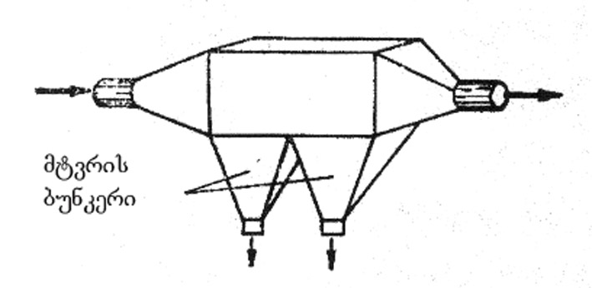
nax. 21.
amave mizniT farTod gamoiyeneba mtvris tomrebic. igi warmoadgens konusurbunkerian cilindrs, romelSic mtvriani haeri Sedis zevidan centraluri miliT, gasufTavebuli ki gamodis specialuri miliT (nax. 22). centraluri miliT Semavali haeri icvlis mimarTulebas 180°-iT, 25-30 mkm-ze didi zomis nawilakebi ki inerciis ZaliT ileqeba bunkerSi, amitom mtvris tomrebs inerciul aparatebs uwodeben.
5 mkm-ze meti zomis mtvris nawilakebis mosacileblad farTod iyeneben e.w. `ciklonebs~ (nax. 23). cikloni vertikaluri svetia aucileblad wriuli kveTiT, romelSic haeri miewodeba korpusis zedapiris mxebis mimarTulebiT, ris gamoc haeri asrulebs winsvliT da brunviT moZraobas. am dros aRiZvreba centridanuli Zalebi da mtveri enarcxeba ciklonis kedlebs, ileqeba masze da koStebis saxiT iyreba bunkerSi. ciklonebs centridanul aparatebs uwodeben.

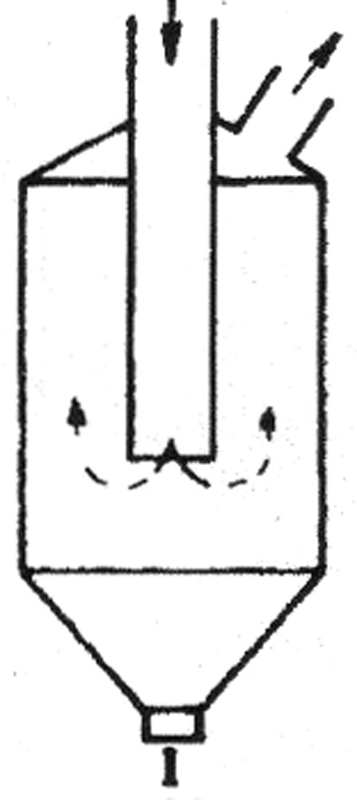
nax. 22.
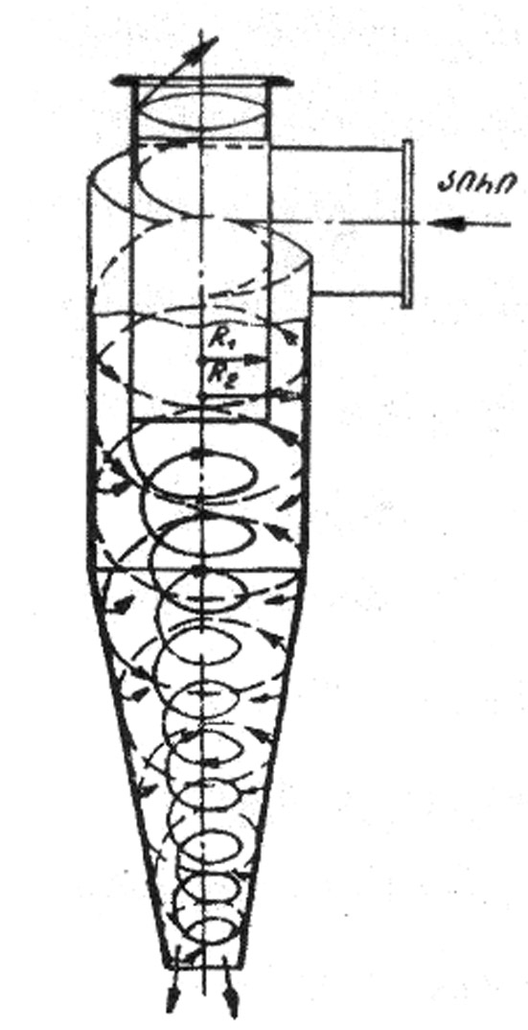
nax. 23.

ciklonSi sasurvelia haeris miwodebis siCqare iyos mudmivi, raTa ar moxdes kedlebze daleqili mtvris wataceba da haeris meoradi gamtverianeba. am movlenis Tavidan acileba SeiZleba sveli gawmendis meTodis elementebis SemotaniT – ciklonis kedlebi Camoirecxeba wylis nakadiT.
(mikroni = μ) mkm = mikrometri (10⁻⁶ metri = 10⁻⁴ sm)
gamfiltravi meTodis upiratesobas warmoadgens gawmendis maRali xarisxi. saTanado filtrebis kombinirebiT SesaZlebelia yvela zomis mtvris nawilakebis Sekaveba. filtrebi arsebobs qsovilovani da boWkovani.
qsovilovan filtrebSi (naqsovi _ Stapeli, Sali, sinTezuri boWkosi) mtvris Sekaveba xdeba Semdegi TanmimdevrobiT – pirvelad ileqeba qsovilis forebis Sesabamisi zomis mtvris nawilakebi. Semdeg forebis zomebi TandaTan mcirdeba. amiT gawmendis efeqti izrdeba, radgan mcire zomis nawilakebi Sekavdeba, Tumca sabolood SeiZleba forebis dacoba moxdes. amis Tavidan asacileblad axdenen filtris regeneracias – forianobis aRdgenas meqanikuri dabertyviT, SekumSuli haeris sawinaaRmdego mimarTulebiT gatarebiT. e.i. qsovilovani filtrebi mravaljeradi gamoyenebisaa (am principiT xdeba saojaxo mtversasrutis muSaoba).
boWkovani filtrebi mzaddeba Txeli qeCisagan, iyeneben 0,01-dan 100 mkm-mde sisqis qaRalds, muyaos an sinTezur boWkos (nax. 24).
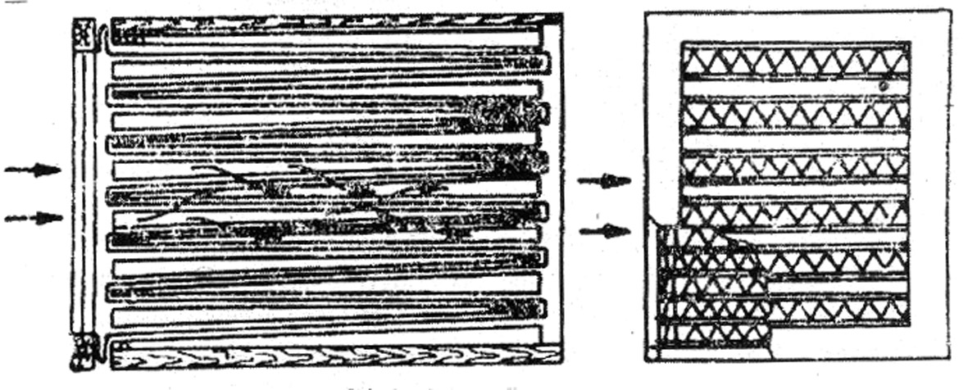
nax. 24. boWkovani filtri

gafiltvraSi monawileobs TiToeuli boWko, mtvris daWera da dagroveba ki xdeba mTel siRrmeSi. misi regeneracia SeuZlebelia, amdenad igi erTjeradi gamoyenebisaa, riTac gansxvavdeba qsovilovani filtrisagan; amitom mas iyeneben naklebad gaWuWyianebuli haeris gasawmendad. boWkovan filtrebSi 5-0,1 mkm zomis nawilakebis Sekavebis efeqti 99,99%-s aRwevs, ris gamoc mas radiaqtiuli mtvris Sesakavebladac iyeneben.
eleqtrostatikuri gawmendis aparatis sqema mocemulia naxazze 25. maRali Zabvis denis miwodebis SemTxvevaSi eleqtrofiltrSi warmoiqmneba eleqtruli veli, potencialTa sxvaobis garkveuli mniSvnelobisas xdeba velis ganmuxtva da kameraSi arsebuli airis ionizireba. am areSi mtvriani haeris gatarebisas mtvris nawilakebic imuxteba, miemarTeba saTanado muxtis damleqavi eleqtrodebisaken da ileqeba masze (kulonis Zalebis gavleniT). eleqtrofiltrebis klasifikacia xdeba sxvadasxva principiT: ganmmuxtavi da damleqi eleqtrodebis mdebareobis mixedviT _ erTzoniani (Tu orive erT kameraSia moTavsebuli) da orzoniani – Tu cal-calke kamerebSia moTavsebuli.
formis mixedviT arCeven milisebursa da firfitisebur damleq eleqtro-filtrebs;
airebis moZraobis mimarTulebis mixedviT – vertikalursa da horizontalurs;
Tanmimdevrulad ganlagebuli el. velebis mixedviT _ erT da mravalvelians (ori, sami da a.S.).
sawarmoo gamavali airebidan mtvris mocilebis sveli meTodi emyareba atmosferos TviTgawmendis meqanizms – naleqebi (Tovli, wvima) waritacebs mtvris nawilakebs da haeri sufTavdeba.
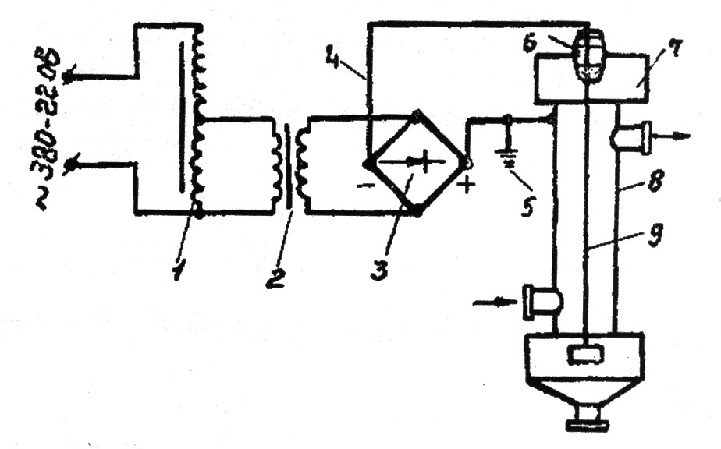
nax. 25. eleqtrofiltris kvebis eleqtruli sqema:
1 – Zabvis regulatori; 2 _ maZlierebeli transformatori; 3 _ maRalvoltiani gammarTveli; 4 _ maRalvoltiani kabeli; 5 _ damiweba; 6 _ izolatori;
7 _ eleqtrofiltri; 8 _ saleqi eleqtrodi; 9 _ gvirgvinovani eleqtrodi

es procesi _ wylis mier mtvris nawilakebis dasveleba da wataceba xdeba specialur aparatebSi _ skruberebSi. am vertikalur koSkebSi wylisa da haeris Sexebis gasazrdelad mowyobilia specialuri wyoburebi an frqvevanebi (nax. 26).

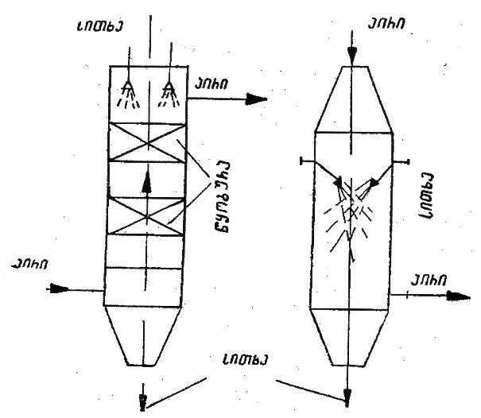
a) wyoburiani; b) Rrutaniani.
nax. 26. skruberis sqema.
skruberebis Rirsebaa: 1. konstruqciis simartive da SedarebiT mcire fasi; 2. mSral mtverdamWerebTan SedarebiT maRali efeqturoba; 3. boWkovan da qsovilovan filtrTan SedarebiT mcire zomebi; 4. maRali temperaturis da airis gazrdili tenianobis dros gamoyenebis SesaZlebloba; 5. feTqebad airebze muSaobis SesaZlebloba.

VIII. samrewvelo gamavali airebis gasufTaveba mavne airebisagan

sawarmoo gamavali airebidan mavne airadi komponentebis (qimiuri gaWuWyianeba) mocileba xdeba ori meTodiT:
1. qimiuri gardaqmnis meTodiT;
2. STanTqmis (sorbciis) meTodiT.
qimiuri gardaqmnis meTodi gulisxmobs airadi nivTierebis mavne formidan naklebad mavne formaSi gadayvanas, rac SeiZleba ganxorcieldes reagentuli an katalizuri meTodiT. ganvixiloT konkretuli magaliTebi.
sawvavis wvis Sedegad warmoiqmneba naxSirJangi (CO) an naxSororJangi (CO₂). pirveli miiReba arasruli wvis Sedegad (Jangbadis naklebobisas), meore ki sruli wvisas.
naxSirJangi Zlier toqsikuria, amdenad, Tu mas gadaviyvanT naxSirorJangis formaSi, haeri gasufTavebulad SeiZleba CaiTvalos. radgan CO Jangbadis naklebobisas miiReba, misi gardaqmna reagentuli meTodiT SesaZlebelia saTanado reagentis O₂-is gamoyenebiT
2CO + O₂  2CO₂
gogirdwyalbadi (H₂S) arasasiamovno sunis toqsikuri nivTierebaa, misi gauvne-belyofa reagentuli meTodiT SesaZlebelia 1) mimocvlis reaqciebiT an 2) Jangva-aRdgeniTi reaqciebiT:
1) Fe₂O₃ + 3H₂S Fe₂S₃ + 3H₂O;
2) 2H₂S + 3O₂  2SO₂ + 2H₂O.
katalizuri meTodiT qimiuri gardaqmna emyareba katalizatorebis moqmedebis princips – katalizatori uSualod reaqciis produqtSi ar Sedis, is xels uwyobs reaqciis gaaqtiurebas da sasurveli wonasworobis swrafad miRwevas.
STanTqmis (sorbciis) meTodiT mavne komponentebis mocileba xdeba Txevadi mSTanTqmelebis – absorbentebis gamoyenebiT (absorbciis procesi) an myari mSTanTqmelebis – adsorbentebis gamoyenebiT (adsorbciis procesi).
Txevad mSTanTqmelebad iyeneben Cveulebriv wyals, romelime marilis, mJavis an tutis xsnars, romelime organul gamxsnels an teqnologiur procesSi miRebul xsnars. yvela konkretul SemTxvevaSi mSTanTqmeli siTxis SerCeva xdeba STasanTqmel nivTierebasTan misi urTierTqmedebis mixedviT.
mavne airebis adsorbciuli meTodiT mocilebisaTvis gamoiyeneba myari nivTierebebi – naxSiri, silikogeli, alumogeli, bunebrivi da sinTezuri ceoliTebi, iongacvliTi fisebi da sxv.
adsorbciis procesi xdeba myari mSTanTqmelis zedapirze da gawmendis efeqti uSualodaa damokidebuli mSTanTqmeli zedapiris farTze. am farTis gazrda SesaZlebelia myari mSTanTqmelebis gaaqtiurebiT – maTi forianobis an dispersiulobis xarisxis gazrdiT.
mSTanTqmeli nivTierebebis desorbcia, anu adsorbentis regeneracia xdeba gadaxurebuli wylis orTqliT an sxva gamomdevni agentiT. desorbents atareben gasasuTavebeli airis moZraobis sawinaaRmdego mimarTulebiT. orTqlis narevi (wylis orTqli da gamosadevni nivTierebis narevi) gamoidevneba aparatidan da miewodeba sawdoms, an sareqtifikacio svets dasacileblad. adsorbents aSroben cxeli haeriT, aciveben da kvlav iyeneben adsorberSi.
perioduli qmedebis adsorberis umartivesi aparatia zelinskis airwinaRi, masSi mSTanTqmeli gaaqtivebuli naxSiria.
adsorbciis procesis uwyveti cikliT Casatareblad iyeneben iseTYdanadgarebs, romlebSic 2 an meti adsorberia; maTi CarTva xdeba periodulad (nax. 27). erTi adsorberis (I) gajerebis Semdeg airis miwodebas gadarTaven meore adsorberze (II), pirvelSi ki axdenen adsorberis regeneracias, gaSrobas, gacivebas, ris Semdeg airs gadarTaven isev pirvelze, meoreSi ki axdenen regeneracias.
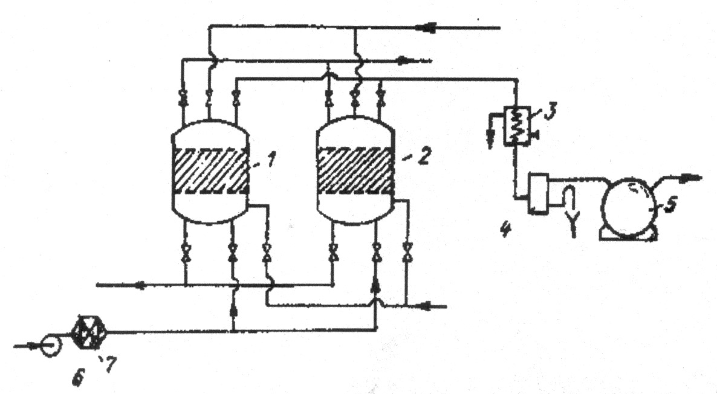
nax. 27. oradsorberiani uwyveti moqmedebis aparati: 1-2 – adsorberi; 3 _ kondensatori; 4 _ separatori; 5 _ sacavi; 6 _ airSemberi; 7 _ kaloriferi.

gasufTavebis Semdeg gamaval airebs miyveba narCeni nivTierebebi, romelTa Semcveloba reglamentirebulia zdg-Ti, sakvamle milidan gaityorcneba atmosferoSi, ifanteba da ganzavdeba. misi gafantva damokidebulia haeris temperaturaze, tenianobaze, qaris mimarTulebasa da siCqareze.
praqtikulad dadgenilia, rom sakvamle milidan gamotyorcnili nivTiereba dedamiwaze maqsimaluri koncentraciiT aRwevs im wertilSi, romelic gamotyorcnis wyarodan daSorebulia sakvamle milis simaRleze (H) 20-jer meti manZiliT (sur. 28).
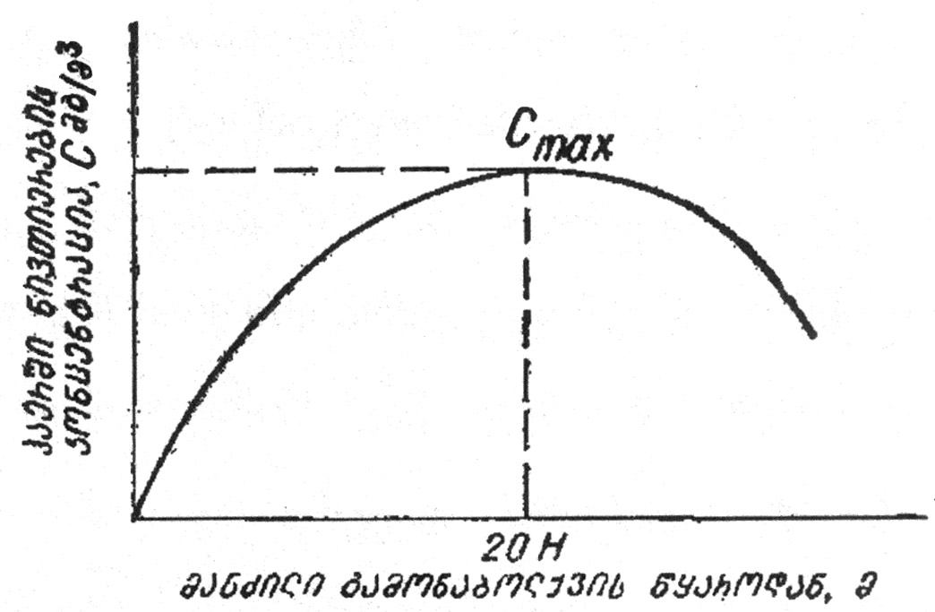
nax. 28. dedamiwis zedapirze mavne nivTierebis koncentraciis (C) damokidebuleba
gamonabolqvis wyarodan manZilze.
sakvamle milis daproeqtebisas aucilebelia misi simaRle ganisazRvros ise, rom dedamiwaze misuli mavne nivTierebis raodenoba minimaluri iyos.
IX. hidrosferos dacva gaWuWyianebisagan

wyali Cveni planetis erT-erTi umniSvnelovanesi, Seucvladi resursia. igi sicocxlis wyaro da is saSeni masalaa, romelsac iyenebs yvela cocxali organizmi. mcenareebisa da cxovelebis organizmSi 50%-mde wyalia, zogSi 98%-mde. TviT adamianis organizmSi 70%-mde wyalia, 20%-is dakargvac ki organizmis gamofitvas da daRupvas iwvevs. dRe-RameSi zrdasrul adamians 2,5 l wyali sWirdeba, aqedan 1 l sasmel wyalze modis, 1,2 l – sakvebSi Semaval wyalze, 0,3 l ki TviT organizmSi gamomuSavdeba nivTierebaTa cvlis dros.
wyali Seucvladia yofacxovrebaSi, ZiriTad komunaluri daniSnulebiT. nebismieri dargi saxalxo meurneobisa saWiroebs wyals, zogi meti, zogi ki naklebi raodenobiT: samTo mompovebeli, energetika, satransporto meurneoba, kvebis mrewveloba, soflis meurneoba da sxv.
gaxsnil nivTierebaTa raodenobis mixedviT wyali iyofa Semdeg jgufebad – mtknari, mineraluri da mlaSe. mtknari ewodeba iseT wylebs, romelTa yoveli litri Seicavs araumetes 1 g marils. mineralur wylebSi es maCvenebeli 1-dan 6 g-mdea, xolo marilTa ufro meti SemcvelobiT xasiaTdeba mlaSe wylebi. mlaSe wylebs miekuTvneba zRvebis, okeaneebisa da zogierTi tbis (mag. kaspiis zRvis) wylebi. maTi marilianoba gansxvavebulia, mag., Savi zRva Seicavs 18 g/l, baltiis zRva – 5-6 g/l, okeane – 35 g/l, yvelaze mlaSe auzia yara-boRazis ube – 300 g/l.
zRvebsa da okeaneebs ukavia dedamiwis zedapiris 70%-ze meti, misi siRrme saSualod 3800 m-ia, maqsimaluri ki 11022 m wynar okeaneSi `marianis Rrmuli~. wylis resursebis raodenobrivi Sefaseba gansxvavebulia, cxril 1-Si gTavazobT erT-erT maTgans (prof. m. lvoviCis mixedviT).
cxrili 1. wylis globaluri resursebi
# | wylis resursebis saxeoba | % | raodenoba  aTasi km³
1 | zRvebisa da okeaneebis wyali | 94,20 | 1370323
2 | miwisqveSa wylebi: maT Soris | 4,1 | 60000
 | aqtiuri wyalcvlis zona | 0,8 | 12000
3 | myinvarebi | 1,5 | 24000
4 | tbebi | 0,019 | 280
5 | niadagis teni | 0,006 | 85
6 | atmosferos teni | 0,001 | 14
7 | mdinaris wyali | 0,0001 | 1,2
 | sul | 100,0 | 1466703,2

cxrilidan miiReba, rom mtknari wylis maragi mTeli wylis daaxloebiT 6%-s Seadgens, maTgan umetesoba naklebad xelmisawvdom, miwisqveSa wylebsa da yinulovan safarze (arqtika, antarqtika) modis, xolo zedapirul mdinareebsa da tbebze mxolod 0,02% modis.
zedapiruli mtknari wylebis ganawileba kontinentebs Soris mocemulia cxril 2-Si.
cxrili 2. kontinentebis mdinaris wylis maragi
# | kontinenti | mdinareTa mTliani Camonadeni, km³/weli | Camonadeni erT sul mosaxleze, aTasi m³/weli
1 | evropa | 3140 | 5,18
2 | azia | 13400 | 7,94
3 | afrika | 4020 | 13,67
4 | CrdiloeTY amerika | 6522 | 26,17
5 | samxreT amerika | 11500 | 74,68
6 | avstralia | 1890 | 1290
7 | antarqtida | 1050 | -
8 | dedamiwa | 41500 | 11,0

mtknari wylis globaluri wliuri moxmareba 4 aTasi km³, saidanac soflis meurneobaze modis 70%, mrewvelobasa da komunalur meurneobaze _ 30%.
rogorc cxril 2-dan Cans, mtknari wylebi araTanabradaa ganawilebuli. mag., evropasa da aziaSi, sadac msoflio mosaxleobis 70%-ia Tavmoyrili, misi maragi mxolod 30% Seadgens. es garkveul sirTuleebs qmnis mosaxleobis wyliT uzrunvelyofaSi.
mtknari wylis deficits, zemoT aRniSnul mizezTan erTad, qmnis misi gaWuWyianeba.
anTropogenuri faqtorebiT gamowveuli gaWuWyianeba mTel rig mdinareebsa da wyalsatevebs gamousadegars xdis, mravali maTgani mkvdar auzebad aris gadaqceuli. gamaWuWyianeblebis saerTo raodenoba weliwadSi 150 mlrd t-s Seadgens, ZiriTadi maT Soris mZime metalebi (Pb, Hg, Cd, Cu, Zn), navTobproduqtebi, zedapirulad aqtiuri nivTierebebi (zan) da policikluri aromatuli naxSirwyalbadebia (pan _ kancerogenuli da mutagenuri Tvisebebis mqone).
es gamaWuWyianeblebi mdinareebidan sabolood zRvebsa da okeaneebSi Cadis. Tu dRes okeanis gaWuWyianeba lokalur da regionul xasiaTs atarebs, axlo momavalSi igi SesaZlebelia globalurSi gadaizardos.
okeaneebis gaWuWyianeba xdeba atmosferodanac (romlis gaWuWyianebis ZiriTadi wyaro adamianis saqmianobaa). mecnierTa monacemebiT atmosferodan okeaneSi yovelwliurad Cadis 2,0·10⁵ – 2·10⁶ t tyvia (Pb) 2,0·10³ – 3·10³ t vercxliswyali (Hg), 1,4·10⁶ t kadmiumi (Сd), 2,0·10³ – 3·10³ t “gqb~, 10³ – 3·10⁴ t dariSxani (As) (pqb – poliqlorirebuli bifenolebi) da sxv.; Zalian saSiSia SO₂-is moqmedebac.
mtknari wylis resursebi SeiZleba gaizardos Semdegi meTodebiT:
1. mlaSe miwisqveSa da okeaneebis wylebis gamtknarebiT;
2. arsebuli wyalsatevebis gaWuWyianebisgan dacviT;
3. zedapiruli wylebidan aorTqlebis SemcirebiT;
4. miwisqveSa wylebis gamoyenebis gazrdiT;
5. polaruli myinvarebis aisbergebis gamoyenebiT.
mlaSe wylebis gamtknareba SeiZleba ganxorcieldes sxvadasxva meTodiT. esenia:
1. distilaciuri procesi;
2. yinulwarmoqmnis procesi (bunebrivi da xelovnuri gayinva);
3. qimiuri meTodebi – iongacvliTi, reagentuli;
4. eqstraqciuli meTodebi;
5. membranuli meTodi – hiperfiltracia, eleqtrodializi;
6. biologiuri meTodi.
yvelaze gavrcelebuli distilaciis meTodia wylis aorTqlebisa da Semdgomi distilaciis da mineralizaciis gziT – igi aRwerili aqvs jer kidev aristoteles Zv.w.aR. III saukuneSi.
gamtknarebul wyals specialurad amuSaveben sunis mosacileblad, filtraven gaaqtivebuli naxSiris feniT, biologiurad asufTaveben wyalmcenareebiT, atareben marmarilos fenaSi Ca-is karbonatis Sesayvanad, amuSaveben ftoriT da amis Semdeg iyeneben sasmelad. gayinviT gamtknareba emyareba mtknari da mlaSe gayinuli wylis dnobis temperaturaTa sxvaobas.
iongacvliTi fisebis moqmedebis farTo speqtri saSualebas iZleva wyals praqtikulad moscildes eleqtrolitebi, Tu maTi koncentracia 2-3 g/l-s ar aRemateba.
zedapiruli wylebis aorTqlebis Sesamcireblad maT faraven specialuri afskebiT. yvelaze saukeTesod iTvleba cximovani spirtebi – heqsadekanoli da oqtadekanoli. isini wylis zedapirze qmnian molekulur afskebs, am dros ar icvleba Jangbadis balansi wyalSi da igi uvnebelia adamianisaTvis.
sasmelad, komunaluri daniSnulebiT, soflis meurneobasa da mrewvelobaSi gamoiyeneba mxolod mtknari wyali. am sferoebSi mlaSe wylebis gamoyeneba SeuZlebelia.
magram zRvebsa da okeaneebs dResac ar daukargavT TavianTi pirveladi daniSnuleba adamianisaTvis – mimosvlis saSualeba, sarewi, kerZod TevzWeris daniSnulebiT, rac amJamad 100-150 mln t-s aRwevs. es Seadgens kacobriobis sakvebis ~1%-s.
zRvebsa da okeaneebidan, garda Tevzisa, xdeba sxva bioresursebis – wyalmcenareebis, moluskebis, midiebis da a.S. rewva. maTi raodenobis gasazrdelad ewyoba wyalqveSa plantaciebi da fermebi.
mTlianobaSi amJamad bioresursebis Semcirebis tendencia SeiniSneba, rac gamowveulia: a) rewvis gazrdiT; b) wylis gaWuWyianebiT; g) erTi saxeobis Semcireba iwvevs sxva saxeobebis Semcirebasac – kvebis jaWvis arsebobis gamo.
zRvebisa da okeaneebis wylis marilianoba ganpirobebulia maTSi sxvadasxva marilebis SemcvelobiT: 89% _ Na, K, Ca, Mg qloridebi, 10% _ maTi sulfatebi, 1% _ maTi karbonatebi. am makrokomponentebis garda zRvis wyalSi perioduli sistemis TiTqmis yvela elementis naerTebia gaxsnili, ra Tqma unda, sxvadasxva koncentraciiT. mag., 5,5 mln t oqro, 4 mlrd t urani, 3000 mlrd t liTiumi da a.S. amJamad bromis 80%-s moipoveben zRvis wylidan. iaponiaSi muSavdeba uranis amoRebis meTodika, sakavSiro akademiis cimbiris ganyofilebaSi ikvlevdnen oqros amoRebis SesaZleblobas da a.S.
am procesebs bevrad gaamartivebs da gaaiafebs bioqimiuri teqnologia _ bunebrivi, biologiuri procesebis qimiuri analogiis Seqmna.
msoflio okeanis mraval raionSi fskeri pirdapir dafarulia rkina-magniumis msxvili konkreciebiT, romelTa maragi 300-350 mlrd tonaa. specialistebi Tvlian, rom momavalSi maTi mopoveba savsebiT rentabeluri gaxdeba.
okeanis fskerze da mis qveS aris qvanaxSiri, navTobi, bunebrivi airi, oqro, spilenZi, almasi. navTobis savaraudo maragi 60-150 mlrd tonaa. amJamad navTobisa da bunebrivi airis mopovebis 20% zRvis Selfebze modis.
wyals aqvs metad mniSvnelovani Tviseba – TviTgawmendis da TviTaRdgenis unari mzis radiaciis, baqteriebis, wyalmcenareebis da wylis organizmebis meSveobiT. zogierTi maTgani gamaWuWyianeblebs gadaamuSavebs da gaauvnebelyofs, zogisTvis ki filtris rols asrulebs da Tavis organizmSi agroveben wyalSi arsebul gamaWuWyianeblebs. es dasturdeba wylisa da calkeuli organizmebis analizuri SeswavliT. ama Tu im nivTierebis Semcveloba cocxal organizmebSi bevrad aRemateba wyalSi maT Semcvelobas. amis Sedegad ziandeba maTi genetika, kvebis jaWviT ziandeba sxva organizmebi (minimates daavadeba). zRvis varskvlava iTvleba rekordsmenad – igi yovel saaTSi filtravs Tavis organizmis moculobaze 40000-jer met wyals.
gamaWuWyianebeli nivTierebebidan yvelaze maRali biokumulaciis unari aqvs tyvias. misi koncentracia wylis organizmebSi 40000-jer ufro maRalia, vidre wyalSi. gansakuTrebiT agroveben tyvias planqtoni, moluskebi, neistonebi – wylis zeda 5 sm-ian fenaSi mcxovrebi organizmebi.
wyalsacavebis gaWuWyianeba ori saxisaa:
1. mineraluri gaWuWyianeba;
2. organuli gaWuWyianeba – a) biologiuri da b) baqteriuli.
mineraluri gaWuWyianebis wyaroebia qimiuri, metalurgiuli, manqanaTmSenebeli qarxnebi, navTobisa da samTo-mompovebeli sawarmoebi: wylebi WuWyiandeba Tixis, qviSisa da madnis narCenebiT, mineraluri mJavebis, marilebisa da mineraluri cximebis xsnarebiT da sxv.
organul gamaWuWyianeblebs miekuTvneba sameurneo-fekaluri wylebi, tyavis, celuloza-qaRaldis, kvebis sawarmoebi da a.S.
baqteriologiuri da biologiuri gaWuWyianebis wyaroebia sxvadasxva mikroorganizmebi _ obis, safuaris soko, mcire wyalmcenareebi da baqteriebi, maT Soris tifis, dizenteriis gamomwvevi bacilebi da sxv.
wylis gamoyeneba ori saxisaa:
1. wyalmoxmareba;
2. wyliT sargebloba.
wyliT sargeblobisas wyali rCeba wyalsacavSi da gamoiyeneba rogorc are an energiis wyaro (xe-tyis dacureba, hidroenergetika, wylis transporti da a.S.).
wyalmomarageba gulisxmobs wyalsacavidan wylis amoRebas. am dros wylis nawili ixarjeba, nawili ki ubrundeba wyalsacavs gaWuWyianebuli – Camdinare wylis saxiT.
amrigad, Camdinare wyali ewodeba naxmar, gaWuWyianebul wyals, romelic saWiroebs gawmendas.
wyalsatevebis xarisxis kontrolisaTvis SemoRebulia mareglamentirebeli sidide zdk (zRvrulad daSvebuli koncentracia). zdk-s mniSvneloba damokidebulia wyalsatevis daniSnulebaze (wyalmommaragebeli, meTevzeobisaTvis, kulturuli dasvenebis kera). mocemuli TanmimdevrobiT mcirdeba momTxovnelobac wylis xarisxis mimarT.
iseve, rogorc atmosferos SemTxvevaSi, zdk gvaZlevs mxolod kontrolis da ara gaWuWyianebis keris aRmofxvris saSualebas. amitom, atmosferos analogiiT, wylisTvisac SemoRebulia Camdinare wylebis CaSvebis normebi.
am normiT gansazRvrulia ara marto Camdinare wylis Sedgenilobis zRvrebi, aramed temperaturac. kerZod, dauSvebelia wyalsatevis temperaturaze 3°C-ze metiT gansxvavebuli temperaturis mqone wylis CaSveba.
amas Semdegi axsna aqvs: temperaturis gazrdiT mcirdeba airTa xsnadoba da mosalodnelia JangbadiT najerobis Semcireba, rac cocxal organizmebs uqmnis safrTxes, agreTve saTanadod ver uzrunvelyofs wyalSi Camdinare lpobis _ igive Jangvis process. aseve mosalodnelia Tevzis naadrevi qviriToba cru temperaturuli signalis miRebis gamo.

X. Camdinare wylebis klasifikacia

warmoqmnis adgilis mixedviT Camdinare wylebi iyofa Semdeg kategoriebad:
1. sayofacxovrebo (komunaluri) Camdinare wylebi (kCw);
2. samrewvelo Camdinare wylebi (sCw);
3. atmosferuli Camdinare wylebi (aCw).
sayofacxovrebo Camdinare wylebi miiReba saojaxo pirobebSi _ samzareulodan, abazanidan, tualetidan kanalizaciaSi mimavali wylebis saxiT. es wylebi ~55% organul da ~45% mineralur nivTierebebs Seicavs. analogiuri Sedgenilobis Camdinare wylebi warmoiqmneba sawarmoebSic _ esaa sasadiloebidan, saSxapeebidan, samrecxaoebidan, tualetebidan Sekrebili wylebi.
samrewvelo Camdinare wylebi didi mravalferovnebiT gamoirCeva. maTi Sedgeniloba damokidebulia sawarmos specifikaze.
atmosferuli Camdinare wylebi ki warmoadgens naleqebiT (Tovli, wvima) miRebul organizebul Canadens, romelic niadagSi ki ar Seiwoveba, aramed saniaRvre arxebiT Caedineba mdinareebSi an wyalsatevebSi. qalaqis pirobebSi atmosferuli Camdinare wylebi sadrenaJo Webidan uerTdeba qalaqis koleqtors. soflis pirobebSi atmosferuli Camdinare wylebi sasawyobo meurneobebis teritoriebidan an fermebidan WuWyiandeba SxamqimikatebiT, wunwuxiT da mimRebi wylis auzis Zlier dabinZurebas aRwevs.
samrewvelo Camdinare wylebi iyofa or jgufad – pirobiTad sufTa da WuWyian Camdinare wylebad. pirobiTad sufTaa gamaciveblad gamoyenebuli sawarmoo wylebi. isini mxolod temperaturas icvlian, amitom gacivebis Semdeg SesaZlebelia maTi wyalsacavSi CaSveba. samrewvelo Camdinare wylebis klasifikacia xdeba sxvadasxva niSniT:
1. gamaWuWyianebeli nivTierebebis Tvisebebis; 2. misi koncentraciis; 3. fazur-dispersiulobis; 4. agresiulobis mixedviT.
Tvisebebis mixedviT ganasxvaveben Semdeg jgufebs:
a) organuli da mineraluri nivTierebebis Semcveli – navTobmompovebeli, navTobqimiuri, safeiqro mrewvelobis, kvebis mrewvelobis, konservebis, Saqris damamzadebeli sawarmoebis Camdinare wylebi;
b) organuli nivTierebebis Semcveli – kvebis, rZis, xorcis, celulozis, qimiuri, mikrobiologiuri, kauCukis, plastikuri masalebis sawarmoTa Camdinare wylebi.
koncentraciis mixedviT samrewvelo Camdinare wylebi iyofa oTx jgufad:
a) C _ 1-500 mg/l (C _ koncentracia);
b) C _ 500-5000 mg/l;
g) C _ 5000-30000 mg/l;
d) C > 30000 mg/l.
agresiulobis mixedviT es Camdinare wylebi iyofa:
a) sust agresiul wylebad _ pH = 6-6,5 (susti mJava);
pH = 8-9 (susti fuZe)
b) Zlier agresiul wylebad pH < 6 (Zlieri mJava)
pH > 9 (Zlieri tute);
g) araagresiul wylebad pH = 6,5-8.
samrewvelo Camdinare wylebis gasufTavebis meTodebis SerCevisaTvis yvelaze srulyofilad iTvleba kulskis mier mocemuli klasifikacia _ gamaWuWyianebeli nivTierebebis zomebis mixedviT.
a) wylebi Sewonil mdgomareobaSi Seicaven 10⁻⁴ sm da ufro didi zomis wyalSi uxsnad nawilakebs. am nawilakTa sididis qveda zRvari 10⁻⁴sm is zomaa, rasac adamianis Tvali aRiqvams, zeda zRvari ki ar aris SezRuduli _ es SeiZleba iyos madnebis gamamdidrebel sawarmos wylebSi _ koStebi, xis damamuSavebel sawarmos wylebSi – nafotebi da a.S.
b) maRalmolekuluri nivTierebebis, zolebis (koloiduri xsnarebi) Semcveli wylebi _ nawilakTa zomebiT 10⁻⁵-10⁻⁶ sm (koloiduri zomis nawilakebi). maT Tvali ver aRiqvams, magram maT arsebobaSi martivad SeiZleba davrwmundeT – sinaTlis wvrili sxivis gatarebisas miviRebT ganaTebul konuss, am wonis nawilakebi iwveven sinaTlis sxivis gabnevas, radgan sinaTlis talRis sigrZec amave rigisaa.
g) ionebad distilirebuli nivTierebebis Semcveli, e.w. WeSmariti xsnarebi, maTi zomebia 10⁻⁷-10⁻⁸ sm;
d) biologiuri da samrewvelo warmoSobis 10⁻⁶-10⁻⁷ sm zomis airebis an organuli naerTebis Semcveli wylebi.
TiToeuli jgufis wylebisaTvis rekomendebulia gawmendis garkveuli meTodebi. aqve unda aRvniSnoT, rom Camdinare wylebis gawmendis erTiani, universaluri meTodi ar arsebobs. sanitaruli moTxovnis donemde Camdinare wylebis gasawmendad xdeba sxvadasxva meTodebis kombinireba. gawmendis meTodebis SerCeva xdeba Camdinare wylis Sedgenilobis, raodenobis, gamoyenebuli meTodis ekonomiurobis mixedviT da sxv.
samrewvelo Camdinare wylebis gawmendis yvela arsebuli xerxi SeiZleba gaerTiandes meqanikur, fizikur, fizikur-qimiur, qimiur da bioqimiur meTodebad.
gavecnoT TiToeul maTgans.

Camdinare wylebis meqanikuri gawmenda
am meTodiT Camdinare wylebidan xdeba didi zomis uxsnadi minarevebis mocileba zemoT ganxiluli bolo klasifikaciis a) jgufi. es procesi xorcieldeba dawdomiT, gawurviT, gafiltvriT, centrifugirebiT.
didi zomis nawilakebis Sekaveba SesaZlebelia cxaurebiT, gisosebiT, qviSis fenaSi gatarebiT, specialuri filtrebis gamoyenebiT an wylis SegubebiT _ mtverdamWeri kameris analogiurad, siCqaris cvlilebis gamo moxdeba didi zomis nawilakebis daleqva – es dawdomis procesia.
meqanikuri meTodi gawmendis maRal xarisxs ver uzrunvelyofs, amitom mas iyeneben winaswari, uxeSi gawmendisaTvis.

ACamdinare wylebis gawmendis fizikuri meTodi
fizikuri meTodi moicavs Termul damuSavebas: maRali temperaturis pirobebSi – aorTqlebas, dabali temperaturis pirobebSi – gayinvas (krioskopuli ebulioskopuri meTodi).
am meTodiT orTqlis an yinulis saxiT miiReba gasufTavebuli wyali.

samrewvelo Camdinare wylebis fizikur-qimiuri gawmenda
es meTodi aerTianebs koagulaciis, flokulaciis, flotaciis, sorbciis, iongacvliT, eleqtrodializur procesebs, romelTa saSualebiTac SesaZlebelia (b) da (g) jgufis gamaWuWyianeblebis mocileba.
10⁻⁵-10⁻⁶ sm zomis koloiduri nawilakebis mocileba xdeba koagulaciis, flokulaciis procesebiT. am dros xdeba nawilakTa gamsxvileba da Semdgomi mocileba meqanikuri meTodiT.
radgan koloidur nawilakebs aqvs eleqtruli muxti, molekulur ZalebTan erTad (romlebic SedarebiT mcire manZilze mJRavndeba), moqmedeben erTnairmuxtiani nawilakebis ganzidvis Zalebic. urTierTmizidvis Zalebi Zlierdeba nawilakTa eleqtruli potencialis Semcirebisas, rasac aRweven maRalmuxtiani eleqtrolitebis e.w. koagulantebis saSualebiT. koagulantebad gamoiyeneba Al-is, Fe-is, Cr-is marilebi. es marilebi wyalSi ganicdian hidrolizs:
Al₂(SO₄)₃ + 6H₂O  2Al(OH)₃ + 3H₂SO₄,
FeCl₃ + 3H₂O Fe(OH)₃ + 3HCl.
warmoqmnili aluminisa da rkinis hidroJangebi Al(OH)₃, Fe(OH)₃ fifqiseburi zedapiriT xasiaTdebian, maTze xdeba koloiduri nawilakebis sorbireba da daleqva damwdomis fskerze.
koloiduri nawilakebis garkveul stabilurobas ganapirobebs wyalxsnarebSi wylis dipoluri molekulebis orientirebiT warmoqmnili hidratuli birTvebi, rac xels uSlis sxvadasxva niSniani muxtebis urTierTmizidvas. aseTi xsnarebis temperaturuli damuSavebiT (gacxelebiT) izrdeba maTi moZraobis intensivoba, birTvebi iSleba, koloiduri sxvadasxva muxtiani nawilakebi urTierTmiizideba, msxvildeba da SesaZlebelia maTi meqanikuri meTodiT mocileba.
flokulacia koagulaciis erT-erTi saxea. am dros specialuri nivTierebebis _ flokulatorebis saSualebiT koloiduri nawilakebi warmoqmnian fxvier fifqisebur grovebs da ileqebian. erT-erTi flokulatori saxamebelia.
flotacia aris nivTierebis nawilakebis molekuluri Sewebeba fazaTa gamyof zedapirze, Cveulebriv airisa (haeris) da wylis. rodesac nawilakebi ar sveldeba siTxiT, warmoiqmneba kompleqsebi `nawilakebi-buStukebi~, romlebic amotivtivdebian wylis zedapirze da maT qafis saxiT acileben.
fizikur-qimiuri gawmendis erT-erTi meTodia sorbcia, STanTqma. mSTanTqmel sxeuls ewodeba sorbenti, xolo STasanTqmels _ sorbanti. sorbcia erT-erTi yvelaze efeqturi meTodia Camdinare wylebis gasawmendad. sorbentebad iyeneben torfs, silikogels, alumogels, ceoliTebs, gaaqtivebul naxSirs.
sorbentis aqtiuroba xasiaTdeba sorbentis erTeul moculobaze (kg/m³) an erTeul winaze (kg/kg) STanTqmuli nivTierebis raodenobiT.
sorbciis procesi SeiZleba ganxorcieldes statikur (roca siTxe ar gadaadgildeba sorbentis mimarT) da dinamikur (roca siTxe gadaadgildeba sorbentis mimarT) pirobebSi.
sorbciis uwyveti procesis gansaxorcieleblad iyeneben paralelur reJimSi momuSave ramdenime seqcias, mimdevrobiT ganlagebuli 3-5 filtriT. sorbentis zRvrulad gajerebisas pirveli filtri gamoirTveba saregeneraciod, wyali ki miewodeba Semdeg filtrs. amJamad sorbciul filtrebad gamoiyeneba cilindruli, erTiarusiani adsorberebi, isini daaxloebiT 4 m simaRlis svetebia (nax. 9).

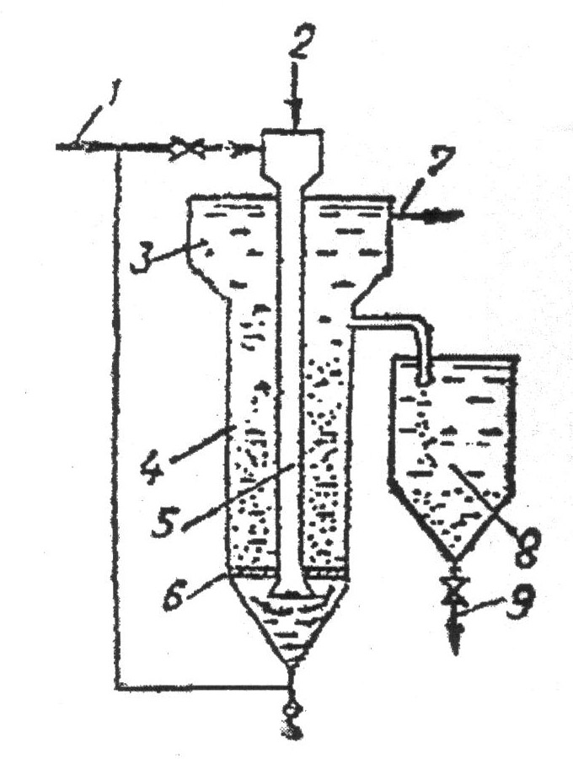
nax. 9. adsorberi

iongacvliTi meTodi emyareba Camdinare wylebSi arsebuli arasasurveli ioinebis mimocvlas sorbent-ionitSi arsebul ionebTan. ionitebi maRalmolekuluri, polimeruli fisebia.
ionTa muxtis mixedviT ionitebi iyofa kaTionitebad (kaTionebis mimocvla) da anionitebad (anionebis mimocvla). kaTionitebi H⁺ an Na⁺ formiT gamoiyeneba (es ionebi gadava wyalSi), anionitebi ki OH⁻ an Cl⁻ formiT.
ionmimocvla sqematurad SeiZleba Semdegi reaqciebis saxiT warmovadginoT:L
nRH⁺ + Kt^{n} R_{n}Kt + nH⁺ kaTionitisaTvis;
anionitebis SemTxvevaSi
nR – OH + An^{n-}  R_{n} – An + nOH⁻
nR – Cl + An^{n-}  R_{n} – An + nCl⁻
sadac R _ ionmimocvliTi fisis organuli polimeruli karkasia;
Kt^{n+} _ xsnarSi arsebuli kaTioni muxtiT (n⁺);
An^{n-} _ ki xsnarSi arsebuli anioni muxtiT (n⁻).
ionmimocvlis metad mniSvnelovani Tvisebaa Sebrunebadoba, e.i. reaqciis SebrunebiT warmarTvis SesaZlebloba, riTac xdeba ionitebis regeneracia da amave dros, Camdinare wylidan amoRebuli nivTierebebis utilizacia.
eleqtrodializi marilTa ionebis separaciis procesia. igi xorcieldeba membranul aparatebSi eleqtrodenis moqmedebiT. eleqtrodializatori dayofilia erTmaneTis monacvle kaTionuri da anionuri membranebiT, romlebic qmnian makoncentrirebel (marilxsnaruli) da gaumariloebis (diluaturi) kamerebs. membranebi mzaddeba Termoplastikuri polimeruli SemakavSireblisa da ionmimocvliTi fisebis fxvnilebisgan. am procesis sqema mocemulia nax. 10-ze.
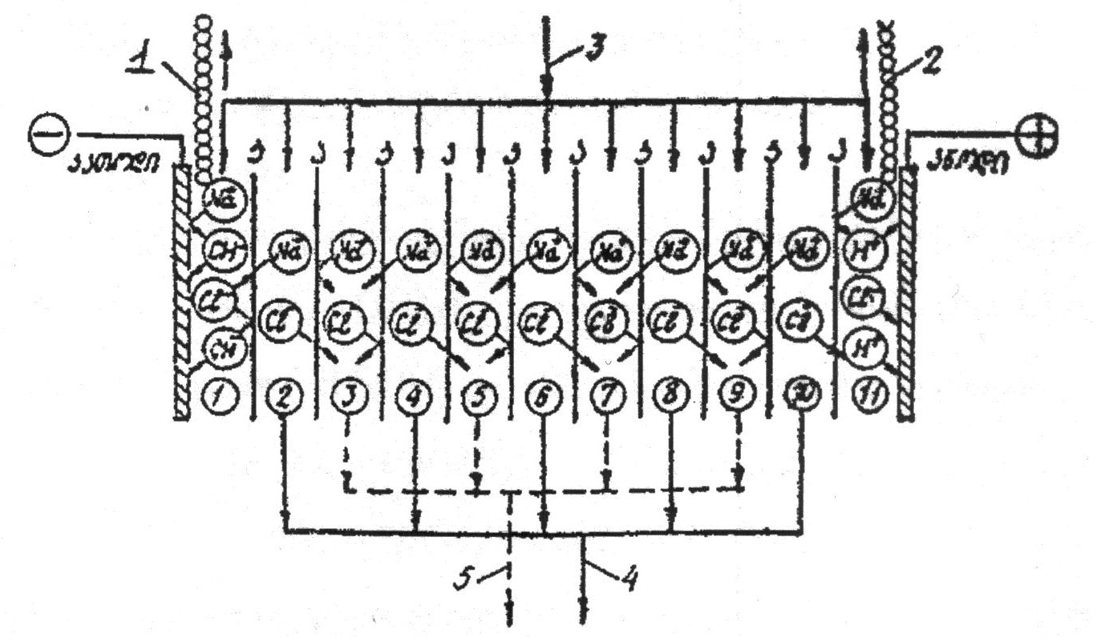
nax. 10. eleqtrodializis procesis sqema
A _ anionituri membranebi; K _ kaTionituri membranebi;
1 _ airadi wyalbadis gamosasvleli; 2 _ airadi Jangbadis da qloris gamosasvleli; 3 _ daumuSavebeli Camdinare wylis miwodeba; 4 – damuSavebuli (gaumarilebeli) Camdinare wylis gamoSveba; 5 – koncentrirebuli marilxsnaris gamoSveba.
mudmivi denis gavleniT kaTionebi moZraoben kaTodisaken (1). gaivlian kaTionur membranas, magram Sekavdebian anionur membranebze. anionebi ki moZraoben anodisaken (2), gaivlian anodur membranebs da Sekavdebian kaTionur membranebze. amis Sedegad erTi rigis luwi kamerebidan (nax. 10) orive niSnis ionebi gaiyvaneba momijnave kent kamerebSi.
eleqtrodializuri meTodi gamoiyeneba maRali mineralizaciis Camdinare wylebis (3-8 g/l) gasawmendad.

sawarmoo Camdinare wylebis qimiuri gawmenda
qimiuri gawmendis ZiriTadi meTodebia neitralizacia da daJangva, aseve iyeneben daleqvis meTods.
wyalxsnarebSi neitralizaciis tipiuri reaqcia mimdinareobs mJavebSi arsebul hidratirebul wyalbad ionsa (H₃O⁺) da tuteebSi arsebul hidroqsil ionebs (OH⁻) Soris:
H₃O⁺ + OH⁻  2H₂O.
aRniSnuli reaqciis Sedegad am ionTa koncentracia uaxlovdeba TviT wyalSi maT koncentracias (pH = 7). praqtikulad, neitralurad iTvleba Camdinare wylebi, romelTa pH = 6,5-8,5.
amdenad, neitralizacias eqvemdebareba iseTi Camdinare wylebi, romelTa pH naklebia 6,5-ze da metia 8,5-ze. ufro saSiSia mJava Camdinare wylebi.
qimiuri gawmendisas iyeneben ganeitralebis Semdeg xerxebs:
1. mJava da tute Camdinare wylebis urTierTganeitraleba;
2. reagenturi ganeitraleba.
gamaneitralebel reagentebad mJava Camdinare wylebisaTvis iyeneben Caumqral kirs (CaO), Camqral kirs (Ca(OH)₂), kalcinirebul sodas (Na₂CO₃), kaustikur sodas (NaOH), amiakis wyals (NH₄OH) da sxv. ganvixiloT magaliTebi:
H₂SO₄ + Ca(OH)₂  CaSO₄ + 2H₂O,
H₂SO₄ + CaCO₃ = CaSO₄ + H₂O + CO₂
gamaneitralebel filtrebad iyeneben uwyveti qmedebis filtrebs, romelTa zedapirze Txel Sred dafenilia gamaneitralebeli nivTierebebi: kiri (CaO), kirqva (CaCO₃), dolomiti (CaCO₃MgCO₃) magneziti (MgCO₃) im SemTxvevaSi, Tu Camdinare wylebi ar Seicavs mZime metalebs, radganac pH>7-is SemTxvevaSi isini gamoileqebian da gaWedaven filtris forebs.
daJangvis meTods iyeneben toqsikuri minarevebis (cianidi, spilenZis da TuTiis cianokompleqsebi da a.S.) Semcvelobisas, Camdinare wylebis gasauvnebelyofad, an iseTi minarevebis mosacileblad, romelTa amoReba Camdinare wylidan an sxva meTodiT gauvnebelyofa mizanSewonili ar aris (gogirdwyalbadi, sulfidebi).
yvelaze gavrcelebuli damJangvelia qlori, igi wyalTan or mJavas warmoqmnis _ marilmJavas da qveqlorovan mJavas:
Cl₂ + H₂O  HCl + HClO
qveqlorovani mJava HClO aramdgradia da advilad iSleba Semdegi reaqciiT:
HClO  HCl + O
gamoyofili atomuri Jangbadi Zlieri reaqciis unariT xasiaTdeba; swored amas emyareba qloriani wylis, aseve kalciumis, natriumis hipoqloritebis (Ca(ClO)₂ da NaClO), aseve qloriani kiris (Ca(ClO)₂) damJangveli moqmedeba.
hipoqloritTa wyalxsnarebSi haeris naxSirorJangi da wylisgan miRebuli naxSirmJava gamoaZevebs qveqlorovan mJavas
Ca(ClO)₂ + H₂CO₃  CaCO₃ + HClO,
NaClO + H₂CO₃  NaHCO₃ + HClO.
cianidebis daJangviT miiReba naklebtoqsikuri cianatebi
CN⁻ +3ClO⁻  CNO⁻ + Cl⁻.
ufro Rrma daJangviT ki miiReba azoti da naxSirorJangi
2CNO⁻ +3ClO⁻  2CO₂ + N₂ + 3Cl⁻ + O⁻²
gogirwyalbadisa da sulfidebis Jangva Semdegi reaqciebiT xdeba:
H₂S + 3ClO⁻  H₂SO₃ + 3Cl⁻
NaHS + 3ClO⁻  Na₂SO₃ + 3Cl⁻
Jangvis procesi SeiZleba ganxorcieldes ozoniTac. igi emyareba ozonis daSlas atomuri Jangbadis gamoyofiT: O₃ O₂ + O

Camdinare wylebis biologiuri gawmenda
es meTodi wylis TviTgawmendis procesis analogiuria. igi xorcieldeba aqtiur lamSi arsebuli mikroorganizmebiT; xSirad xdeba garkveuli saxis baqteriebis kultivireba ama Tu im gamaWuWyianeblis gauvnebelyofisaTvis.
biologiuri gawmendis meTodi gansakuTrebiT efeqturia organuli nivTierebebiT gaWuWyianebuli wylebisTvis kulskis klasifikaciis (d) jgufi.
biologiuri gawmenda SeiZleba ganxorcieldes bunebriv an xelovnur pirobebSi.
bunebriv pirobebSi gawmenda xdeba sarwyav an gamfiltrav velebze. sarwyavi velebi miwis is nawilia, romelzec moyavT sasoflo-sameurneo kulturebi an balaxi, an tye-parkebi, sadac erTdroulad xdeba morwyvac da Camdinare wylis gawmendac.
gamfiltravi velebis daniSnuleba mxolod Camdinare wylebis biologiuri filtraciaa.
xelovnur pirobebSi Camdinare wylebis gawmendas mravali wlis istoria gaaCnia. pirveli gamwmendi danadgari – biofiltri aages inglisSi 1893 wels, xolo aerotenki _ 1914 wels.
aerotenkebi specialuri danadgarebia, romelSic Setanilia lami, xdeba haeris Seberva, radgan baqteriebi aerobul pirobebSi arseboben da funqcionireben.
biologiuri gawmendis danadgarebi sam jgufad iyofa biomasis ganlagebis mixedviT. pirveli jgufis aparatebSi biomasa damagrebulia uZrav masalaze, xolo Camdinare wyali Txeli feniT miedineba masze. es danadgarebi biofiltrebia. meore jgufis aparatebSi biomasa wyalSi Tavisufal (Sewonil) mdomareobaSia, xolo mesame jgufis aparatebSi Serwymulia biomasis ganlagebis orive xerxi: aerotenkebi – meore jgufis aparatebia, xolo mesamesi – CaZirebuli biofiltrebi – biotenkebi.
yvelaze gavrcelebuli danadgarebia biofiltrebi da aerotenkebi. aerotenkebs iyeneben maRali sawyisi Jangbadis biologiuri xarjvis (БПК) maCveneblis mqone Camdinare wylebis gasawmendad.
nax. 11-ze mocemulia Camdinare wylebis biologiuri gawmendis sqema.
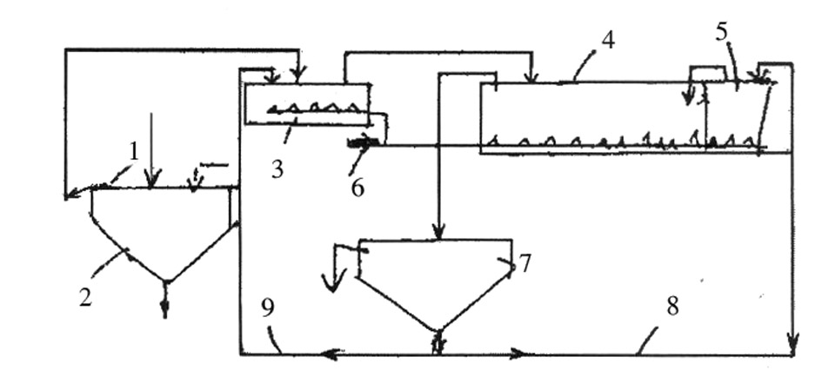
nax. 11. Camdinare wylebis biologiuri gawmendis principuli sqema

Camdinare wylebi (1) miewodeba damwdoms (2), sadac cildeba Sewonili nawilakebi, Semdeg dawmendili wyali Sedis preaerator-gamasaSualoebelSi (3), aqve Sedis Warbi lamis nawili meoradi damwdomidan. Camdinare wyali aq ganicdis winaswar aeracias 15-20 wT-is ganmavlobaSi. amis Semdeg Camdinare wyali miewodeba aerotenkebs (4), sadac mimdinareobs gawmendis ZiriTadi procesi.
koncentrirebis Semdeg Camdinare wyali lamTan erTad miewodeba meore damwdoms (7), sadac xdeba wylisagan mocileba. lamis umetesi nawili ubrundeba aerotenks, xolo naWarbi (9) gadadis preaeratorSi.
aerotenkSi Sesvlamde Camdinare wyali unda Seicavdes Sewonil nawilakebs araumetes 150 mg/l, navTobproduqtebs araumetes 25 g/l.
Camdinare wylis temperatura unda iyos 6-30°C farglebSi, pH-ki 6,5-dan 9-mde.
Cvens mier ganxiluli Camdinare wylebis gawmendis meTodebi gamoiyeneba aseve bunebrivi wylebis gasawmendadac wyalmoxmarebisas.
wyalmomaragebis sistemaSi biologiuri gawmendis Semdeg aucilebeli stadiaa wylis dezinfeqcireba, rac xorcieldeba qlorirebiT, ozonirebiT, an infrawiTeli dasxivebiT.
dezinfeqcirebis mizania wyalSi arsebuli baqteriebis, mikroorganizmebis gauvnebelyofa da sasmeli wylis moqmedi saxelmwifo standartis moTxovnebamde dayvana. qlorirebisa da ozonirebis procesis arsi Cven ukve ganvixileT Camdinare wylebis qimiuri meTodiT gawmendisas.

XI. niadagis dacva

niadagi xmeleTis nawilia, romlis ZiriTadi Tviseba nayofierebaa (akad. v. vi-liamsis mixedviT). noyieri niadagi uzrunvelyofs mcenares wylisa da sakvebi nivTierebebis saWiro raodenobiT.
niadagi miekuTvneba Sereul resursTa jgufs – igi Sedgeba rogorc araorganuli, aseve biologiuri komponentebisagan. sxvadasxva faqtorebis gavleniT niadagi kargavs nayofierebas, amdenad igi gamolevadi resursia, magram racionaluri gamoyenebisas inarCunebs Tavis Tvisebebs, e.i. aRdgenadia.
niadagis fondis Semcirebis mizezi araxelsayreli bunebrivi procesebis garda, ZiriTadad anTropogenuri faqtorebia.
niadags udides zians ayenebs erozia (laT. gancalkeveba), damlaSeba, daWaobeba, qimiuri dabinZureba, aseve pirdapiri ganadgureba – gzebis gayvana, sawarmoebisa da infrastruqturis, sacxovrebeli saxlebis mSenebloba da a.S.
erozia ori saxisaa _ wylismieri da qarismieri (deflacia), aseve cnobilia irigaciuli da teqnikuri erozia.
yvelaze gavrcelebuli da saSiSia wylismieri erozia. wvimis, Tovlis an niaRvris moqmedebiT gadairecxeba niadagis noyieri fena. am saxis erozias xels uwyobs mcenareuli safaris mospoba, gansakuTrebiT mTis ferdobebze. wylismieri eroziis nairsaxeobaa irigaciuli erozia gamowveuli morwyvis wesebis darRveviT.
qarismieri erozia saSiSia naxevradmSrali niadagebisaTvis.
mtvriani qariSxlis dros xdeba niadagis noyieri fenis gamofitva, misi Semadgeneli komponentebis, Teslis, aseve fesvgaumagrebeli jejilis gadatana.
daCqarebuli eroziis mizezia tyeebis usistemo gaCexva, saZovrebis uwesrigo gamoyeneba, araswori xvna ferdobebze, miwaTmoqmedebis araswori meTodebi – mono-kulturebis danergva, romelic cudad icavs niadags mzis sxivebisagan, aRaribebs im nivTierebebiT, romelic am monokulturebs sWirdeba.
niadagis eroziisagan dacvis TvalsazrisiT yvelaze efeqturia tye, romlis 1 ha akavebs 50 m³ wyals. tenis SekavebiT meore adgilzea mdeloebi, romelTa kargad ganviTarebuli fesvTa sistema icavs niadags wylis dartymisa da mzis sxivebis moqmedebisagan. TavTaviani kulturebi ufro kargad icaven niadags, vidre saToxni kulturebi. mag., 5°-iani kuTxiT daxris mqone ferdobebis mcenareebiT daucvleli niadagis 18 sm-iani fenis gadarecxvas sWirdeba 2-3 weli, simindis naTesebians – 9 weli, TavTaviani kulturebisas – 35 weli, xolo balaxovani safarisas _ 10 aTasi weli.
mcenareuli safaris ganadgureba xdeba araswori mesaqonleobiTac.
niadagis dazianeba xdeba transportiT, miwissaTxreli manqanebiT da sxva teqnikuri saSualebebiT, rac iwvevs e.w. teqnikur erozias. unda aRiniSnos, rom eroziuli movlenebis Tavidan acileba ufro advilia, vidre maTi Sedegebis aRmofxvra.
niadagis damlaSeba miwaTmoqmedebisaTvis seriozuli problemaa. normalur pirobebSi niadagi Seicavs sxvadasxva marilebs _ karbonatebs: natriumis Na₂CO₃, magniumis MgCO₃, kalciumis CaCO₃, aseve sulfatebs Na₂SO₄ da sxv. amaTgan Na-is marilebi auaresebs niadagis fizikur Tvisebebs.
niadagis damarilianebis mizezi SeiZleba gaxdes mcire siRrmeze arsebuli gruntis wylebi, romlebic cxel, gvalvian pirobebSi niadagis forebiT amodis maRla da orTqldeba, masSi gaxsnili marilebi ki rCeba niadagis zedapirze, meorad damlaSebas ki iwvevs araswori sairigacio sistema.
xSirad, miwaTmoqmedebis xelSemSleli faqtoria daWaobebuli niadagebi.
amave dros, Waobebi miwis – niadagis Zvirfasi rezervia: amoSrobili Waobebis niadagi nayofieria, masSi didi raodenobiTaa azotis naerTebi, sxvadasxva organuli nivTierebebi.
unda aRiniSnos, rom Waobebs didi hidrologiuri mniSvneloba aqvs, isini wylis rezervuarebia – garkveul teritoriaze inarCuneben gruntis wylebis maRal dones, amitom maTi amoSroba SeiZleba patara mdinareebis daSrobis, gruntis wylebis mkveTri Semcirebis mizezi gaxdes.
niadagis qimiuri dabinZureba metad seriozuli problemaa. mas iwvevs rogorc biosferos komponentebis _ atmosferos, hidrosferos qimiuri gaWuWyianeba, aseve soflis meurneobis intensifikacia _ sasoflo-sameurneo produqtebis ufro Warbi raodenobiT misaRebad sasuqebisa da Sxamqimikatebis gamoyeneba.
msoflioSi mosaxleobis raodenobrivi mateba zrdis moTxovnilebas kvebis produqtebze, saxnav-saTesi farTis sxvadasxva mizeziT Semcireba ki kidev ufro amZafrebs am problemas.
sasuqebisa da pesticidebis sargeblianoba udavoa. sasoflo-sameurneo produqtebis 50%-iT matebas swored sasuqebs miaweren.
gaerTianebuli erebis organizaciis UNO da sasoflo-sameurneo organizaciis FAO monacemebiT sasoflo-sameurneo produqciis mavneblebiTa da daavadebebiT gamowveuli yovelwliuri danakargi mTeli mosavlis 20%-ze mets Seadgens.
niadagSi ZiriTadad SeaqvT azotis (N), fosforis (P) da kaliumis (K) Semcveli sasuqebi, vinaidan yvelaze metad swored es elementebi sWirdeba mcenares. aseve saWiroa gogirdi (S), kalciumi (Ca), magniumi (Mg), mikroelementebi _ rkina (Fe), manganumi (Mn), TuTia (Zn), spilenZi (Cu), molibdeni (Mo), bori (B) da sxv.
niadagSi sasuqebis mcire dozebiT Setana cvlis sakvebi nivTierebebis marags da TviT niadagis Tvisebebs, magram sasuqebis sistematurad didi doziT da niadagis mJavianobis gauTvaliswineblad gamoyenebam SeiZleba seriozuli darRvevebi gamoiwvios sakvebi nivTierebebis biogeoqimiur ciklsa da bunebriv garemoze. Na⁺ da Cl⁻ ionebis siWarbe gavlenas axdens fermentebis aqtiurobaze, fotosinTezis procesSi energiis gamomuSavebaze, icvleba aminomJavebis Sedgeniloba, cilebis gacvlis gzebis rRvevis gamo warmoiqmneba Sualeduri da saboloo toqsikuri nivTierebebi. marilebisadmi mgrZnobiare protoplazmebi iRupeba 1-1,5% NaCl-is xsnarSi.
sulfatebisa da nitratebis toqsikuroba qloridebze naklebia, fosfatebi ki TiTqmis aratoqsikuria.
mineraluri kvebis elementebi didi raodenobiT grovdeba fesvebSi, Reroebsa da foTlebSi. wylis aorTqleba foTlebidan iwvevs marilebis dagrovebas, rasac mcenare foTlebis dayriT ewinaaRmdegeba, es ki arRvevs mcenaris bunebriv zrdas.
biosferosTvis yvelaze saSiSi azotovani sasuqebia, maTi niadagidan gamorecxva iwvevs wyalsatevebis azotiT gamdidrebas da gruntis wylebis gaWuWyianebas. am dros wyalsatevebSi xdeba wyalmcenareebis intensiuri zrda, isini kvdomis Semdeg baqteriulad iSlebian Jangbadis Warbi moxmarebiT da Jangbadis deficitis gamo Tevzebsa da sxva cocxal organizmebs daRupva eliT. am process evtrofikaciis procesi ewodeba.
meore problema _ es aris nitratebisagan maRaltoqsikuri nitritebisa da kancerogenuli nitraminebis warmoqmna.
adaminisaTvis SedarebiT naklebtoqsikuria fosforovani sasuqebi, romelic mtkiced magrdeba niadagSi da maTi gamorecxva umniSvnelod xdeba.
mineraluri sasuqebis mesame ZiriTadi elementi – kaliumi arsebiT mavne gavlenas garemoze ar axdens, magram Tu igi qloridebis saxiTaa, SeiZleba uaryofiTi Sedegi miviRoT gruntis wylebsa da wyalsatevebSi qloris SeRwevis gamo.
sasuqebis intensiuri gamoyenebisas garemoze uaryofiTi gavlenis Sesamcireblad saWiroa Semdegi pirobebis dacva:
_ sasuqebis Setanis teqnologiis srulyofa (Cayris siRrmis SerCeva, Setanis optimaluri vadebis dacva da sxv.);
_ niadagur procesebSi TandaTanobiT CarTvadi, nela moqmedi azotovani sasuqebis gamoyeneba;
_ uqloro sasuqebis Seqmna da a.S.
sasuqebis ekonomiisa da evtrofikaciisagan wyalsacavebis dasacavad mizanSewonilia wyalSi uxsnadi sasuqebis Seqmna da sarwyavad azotmJavas susti xsnaris gamoyeneba.
pesticidebi mcenareTa dacvis qimiuri saSualebebis saerTo saxelwodebaa (pestis _ mavne, credo _ vklav). isini sxvadasxva qimiuri nivTierebebia, romelTac unari SeswevT SerCeviT mospon mavne mwerebi, sarevela balaxebi, mcenareTa daavadebis amgznebebi da sxv.
daniSnulebis mixedviT pesticidebi iyofa daaxloebiT 10 jgufad, mag. mwerebis mosaspobad _ inseqticidebi (insectum _ mweri), sarevelebis winaaRmdeg _ herbicidebi (herba _ balaxi, mcenare), sokovani daavadebebis winaaRmdeg fungicidebi da a.S. biosferoSi pesticidebis moZraobis sqema mocemulia xanazze 32.
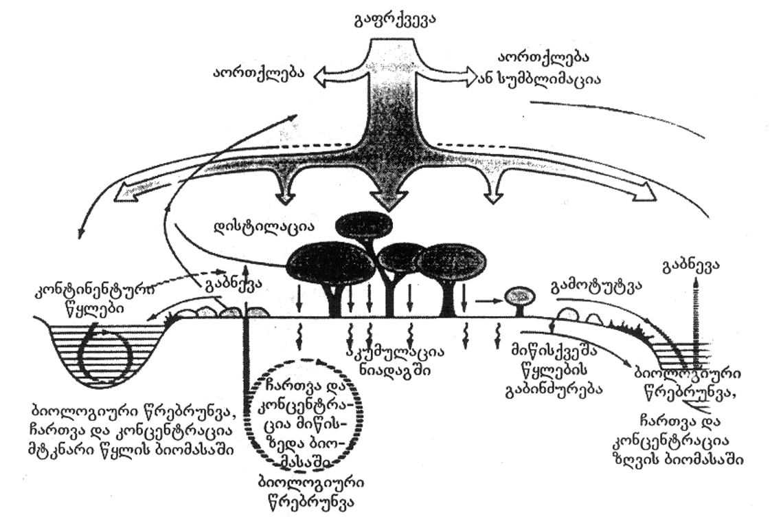
nax. 32. pesticidebis moZraoba biosferoSi

pesticidebis gamoyenebas dadebiTTan erTad uaryofiTi Sedegic axlavs _ toqsikurobis gamo isini potenciurad saSiSia cocxali organizmebisaTvis, maT Soris adamianebisaTvisac, radgan maRalia kvebis jaWviT adamianis organizmSi maTi moxvedris saSiSroeba.
gansakuTrebiT saSiSia vercxliswylisa da qloris Semcveli pesticidebi, xolo SedarebiT usafrTxoa fosfororganuli pesticidebi.
unda aRiniSnos, rom xelovnurad miRebul pesticidebs saerTo naklic gaaCniaT _ mavneblebi droTa ganmavlobaSi maT mimarT imunitets gamoimuSaveben; isini ver erTvebian bunebriv wrebrunvebSi saTanado mikroorganizmebis ararsebobis gamo da amdenad, didxans rCebian, grovdebian garemoSi da abinZureben mas.
yovelive zemoTqmulidan gamomdinare, metad aqtualuria mcenareTa dasacavad qimiurTan erTad biologiuri meTodis gamoyenebac.
biologiuri meTodiT xdeba mxolod mavneblebis mocileba, ar ziandeba sxva cocxali organizmebi da ar binZurdeba garemo.
TandaTanobiT met aqtualobas iZens soflis meurneobaSi bioqimiuri meTodebis gamoyeneba. uxsovari droidan cnobilia zogierTi mcenaris mavneblebis winaaRmdeg gamoyenebis faqtebi _ anwli, niori, gvirila da a.S. maT aRnagobaSi arsebuli qimiuri nivTierebebi asruleben antiseptikisa da pesticidebis rols. am nivTierebebis identifikacia da maTi analogebis xelovnurad miReba mraval problemas gadawyvetda _ maT mimarT mavneblebs Semguebloba ar uviTardebaT, advilad erTvebian bunebriv wrebrunvaSi, ar abinZureben garemos da arc adamianisaTvis arian saSiSi.
biologiuri meTodi mavneblebis sterilizaciasa da hormonebis gamoyenebasac gulisxmobs, am ukanasknelTa umniSvnelo raodenobiT gamoyenebac ki (~10⁻⁹g) aCerebs zogierTi mweris ganviTarebas.
rogorc adre aRvniSneT, Sxamqimikatebi adamianis organizmSi ZiriTadad kvebis jaWviT xvdeba _ piris Rrudan, anu oraluri gziT, da ZiriTadad Tirkmelebsa da RviZlSi grovdeba. sasunTqi gzebidan, anu inhalaciuri gziT moxvedrili Sxamqimikatebi ki filtvebsa da Tavis tvinSi grovdeba.
rogorc vTqviT, niadagi gamolevadi, magram aRdgenadi resursia. racionaluri gamoyenebiT am umniSvnelovanesi resursis metnaklebad SenarCuneba SesaZlebelia, risTvisac aucilebelia niadagis dazianebis gamomwvevi zemoT ganxiluli subieqturi faqtorebis gamoricxva, xolo obieqturi faqtorebis minumamde dayvana.
ekonomikis mravali dargi – samTo-mompovebeli, samSeneblo, gadamamuSavebeli, energetika da sxv. _ Tavisi saqmianobisas axdens niadagis dazianebas, mis rRvevas. miwis kanonmdeblobiT TiToeuli sawarmo valdebulia gaataros dazianebuli niadagis aRdgenisa da rekultivaciis RonisZiebebi.
miwebis rekultivacia – es aris mrewvelobis mier darRveuli miwis aRdgenisa da produqtiulobis amaRlebisaken mimarTul RonisZiebaTa erToblioba (sainJinro, samTo-teqnikuri, melioraciuli da a.S.) am miwebis sxvadasxva saxiT sameurneo gamoyenebaSi dasabruneblad.
teritoriebis aRdgena xorcieldeba oTxi mimarTulebiT: sasoflo-sameurneo gamoyenebisaTvis (miwaTmoqmedeba, mebaReoba), tyis nargavebis gasaSeneblad, wyalsatevebis mosawyobad da sacxovrebeli da kapitaluri mSeneblobisaTvis.
rekultivizaciis procesi, Cveulebriv, or etapad iyofa: samTo-teqnikuri da biologiuri.
samTo-teqnikuri etapis dros xdeba teritoriis momzadeba, kerZod, nayarebis dagegmva, gamosayeneblad moxerxebul mdgomareobaSi moyvana, nayofieri gruntis dayra, misasvleli gzebis mowesrigeba da a.S.
biologiuri etapi ki gulisxmobs darRveuli niadagebis aRdgenas, merqnuli jiSebis dargviT, an sasoflo-sameurneo kulturebis moyvaniT. am dros saWiroa garkveuli Tanmimdevrobis dacva – jer unda dairgas didi mcenareuli masis mqone naklebad momTxovni kulturebi, romlebic xels Seuwyoben niadagis nayofierebis TandaTanobiT aRdgenas, amis Semdeg ki dairgveba sxva, ufro pretenziuli kulturebi.

XII. klimatur cvlilebaze bunebrivi da anTropogenuri faqtorebis gavlena

miuxedavad mecnierebasa da teqnikaSi miRweuli udidesi progresisa, amindi kvlavac rCeba dedamiwaze cxovrebis TiTqmis yvela sferos ganmgeblad. soflis meurneoba, energetika, transporti, komunaluri meurneoba, turizmi _ ai, arasruli CamonaTvali ekonomikis seqtorebisa, romlebic uSualod reagirebs amindisa da klimatis cvalebadobaze.
klimati, anu hava, warmoadgens mocemuli teritoriisTvis damaxasiaTebeli amindis mravalwliur reJims, romelic ganpirobebulia mzis radiaciiT, misi gardaqmnebiT atmosferoSi, agreTve okeanesa da atmosferoSi mimdinare cirkulaciuri procesebiT. klimatur elementebSi Sedis: haeris temperatura, atmosferuli naleqebi, qari, haeris sinotive, Rrublianoba, mzis naTeba da sxv.
dedamiwis arsebobis manZilze, romlis xangrZlivobad miiCneva 4,5 mlrd weli, icvleboda misi brunvis RerZis daxriloba, kontinentebis moxazuloba da mdebareoba, atmosferos qimiuri Semadgenloba da sxva faqtorebi, rac ganapirobebda Cvens planetaze klimatis did cvalebadobas: gamyinvarebis epoqebs cvlida daTbobis periodebi, Sesabamisad, icvleboda mcenareuli da cxovelTa samyaro. gamyinvarebis epoqebSi okeanis done 100 metriT dabali iyo Tanamedrove donesTan SedarebiT. globaluri daTbobis bolo mkveTrad gamoxatuli periodi aRiniSna X-XII saukuneebSi, rodesac amJamad myinvarebiT dafaruli grenlandiis sanapiroze gaCnda saZovrebi, ramac ganapiroba evropis CrdiloeTidan aq vikingebis gadasaxleba. amave periods ekuTvnis axlaxan myinvarwveris ferdobze, zRvis donidan 4 aTasi metris simaRleze myinvarebSi aRmoCenili monastris Senoba. es mowmobs aRniSnul periodSi kavkasionis gamyinvarebis mkveTr Sesustebas.
globaluri daTbobis axali periodi daiwyo XIX saukunis meore naxevarSi, rac gamoixata dedamiwis sxvadasxva regionSi myinvarebis TandaTanobiTi degradaciiT da msoflio okeanis donis matebiT. es procesi gansakuTrebiT gaZlierda gasuli saukunis 70-iani wlebidan _ globalurma daTbobam moicva yvela kontinenti, daCqarda myinvarebis degradacia da okeanis donis zrda.
miRebuli Sexedulebebis Tanaxmad, amJamad mimdinare globaluri daTbobis mTavar mizezs warmoadgens bolo ori saukunis manZilze kacobriobis mier wiaRiseuli sawvavis mzardi moxmareba, ramac gamoiwvia atmosferoSi e.w. `saTburis efeqtis~ gaZliereba. es efeqti yalibdeba atmosferoSi radiaciul nakadebze e.w. `saTburis gazebis~ zemoqmedebis Sedegad, rac iwvevs Ramis saaTebSi dedamiwis gacivebis Senelebas. am gazebis ararsebobis SemTxvevaSi dedamiwis klimati mTvaris havas daemsgavseboda. saTburis gazebidan dedamiwis siTburi balansis SenarCunebaSi mTavari roli miuZRvis naxSirorJangs (CO₂), meTans (СH₄) da azotis qveJangs (N₂O), romelTagan atmosferoSi Tavisi raodenobiT ZiriTadia CO₂. bolo saukunis manZilze am gazis koncentraciam atmosferoSi moimata 30%-iT, ramac gamoiwvia saSualo globaluri temperaturis gazrda 0,7°C-iT, xolo okeanis donis aweva 20 sm-iT.
mimdinare saukuneSi globaluri mniSvneloba gaaCnia imas, Tu ra gziT warimarTeba kacobriobis socialur-ekonomikuri ganviTareba. im SemTxvevaSi, Tu msoflio saTanadod Seafasebs globalur daTbobasTan dakavSirebul safrTxeebs da koordinirebulad daiwyebs brZolas saTburis gazebis emisiebis Sesamcireblad, ganaxlebadi energetikuli resursebis asaTviseblad, energoefeqturobis gasazrdelad da atmosferodan CO₂-is STanTqmis obieqtebis (tyeebis) gasafarToeblad, saukunis dasasrulisTvis temperaturis nazardma SeiZleba Seadginos mxolod 2-3°C. magram, Tu qveynebi gaagrZeleben saTburis gazebis amJamindeli da ufro meti odenobiT emisiebs atmosferoSi, temperaturis globalurma matebam SeiZleba miaRwios 6°C, xolo zRvis donem SeiZleba aiwios 60 sm-iT. klimatis cvlilebis am scenarebis Sedgenisas ar aris gaTvaliswinebuli daTbobis mimarT sxva raime mZlavri, globaluri masStabis procesis, magaliTad vulkanebis masiuri amofrqvevebis ukuqmedeba, ramac SeiZleba mniSvnelovnad Seamciros daTbobis saprognozo sidideebi. atmosferoSi saTburis gazebis anTropogenur emisiebSi udidesi wvlili SeaqvT amerikis SeerTebul Statebs, ruseTs, iaponias, CineTs, germanias, gaerTianebul samefosa da kanadas.
miuxedavad imisa, rom globaluri daTboba jerjerobiT sawyis stadiaSi imyofeba, misi zegavleniT msoflios yvela regionSi ukve aRiniSneba klimatis cvlilebiT gamowveuli rigi safrTxeebis sixSirisa da intensivobis zrda. globaluri daTbobis negatiuri Sedegebidan aRsaniSnavia:
_ dedamiwis yinulovani safaris, anu kriosferos degradacia. am procesis Tanmdevi uaryofiTi movlenebia okeanis donis Semdgomi aweva, mtknari wylis msoflio maragis Semcireba, wylis resursebis gadanawileba sxvadasxva regionebs Soris, okeanesa da atmosferos cirkuluaciuri procesebis transformacia. ase, magaliTad, grenlandiis yinulovani safaris gadnoba amcirebs atlantikis okeanis Crdilo nawilSi wylis marilianobas, rac asustebs golfstrimis Tbili dinebis intensivobas. es ukanaskneli ki ganapirobebs Crdilo evropis klimats, romelic am dinebis gareSe 10°C-iT ufro civi iqneboda.
_ amindis eqstremaluri movlenebis gaxSireba. bolo 10-20 wlis manZilze msoflios sxvadasxva regionSi sagrZnoblad imata gvalvebis sixSirem da xangrZlivobam. amasTan erTad gaizarda uxvi naleqebis intensivoba, ramac gamoiwvia Tanmdevi movlenebis _ wyaldidobebis, Rvarcofebisa da mewyerebis gaxSireba. did qalaqebSi imata sicxis talRebis ganmeorebadobam.
_ tropikuli qariSxlebis sixSirisa da intensivobis zrda. am eqstremalur movlenas Zlieri qarisa da uxvi naleqebis Sedegad TavisTavad sdevs damangreveli Sedegebi, romlebic am bolo 10-20 wlis manZilze kidev ufro mZafrdeba okeanis donis awevisa da Stormuli modenebis gaZlierebis gamo.
_ jandacvis pirobebis gauareseba, rac upirveles yovlisa gamoixateba tropikul da subtropikul qveynebSi malariisa da sxva, gadamtan mwerebTan dakavSirebuli, daavadebebis arealis gavrcelebaSi, agreTve gvalviTa da mtknari wylis naklebobiT gamowveuli SimSimlobisa da diareul daavadebaTa gamZafrebaSi.
_ bunebrivi ekosistemebis transformacia. igi gamoixateba tyeebisa da bunebrivi saZovrebis jiSobrivi Semadgenlobis cvlilebaSi, ris drosac temperaturisa da naleqebis Secvla iwvevs Zvel pirobebs Seguebuli florisa da faunis saxeobebis dakninebas an migracias, da maTi adgilis dakavebas axal pirobebTan Seguebuli jiSebiT.
amave dros, globalur daTbobas SeuZlia rigi dadebiTi Sedegebis motanac, romelTagan aRsaniSnavia soflis meurneobis arealis gavrceleba evraziisa da Crdilo amerikis CrdiloeT nawilebSi, xolo zomieri sartylis mTian regionebSi – axlandelTan SedarebiT ufro did simaRleebze. gaixsneba agreTve sanaosno gza Crdilo yinulovani okeanis gavliT.
saqarTvelos pirobebSi globalurma daTbobam ukve gamoiwvia mTeli rigi uaryofiTi Sedegebisa. kerZod, Savi zRvis sanapiro zonaSi zRvis donis awevam da Stormuli modenebis gaZlierebam gamoiwvia sanapiro zolis degradaciisa da zRvis mier plaJebis mitacebis procesis gaZliereba. saqarTvelos mTian regionebSi uxvi naleqebis gaxSirebas Tan sdevs wyaldidobebis, Rvarcofebisa da mewyerebis SemTxvevebis zrda, xolo vake raionebSi – gvalvebis gaZliereba.
globalur daTbobasTan dakavSirebuli safrTxeebis SeZlebisdagvarad Tavidan asacileblad da misi uaryofiTi Sedegebis koordinirebuli ZalebiT Sesarbileblad 1992 wels rio-de-JaneiroSi Catarebul msoflio samitze miRebul iqna gaeros klimatis cvlilebis CarCo konvencia, romelic xelmomwer qveynebs avaldebulebs Semdegi principebis Sesrulebas:
- saTburis gazebis emisiis wyaroebisa da STanTqmis obieqtebis perioduli inventarizacia;
- saTburis gazebis emisiebis Semcireba energoefeqturi teqnologiebisa da ganaxlebadi energiis wyaroebis aTvisebis xelSewyobiT;
- saTburis gazebis STanTqmis gaZliereba gatyianebisa da tyeebis aRdgenis stimulirebiT;
- klimatis cvlilebasTan saadaptacio RonisZiebaTa momzadeba da ganxorcieleba;
- farTo sazogadoebis Semecnebis donis amaRleba klimatis cvlilebasTan dakavSirebul sakiTxebSi;
- erovnuli Setyobinebis, anu moxsenebis, perioduli momzadeba qveyanaSi konvenciis ZiriTadi moTxovnebis Sesrulebis Sesaxeb.
klimatis cvlilebis konvenciis xelmomweri qveynebis umetesobam ivaldebula 2012 wlisTvis saTburis gazebis emisiis saSualod 5%-iT Semcireba, rac, upirveles yovlisa, gulisxmobs energoefeqturi teqnologiebis danergvas da ganaxlebadi energoresursebis aTvisebas.
aRniSnuli miznis misaRwevad ganviTarebul qveynebs Soris TanamSromlobisa da ganviTarebadi qveynebisTvis daxmarebis gasaZliereblad 1997 wels konvenciis mmarTveli organos mier miRebuli iqna e.w. `kiotos oqmi~. am dokumentma gza gauxsna ganviTarebul qveynebs uaxlesi teqnologiebis dasanergad ganviTarebad qveynebSi, rasac Tan mohyva saTburis gazebis emisiebis Semcirebis stimulireba dazogil emisiebze fasis dadebiT. am e.w. `sufTa ganviTarebis~ meqanizmma, romelSic Sedis `emisiebiT vaWroba~, bolo 10 wlis manZilze farTod CaiTria bevri ganviTarebuli da ganviTarebadi qveyana, maT Soris aSS, iaponia, germania, CineTi, indoeTi, brazilia da sxv. 1 tona dazogili CO₂-is fasi sxvadasxva wlebSi icvleboda 10-20 aSS dolaris farglebSi. emisiebiT vaWrobis Sedegad mogebaSi rCeba rogorc teqnologiis damnergavi, aseve teqnologiis mimRebi qveynebi, romelic Tavisufldeba saTburis gazebiTa da aerozolebiT zedmeti gaWuWyianebisgan.
saqarTvelo klimatis cvlilebis konvencias miuerTda 1994 wels. 1996 wels qveyanaSi daiwyo klimatis cvlilebis erovnuli programis Sesruleba, xolo 1997-1999 wlebSi momzadda pirveli erovnuli Setyobineba. 2000 wlidan saqarTveloSi ganxorcielda 20-ze meti proeqti energoefeqturobisa da ganaxlebadi energiebis aTvisebis dargSi, romlebSic garemos dacvisa da energetikis saministroebTan erTad aqtiurad monawileoben akademiuri institutebi da arasamTavrobo organizaciebi.
2006-2009 wlebSi saqarTveloSi momzadda klimatis cvlilebis konvenciisadmi meore erovnuli Setyobineba. masSi detaluradaa ganxiluli 1998-2006 wlebisTvis saTburis gazebis inventarizaciis ZiriTadi Sedegebi, klimatis cvlilebis trendebi winaswar SerCeul 3 mowyvlad regionSi _ Savi zRvis sanapiro zonaSi, qvemo svaneTSi, dedofliswyaros raionSi da moyvanilia 2100 wlamde klimatis cvlilebis prognozi dasavleT da aRmosavleT saqarTvelos klimatur olqebSi. aRniSnuli regionebisaTvis gansazRvrulia klimatis cvlilebis mimarT saadaptacio RonisZiebebi, xolo mTlianad saqarTvelos teritoriisTvis Sefasebulia saTburis gazebis emisiis Semamcirebeli politikis efeqturoba da SemoTavazebulia konkretuli RonisZiebebi am politikis realobaSi gasatareblad.

XIII. unarCeno da mcirenarCeniani teqnologiebis Seqmnis safuZvlebi da ZiriTadi mimarTulebebi

unarCeno teqnologia aris codnis, meTodebisa da saSualebebis praqtikuli gamoyeneba, raTa adamianTa moTxovnilebis Sesabamisad uzrunvelyofil iqnes bunebrivi resursebisa da energiis yvelaze racionaluri gamoyeneba da garemos dacva~.
cxadia, koncefcia `unarCeno teqnologia~ garkveul zRvrebSi pirobiT xasiaTs atarebs. unarCeno teqnologiis cnebis qveS igulisxmeba Teoriuli zRvari, warmoebis idealuri modeli, romelic umetes SemTxvevaSi srulad ki ara, aramed nawilobriv (mcirenarCeniani teqnologia) iqneba realizebuli. teqnikuri progresis Sesabamisad, unarCeno teqnologiis ganxorcieleba unda moxdes sul ufro meti miaxloebiT.
unarCeno teqnologiis kriteriums, anu misi usafrTxoebis sazoms warmoadgens recirkulirebadi narCenebis raodenobis fardoba narCenebis saerTo raodenobasTan. aseTi kriteriumis zusti gamoTvla saWiroebs Sesworebis koeficientis SemoRebas narCenebis toqsikurobaze.
unarCeno teqnologiis ganviTarebis ZiriTadi mimarTulebebia:
_ Camdinare naxmari wylebis gawmendis arsebuli da perspeqtiuli meTodebis bazaze sxvadasxva saxis uCanadeno sqemebisa da wyalbrunvis ciklebis SemuSaveba;
_ airTa gawmendis efeqturi sistemebis Seqmna, aseve, airadi gamonayofis likvidacisi mizniT teqnologiuri sqemebis srulyofa da airTa ciklebis Seqmna;
_ sawarmoo narCenebis, romlebic ganixileba rogorc meoradi materialuri resursebi, gadamuSavebisa da gamoyenebis sistemebis Seqmna da danergva;
_ principulad axali procesebis Seqmna da danergva, romlebic gamoricxaven ZiriTadi narCenebis momcem teqnologiur stadiebs;
_ iseTi teritoriul-samrewvelo kompleqsebis (tsk) Seqmna, romlisTvisac damaxasiaTebelia nedleulisa da narCenebis materialuri nakadebis Caketili sqema.
unarCeno teqnologias aqvs Semdegi upiratesobebi:
_ WuWyiani Camdinare wyali ar Cadis wyalsatevSi, aramed adgilzeve sufTavdeba da ubrundeba sawarmoo cikls;
_ sufTa wyalze moTxovnileba mkveTrad mcirdeba, radgan xdeba misi mravaljeradi gamoyeneba;
_ mcirdeba an mTlianad ispoba mavne emisiebi atmosferoSi;
_ myari narCenebi sawarmos mier ki ar iyreba, aramed gamoiyeneba nedleulad sxvadasxva produqciis misaRebad.
unarCeno samrewvelo sawarmoTa Seqmnis safuZvelia nedleulis kompleqsuri gadamuSaveba, radganac sawarmoo narCenebi-es aris nedleulis gamouyenebeli nawili.
nedleulis kompleqsur gamoyenebas udidesi mniSvneloba aqvs rogorc ekologiuri, aseve ekonomikuri TvalsazrisiT.
yvela narCeni SeiZleba daiyos 2 jgufad: 1) teqnologiuri narCenebi warmoadgens nedleulis gadamuSavebisa da produqtis miRebis teqnologiuri procesebis narCenebs; 2) komunaluri (sayofacxovrebo) narCenebi. orive tipis narCenebi SeiZleba iyos myar, Txevad an airad mdgomareobaSi.
ganvixiloT maTi likvidaciis gzebi _ unarCeno teqnologiis Seqmnis etapebi.
myari narCenebis likvidaciis ZiriTadi mimarTulebebi
narCenebisa da mavne gamonayofis warmoqmna teqnologiuri procesebis praqtikulad yvela safexurze xdeba – sasargeblo wiaRiseulis gamoyenebidan produqciis miRebamde (nax. 33).
bunebaSi iSviaTad gvxvdeba sabado mxolod erTi sasargeblo wiaRiseuliT, ufro xSirad igi Seicavs Tanmxleb elementebsac. nedleulis kompleqsuri gamoyeneba gulisxmobs yvela sasargeblo komponentis amoRebas.
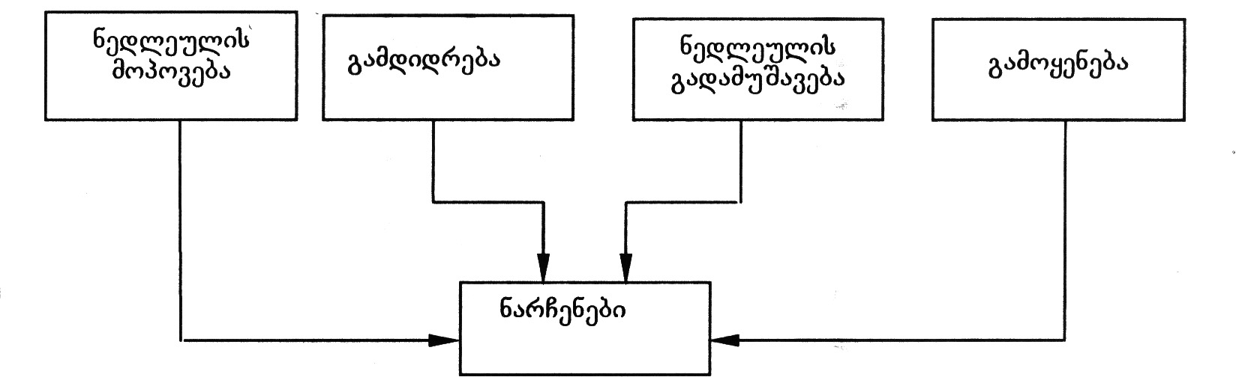
nax. 33. teqnologiuri narCenebis warmoqmnis wyaroebi

samrewvelo narCenebi pirobiTad 3 nawilad iyofa:
1 _ sasargeblo wiaRiseulis mimpovebel sawarmoTa msxviltonaJiani nayarebi; fuWi qanebis nayarebi; arakondiciuri madnebi; widebi, Slamebi, aseve mtverdamWeri da Camdinare wylebis gamwmendi sistemebis naleqebi;
2 _ sawarmoo danakargebi – sawarmoTa gamonayofi kvamlis (Wvartlis) da mtvris saxiT. airgamwmendi sistemebis arsebobisas es narCenebi pirvel jgufs miekuTvneba da maTTan erTad garkveul pirobebSi SeiZleba gamoyeneba Semdgomi gadamuSavebisaTvis;
3 _ narCenebis is jgufi, romelic gamousadegaria Semdgomi gadamuSavebisaTvis teqnologiis Tanamedrove doneze, an saSiSia adamianisTvis.
aseTi narCenebi unda ganadgurdes an Caimarxos, xolo pirveli da meore jgufis myari narCenebis gadamuSaveba xdeba Semdegi meTodebiT: meqanikuri (dawvrilmaneba, klasifikacia, daxarisxeba, Sereva, granulireba), hidromeqanikuri (dawdoma, gafiltvra, centrifugireba), masagacvla (eqstraqcia, Sroba, kristalizacia) da qimiuri. mokled ganvixiloT TiToeuli maTgani.
dawvrilmanebas mimarTaven gadasamuSavebeli masalis nawilakTa zomis Sesamcireblad Semdgomi procesebis daCqarebis mizniT. dawvrilmaneba aris mSrali da sveli (wylis Tanaobisas).
klasifikacia, daxarisxeba (gacxrilva) _ es aris dawvrilmanebuli masalis dayofa fraqciebad miaxloebiT erTnairi zomis marcvlebad. es procesi ZiriTadad xdeba sacrian aparatebSi.
Sereva warmoebs myari nivTierebebis narevebis an suspenziebis misaRebad.
granulireba _ mtvriseburi myari masalis gamsxvileba Semdgomi gamoyenebis gaadvilebis mizniT. am dros iyeneben damsvelebel an SemakavSirebel danamatebs (wyali, polifosfati da a.S.).
dawdoma _ simZimis ZaliT mZime nawilakebis daleqva, mas iyeneben suspenziisaTvis.
filtracia _ foriani tixrebiT myari nawilakebis Sekaveba.
centrifugireba _ specialur aparatebSi – centrifugebSi myari nawilakebis mocileba siTxisagan centridanuli ZaliT.
eqstraqcia _ erTi an ramdenime komponentis amowdoma romelime gamxsnelis gamoyenebiT (wyali, mJava, tute, organuli gamxsneli an maTi narevi).
Sroba _ myari sxeulidan tenis mocilebis procesi. igi SeiZleba ganxorcieldes sxvadasxva xerxiT, kerZod, meqanikuriT – dawneva, gafiltvra, centrifugireba; fizikur-qimiuriT _ higroskopuli nivTierebebis gamoyenebiT; Tburi _ aorTqlebis gziT.
kristalizacia _ myari fazis gamoyofa masalis gamagrebisas (nadnobidan) an myari, gaxsnili nivTierebisa – xsnaridan. es yvelaze mniSvnelovani xerxia sufTa saxis myari nivTierebis misaRebad.
qimiuri meTodi – narCenebis gadamuSaveba qimiuri reagentebis gamoyenebiT, ra drosac umetesad xdeba sxvadasxva meTodebis kombinireba.
mesame jgufis narCenebis _ gansakuTrebiT saSiSi, radiaqtiuri da zogierTi momwamvleli nivTierebebis izolacia xdeba specialur sacavebSi Camarxvis gziT.
maTi SlamSemkrebSi Senaxvisas am ukanasknels Semdegi moTxovnebi waeyeneba:
_ narCenebis wyarodan mcire dacileba;
_ miwisqveSa wylebis gaWuWyianebisagan dasacavad xsnar-gaumtari ekranebis mowyoba;
_ sxvadasxva saxis drenaJebisa da rezervuarebis mowyoba xsnarebis mosacileblad maTi gauvnebelyofis mizniT.

myari komunaluri narCenebis (mkn) gadamuSavebis da likvidaciis gzebi
komunaluri narCenebis gatana da gauvnebelyofa savaldebuloa da aucilebelia. sanitaruli mniSvnelobis garda, amas ekonomikuri mniSvnelobac aqvs, radgan maTi, kerZod qaRaldis, muyaos, sxvadasxva WurWlis, plastmasis, sakvebi narCenebis da a.S. gadamuSaveba, rogorc nedleulis meoradi wyarosi, pirveladi nedleulis dazogvis saSualeba iZleva. mkn tipiuri ganawilebis sqema mocemulia nax. 34-ze.
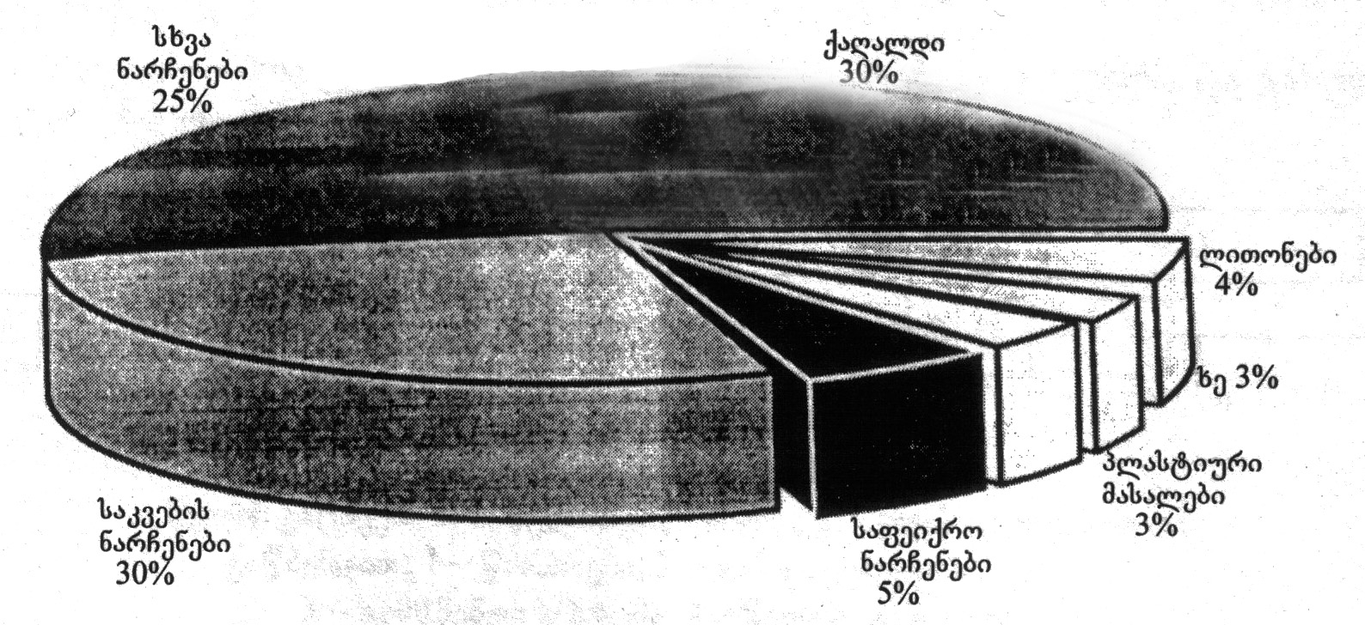
nax. 34. myari sayofacxovrebo narCenebis pirobiTi Semadgenloba
dReisaTvis msoflioSi sayofacxovrebo narCenebis gauvnebelyofisa da gadamuSavebis Semdegi meTodebi arsebobs:
1. kompostireba. mkn-s biologiuri (bioTermuli) gadamuSaveba kompostisa da biosaTbobis misaRebad warmoebs misi TviTaalebis xarjze, rac xorcieldeba mezofiluri da Termofiluri mikroorganizmebiT anaerobul pirobebSi;
procesis mimdinareobisas temperatura iwevs 60°C-mde, am dros iRupeba daavadebis gamomwvevi mikroorganizmebi, buzebi, Wuprebi, matlebi da sxv. amave dros, viTardeba mikroflora, romelsac rTuli, swraflpobadi organuli nivTierebebi gadayavs mcenareebis mier advilad SesaTvisebel formaSi.
2. dawva. nagvis dawva gauvnebelyofis yvelaze saimedo saSualebaa avadmyofobis gamomwvevi mikroflorisa da misi sakvebi aris mosaspobad. Rumelebi aRWurvilia airebis gamwmendi da rekuperaciis sistemebiT;
3. Camarxva. am gziT spoben gansakuTrebiT saziano narCenebs;
4. nayari (poligoni), romelic yvelaze gavrcelebuli meTodia.
araorganizebuli nayari abinZurebs garemos, iwvevs infeqciis gavrcelebas.
udidesi mniSvneloba eniWeba komunaluri myari narCenebis daxarisxebas, calkeuli Semadgeneli nawilebis amoRebasa da saTanado gamoyenebas.
nagavsayrelidan gamoyofili gazi (meTani) SeiZleba gamoyenebuli iqnas Tburi da eleqtruli energiis misaRebad.
mecnierebi Tvlian, rom ar aris iseTi narCeni, romlis gamoyenebac ar SeiZlebodes, Tu SemuSavebulia saTanado teqnologiuri procesebi.

Txevadi narCenebis likvidaciis ZiriTadi mimarTulebebi
Txevadi narCenebi udides zians ayenebs garemos. wyalsatevebis gaWuWyianeba, maTSi florisa da faunis mospoba _ sakiTxis erTi mxarea, xolo meore _ mtknari wylis, ukve deficituris, didi raodenobiT dakargvaa, mesame _ Camdinare wylebSi Semavali Zvirfasi samrewvelo komponentebis dakargvis albaToba.
Txevadi narCenebis likvidaciis ZiriTadi xerxebia:
a) Sekruli wyalbrunvis sqemebis (lokaluri da saerTo daniSnulebis) Seqmna gawmendis meTodebTan SexamebiT;
b) wylis xarjvis normebis Semcireba teqnologiuri operaciebisa da mowyobilobaTa srulyofis gziT.
Camdinare wylebis rTuli fizikur-qimiuri Sedgeniloba, naerTTa mravalferovneba da maTi urTierTqmedeba SeuZlebels xdis universaluri uCanadeno sqemis SerCevas, romelic gamosadegi iqneboda saxalxo meurneobis sxvadasxva dargSi.
arsebobs wyalbrunvis sqemebis Semdegi tipebi:
1. wyali gamacivebeli agentia, is ar WuWyiandeba da isev ubrundeba cikls gacivebis Semdeg;
2. wyali WuWyiandeba teqnologiur procesSi qimiuri nivTierebebiT da gawmendis Semdeg ubrundeba cikls;
3. wyali gamoyenebis procesSii cxeldeba da WuWyiandeba, gacivebisa da gasufTavebis Semdeg ubrundeba cikls (nax. 35).

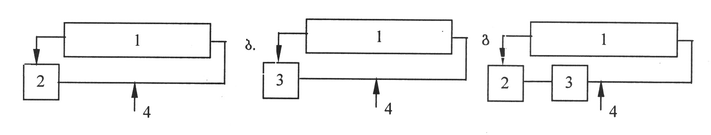
nax. 35. sabrunavi wyalmomaragebis sqemebi
a. wylis gacivebiT; b. wylis gawmendiT; g. wylis gacivebiT da gawmendiT
1 _ warmoeba; 2 _ gamacivebeli sistema; 3 _ gamwmendi sistema;
4 _ wylis miwodeba

sabrunavi wyalmomaragebis efeqturobis kriteriumia wylis gamoyenebis koeficienti
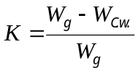
sadac 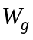 _ wyalsatevebidan miwodebuli wylis moculoba;
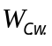 _ CaSvebuli Camdinare wylis moculoba.
rac ufro axloa K erTTan, miT ufro efeqturad moqmedebs wyalmomaragebis sistema.

airadi gamonabolqvis likvidacis gzebi
sawarmoo narCenebiT atmosferos gaWuWyianebis Semcirebis aRiarebuli meTodia gamavali airebis gamwmendi maRalefeqturi meTodebisa da intensiuri airgamwmendi mowyobilobebis Seqmna. Tumca, am tradiciul mimarTulebas aqvs Tavisi naklic.
1. praqtikulad ver xorcieldeba gamavali airebidan gamaWuWyianebeli komponentebis sruli amoReba da xdeba airebis gabneva atmosferoSi, ris Sedegadac gaWuWyianeba vrceldeba did manZilze.
2. airebis gawmendisas didi raodenobiT warmoiqmneba sxvadasxva Slami, romelic ver poulobs gamoyenebas da aucilebelia ZviradRirebuli SlamSemkrebis ageba.
3. airgamwmendi sistemebi sakmaod ZviradRirebulia.
atmosferos dacvis yvelaze efeqturi meTodebia: 1. airadi narCenebis Semcireba teqnologiis SecvliT, aparaturuli procesis srulyofiT, nedleulis SecvliT, mowyobilobis hermetizaciiT, garegani gaTbobis mowyobiT da a.S.; 2. teqnologiuri procesebis Seqmna airTa recirkulaciiT.
narCenebis kompleqsuri gadamuSavebis sqema mocemulia naxazze 36.
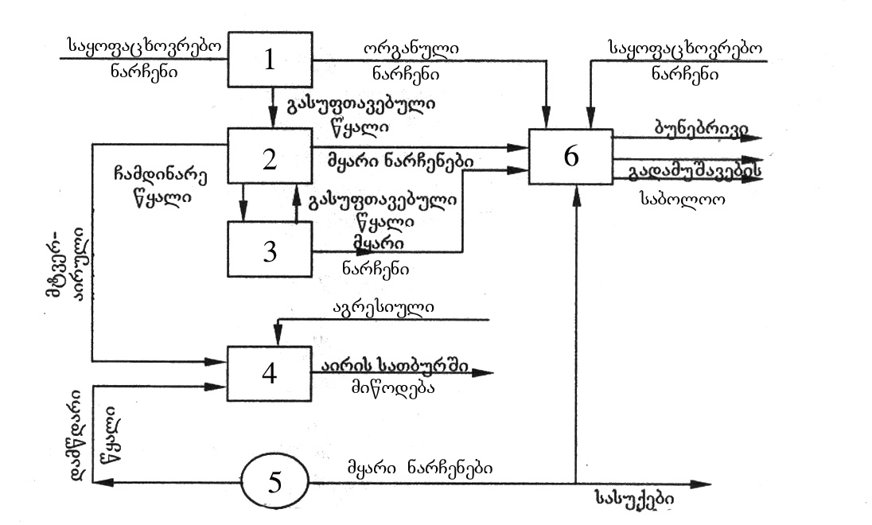
nax. 36. narCenebis kompleqsuri gadamuSavebis sqema
1. biologiuri gawmendis sadguri; 2. samrewvelo sawarmoebi; 3. qarxnis wyalbrunvis sistemebi; 4. reaqtori; 5. damwdomi; 6. myari narCenebis gadamamuSavebeli saamqroebi

cxadia, unarCeno sawarmo ver iqneba ekonomikurad maRalefeqturi, radgan unarCeno teqnologiis danergva rTuli, xangrZlivi, didi danaxarjebis momTxovni procesia. misi ekonomikuri efeqturobis gamoTvlisas saWiroa sxva faqtorebis (garda teqnologiuri procesis Rirebulebisa) gaTvaliswinebac, kerZod:
_ socialuri faqtori, garemos dabinZureba samrewvelo centrebSi iwvevs mraval profesiul daavadebas da Sromisunarianobis Semcirebas, mosaxleobis migracias sxva regionebSi, bavSvTa daavadebas da a.S.;
_ samrewvelo gaWuWyianebis zonaSi moyvanili sasoflo-sameurneo produqtebis xarisxis gauareseba;
_ ZiriTadi fondebis cveTa da a.S.

XIV. ekologiuri monitoringi roli garemos dacvis sferoSi

zogadi cnobebi ekologiuri monitoringis Sesaxeb
უშუალოდ ადამიანის საქმიანობის შედეგად ბიოსფეროში მიმდინარე ცვლილებების დასადგენად საჭირო გახდა დაკვირვებათა სისტემის ჩამოყალიბება. მას ამჟამად უწოდებენ ეკოლოგიური მონიტორინგის სისტემას.
ეკოლოგიური მონიტორინგი არის ბუნებრივ გარემოში მიმდინარე ცვლილებებზე დაკვირვების, შეფასებისა და პროგნოზირების ერთიანი საინფორმაციო სისტემა, შექმნილი ბუნებრივი პროცესების ფონზე ამ ცვლილებათა ანთროპოგენული მდგენელის გამოყოფის მიზნით.
ეკოლოგიური მონიტორინგის სისტემა აგროვებს, სისტემაში მოჰყავს და აანალიზებს ინფორმაციას:
- ბუნებრივი გარემოს მდგომარეობის;
- გარემოს დამაბინძურებელ წყაროებზე და ზემოქმედების ფაქტორების;
- მთლიანობაში გარემოს დასაშვებ ცვლილებებისა და დატვირთვის;
- ბიოსფეროს არსებულ რეზერვების შესახებ.
ამრიგად, ეკოლოგიური მონიტორინგის სიტემაში შედის დაკვირვება როგორც ბიოსფეროს ელემენტების მდგომარეობაზე, ასევე ანთროპოგენული ზემოქმედების წყაროებსა და ფაქტორებზე.
ეკოლოგიური მონიტორინგი მოიცავს მოქმედების სამ ძირითად მიმართულებას:
- დაკვირვებას ზემოქმედების ფაქტორებსა და ბუნებრივი გარემოს მდგომარეობაზე;
- ბუნებრივი გარემოს ფაქტობრივი მდგომარეობის შეფასებას;
- ბუნებრივი გარემოს მდგომარეობის პროგნოზსა და პროგნოზირებადი მდგომარეობის შეფასებას.
მართალია, ეკოლოგიური მონიტორინგი არ იძლევა ბუნებრივი გარემოს მდგომარეობის ხარისხის მართვის საშუალებას, მაგრამ იგი იძლევა ინფორმაციას ასეთი მართვის განსახორციელებლად.
გარემოს ეფექტური შეფასებისა და პროგნოზის განხორცი ელების მონიტორინგი უნდა მოიცავდეს დაკვირვებებს დამაბინძურებელ წყაროებზე, ბუნებრივი გარემოს დაბინძურებასა და ამ დაბინძურებით გამოწვეულ ეფექტებზე.

დამაბინძურებელი წყაროების მონიტორინგი
დამაბინძურებელი ნივთიერებები შესაძლებელია მოხვდნენ სხვადასხვა გარემოში: ატმოსფეროში, წყალსა და ნიადაგში. ატმოსფეროში დამაბინძურებელი ნივთიერებების ემისია არის შემდგომში წყლისა და ნიადაგის დაბინძურების ძირითად წყარო გლობალური, ზოგიერთ შემთხვევაში კი რეგიონალური მას–შტაბით.
დამაბინძურებელი ნივთიერებების ემისიის პირდაპირი გაზომვა, ლოკალურ დონეზე დამაბინძურებელი წყაროების კონტროლის ერთ-ერთი ყველაზე ეფექტური საშუალებაა, ხოლო გლობალური მასშტაბით ხდება ასეთი წყაროების არაპირდაპირი - მიახლოებითი შეფასება: სათბობის მოხმარების, ნედლეულისა და წარმოების ტექნილოგიის გათვალისწინებით.
გამონატყორცნს ყოფენ სამ ძირითად – ორგანიზებულ, არაორგანიზებულ და განაწილებულ ჯგუფად.
ორგანიზებული გამონატყორცნი მიიღება საკვამლე მილიდან. მას ახასიათებს გამონატყორცნის სიმაღლე (ათეული ან ასეული მეტრი), დამაბინძურებელი ნივთიერებებათა მაღალი კონცენტრაცია და დიდი მოცულობა.
არაორგანიზირებული გამონატყორცნი დაკავშირებულია ატმოსფერიში დამაბინძურებელი ნივთიერებების მოხვედრაზე ძირითადად საწარმოო შენობებიდან. ამ შემთხვევაში დამაბინძურებელი ნივთიერებების კონცენტრაცია და მოცულობა გაცილებით ნაკლებია, ვიდრე ორგანიზებული ემისიის დროს. გამოტყორცნა ხდება მცირე სიმაღლეზე და განაწილებულია დედამიწის ზედაპირიდან ზემოთ პირველ ათეულ მეტრზე.
განაწილებული გამონატყორცნი დაკავშირებულია ძირი-თადად ტრანსპორტთან - პირველ რიგში ავტოტრანსპორტთან, აგრეთვე სასოფლო–სამეურნეო მიწებისა და ტერიტორიების შხამქიმიკატებით დამუშავებასთან ავიაციის გამოყენებით, რადგანაც ამ ნივთიერებების გარკვეული რაოდენობა ყოველთვის რჩება ატმოფერულ ჰაერში.

დამაბინძურებელი წყაროების დახასიათება
დამაბინძურებელი წყაროების დახასიათებისათვის საჭიროა ვიცოდეთ დამაბინძურებელი ნივთიერებების შედგენილობა და კონცენტრაცია, ასევე აეროზოლების დისპერსული შემცველობა და და ემისიის სიმძლავრე, რომელიც ტოლია დროის ერთეულში გამოტყორცნილი ნივთიერებების რაოდენობისა.
ბუნებრივ გარემოში მოხვედრილ ანთროპოგენულ ნივთიერებათა რაოდენობა მუდმივად იზრდება. მიუხედავად ამისა, გარემოს დაბინძურება მოდის ძირითადად რამდენიმე ათეულ ნივთიერებაზე. განვიხილოთ ზოგიერთი მათგანი, რომლებიც გამოიტყორცნება ატმოსფეროში ან წარმოიქმნება მასში ქიმიური გარდაქმნების შედეგად:
1. გაზური გამონატყორცნი: გოგირდოვანი აირი (SO₂), აზოტის ოქსიდები - NO, NO₂, ნახშირბადის ოქსიდი (CO), ფრეონები და ამიაკი (NH₃);
2. ნივთიერებები, რომლებსაც შეუძლია არსებობა აეროზოლურ და ორთქლის ფაზებში: შხამქიმიკატები, პოლიქლორირებული ბიფენილები, რეაქციისუნარიანი ნავთობის ნახშირწყალბადები, ბენზაპირენი, ვერცხლისწყალი.
3. პირველადი და მეორეული აეროზოლები:
პირველადი - ჭვარტლი, არატოქსიკური მტვერი, მძიმე ლითონები;
მეორეული - სულფატები და ნიტრატები.
4. რადიოაქტიური იზოტოპები, მათ შორის ხანგრძლივად სიცოცხლისუნარიანი, როგორიცაა სტრონციუმი-90; ცეზიუმი-137; კრიპტონი-85; ნახშირბადი-14 და სხვა.
ზემოთ ჩამოთვლილი ბევრი ნივთიერება წარმოიქმნება გარემოში მიმდინარე პროცესების შედეგად და ამიტომ, როგორც წესი, ყოველთვის არსებობს ბუნებრივ გარემოში.

ემისიების შედგენილობა
გამონატყორცნში ყოველთვის არსებობს არაერთი ნივთიერება და მისი შედგენილობა განისაზღვრება წარმოების ხასიათითა და გამოყენებული ტექნოლოგიით. შესაძლებელია გამოვყოთ ნივთიერებათა ჯგუფი, რომელიც დაკავშირებულია წიაღისეული სათბობის: ნახშირის, ნავთობპროდუქტების, ბუნებრივი აირის წვასთან. საწარმოების, ელექტროსადგურებისა და ტრანსპორტის მიერ წიაღისეული სათბობის სრული წვისას ატმოსფეროში უნდა გამოიყოფოდეს ნახშირორჟანგი და წყლის ორთქლი, ასევე გოგირდის ოქსიდები, აზოტის ოქსიდები და მინერალური ნაწილაკები, რომელთა ქიმიური შედგენილობა იცვლება იმის მიხედვით, რა საწყისი ქიმიური შედგენილობა აქვს სათბობს. რეალურად წიაღისეული სათბობი ძალზე იშვიათად იწვის სრულად. ამის გამო გამონატყორცნში არსებობს შემდეგი ძირითადი ნივთიერებები:
1. ნახშირბადის ნაერთები: ნახშირორჟანგი (CO₂); ნახშირბადის ოქსიდი(CO); დაუმწვარი ნახშირწყალბადები ან დაჟანგული ნივთიერებები (ალდეჰიდები და მჟავები).
2. გოგირდის შენაერთები: ძირითადად გოგირდოვანი ანჰიდრიდი (SO₂), რომელსაც შეუძლია გადასვლა გოგირდის ანჰიდრიდში (SO₃) და წყლის ორთქლის არსებობის შემთხვევაში – გოგირდმჟავაში (H₂SO₄).
3. აზოტის ოქსიდები (NO_{X}): წარმოიქმნება საწვავის წვის პროცესში ატმოსფერული აზოტისა და ჟანგბადისაგან, შედგება აზოტის ოქსიდისა და აზოტის დიოქსიდისაგან, ტემპერატურის აწევისას იზრდება როგორც ჟანგეულების გამოსავალი, ასევე კონცენტრაციების თანაფარდობა აზოტის ოქსიდსა (NO) და აზოტის დიოქსიდს (NO₂) შორის.
4. მტვერი: შედგება ჰაერში შეწონილი ნაცრის ნაწილა-კებისაგან, 1–100მკმ რიგის ნახშირისაგან, დაახლოებით 1მკმ ჭვარტლისაგან, რომელიც წარმოიქმნება საწვავის ძალზე მცირე ზომის უწვავი ნაწილაკებისაგან. მტვრის შედგენილობაში არის ასევე მინერალური ნაწილაკები, ლითონთა, მათ შორის მძიმე ლითონთა ოქსიდები.
ზემოთ ჩამოთვლილი აირები და ნაწილაკები ურთიერთ-ქმედებენ ატმოსფერულ ტენთან და ერთმანეთთანაც, რის შედეგადაც წარმოიქმნება ატმოსფერული აეროზოლები (აირულ ფაზას, მასში შეწონილ თხევად და მყარ ნაწილაკებთან ერთად აეროზოლი ეწოდება), რომელთაც ყოფენ ორ ძირითადად ჯგუფად: წვრილდისპერსულ და უხეშდისპერსულ ფრაქციებად. ისინი ხასიათდება გარკვეული ზომითა და ელემენტთა შედგენილობით.
აეროზოლების წარმოქმნისა და გარდაქმნის პროცესები ძირითადად მიმდინარეობს წვრილდისპერსულ ფრაქციაში. წვრილდისპერსული ფრაქციის აეროზოლები წარმოადგენენ კონდენ–საციის ბირთვებს, აიტკენის ნაწილაკებს და კომულაციურ ნაწილაკებს.
წვრილდისპერსული ფრაქციის აეროზოლების მახასია–თებლები დამოკიდებულია ადგილობრივ ანთროპოგენურ წყაროებზე. მათ დიდი ხნის მანძილზე შეუძლიათ არსებობა ატმოსფეროში და გადაადგილდებიან ჰაერის მასებით დიდ მანძილებზე (1000კმ-მდე), ე.ი გლობალურად ვრცელდებიან.
ატმოსფეროში გამოყოფილი აირებისა და ორთქლის ურთიერთქმედება განსაზღვრავს აეროზოლების სიცოცხლის ხანგრძლივობას.
უხეშდისპერსული ფრაქციის აეროზოლები ძირითადად შეიცავს მყარ ნაწილაკებს, რომლებიც ატმოსფეროშია გაფრქვეული და სიმძიმის ძალის ზეგავლენით ილექება დედამიწის ზედაპირზე. ასეთი აეროზოლები გეოგრაფიული და ქიმიური შედგენილობის მიხედვით იყოფა ოთხ ჯგუფად: ბუნებრივ, ქალაქის, საწარმოო რაიონებისა და საკვამლე ალის.

ცხრილი 2. 3. ატმოსფეროში აეროზოლების საშუალო ქიმიური შედგენილობა და
კონცენტრაცია
ნივთიერება | წვრილდისპერსული ფრაქცია |  | უხეშდისპერსული ფრაქცია
ნივთიერება | მკგ/მ³ | % | მკგ/მ³ | %
Al₂O₃ | 0,02 | 0,4 | 0,53 | 13,4
SiO₂ | 1,54 | 29,2 | 2,40 | 60,6
(NH₄)₂SO₄ | 2,81 | 53,3 | 0,25 | 6,3
K | 0,21 | 4,0 | 0,09 | 2,3
CaO | 0,04 | 0,8 | 0,34 | 8,6
TiO₂ | 0,13 | 2,5 | 0,02 | 0,5
Fe₂O₃ | 0,006 | 0,1 | 0,23 | 5,8
ZnO | 0,04 | 0,8 | 0,004 | 0,1
PbO | 0,10 | 1,9 | 0,004 | 0,1
სხვა ოქსიდები | 0,37 | 7,0 | 0,09 | 2,3
საერთო რაოდენობა | 5,27 | 100,0 | 3,96 | 100,0
აეროზოლების ქიმიური შედგენილობა ძალზე განსხვავებულია და დამოკიდებულია თვით წყაროებზე. მაგალითად, 2.3 და 2.4 ცხრილებში მოცემულია ელემენტების საშუალო ქიმიური შედგენილობა და გამოვლენილი კონცენტრაციები ცალკეულ აეროზოლურ ფრაქციებში, საიდანაც მკაფიოდ ჩანს, რომ აეროზოლები ძირითადად შედგება ამონიუმის სულფატისა და გოგირდმჟავისაგან.

ცხრილი 2.4. ელემენტების საშუალო კონცენტრაციები (მკგ/მ³) მიწისპირა აეროზოლებში
ნივთიერება | ოკეანე | სამრეწველო ცენტრი | უდაბნო
Cl | 0,24-1,52 | 0,79 | 0,30-0,40
S | 0,09-0,24 | 0,20 | 0,26-0,32
K | 0,04-0,34 | 0,58 | 0,17-0,29
Na | 0,38 | 0,35 | 0,28-0,15
Si | 0,07-0,48 | 0,48 | 0,27-0,54
Ca | 0,03-0,13 | 2,22 | 0,18-0,44

წარმოების არაერთი დარგისათვის, როგორიც არის ტრანსპორტი, ენერგეტიკა, მრეწველობის სხვადასხვა სექტორები, სოფლის მეურნეობა და ა.შ., შესაძლებელია მივუთითოთ მათთვის სპეციფიკური დამახასიათებელი დამაბინძურებელი ნივთიერებების ემისიები და შემდგომი გავრცელება გარემოში. მაგალითად, შავ მეტალურგიაში ჟანგბადის შებერვის მეთოდის გამოყენებისას გამონატყორცნისათვის დამახასიათებელია კვამლის მოწითალომოყვითალო შეფერილობა, რაც რკინის ოქსიდების დიდი კონცენტრაციით შემცველობითაა გამოწვეული.
ფერად მეტალურგიაში კოლჩედანური მადნების გადამუშავებისას წარმოიქმნება დიდი რაოდენობით გოგირდოვანი აირი, მტვერი კი შეიცავს სხვადასხვა ლითონებს: ტყვიას, ცინკს, რკინას, და ა.შ. ალუმინის ელექტროლიზის დროს გამოიყოფა ფთორის შენაერთები - ფთორიდებისა და გაზური ნივთიერებების, სახელდობრ ფტორწყალბადმჟავას (HF) სახით.
ცემენტის საწარმოები არის არატოქსიკური მტვერის მძლავრი წყარო.
ქიმიური წარმოება ხასიათდება დიდი რაოდენობით სხვადასხვა ნივთიერების ემისიით, რომლებიც გამოიტყორცნება ატმოსფეროში. მაგალითად, აზოტმჟავას წარმოებისას შესაძლებელია დიდი რაოდენობით ამიაკის ემისია, ქლორის მიღების ტექნოლოგიის დარღვევისას აღინიშნება ქლორისა და მარილმჟავას გამოტყორცნა. ნავთობგადამამუშავებელი საწარმოები გამოტყორცნიან მსუბუქ და მძიმე დაუწვავ ნახშირწყალბადებს, გოგირდწყალბადს, მერკაპტანს.
ავტოტრანსპორტის გამონაბოლქვი შეიცავს ტყვიის მნიშვნე–ლოვან რაოდენობას, რომელსაც ტეტრაეთილტყვიის სახით ამატებენ ბენზინში უკანასკნელის ოქტანური რიცხვის გასაზრდელად, ასევე CO და NO₂.
ზღვებისა და ოკეანეების ძირითადი ლოკალური დაბინ-ძურების წყარო არის ტანკერებიდან ნავთობპროდუქტების ჩაღვრა მათი რეზერვუარების რეცხვისას და ავარიების შედეგად.
გარემოს რადიაციული დაბინძურების ძირითად წყაროებად მიჩნეულია ატომური ენერგეტიკისა და საწარმოების გამონატყორცნი, ასევე ბირთვული აფეთქებები.
ურანის მადნების მოპოვებისას და გადამუშავებისას ხდება ნიადაგის, წყლისა და ატმოსფეროს დაბინძურება ბუნებრივი რადიოაქტიური იზოტოპებით - ურანის დაშლის პროდუქტებით და ნაკლებად – თვით ურანით.
ურანის გამამდიდრებელი ქარხნებიდან ურანის კუდებს (ნარჩენებს), რომელთა უმეტესობა სანახევროდ მყარი ფრაქციისაგან შედგება, ღვრიან სუსპენზიის სახით განცალკევებულ ნაკვეთებზე. რადონი – 222 ატმოსფეროში გამოიყოფა და ვრცელდება მაღაროებიდან, კუდსაგრო–ვებლებიდან და მადნების გადამუშავების დროს.
რადიაციული საწვავის წარმოება და გამოყენება იწვევს ბუნებრივი გარემოს დაბინძურებას ხელოვნური რადიოაქტიური იზოტოპებით - მძიმე ბირთვების გაყოფის პროდუქტებითა და ნეიტრონული აქტივაციით.
რადიოაქტიური ნარჩენები, რომლებიც არ მოხვდა ატმოსფეროში, თხევადი ჩამონადენი, განთავსდება ხმელეთზე სპეცილურად მოწყობილ სამარხებში ან ოკეანის სიღრმეში. ატმოსფეროში რადიაციის გამოყოფა და შემდგომი გავრცელება ამ შემთხვევაში შესაძლებელია მხოლოდ სტიქიურ და ავარიულ სიტუაციებში.
მავნე ნივთიერებების ემისია და მათი კონცენტრაცია გამონატყორცნში
2.5 ცხრილში მოყვანილია მონაცემები ატმოსფერულ ჰაერში ანთროპოგენული და ბუნებრივი ნივთიერებების ემისიისა, რომელიც მნიშვნელოვან როლს ასრულებენ ბუნებრივი გარემოს გლობალურ და რეგიონულ მაკრომასშტაბურ დაბინძურებაში, ასევე მითითებულია მათი სიცოცხლის ხანგრძლივობაც.
ბირთვული იარაღის გამოცდაზე მორატორიუმის შემოღებამდე აღნიშნული იარაღის გამოცდის შედეგად გლობალურ და მაკრომასშტაბურ დონეზე აღინიშნებოდა რადიოაქტიური პროდუქტების გავრცელება ატმოსფეროში, წყალში და ხმელეთზე. ამ პერიოდში ბიოსფეროში ბირთვული იარაღის აფეთქებების შედეგად გამოიყო და გავრცელდა დაახლოებით 7,4·10¹⁷ ბეკერელი სტრონციუმი-90 და 1,126*10¹⁸ ბეკერელი ცეზიუმი-137, რომლებიც შედარებით თანაბრად განაწილდა მთელი დედამიწის მაშტაბით.

ცხრილი 2.5. ანთროპოგენულ და ბუნებრივ ნივთიერებათა ემისია.

(მლნ.ტ/წ.)ნივთიერება | ანთროპოგენული ნივთიერება | ბუნებრივი ნივთიერება | სიცოცხლის დრო
1. ნახშირორჟანგი  2. ნახშირჟანგი  3. ფრეონები  4. კრიპტონი - 85  5. გოგირდოვანი აირი  6. აზოტის ოქსიდები  7.შხამქიმიკატები და პოლიქლორირებული ბიფენილები  8. ბენზ(ა)პირენი  9.შეწონილი ნაწილაკები  10. ვერცხლისწყალი  11. ტყვია | 1,5 * 10⁴  3 * 10²  0,7  7,4 * 10¹⁷  1,5 * 10²  50  0,1  4,5 * 10⁻³  3 * 10²  10⁻²  0,5 | 10⁶  10² -10⁴  -  3,7 * 10¹⁰  3-30  10³  -  5 * 10⁻⁴  2 * 10³  6 * 10⁻²  10⁻² –5*10⁻² | 5 წ.  0,3 – 3 წ.  30 წ.  15,5 წ.  0,5–2 დღე  5 დღე  2-10 დღე  2-7 დღე  2-5 დღე  10 დღე  2-5 დღე

ცალკეული საწარმოების ემისიის სიმძლავრე განისაზღვრება წარმოების მოცულობით, ტექნოლოგიით, ნედლეულისა და გამოყენებული საწვავის შედგენილობით. მაგალითად, გოგირდოვანი აირისა და აზოტის ოქსიდების ემისია ფერადი მეტალურგიის უმსხვილესი საწარმოებისა და თბოელექტროსადგურების მიერ შესაძლებელია აღწევდეს (0,1...1)*10⁶ მილიონ ტონას წელიწადში. საწარმოთა უმეტესობისთვის ეს სიდიდე გაცილებით ნაკლებია. მსხვილი თბოელექტროსადგურების მიერ სხვადასხვა სათბობზე მუშაობისას ემისია შეადგენს: ნახშირზე: 10⁵ტ/წ. გოგირდოვან აირს; 3*10⁴ ტ/წ აზოტის ოქსიდებს; მაზუთზე - 4*10⁴ ტ/წ გოგირდის ოქსიდებს და 3*10⁴ ტ/წ აზოტის ოქსიდებს; ბუნებრივ აირზე მომუშავე: 20ტ/წ და 2*10⁴ ტ/წ შესაბამისად გოგირდის და აზოტის ოქსიდებს.
დამაბინძურებელი ნივთიერებების კონცენტრაცია ორგანიზებულ გამონატყორცნში დედამიწის ზედაპირთან არ უნდა აღემატებოდეს ზღვრულად დასაშვებ კონცენტრაციას, რომელიც მიღებულია მოქმედ კანონმდებლობაში სანიტარიულ–ჰიგიენური წესებიდან გამოდინარე. გამონატყორცნის კონცენტრაცია შესაძლებელია იყოს ზდკ-ზე 10³–10⁶-ჯერ მეტი იმის მიხედვით, რა სიმაღლის არის გამაფრქვეველი მილი. არაორგანიზებულ გამონატყორცნში ზდკ-ს გადაჭარბება უფრო ნაკლებია.
ბენზინზე მომუშავე ავტოტრანსპორტის მიერ გამოტყორცნილი ნახშირბადის მონოქსიდის კონცენტრაცია საშუალოდ შეადგენს 4%-ს, რაც ზდკ-ის აღემატება 10⁴-ჯერ, ამასთანავე ემისიის სიმძლავრე აქ დაბალია.

ემისიის კონტროლი
ძირითადი მაკონტროლებელი პარამეტრი არის სხვადასხვა დამაბინძურებელი ნივთიერებების გამოტყორცნის სიმძლავრე.
ორგანიზებული ემისიის შემთხვევაში ნაკადის განივი კვეთი, როგორც წესი, ცნობილია. დამაბინძურებელი ნივთიერებების C კონცენტრაციას და V ნაკადის სიჩქარეს ზომავენ უშუალოდ მილში ან მილის გამოსასვლელთან. მაშინ დამაბინძურებელი ნივთი–ერებების ემისიის სიმძლავრე ტოლია:
q = cvS,
სადაც, S მილის დიამეტრია.
არაორგანიზებული გამონატყორცნისა და ასევე განაწილე–ბული წყაროებიდან ემისიების, მათ შორის ავტოტრანსპორტის გამონაბოლქვის გაზომვის დამაკმაყოფილებელი და სრულფასოვანი საშუალებები ამჟამად პრაქტიკულად არ არსებობს.
აღსანიშნავია, რომ ემისიის კონტროლი ყველაზე შედეგიანია იმ შემთხვევაში, როდესაც მას ახორციელებენ ის ორგანიზაციები, რომლებიც არ ექვემდებარებიან იმ საწარმოებს, რომლებისაცაა გამონატყორცნი.
იმპაქტური მონიტორინგი

ლოკალურ მონიტორინგს, რომელიც ჩატარდა ძლიერ დაბინძურებულ ადგილებში–ქალაქებში, დასახლებულ პუნქტებში, წყლის ობიექტებსა და ა.შ., უწოდებენ იმპაქტურს.
დამაბინძურებელი წყაროების სიახლოვის გამო იქ დიდი რაოდენობით არის ყველა ის ძირითადი ნივთიერება, რომელიც შედის გამონატყორცნის შედგენილობაში. კერძო შემთხვევაში მათი კონცენტრაცია შეიძლება აღემატებოდეს ამ ნივთიერებებისათვის მიღებულ ზღრულად დასაშვებ კონცენტრაციას რამდენიმე ათეულჯერ, ხოლო ექსტრემალურ შემთხვევებში - ასეულჯერ.
2.6 ცხრილში საორენტაციოდ მოცემულია დასახლებული პუნქტების და ასევე საწარმოების სამუშაო ზონის ატმოსფერული ჰაერის ძირითადი მავნე ნივთიერებების ერთჯერადი და დღეღამური ზღრულად დასაშვები კონცენტრაციები, ხოლო 2.7 ცხრილში მოყვანილია საშუალო წლიური ზღრულად დასაშვები ზოგიერთი გამა - გამოსხივების მქონე იზოტოპის კონცენტრაცია ატმოსფერულ ჰაერში და წყალში. სულ ნორმირდება 250-ზე მეტი იზოტოპი.
ცხრილი 2.6. ჰაერის ძირითადი მავნე ნივთიერებების ერთჯერადი და სადღეღამისო ზდკ (მგ/მ³)
ნივთიერება | დასახლებული პუნქტები |  | სამუშაო ზონა
ნივთიერება | ერთჯერადი | საშუალო სადღეღამისო | სამუშაო ზონა
ამიაკი | 0,20 | 0,04 | 20
ბენზოლი | 1,5 | 0,8 | 5
აზოტის დიოქსიდი | 8,5 * 10⁻² | 8,5 * 10⁻² | -
ოზონი | - | - | 0,1
ნახშირბადის ოქსიდი | 3,0 | 1,0 | 20
არატოქსიკური მტვერი | 0,5 | 0,15 | -
ლითონური ვერცხლისწყალი | - | 3 * 10⁻⁴ | 10⁻²
გოგირდის ოქსიდი | 0,5 | 0,05 | 10
გოგირდწყალბადი | 8 * 10⁻³ | 8 * 10⁻³ | 10
გოგირდნახშირბადი | 3 * 10⁻² | 10⁻² | 10
ფენოლი | 10⁻² | 10⁻³ | 10
ქლორი | 0,1 | 0,03 | 1

ატმოსფეროს ლოკალური დაბინძურებისას არსებობს მჭიდრო კავშირი წყაროების ადგილმდებარეობას, მათ მახასიათებლებსა და მეტეოროლოგიურ პირობებს შორის. ეს კავშირი იძლევა დაკვირვებათა სისტემის სწორად ჩამოყალიბების საშუალებას. გარდა სტაციონარულ სადგურებზე დაკვირვებებისა, ტარდება აგრეთვე სამარშრუტო დაკვირვებები სათანადო მოწყობი–ლობებით აღჭურვილი ავტოტრანსპორტის მეშვეობით. საგუშაგოებისა და ავტოლაბორატორიების მარშრუტები შეირჩევა ისეთნაირად, რომ შესაძლებელი გახდეს ატმოსფერული ჰაერის დაბინძურების შესახებ სრულყოფილი სურათის მიღება, შესაბამისად იშვიათი საკონტროლო ხაზის მეშვეობით. ქალაქებში, სადაც არის ერთი მილიონი მოსახლეობა, საკმარისია 2 ან 3 ასეთი საგუშაგო.
დაკვირვება ხდება დამაბინძურებელი ნივთიერებების შეზღუდელ რაოდენობაზე. ეს ნივთიერებებია: მტვერი, ჭვარტლი, გოგირდოვანი აირი, ნახშირბადის ოქსიდები და აზოტის დიოქსიდი, ასევე მოცემული ქალაქისა ან რაიონისათვის სპეციფიკური დამაბინძურებელი ნივთიერებები, რომლებიც დაკავშირებულია საწარმოთა კონკრეტულ ტიპზე.

ცხრილი 2. 7. საშუალო წლიური ზღრულად დასაშვები კონვენტრაციები (ბკ/ლ)

იზოტოპი | ატმოსფერული ჰაერი | წყალი
ნატრიუმი-24 | 0,18 | 1,04 * 10³
ქრომი-51 | 2,8 | 5,6 * 10²
მანგანუმი-54 | 0,044 | 4,4 * 10³
კობალტი-60 | 0,011 | 1,3 * 10³
თუთია-65 | 0,074 | 3,7 * 10³
ცირკონიუმი-95 | 0,041 | 2,3 * 10³
ნიობიუმი-95 | 0,126 | 0,36
რუტენიუმი-106 | 0,0070 | 4,4 * 10²
ცეზიუმი-137 | 0,018 | 5,6 * 10²
ლანთანი-140 | 0,155 | 8,8 * 10²
ცერიუმი-144 | 0,0071 | 4,4 * 10²

ზედაპირული წყლების (მდინარე, ტბა, წყალსაცავი და ა.შ.) იმპაქტური მონიტორინგი ხორციელდება სტაციონარულ დაკვირვებათა პუნქტებში, რომლებიც უშუალოდ კონცენტრი–რებულია საწარმოებიდან წყლის ჩამონადენის ადგილებთან.
ზღვების იმპაქტური მონიტორინგის შემთხვევაში დაკვირვებათა სისტემა ეფუძნება ლოკალურ პუნქტებს (სადგურებს). მათი ადგილმდებარეობა განისაზღვრება დამაბინძურებელი წყაროების განაწილებით და დამაბინძურებელი ნივთიერებების გავრცელების პირობებით.
ნიადაგის იმპაქტური მონიტორინგი აგრეთვე ეყრდნობა სტაციონარულ დაკვირვებათა პუნქტების ქსელს, საიდანაც ხდება ნიადაგის სინჯების აღება და ატმოსფეროდან დამაბინძურებელი ნივთიერებების ნაკადის გაზომვა.

ფონური მონიტორინგი

ადამაინის საქმიანობის მასშტაბების ზრდამ გამოიწვია გარემოს დაბინძურება არამარტო ლოკალურ და რეგიონულ დონაზე, არამედ მთლიანად დედამიწაზეც. გარემოს გლობალური დაბინძურება პირველად ნათლად გამოიხატა გასული საუკუნის 50–იანი წლების მიწურულს ბირთვული იარაღის აფეთქებების შედეგად რადიოაქტიური პროდუქტების გავრცელების გამო. ამავე პერიოდში სპეციალისტებმა დააფიქსირეს ანთროპოგენული ნახშირორჟანგის დაგროვება ატმოსფეროში. შემდგომ წლებში დადგინდა, რომ გლობალურად მოხდა ატმოსფეროს დაბინძურება ფრეონებითა და შხამქიმიკატებით, ხოლო ოკეანეების წყლებისა – შხამქიმიკატებითა და ნავთობპროდუქტებით. ზოგიერთი რეგიონი, როგორიცაა ევროპის დიდი ნაწილი, აშშ-ის ჩრდილო–აღმოსავლეთი და კანადის მიმდებარე რაიონები, აღმოჩნდა მჟავური წვიმების ზონაში. ეს პროცესი დაკავშირებულია გოგირდოვანი აირისა და სულფატების გავრცელებასთან.
გარემოს გლობალური და მაკრომასშტაბური რეგიონული დაბინძურება ანთროპოგენული ნივთიერებებით, გარდა ოკეანისა ნავთობპროდუქტებით, პრაქტიკულად მთლიანად განისაზღვრება შორეული ატმოსფერული გადატანით და დამაბინძურებელი ნივთიერებების შემდგომი გავრცელებით სხვა გარემოში - ნიადაგში, წყალსა და ბიოტაში. აღსანიშნავია, რომ ნივთიერებების მხოლოდ ძალიან მცირე რაოდენობა ასრულებს შესამჩნევ როლს ასეთი სახის დაბინძურებაში, რადგანაც ეს დაკავშირებულია იმასთან, რომ შესაძლებელი მაკრომასშტაბური დაბინძურება ლიმიტირებულია შემდეგი ფაქტორებით: ნივთიერების სიცოცხლის ხანგრძლივობით ან მისი გარდაქმნით ბუნებრივ გარემოში, ტოქსიკურობით, არასასიამოვნო ეფექტების წარმოქმნის უნარით ბუნებრივ გარემოში და სხვ.
დიდ მანძილზე დამაბინძურებელი ნივთიერებების გადატანის დროს ჰაერის მასების გავრცელების სიჩქარე უდრის რამდენიმე ასეული მეტრიდან ათას კილომეტრამდე დღე-ღამეში. ამიტომ დიდ მანძილებზე გავრცელება შეუძლია მხოლოდ ისეთ ნივთიერებებს, რომელთა სიცოცხლის დრო ატმოსფეროში აღემატება 0,5-1 დღე-ღამეს. ატმოსფეროდან წყალსა და ნიადაგში სხვადასხვა ნივთიერების დაგროვება შესამჩნევია მაშინ, როცა ამ ნივთიერების სიცოცხლის ხანგრძლივობა შესაბამის არეში არანაკლებ ერთი წელია. მრავალი ნივთიერებისათვის ეს დრო უნდა შეადგენდეს ათეულ და ასეულ წელს, რომ შესამჩნევი გახდეს მათი დაგროვება სხვა გარემოში.
მესამე ცხრილის მონაცემები შესაძლებელია გამოყენებული იყოს ანთროპოგენული ნივთიერებებისათვის დამახასიათებელი ქცევის საორენტაციო შეფასებისათვის გლობალური და მაკრო–მასშტაბური რეგიონული დაბინძურების პროცესებში. ცხრილიდან ჩანს, რომ ატმოსფეროში ნივთიერებები სიცოცხლის დროის მიხედვით შეიძლება დაიყოს ორ ჯგუფად, რომლებიც განსხვავდებიან ერთმანეთისაგან ატმოსფეროში გავრცელების ხასიათის მიხედვით:
1 – ნივთიერებები, რომელთა სიცოცხლის ხანგრძლივობაა თითქმის ერთ წლამდე და ზევით. ასეთი ნივთიერებების კონცენტრაცია, შეიძლება ითქვას, მუდმივია და დიდად არ არის დამოკიდებული დედამიწაზე დამაბინძურებელი წყაროების განაწილებაზე;
2 – ნივთიერებები, რომელთა სიცოცხლის ხანგრძლივობაა 10 დღემდე. ატმოსფეროში ამ ნივთიერებების განაწილება მჭიდრო კავშირშია დამაბინძურებელი წყაროებდან ემისიასთან.
შესაძლებელია პირველი ჯგუფის ტიპური ნივთიერებების კონცენტრაციის მნიშვნელობის მითითება. ნახშირორჟანგის საშუალო კონცენტრაცია მე-19 საუკუნესა პერიოდში და მე-20 საუკუნის დასაწყისში, როდესაც ატმოსფეროზე ანთროპოგენული ზემოქმედება მცირე იყო, შეადგენდა დაახლოებით 0,029%-ს და მე-20 საუკუნის 70-80 წლებისათვის მიაღწია 0,036%, დღეისთვის კი დაახლოებით 0,04%–მდე გაიზარდა.
ფრეონების კონცენტრაცია დღეისათვის შეადგენს ჰაერის მოცულობის 4*10⁻¹⁰ ნაწილს. რადგან მისი წარმოქმნის წყაროები არსებობს ჩრდილოეთ ნახევარსფეროში, კონცენტრაცია აქ 10%-ით მეტია.
მუდმივად იზრდება კრიპტონ-85-ის კონცენტრაცია, მე-20 საუკუნის ბოლოსათვის ის უკვე აღემატებოდა 0,555 ბკ/მ³. ატომური ენერგეტიკის განვითარებასთან ერთად მოსალოდნელია ამ საუკუნეში მისი კონცენტრაციის ასევე მნიშვნელოვანი ზრდა.
გოგირდოვანი აირი და აზოტის ოქსიდები, რომლებიც მიეკუთვნებიან მეორე ჯგუფს, მეტეოროლოგიური და სინოპტიკური პირობებიდან გამომდინარე ხასიათდებიან კონცენტრაციის საგრძნობი ვარიაციებით. სამრეწველო რეგიონებში გოგირდოვანი აირის კონცენტრაცია ჰაერში, ჩვეულებრივ შეადგენს 0,05-0,1 მგ/მ³, სოფლის რაიონებში იგი რამდენიმეჯერ ნაკლებია, ოკეანეზე კი – 10-100-ჯერ ნაკლები. რაც შეეხება აზოტის ოქსიდების კონცენტრაციას, ის სამრეწველო რაიონებისათვის არ აღემატება რამდენიმე ათეულ მკგ/მ³-ში, ატმოსფერულ ჰაერში კონცენ–ტრაციის მნიშვნელოვანი სიდიდეა დაახლოებით 10მკგ/მ³, სოფლის რაიონებისათვის კონცენტრაცია 1-2 მკგ/მ³.
ფონური მონიტორინგის გლობალური სისტემები იქმნება UNEP, WMO, UNESCO-ს საერთაშორისო პროგრამების ეგიდთ.
ბუნებრივი გარემოს ფონური მდგომარეობის შესახებ საჭირო ინფორმაციის მიღებისთვის მონიტორინგი უნდა ტარდებოდეს საბაზისო და რეგიონულ სადგურებში.
საბაზისო სადგურები განკუთვნილია ბიოსფეროს მდგომა–რეობის შესახებ საწყისი მონაცემების მისაღებად, ამიტომ მათ განალაგებენ რაიონებში, სადაც უშუალოდ არ არსებობს ანთროპოგენული მოქმედების ფაქტორები. მიჩნეულია, რომ დედამიწაზე საჭიროა შეიქმნას ხმელეთის 30-40 და ზღვებისა და ოკეანეების 10-მდე საბაზისო სადგური.
რეგიონული სადგურები განკუთვნილია ბიოსფეროს მდგომარეობის შესახებ ინფორმაციის მისაღებად იმ ზონებიდან, რომლებიც განიცდიან ანთროპოგენულ ზემოქმედებას. ისინი შუალედური ინფორმაციის წყაროებია ინპაქტურ და საბაზისო დაკვირვებებს შორის. მათი საერთო რაოდენობა დედამიწაზე ზუსტად ცნობილი არ არის, სავარაუდოდ რამდენიმე ასეული მაინც უნდა იყოს.
2.8 ცხრილში მოყვანილია ბიოსფერულ ნაკრძალებში გაზომვებისთვის არჩევითად აღებული დამაბინძურებელი ნივთიერებების პრიორიტეტული სია.
WMO-ს საბაზისო სადგურებზე არსებულ პროგრამაში აუცილებლად შედის ნახშირორჟანგის შემცველობის გაზომვა, ატმოსფეროს გამჭირვალობის დადგენა და ნალექების ქიმიური შედგენლობის განსაზღვრა (ანიონები, კათიონები). გაფართო–ებული პროგრამა დამატებით ითვალისწინებს ოზონის კონცენტრაციის შრის, აგრეთვე აზოტის დიოქსიდისა და ზოგიერთი სხვა აიროვანი შემადგენლის გაზომვას.

ცხრილი 2.8. ნაკრძალებში გაზომვებისთვის აღებული დამაბინძურებელი ნივთიერებების პრიორიტეტული სია
ნივთიერება | ბუნებრივი გარემო
ნივთიერება | ატმოსფერო | ნალექები | ზედაპირული და მიწისქვეშა წყლები | ნიადაგი | ბიოტა
შეწონილი ნაწილაკები | +
ოზონი | +
ნახშირბადის ოქსიდი | +
აზოტის ოქსიდი | +
გოგირდწყალბადი | +
ბენზ(ა)პირენი | + | + | + | + | +
ქლორორგანული შენაერთები (ДДТ და სხვა) | + | + | + | + | +
მძიმე ლითონები  (Pb, Hg, Kd, As) | + | + | + | + | +
ნახშირბადის დიოქსიდი | +
ფრეონები | +
ბიოგენური ელემენტები(N₂,P) |  |  | + | + | +
ანიონები და კათიონები |  | +
რადიონუკლიდები |  | +

რეგიონული სადგურებში განსასაზღვრავი ნივთიერებების რაოდენობა ჰაერის სპეციფიკური დამაბინძურებლების შემადგენლობის გათვალისწინებით მოცემულ რეგიონში იზრდება.
***
ამრიგად, გარემოს ეკოლოგიურ მდგომარეობაზე, სახელმწიფო მონიტორინგის ჩასატარებლად საჭიროა ფართომასშტაბური კვლევები გარემოში მოხვედრილი ანთროპოგენული და ბუნებრივი ნივთიერებების შემცველობისა და შედგენილობის რაოდენობრივი განსაზღვრისათვის. ამისათვის აუცილებელია ატმოსფერული ჰაერის, წყლის, ნიადაგის დაბინძურების ხარისხის დადგენა, რისთვისაც იღებენ შესაბამის სინჯებს და ახდენენ ამ სინჯების გამოკვლევას ანალიზის სხვადასხვა ფიზიკურ-ქიმიური მეთოდით. ეს მეთო–დებია: ფოტომეტრიული: (კოლორიმეტრია, ფოტოკოლორიმეტრია, სპექტროფოტომეტრია), ნეფელომეტრიული, სპექტრული, პოტენ–ციომეტრიული, ლუმინოსენტური, პოლაროგრაფიული, რადიო–ლოგიური, ქრომატოგრაფიული და ა.შ. მათი გამოყენებით შესაძლებელია მავნე ნივთიერებების მიკროკონცენტრაციის განსაზღვრა გარემოში: ატმოსფერულ ჰაერში, სამუშაო ზონის ჰაერში, სასმელ წყალში, ნიადაგში, კვების პროდუქტებში, ასევე შესაძლებელია ერთდროულად განისაზღვროს ერთ აღებულ სინჯში არსებული ნივთიერებეთა კომპლექსი.
სინჯების აღება უნდა მოხდეს სპეციალური ხელსაწყოებისა და დანადგარების საშუალებით სერტიფიცირებული, მათ შორის არასამთავრობო ორგანიზაციის მიერ, რაც უზრუნველყოფს მიღებული შედეგების შესაბამისობას ეკოლოგიური მონიტორინგის სხვა სისტემებით მიღებულ შედეგებთან.

XV. flora da fauna

udidesia mcenareuli safaris – floris roli rogorc bunebaSi, aseve adamianis cxovrebaSi. mas centraluri adgili uWiravs energiisa da nivTierebaTa globalur wrebrunvaSi, gansakuTrebiT unda aRiniSnos fotosinTezis – rTuli bioqimiuri procesis mniSvneloba; mwvane _ qlorofilis Semcveli mcenareebis mier mzis energiis xarjze mimdinare fotosinTezis reaqciiT warmoqmnili Jangbadis wyalobiT Camoyalibda Jangbadis Semcveli atmosfero da ozonis garsi.
mcenareuli safari gavlenas axdens klimatze, xdis mas ufro tenians, amcirebs temperaturis mkveTr cvlilebas, aumjobesebs miwiszeda haeris fenis klimatsa da mikroklimats.
farTod aris cnobili maTi wyaldamcavi da niadagdamcavi mniSvneloba. ganuzomelia mcenareTa roli cxovelTa samyarosTvis _ rogorc sakvebisa da sacxovrebeli garemos Semqmnelis.
mcenareul safarze mniSvnelovnad aris damokidebuli garemos ekologiuri mdgomareoba. mcenareebi STanTqaven sxvadasxva airebs, axSoben xmaurs, gamoyofen da ajereben haers avadmyofobis gamomwvevi baqteriebis momspobi aqroladi nivTierebebiT _ fitocidebiT.
adamiani mcenareebs iyenebs sakvebad, saTbobad, samSeneblo masalad, qimiur nedleulad, samkurnalo daniSnulebiT da sxv.
mcenareebi warmoqmnian mindvrebs (saTibi, mdelo), saZovrebs, torfnarevsa da tyeebs.
tyes mwvane oqros uwodeben da amiT mis gansakuTrebul Rirebulebasa da universalur ekonomikur mniSvnelobas gamoxataven.
mecnierebisa da teqnikis swrafma ganviTarebam, saxalxo meurneobaSi axali, mravalgvari masalisa da nedleulis SemoWram merqani xmarebidan ver gandevna, piriqiT, gaixsna misi gamoyenebis sxva sferoebic, ramac igi ufro metad Zvirfas da universalur masalad gadaaqcia.
`darCa ra yvelaze ufro farTod gavrcelebul masalad da dRemde SeinarCuna ra saTbobis mniSvneloba, merqani gadaiqca ekonomikuri, TavdacviTi, kultruli da sayofacxovrebo mniSvnelobis WeSmaritad universalur masalad... kacobriobis kulturis diad iaraRad qceuli qaRaldi, ubralo magida, aluminze orjer gamZle da msubuqi plastmasis gamWvirvale furceli, sakvebi safuarebi, merqnis filebi, xelovnuri abreSumi da Saleuli, Saqari da rkinis Spalebi, satelefono boZebi da vitaminebi, maRaros bijgebi da sinTezuri kauCuki, Cveulebrivi Robe da meTilis spirti, aromatuli zeTebi da vagonebi, violino da fermeris uremi, samkurnalo preparatebi da feTqebadi nivTierebebi, merxebi da asanTi, xelovnuri tyavi da sportinventari _ ai, merqnis gamoyenebis Tanamedrove damaxasiaTebeli magaliTebis arasruli CamonaTvali~ _ p. vasilievi.
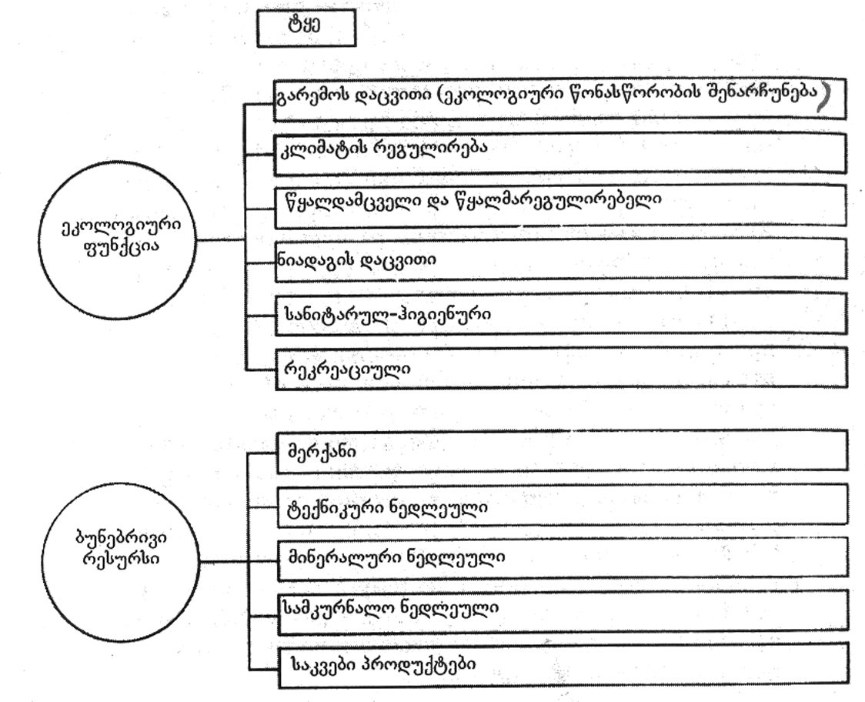
nax. 37. tyis mniSvneloba bunebaSi da adamianis cxovrebaSi

tyis mniSvneloba marto pirdapiri sargeblobiT ar amoiwureba. igi Semkulia uamravi sasargeblo TvisebiT, riTac zemoqmedebas axdens landSaftis sxva tipebze. tyeebi xels uSlian mTebSi Rvarcofebis warmoqmnas, amcireben da asusteben wyaldidobebs, niadagis gamorecxvas, aneleben qaris siCqaresa da niadagis gamofitvas, aCereben qviSis moZraobas, uzrunvelyofen mecxoveleobis ganviTarebas.
tye dedamiwis tansacmelia, romelic niadagis nayofierebas ganapirobebs. igi xels uwyobs atmosferoSi naleqebis niadagSi CaJonvas, gruntis wylebis Sevsebas, mdinareTa auzebSi hidrologiuri reJimis regulirebis, tenis aorTqlebis Semcirebas.
tye adamianis cxovrebis normalur higienur pirobebs qmnis, akmayofilebs mis esTetikur moTxovnilebebs, uzrunvelyofs cxovelTa kvebas da yofas. tye nairgvari xil-kenkris, sakvebi resursebis, nadir-frinvelis xorcis, bewveulis miRebis wyaroa, mefutkreobis ganviTarebis safuZvelia.
tyis mniSvneloba WeSmaritad usazRvroa. samwuxarod, misi sikeTiT Cven xSirad marTebulad ver vsargeblobT, gadametebuli momxmarebluri midgomiT udides zians vayenebT mas.
saTibebisa da mdeloebis mcenareTa saxeobebi mravalferovania. pirutyvis sakveabd maT udidesi roli eniWebaT, radgan mdidaria vitaminebiT, mikroelementebiTa da mineraluri marilebiT. mdelos balaxTa Soris mravali neqtarosani da samkurnalo saxeobebia. maTi nawili dekoratiuli mizniTac gamoiyeneba.
garda mwvane fotosinTezirebadi mcenareebisa, bunebaSi gvxvdeba srul sibneleSi arsebuli mcenareebi, mag. sokoebi. isini izrdebian sxva mcenareebis mier sinTezirebuli organuli naerTebiT _ es paraziti mcenareebia. maT ar sWirdebaT qlorofili, amitom ufro mravalferovani Seferiloba aqvT _ yviTeli, TeTri, wiTeli, vardisferi, bordo da a.S.
flora miekuTvneba gamolevad, magram aRdgenad resursTa ricxvs. miuxedavad amisa, araracionaluri moxmarebis gamo, mravali saxeobis Sesaxeb mxolod informaciaRa SemogvrCa.
mcenareuli safaris ganadgureba xdeba rogorc bunebrivi mizeziT: stiqiuri movlenebiT – miwisZvrebiT, wyaldidobebiT, bunebrivi xanZrebiT, aseve sxvadasxva daavadebebiTa da mavneblebiT dazianebis gamo. ZiriTadi mizezi mainc anTropogenuri faqtorebia – garemos obieqtebis (atmosferos, hidrosferos, niadagis) gabinZureba sawarmoo narCenebiT, rac garkveul gavlenas axdens mcenareul safarze, aseve infrastruqturis ganviTareba gzebis, sawarmoebis, dasaxlebebis mSenebloba.
mcenareTa zogierTi saxeobis SenarCunebas didad Seuwyo xeli gaerTianebuli erebis ganaTlebis, mecnierebisa da kulturis sakiTxebis organizaciis UNESCO-s mier 1946 wels SemoRebulma `wiTelma wignma~. es wigni Sedgeba wiTeli, yviTeli da mwvane furclebisagan. gadaSenebis pirad myofi mcenareebi da cxovelebi Setanilia wiTel furclebze, iSviaTi – yviTel furclebze, aRdgenilebi ki _ mwvane furclebze.
rogorc veluri, aseve kulturuli mcenareebis daavadebebisa da mavneblebis winaaRmdeg brZolis sxvadasxva xerxi arsebobs, romlebic sam kategoriad SeiZleba daiyos: meqanikur, biologiur da qimiur meTodebad. meqanikuri gulisxmobs daavadebuli mcenareebis da mavneblebis ganadgurebas. biologiuri _ mavneblebis mteri saxeobebis gamoyenebas, mag., kodalebis da sxv. qimiuri meTodi ki iTvaliswinebs sxvadasxva Sxamqimikatebis _ pesticidebis gamoyenebas.
soflisa da satyeo meurneobaSi ZiriTadad gamoiyeneba Semdegi pesticidebi: inseqticidebi _ mavne mwerebTan brZolisaTvis; herbicidebi _ sarevelebTan brZolisaTvis; fungicidebi _ sokovani daavadebebis winaaRmdeg.
pesticidebs miakuTvneben aseve repelentebs – mwerebis, mRrRnelebis da sxva cxovelebis dasafrTxobad, agreTve mosazidad gamoyenebul atraqtantebsa da mwerebis sterilantebs.
pesticidebs garkveuli moTxovnebi waeyeneba _ isini uvnebeli unda iyos adamianisaTvis, sxva cocxali organizmebisaTvis, unda wamlavdes mxolod mavne organizms.
sinTezur pesticidebs garkveuli nakli aqvT: a)maTi SerCeviToba ar aris maRali xarisxis, SeiZleba daazianos mwerebis sasargeblo saxeobebic; b)mavneblebs maT mimarT ramdenime TaobaSi imuniteti gamoumuSavdebaT da saWiro xdeba sxva pesticidis Seqmna; g)xdeba garemoSi maTi dagroveba, radgan maTi gadamamuSavebeli baqteriebi bunebaSi ar arsebobs.
yovelive zemoTqmulidan gamomdinare, izrdeba interesi bunebrivi Sxamqimikatebis – peritrinebis mimarT. maT Seicavs gvirila, anwli, niori da a.S. peritrinebs aqvT mTeli rigi upiratesobebi sinTezur SxamqimikatebTan SedarebiT: mavneblebs maT mimarT Semguebloba ar gaaCniaT, garemosTvis uvnebelia da maTi dagroveba ar xdeba – advilad erTvebian bunebriv wrebrunvaSi.
garkveuli teritoriebis mavneblebisagan dasacavad iyeneben agreTve usafrTxo saSualebebs – repelentebs. mag., cnoblia, rom Ramurebi gamoscemen ultrabgerebs, romelTac gaurbian mwerebi, Sesabamisad, SeiZleba amis imitireba.
gamoyenebuli Sxamqimikatebis raodenobis Sesamcireblad SesaZlebelia mwerebis, zogadad mavneblebis mozidva da mcire teritoriaze Sxamqimikatis naklebi raodenobis gamoyeneba. mag., sxvadasxva mwerebi yvavilebis surnels etanebian, amitom maTTan sabrZolvelad SesaZlebelia analogiuri atraqtantebis gamoyeneba.
mavneblebis gamravlebis unaris Sesamcireblad iyeneben sxvadasxva sterilantebs.
garemos erT-erTi mniSvnelovani komponentia fauna _ cxovelTa samyaro. igi adamianisTvis aucilebeli cilebiT mdidari sakvebi elementia, gamwevi Zala, sarewi resursia (bewvi, Zvlebi), samkurnalo preparatebis miRebis wyaroa, biologebis dakvirvebis obieqti da medicinis ganviTarebisaTvis fasdaudebeli elementia. cxovelTa samyaros udidesi esTetikuri mniSvnelobad eniWeba rogorc bunebriv pirobebSi, aseve sacxovrebel pirobebSic (akvariumis Tevzebi, sxvadasxva Citi, Sinauri cxovelebi da a.S.).
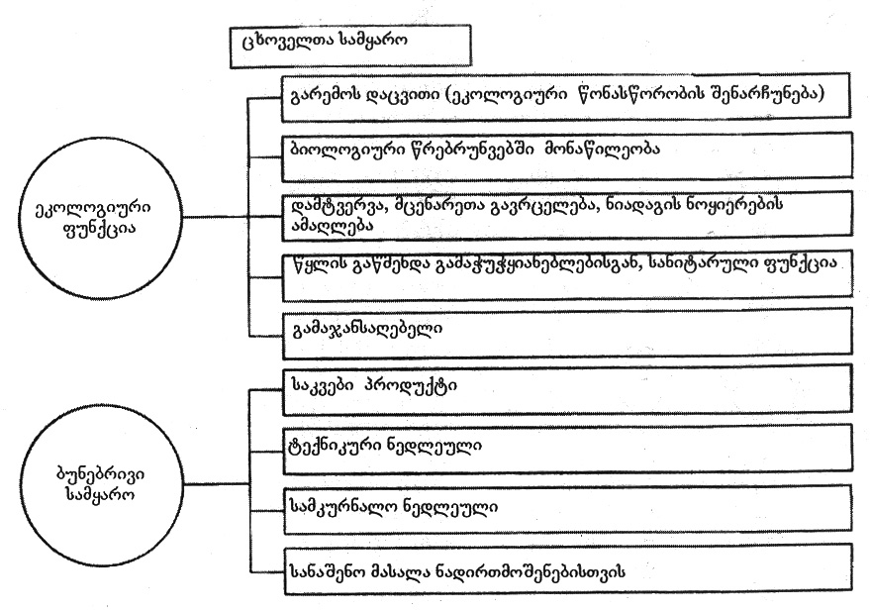
nax. 38 cxovelTa roli bunebaSi da adamianis cxovrebaSi

cxovelebi monawileobas Rebuloben nivTierebaTa biologiur da agreTve planetis nivTierebaTa mimoqcevaSi, mTeli rigi nivTierebebis bioqimiur gardaqmnaSi, landSaftis formirebaSi, niadagisa da gamofituli qanebis warmoqmnaSi, mineralizaciisa da sinTezis procesebSi.
niadagSi didi raodenobiT mcxovrebi wvrili Wiebi, tkipebi, WianWvelebi, xoWoebi da sxva organizmebi afxviereben niadags, aumjobeseben aeracias da tenis SeRwevadobas, amdidreben organuli nivTierebebiT, zrdian miwis nayofierebas.
cxovelebis monawileobiT yalibdeba miwisqveSa da gruntis wylis qimiuri Sedgeniloba, warmoiqmneba gansakuTrebuli miwisqveSa atmosfero.
faunis warmomadgenlebi did gavlenas axdenen mcenareTa zrda-ganviTarebaze, kerZod, mcenareTa damtvervaze (mwerebi, zogierTi frinvelebi), Teslis gadatanaze (frinvelebi, ZuZumwovrebi).
cxovelTa samyaros safrTxe emuqreba rogorc bunebaSi mimdinare procesebiT _ stiqiuri movlenebiT, aseve anTropogenuri faqtorebiT. swored, adamianis mier maTi araracionaluri gamoyeneba iseve, rogorc floris SemTxvevaSi, gaxda mravali saxeobis gadaSenebis mizezi.
adamianis zemoqmedeba cxovelebze xorcieldeba ori gziT: pirdapiri _ uSualo devniT da ganadgurebiT da arapirdapiri – maTi cxovrebis pirobebis, saarsebo garemos SecvliT.
pirdapir zemoqmedebas ganicdian ZiriTadad samrewvelo cxovelebi, romlebic didi raodenobiT iZlevian xorcs, bewvs, cxims da a.S. pirdapir zemoqmedebas miekuTvneba, agreTve, cxovelTa aklimatizacia – maTi gadasaxleba axal teritoriaze, sadac isini xSirad iqcevian mavneblebad, daavadebis gamavrceleblebad, aseve adgilobrivi saxeobebis konkurentebad.
pirdapiri zemoqmedebis saxea soflis meurneobaSi gamoyenebuli sxvadasxva SxamqimikatebiT mavneblebTan erTad sasargeblo saxeobebis daRupvac.
cxovelebze adamianis arapirdapiri gavlena gulisxmobs maTi saarsebo garemos Secvlas _ tyis gaCexvas, velis gadaxvnas, Waobis amoSrobas, wyalsatevebisa da kaSxlebis agebas, gzebis, soflebisa da qalaqebis mSeneblobas, atmosferos, wylisa da niadagis gaWuWyianebas da sxv.
iseve, rogorc mcenareebis SemTxvevaSi, cxovelTa samyaros sxvadasxva saxeobebis SenarCunebaSi didi roli iTamaSa e.w. `wiTelma wignma~.
cxovelTa daavadebisa da mavneblebis winaaRmdeg brZolisaTvis igive meTodebi gamoiyeneba, rac mcenareebis SemTxvevaSi _ meqanikuri, biologiuri da qimiuri.
cxovelebi gamolevadi, Tumca aRdgenadi resursia, rasac maTi gamravlebis unari ganapirobebs. bunebaSi daculia raodenobrivi regulirebis meqanizmi _ kvebis jaWviT dakavSirebuli saxeobebi aregulireben am process. mtacebeli cxovelebi erTgvari sanitrebis rols asruleben bunebaSi, radgan daavadebuli da davrdomili individebi xdebian ZiriTadad maTi msxverpli.
mecxoveleobaSi gamoyenebuli pesticidebi daniSnulebis mixedviT ramdenime jgufad iyofa:
1. akaricidebi _ tkipebTan brZolisaTvis;
2. baqtericidebi – baqteriebis winaaRmdeg;
3. zoocidebi _ mavne xerxemlianebis, ZiriTadad mRrRnelebis winaaRmdeg;
4. nematocidebi _ mrgvali Wiebis winaaRmdeg;
5. inseqticidebi – mavne mwerebis winaaRmdeg.

Ll i t e r a t u r a

1. v. erisTavi, a. danelia, r. alasania, l. arxipova.
garemos gaWuWyianebis wyaroebi da maTi likvidaciis teqnikuri
RonisZiebebi. damxmare saxelmZRvanelo, Tbilisi, 1985. gv. 223.
2. n. CxubianiSvili, g. mWedliSvili, m. demetraZe. ekologia da
garemos dacva. damxmare saxelmZRvanelo, Tbilisi, 2008. gv. 85.
3. n. mumlaZe, m. demetraZe. bunebrivi resursebi da energetikis
ekologiuri aspeqtebi. damxmare saxelmZRvanelo, Tbilisi, 2009. gv. 90.
4. b. beritaSvili. klimaturi cvlileba da misi gamomwvevi
anTropogenuri faqtorebi. saxelmZRvanelo, Tbilisi, stu 2011. gv. 180.
5. b. beritaSvili, d. erisTavi, m. gugeSiZe. garemos monitoringis
safuZvlebi, saxelmZRvanelo, Tbilisi, stu 2013. gv. 166.
6. m. gordeziani, g. kvesitaZe. ekologiis qimiuri safuZvlebi.
saxelmZRvanelo, Tbilisi 2002. gv. 234.
7. Новиков Ю.В. Экология, окружающая среда и человек. Москва, 2005. 720 с.

