Trophy Policy
- Students who did not receive a trophy but performed at the Annual Spring Class Recital receive a medal and certificate for piano achievement.

- Each student who receives a trophy will also receive a certificate for piano achievement.

Annual Trophy
All criteria must be met in order to be eligible

Vivo Música
Eligibility:

- Must have performed in both of the yearly class recitals (December and May)
- For students of Cy-fair Music and Arts: must have performed at annual School Spring Recital (April)
- Must have taken and received at least a 90 percent on one of the following: Music Theory Test and World of Music through Texas Music Teacher Association
- Must be a student in my class for a minimum of 8 months

Bravo
Eligibility:

- Must have performed in both of the yearly class recitals (December and May) and have delivered the desired or expected results achieved in class.
- For students of Cy-fair Music and Arts: must have performed at annual School Spring Recital (April)
- Must have taken and received a minimum of 90 percent on at least one of the following: Music Theory Test and World of Music through Texas Music Teacher Association
- Student almost always completes all homework given throughout the year
- Must be a student in my class for a minimum of 8 months

Star Musician
Eligibility:

- Must have performed in both of the yearly class recitals (December and May) and have delivered the desired or expected results achieved in class.
- For students of Cy-fair Music and Arts: must have performed at annual School Spring Recital (April)
- Must have taken and received a minimum of 90 percent on at least one of the following: Music Theory Test and World of Music through Texas Music Association
- Student almost always completes all homework given throughout the year
- Must have participated in either the Spring or Fall Music Festivals, Benefit Concert, or Piano Contest at least once throughout the year
- Must be a student in my class for a minimum of 8 months
If you are interested in having your child participate in either the Fall or Spring Music Festival, Benefit Concert, or Piano Contest please contact me directly after the May or December class recital.
Four Year Achievement in Piano

All criteria must be met in order to be eligible

Vivo Música
Eligibility:

- Must have performed on all class recitals throughout the four-year term
- Must have participated and received a minimum of 90 percent on at least one of the following: Music Theory Test and World of Music through Texas Music Association every year or must have participated in either the Spring or Fall Music Festivals, Benefit Concert, or Piano Contest.
- Must be a student in my class for all four years

Bravo
Eligibility:

- Must have performed on all class recitals throughout the four-year term
- Must have taken and received a minimum of 90 percent on at least one of the following: Music Theory Test and World of Music through Texas Music Association every year
- Must have participated in either the Spring or Fall Music Festivals, Benefit Concert, or Piano Contest at least once throughout the four-year term
- Must be a student in my class for all four years

Star Musician
Eligibility:

- Must have performed on all class recitals throughout the four-year term and have delivered the desired or expected results achieved in class
- Must have taken and received a minimum of 90 percent on at least one of the following: Music Theory Test and World of Music through Texas Music Association every year
- Must have participated in either the Spring or Fall Music Festivals, Benefit Concert, or Piano Contest a minimum of three times in the past two years
- Must be a student in my class for all four years

Next Achievement in Piano Trophies follow every two years:
Six Year/Eight Year/ Ten Year/ Twelve Year/ etc.
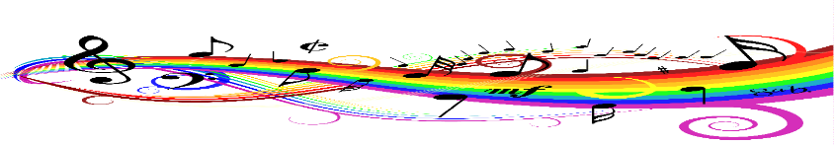
This Photo by Unknown Author is licensed under CC BY

