- How do you feel when you want to eat?
- Where can you eat?
- What food do you like to order when you eat out?
- Imagine you are in a restaurant in New York. How do say these sentences?
- אפשר לאכול כאן?
- אני רוצה בבקשה חביתת עין וסלט עם עגבניות, מלפפונים, חסה ובלי בצל.
- סטייק מבשר (תרנגול) הודו ומיץ תפוזים.
- אני רוצה טוסט עם זיתים.
- אני רוצה צנימים עם חמאה וריבה.
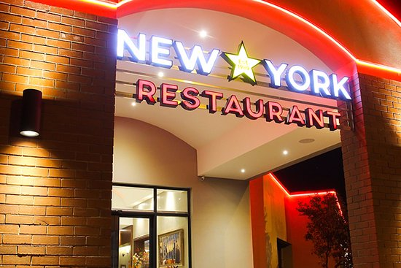

- It wasn't easy, was it?
Now you are going to watch "Israeli at a New York Restaurant" on YouTube https://www.youtube.com/watch?v=FpVl2aL_9Sg

- To travel because English is widely spoken in the world.

- To order in a restaurant when we are abroad..
- To meet new people.
- To know English is useful to chat and surf the net.

- To understand the instructions to tech manuals and devices.

- To get a better job.

- To understand books and magazines.

- To get the meaning of lyrics in English songs.

- To understand TV shows.

- To understand a new culture, customs and traditions.

