WhatsApp Manual

HOW TO INSTALL WHATSAPP:
IPHONE USER:
Step 1: Download and Install WhatsApp
On your iOS device, enter the App Store and search for "WhatsApp." Tap "Get," then "Install" next to the app WhatsApp Messenger by WhatsApp Inc
After WhatsApp finishes downloading, tap "Open" to launch the app.
Step 2: Register and Verify your Phone Number
Tap "Continue," then tap "Allow" for each if you wish to grant these permissions.
WhatsApp will next request access to send you notifications. Tap "OK" to be notified when you receive new messages
First, you'll have to accept the WhatsApp Terms of Service and Privacy Policy.
Tap "Agree & Continue."
Enter your mobile phone number and tap "Done."
Click "Yes." In order to confirm your phone number, you will be sent an SMS text with a six-digit code.
Android User:
Step 1: Download and Install WhatsApp
On your Android, enter the Playstore and search for "WhatsApp." Tap "Install," with the app WhatsApp Messenger by WhatsApp Inc
Step 2: Register and Verify your Phone Number
Open WhatsApp.
Tap Agree and Continue at the bottom of the screen.
Tap Continue on the pop-up.
Tap Allow on both boxes to grant WhatsApp access to your files and contacts.
Enter your phone number. Tap OK to confirm the number you entered.
Enter the verification code that's texted to you. Tap Next.
With all that done, you're now officially signed up for WhatsApp and ready to start using it!

HOW TO ADD A CONTACT:
Step 1: Tap the green chat circle at the bottom-right of the screen.
Step 2:Tap New contact.
Step 3:Enter your contact's info
4
Step 4: and then tap the blue checkmark at the top right when you're done.
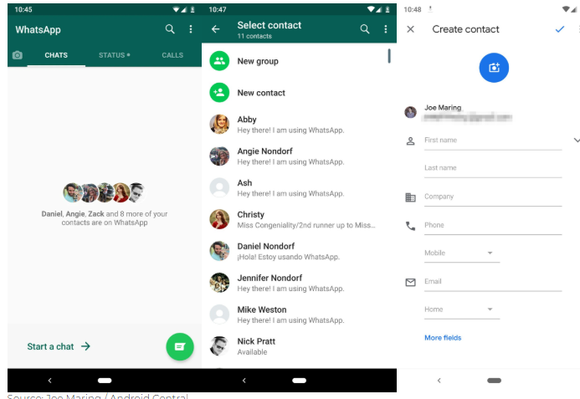
3
2
1

HOW TO SEND A MESSAGE:
Step 1: Tap the green chat circle at the bottom-right of the screen.
Step 2: Search for the name of the person you want to send a message. Click that contact.
Step 3: Type a message
Step 4: Click the arrow icon that appears alongside the text box to send it on the bottom-right of the screen.

HOW TO ADD A FILE OR PICTURE IN THE MESSAGE:
Step 1: Tap the green chat circle at the bottom-right of the screen.
Step 2: Search for the name of the person you want to send a message. Click that contact.
Step 3: Send pictures or files on WhatsApp by tapping the paperclip or camera icons at the bottom of the screen. If you want to add more files, tap on the add file.
Step 4: Click the arrow icon that appears alongside the text box to send it on the bottom-right of the screen.

HOW TO SEND A VOICE MESSAGE:
Step 1: Tap the green chat circle at the bottom-right of the screen.
Step 2: Search for the name of the person you want to send a message. Click that contact.
Step 3: On the bottom side of the screen, you can see a microphone icon. Click that icon, hold to record the voice message you want to relay. Once you release the record it will automatically send.

HOW TO ADD A NEW GROUP:
Step 1: Tap the three dots at the upper-right corner.
Step 2: Tap New group
Step 3: Select the contacts you want to add and then tap the green circle with a check mark.
Step 4: Type the group name
Step 5: Tap the green circle with a check mark.
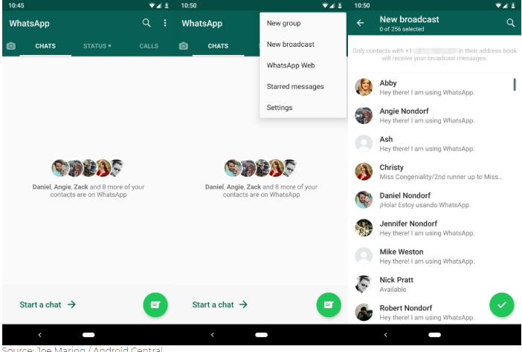
HOW TO CHECK THE DOCUMENTS SENT:
Step 1: Go to a certain contact or group, click it
Step 2: Tap the three dots at the upper-right corner.
Step 3: Tap the Media, links, and docs or if it is a group tap Group Media
Step 4: You can see that there are three tabs – Media, Docs, and Links
Step 5: Click on the file you want to check

HOW TO CALL:
Step 1: Tap a certain contact or group.
Step 2: On the upper-right section you can see two icons. A video camera icon is for video call and A telephone icon is for a regular call.
Step 3: Tap on the icon and call.

HOW TO FORWARD A MESSAGE OR CHAT:
Step 1: Go to certain contact or group
Step 2: Tap and hold the message you want to forward. To forward multiple messages, you can select additional messages after you select the first message.
Step 3: Once you hold the message, the upper screen will show new icons. Click on the upper right arrow icon to forward.
Step 4: Search for or select the individual or group chats you want to forward the messages to.
Step 5: Tap Send.

