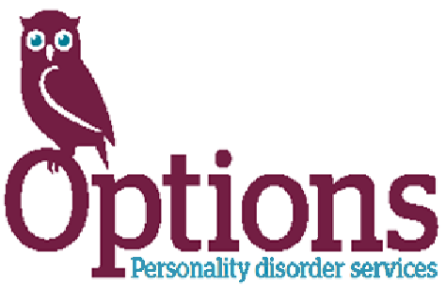
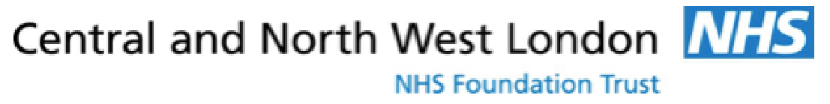

Distraction Pack

The Options and Mental Health Teams at HMP Downview and the PIPE Team at HMP Send have put together this distraction pack to help support you during this difficult time. We hope the activities included will help you to both stay active, relax and distract you. We have also included some psychological techniques that may help with some mental health problems such as anxiety, low mood and emotion regulation.
In this pack, you will find:
Word searches - Find and circle all of the listed words that are in the word search. The words can be hidden in any direction.
Crosswords – Use the clues to find out the words needed to fill in the crossword.
Sudoku’s - Fill in the grid so that each line (both straight and sideways) has all letters from 1-9, and that all boxes also have all numbers from 1-9. Numbers shouldn’t appear more than once in a line or in a box.
Dot to dot – Use your pen or pencil to join up the different dots following the order of the numbers, to reveal the picture.
Hidden object - Try to find all of the parts of the picture that you are asked to (they’ll be quite hard to see). When you find them, colour them in so that you remember where they were.
Colouring – Different pictures for you to colour in.
Yoga – For you to try.
Anagrams – Unscramble the jumbled words to find out what they are trying to say. The theme of the anagrams will give you a clue. Tip: try arranging the different letters in a circle on another part of the page – this way of looking at it can make the anagram easier to solve.
Spot the difference – Try and spot the difference between the two pictures.
Mazes – Find your way out of the maze.

This Weeks’ News

The public must stop meeting in groups in parks, beaches and markets since the pubs, cafes, restaurants and schools have closed.

Chains including McDonald’s, Waterstones, Primark and Patisserie Valerie said they would be closing their shops from Monday (23/03/2020).

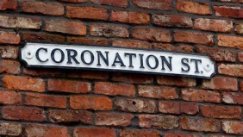
ITV said it would stop filming Coronation Street and Emmerdale as broadcasters continued to adjust to the crisis.

The Queen has moved from Buckingham Palace to Windsor Castle since Thursday, to be in contact with less people.

A Zoo in Chicago decided to close its gates to the public and while the zoo was closed, the staff let the penguins roam free to explore the zoo.
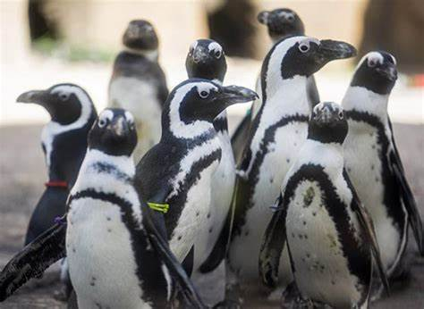

Acts of Kindness

Beauty Banks, a charity that supplies essential toiletries to people in poverty, launched an emergency virus-related appeal on Sunday. "Since just after noon yesterday we've raised £60,000 to pay for soap, hand sanitiser, washing powder and so on to help people who don't have the money to stockpile."

- Ali, from south London, said her two daughters, Scarlet, 10, and Grace, 12, posted handwritten notes to the houses on their road. "They are pretty caring girls," she said. "We live in a really lovely neighbourhood which is full of great community spirit."

- A cafe in Glasgow's Southside is delivering soup to the elderly and people with underlying health issues, while a shop in Stenhousemuir is dropping off packages of hand gel to local pensioners.

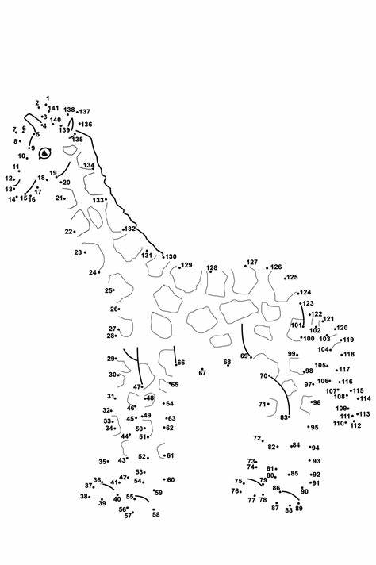

Dot to dot

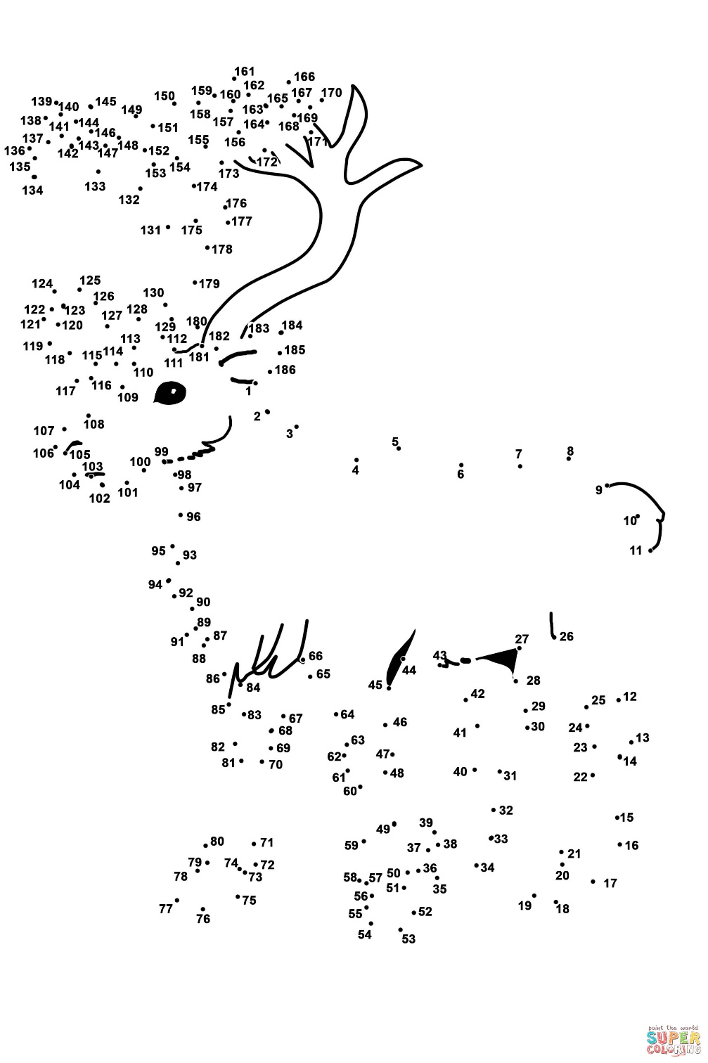

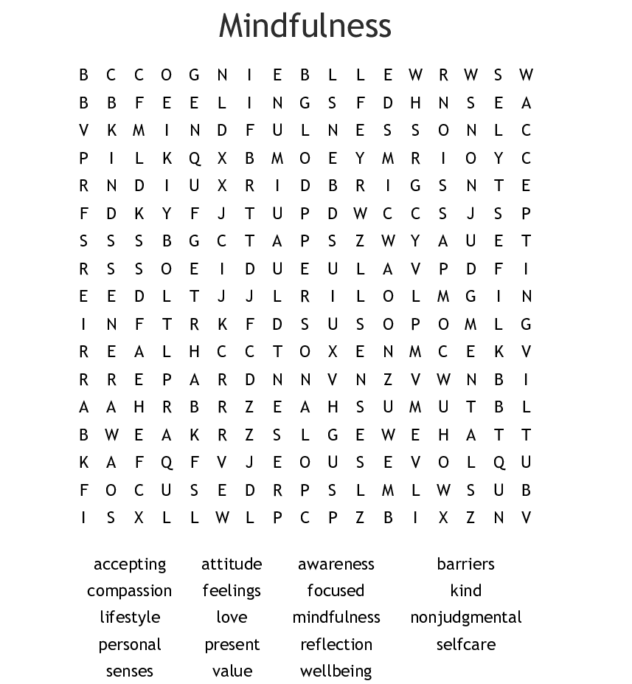

Breathing to relax
Breathing too quickly, and deeply, can make you feel dizzy, faint or even more anxious. Taking slow, regular breaths can help you to control anxious thoughts and feelings, and make you feel calmer.
To control your breathing:
- Place one hand on your chest and the other over your stomach. You want your stomach to move more than your chest as you breathe
- Take a slow, regular breath in (through your nose if you can). Watch your hands as you breathe in. The hand on your stomach should move and your chest should not
- Breathe out slowly through pursed lips

Sudoku
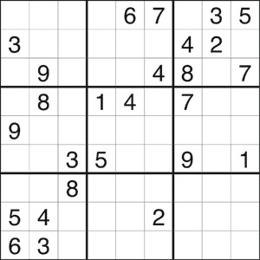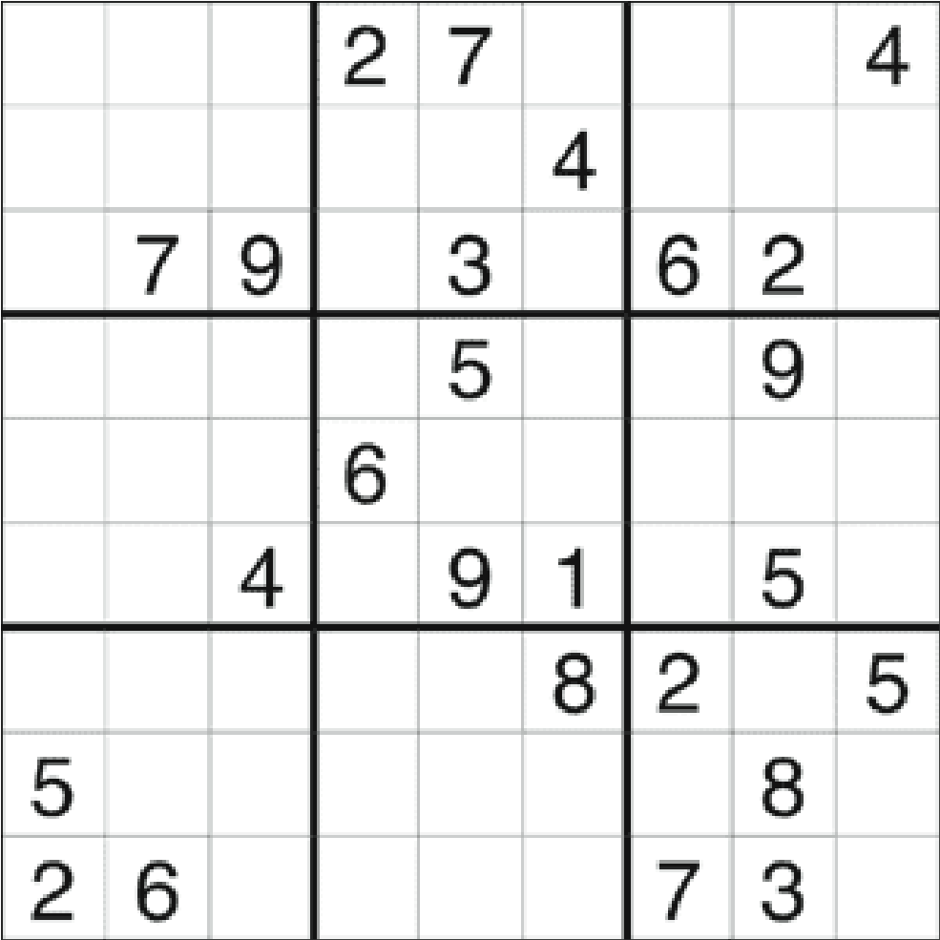
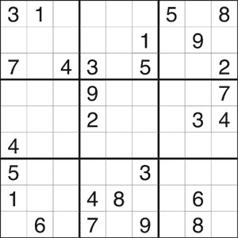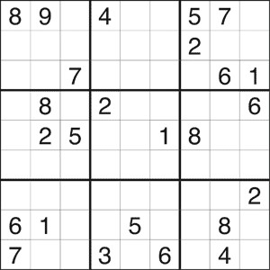
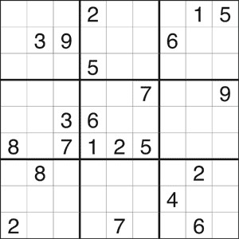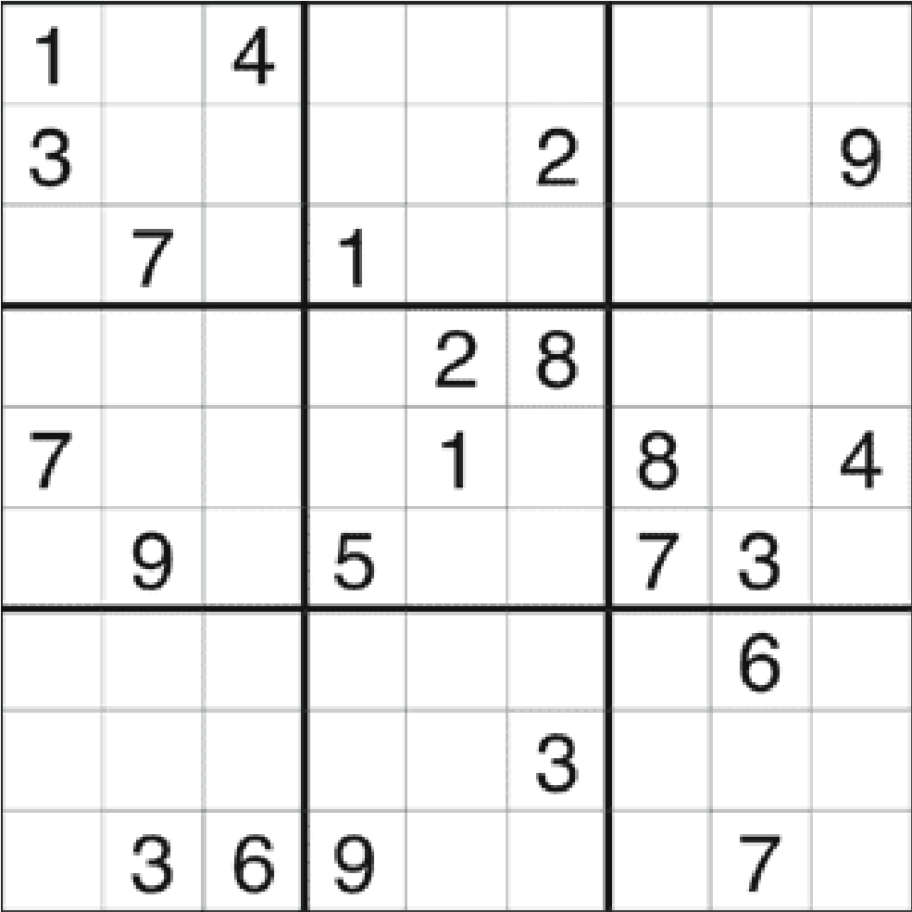

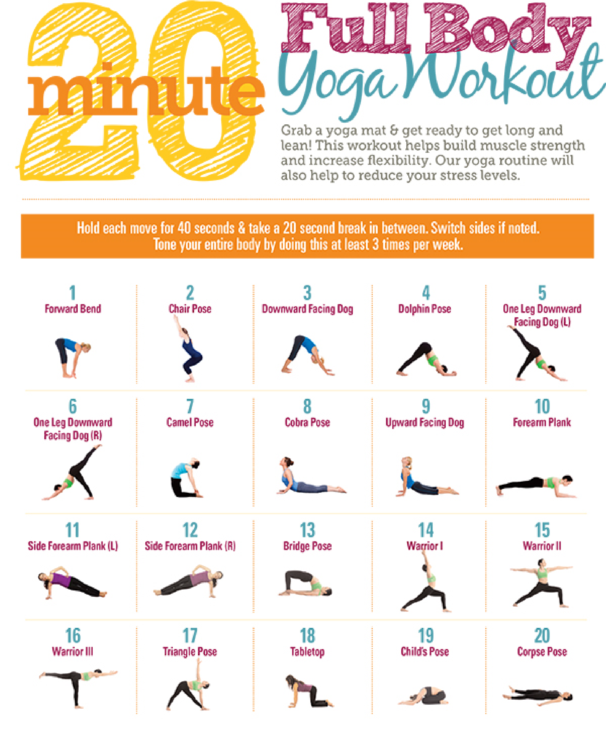

Spot the difference
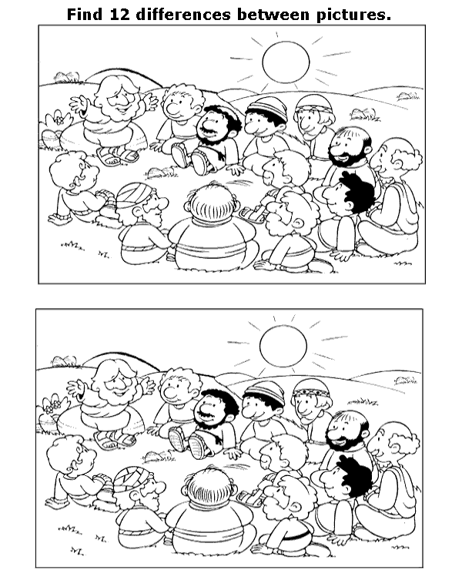

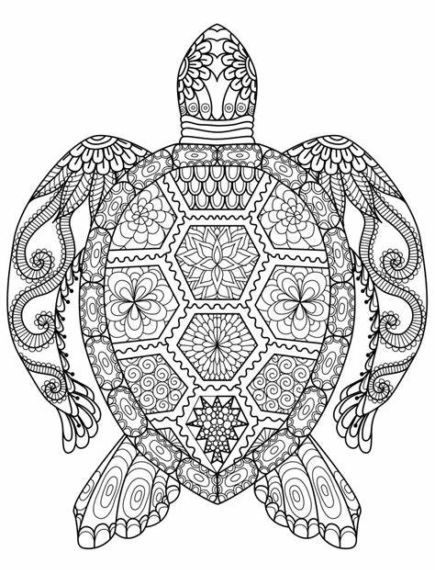
Colouring

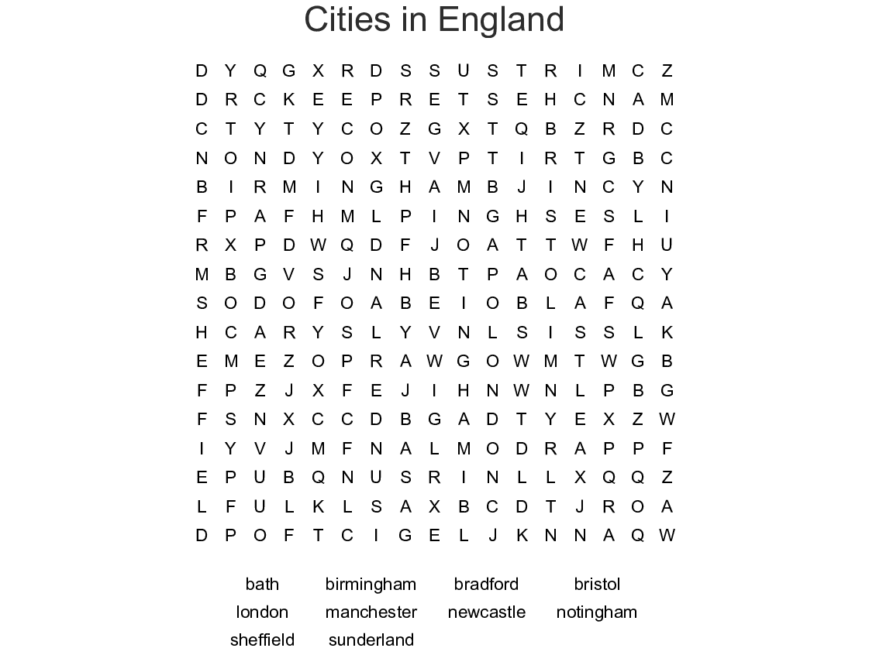

1st Stop

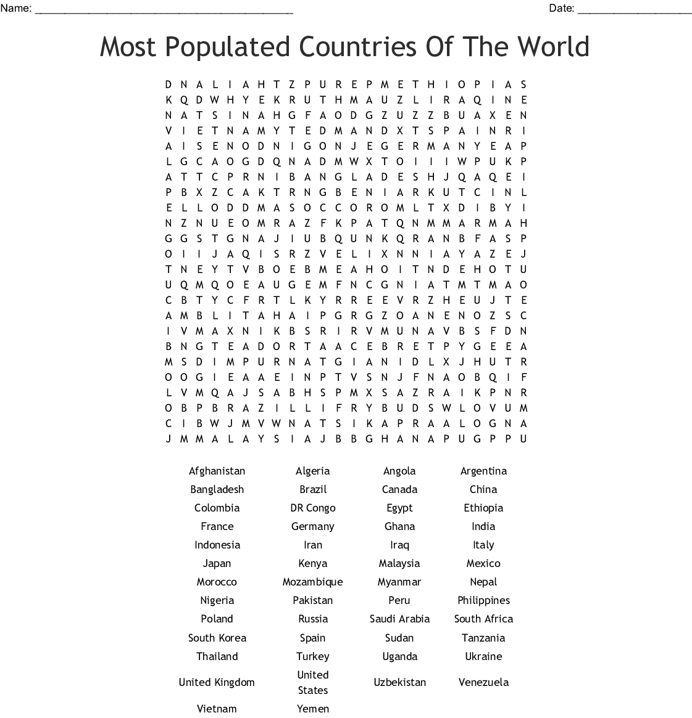

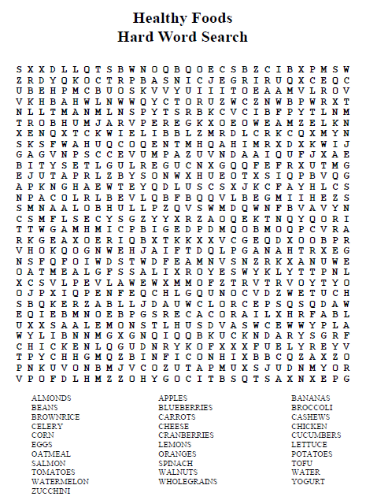

Crossword
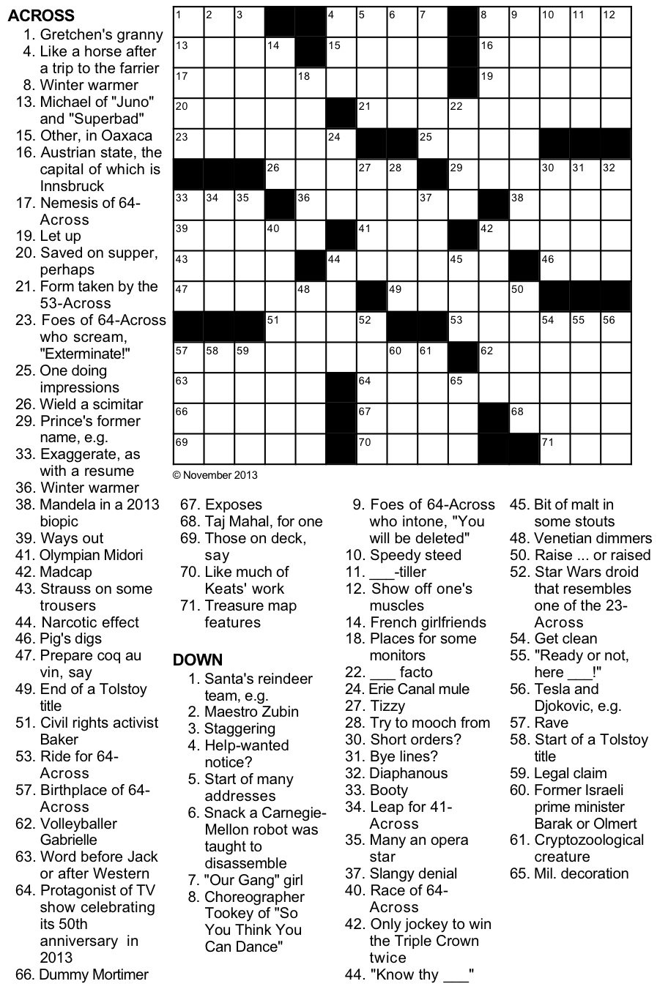

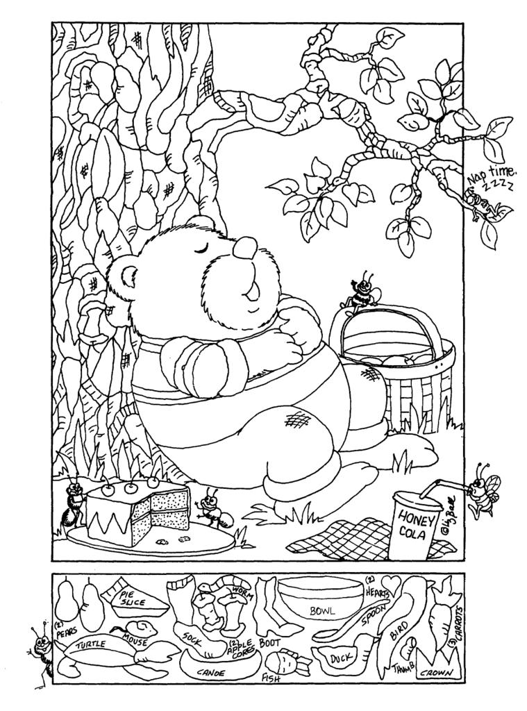
Hidden object

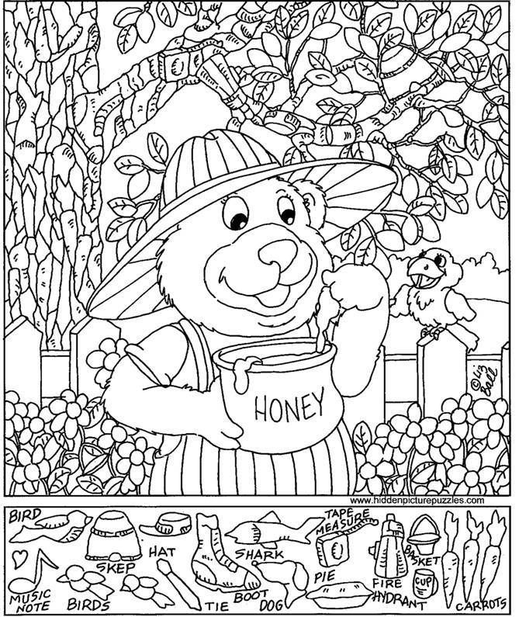

Maze

