|  |
| --- |
| Monday 30th March, 2020 |

|  |
| --- |
| Sandford’s Daily Activity Sheet |

|  |  |  |  |  |
| --- | --- | --- | --- | --- |
| What happened on this day:  [[Image result for london marathon](https://www.google.co.uk/url?sa=i&url=https%3A%2F%2Fwww.runnersworld.com%2Fuk%2Ftraining%2Fmarathon%2Fa29188825%2Flondon-marathon-2020%2F&psig=AOvVaw0rhi2bZ9ULI9y4pdSL3oWi&ust=1585129766999000&source=images&cd=vfe&ved=0CAIQjRxqFwoTCNiYmtrqsugCFQAAAAAdAAAAABAD)](https://www.google.co.uk/url?sa=i&url=https%3A%2F%2Fwww.runnersworld.com%2Fuk%2Ftraining%2Fmarathon%2Fa29188825%2Flondon-marathon-2020%2F&psig=AOvVaw0rhi2bZ9ULI9y4pdSL3oWi&ust=1585129766999000&source=images&cd=vfe&ved=0CAIQjRxqFwoTCNiYmtrqsugCFQAAAAAdAAAAABAD)  30th March 1981: The first London Marathon organised by Chris Brasher is run with 7,590 taking part including a number of celebrities raising money for charity. The London Marathon is now a yearly event attracting 30,000 runners from around the world, including some of the world's greatest athletes and tens of thousands of others who complete the marathon raising many millions for charities along the way and many wearing fancy dress costumes.   |  |  | | --- | --- | | [[Image result for question mark](https://www.google.co.uk/url?sa=i&url=https%3A%2F%2Fwww.reddit.com%2Fr%2Fantimeme%2Fcomments%2Ffc4kec%2Fhey_what_was_the_question_mark%2F&psig=AOvVaw1BVDeF5rMVU_hU_eCWgL7P&ust=1585133526159000&source=images&cd=vfe&ved=0CAIQjRxqFwoTCKCv4Nn4sugCFQAAAAAdAAAAABAO)](https://www.google.co.uk/url?sa=i&url=https%3A%2F%2Fwww.reddit.com%2Fr%2Fantimeme%2Fcomments%2Ffc4kec%2Fhey_what_was_the_question_mark%2F&psig=AOvVaw1BVDeF5rMVU_hU_eCWgL7P&ust=1585133526159000&source=images&cd=vfe&ved=0CAIQjRxqFwoTCKCv4Nn4sugCFQAAAAAdAAAAABAO" \t "_blank) | [Have you ever taken part in a marathon or fun run? If not, did you ever want to?!](https://www.google.co.uk/url?sa=i&url=https%3A%2F%2Fwww.reddit.com%2Fr%2Fantimeme%2Fcomments%2Ffc4kec%2Fhey_what_was_the_question_mark%2F&psig=AOvVaw1BVDeF5rMVU_hU_eCWgL7P&ust=1585133526159000&source=images&cd=vfe&ved=0CAIQjRxqFwoTCKCv4Nn4sugCFQAAAAAdAAAAABAO" \t "_blank) |   [0](https://www.google.co.uk/url?sa=i&url=https%3A%2F%2Fwww.reddit.com%2Fr%2Fantimeme%2Fcomments%2Ffc4kec%2Fhey_what_was_the_question_mark%2F&psig=AOvVaw1BVDeF5rMVU_hU_eCWgL7P&ust=1585133526159000&source=images&cd=vfe&ved=0CAIQjRxqFwoTCKCv4Nn4sugCFQAAAAAdAAAAABAO" \t "_blank)   |  |  | | --- | --- | | [[DYM | Bad Joke of the Day Volume 3 | youth workers helping youth ...](https://www.google.co.uk/url?sa=i&url=https%3A%2F%2Fwww.downloadyouthministry.com%2Fbad-joke-of-the-day-video-vol-3&psig=AOvVaw3KWFpDgNCSnfQ4KEJNDKgW&ust=1585384869493000&source=images&cd=vfe&ved=0CAIQjRxqFwoTCMig6IehuugCFQAAAAAdAAAAABAE)](https://www.google.co.uk/url?sa=i&url=https%3A%2F%2Fwww.downloadyouthministry.com%2Fbad-joke-of-the-day-video-vol-3&psig=AOvVaw3KWFpDgNCSnfQ4KEJNDKgW&ust=1585384869493000&source=images&cd=vfe&ved=0CAIQjRxqFwoTCMig6IehuugCFQAAAAAdAAAAABAE) | Why did the fish blush?  *Because it saw the ocean’s bottom!!* | |

|  |
| --- |
| Do you have a favourite?  Music Top 5 1968   1. Hey Jude – The Beatles 2. I Heard it Through the Grapevine – Marvin Gaye 3. Jumpin’ Jack Flash – Rolling Stones 4. The Dock of the Bay– Ottis Redding 5. Born to be Wild – Steppenwolf   Film Releases 1968 |

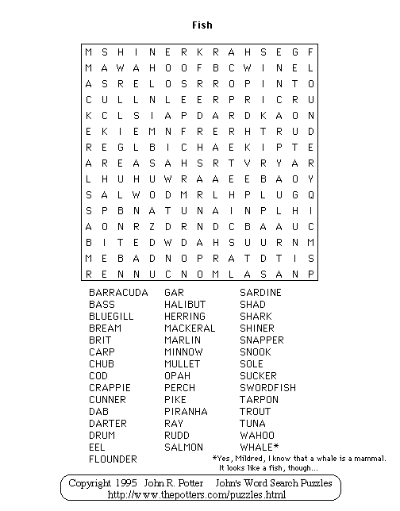

Spot the Difference – 8 to find!

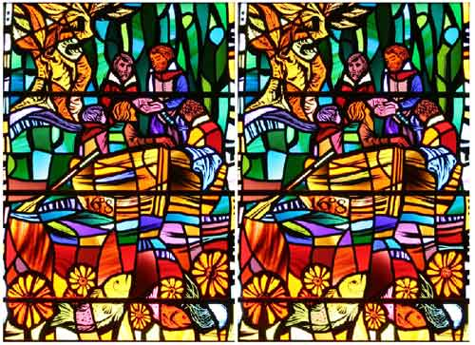

Labyrinth Maze

[](https://www.google.co.uk/url?sa=i&url=https%3A%2F%2Fwww.pinterest.com%2Fpin%2F509469776595096311%2F&psig=AOvVaw1miCd0xuKINdUGjrsSttm7&ust=1585130667895000&source=images&cd=vfe&ved=0CAIQjRxqFwoTCKjdkIbusugCFQAAAAAdAAAAABAJ)

Sudoku

|  |  |
| --- | --- |
| How to complete a sudoku:  1 – Each square is full up of 9 smaller squares.  2 – Each smaller square must have the numbers  1-9 in it.  3 – Each vertical & horizontal line using all 3  squares must have numbers 1-9 in them.  4 – See the completed one here to get an idea of  how it is done! | [Image result for cpompleted easy sudoku](https://www.google.co.uk/url?sa=i&url=https%3A%2F%2Fwww.pinterest.com%2Fpin%2F58969076343311554%2F&psig=AOvVaw19-OxaTQUzprguz7p8IxJs&ust=1585132995221000&source=images&cd=vfe&ved=0CAIQjRxqFwoTCNDWqt32sugCFQAAAAAdAAAAABAD) |

[[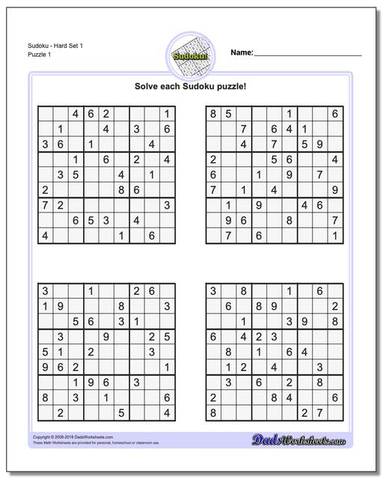](https://www.google.co.uk/url?sa=i&url=https%3A%2F%2Fwww.dadsworksheets.com%2Fpuzzles%2Fsudoku.html&psig=AOvVaw1-18nhHDcG7Gzq-VEaQ70I&ust=1585130777105000&source=images&cd=vfe&ved=0CAIQjRxqFwoTCLDD3bnusugCFQAAAAAdAAAAABAI)](https://www.google.co.uk/url?sa=i&url=https%3A%2F%2Fwww.dadsworksheets.com%2Fpuzzles%2Fsudoku.html&psig=AOvVaw1-18nhHDcG7Gzq-VEaQ70I&ust=1585130777105000&source=images&cd=vfe&ved=0CAIQjRxqFwoTCLDD3bnusugCFQAAAAAdAAAAABAI)