BASIC PAPER AEROPLANE

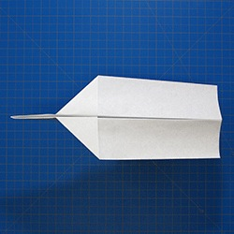

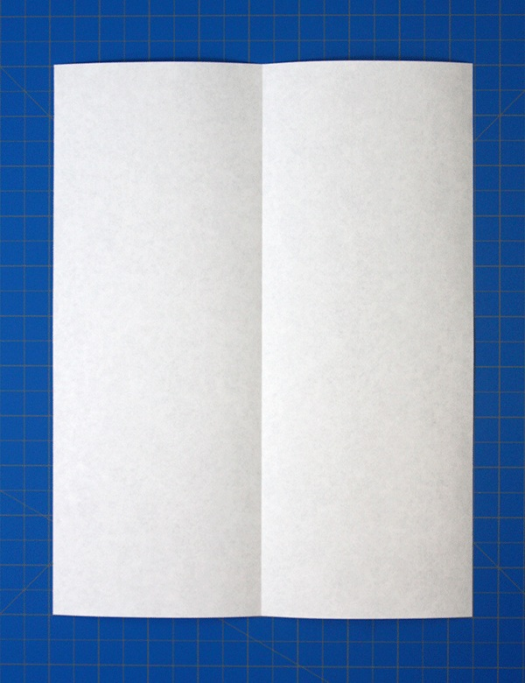

Fold the paper in half

1. 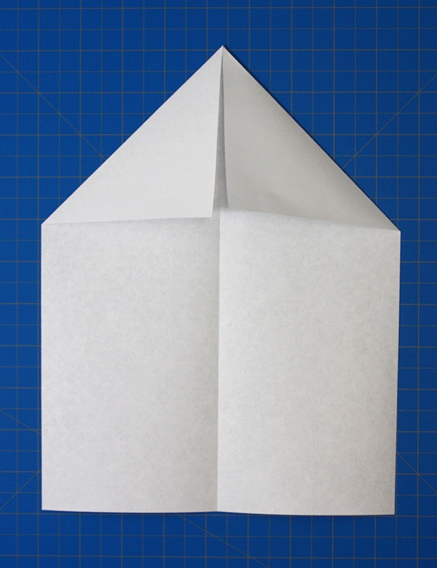

Unfold and then fold the top two corners into the centre line

1. 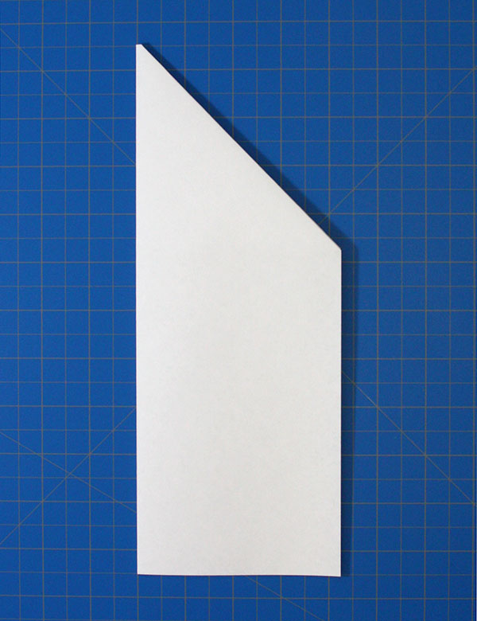

Fold the paper in half again

1. 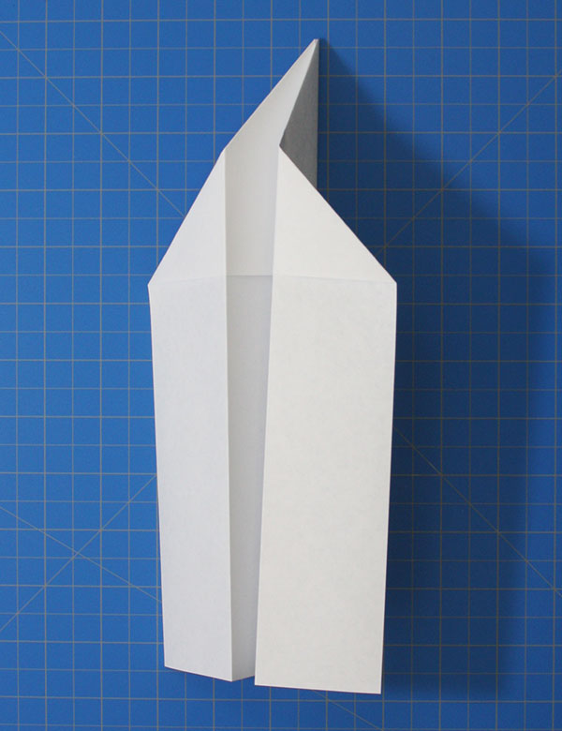

Fold the edges down to meet the bottom of the body