U.S.S Firebird edition 1.1

Newsletter

Ncc-Firebird Away Missions

The Summit Jan 5th
The Crew of Ncc-Firebird has launched its 1st summit and recruiting event in Markham City Hall we were able to get 17 members in total to sing up

The Chief Operation Officer of the NCC- 10533 Uss-firebird had worked with our Markham MP for this even to take place and we were very pleased with the outcome that this summit has done for our shuttle all the attendees learned more about our shuttle and Starfleet as well

Uss-Firebird Away mission

The mission
On the 5th of January the operation officer approached the commanding officer of the Uss-firebird and told him that they needed to create a recruiting event for there new soon to be ship.
So, the uss-firebird embarked on this away mission and was successfully able to get their Crew member prepared for this mission
The Summit was a success since we were able to get new members on board as well |  |  | 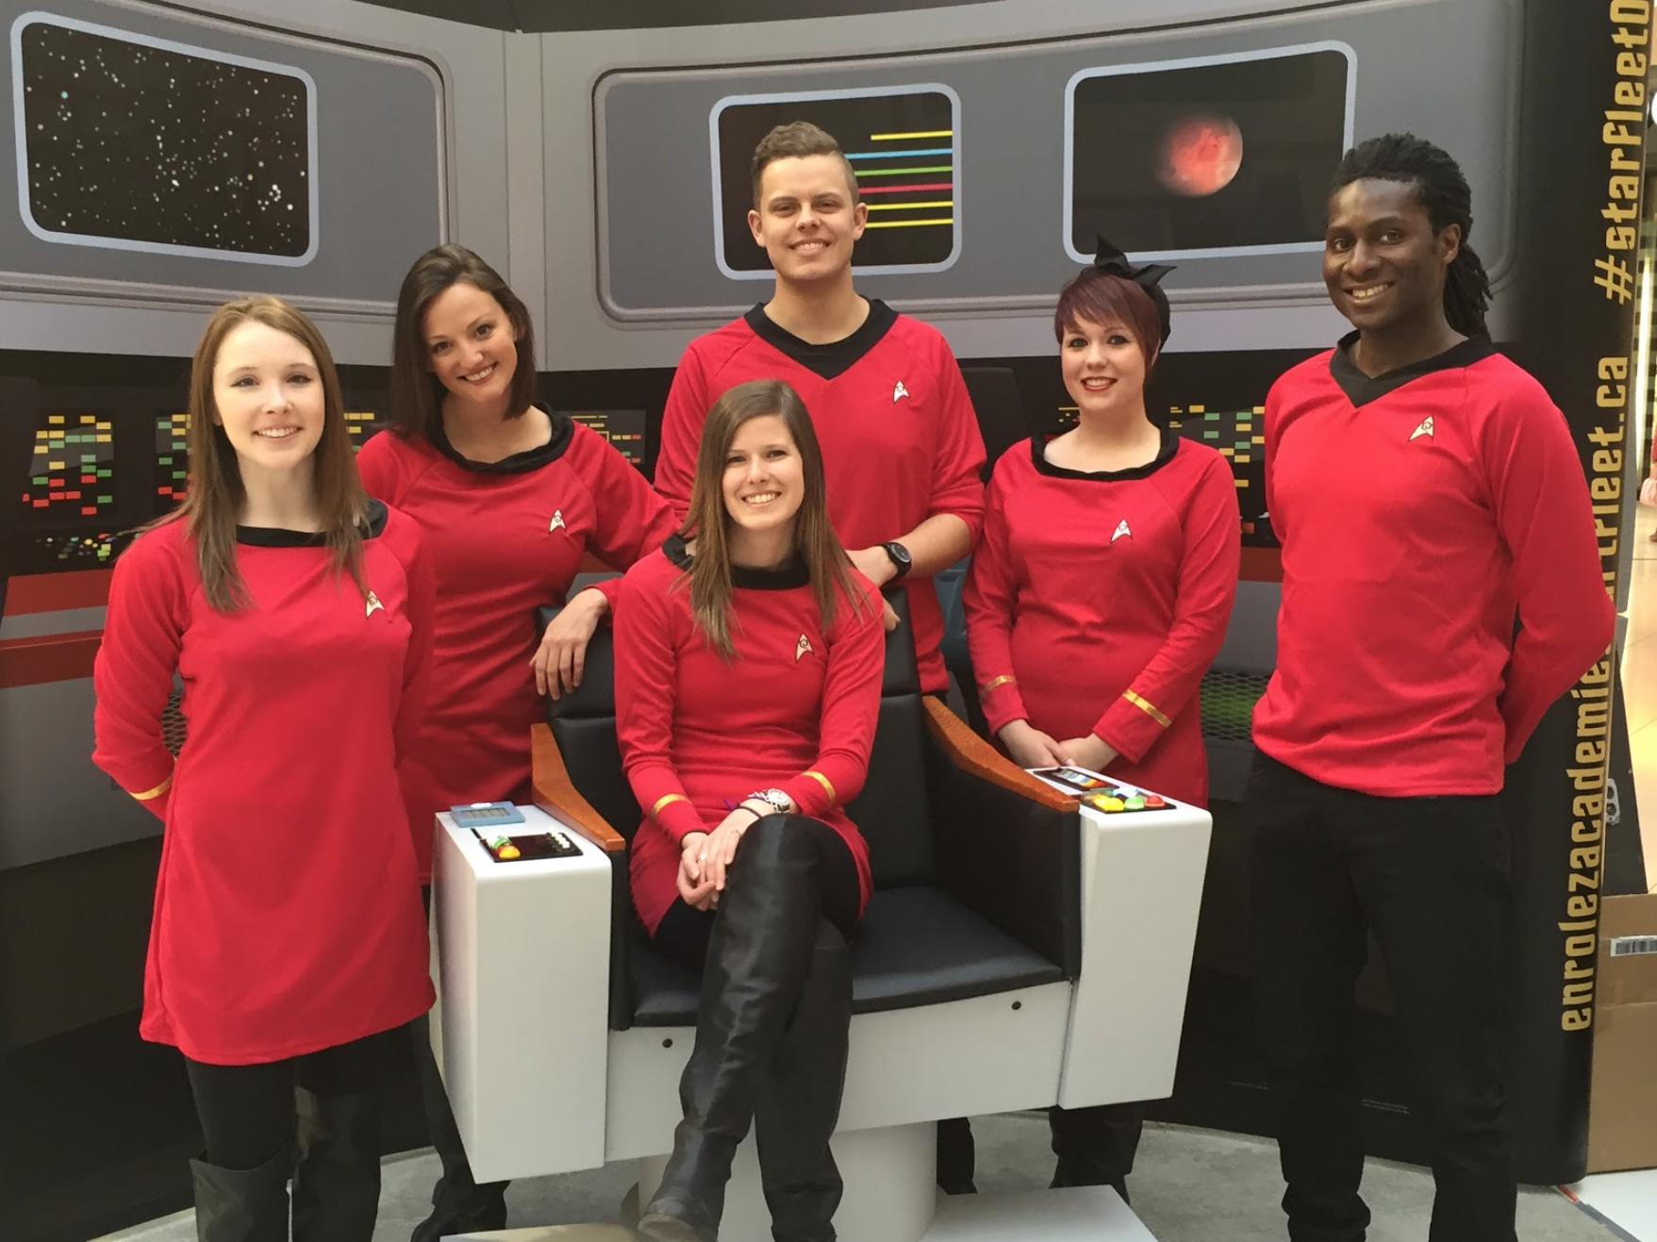

Community Service
On December 25th 2019 we had an event with the salvation army and this event is to help bring small kids there Christmas sprit so the event was also well planned and the Crew member had a lot of fun
