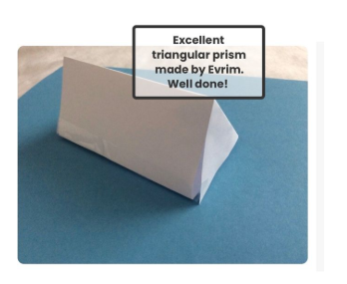
Year 6 took part in a virtual maths lesson today. They learned about nets of 3d shapes. Well done.
Staff and Governors’ Newsletter Issue #1
Friday March 27th, 2020
First of all I would like to thank you for being the amazing, dedicated and supportive group of staff that you are. Thank you also to governors for your continued support. We have been given a challenging task in extraordinary times and I have been so grateful to see the way that you have risen to that challenge, with a degree of willingness that I find quite humbling.
Your hard work and consideration in preparing all those packs in advance of the closure has meant that we have been able to provide a better level of continuity in the education of our pupils at Thomas Walling. Again thank you to the staff that volunteered in that last week before we closed in delivering more than 130 packs to families who were not in school. The welfare support continues!
The vast majority of parents have signed up to Seesaw (99%) and I know that the videos of your teaching, ongoing dialogue and prompt response to queries is much appreciated.
I know that not all staff can view Seesaw, so here are a few comments from parents:

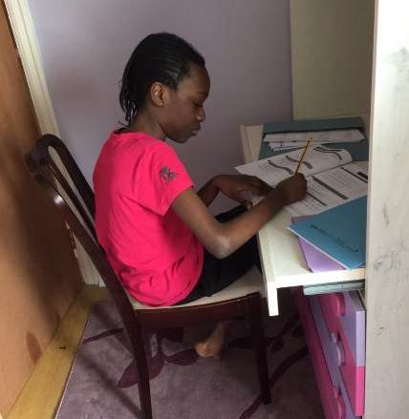
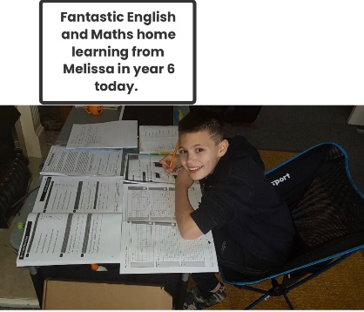

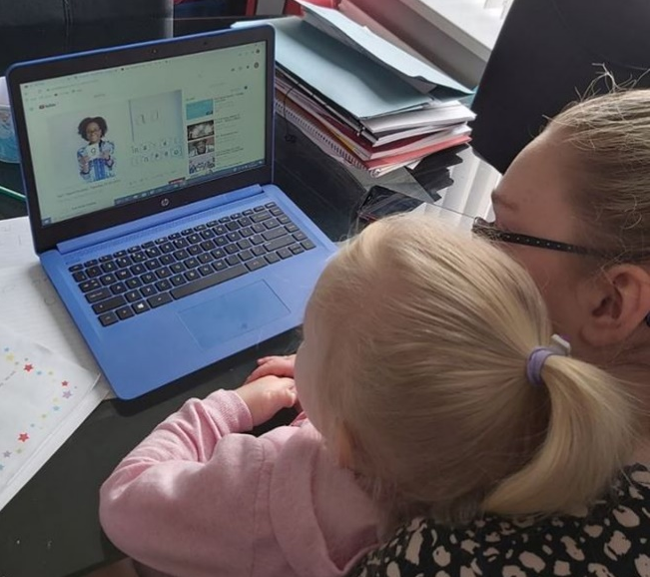
EYFS are also keeping busy with their home learning!

CHECK OUT OUR FACEBOOK PAGE

All going well - thank you for structure!
Just seen your SPAG teaching video-your video is great. Thank you.
Thank you for keeping us updated. She has been doing all of the work sheets and watching the videos every day.
He was so pleased to hear your voice on your video. He has missed you.
I've found the way everything is set out with days and lesson numbers helpful.
You are doing a wonderful job sending us updates and things to do and it’s a lot less stressful knowing you are on the other side of this app to help us. Stay safe and we hope to see you soon.
Vikki Lee (from blog) we're loving seesaw. The contact made from the school has been none stop and we appreciate this. we are going to watch story time after tea :) keep up the amazing work.
I know it is a lot of hard work to keep on top of this daily, working from home, but I wanted you to realise just how much it is appreciated. The senior leadership team are collecting more quotes and will send them around so you can see the impact you are having. Thanks also, to the dedicated staff that came in to teach children in school, and who keep the school running – you can see these activities on face book too!
Rebecca Hann
Keep up the good work, keep safe, keep calm and carry on.

