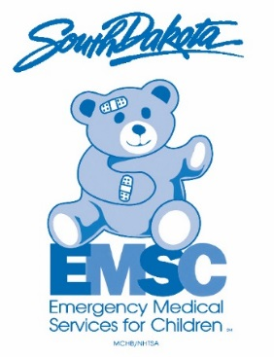
Pediatric Emergency Care Champion (PECC)
* Complete the information below and return to Corolla Lauck by October 30th, 2019.
You may return via e-mail to Corolla.Lauck@usd.edu or by mail to:
SD EMS for Children
Corolla Lauck
1400 West 22nd Street
Route # 5679
Sioux Falls, SD 57105

Agency Name: ________________________________________________________
Street Address: __________________________________PO BOX________________
City: _____ ___________________________________________________
State: _________ Zip Code: _________
Agency Phone Number: _____________________________

Designated PECC: __________________________________________________
PECC Cell Number: __________________________________________________
PECC E-mail Address: __________________________________________________

Agency Director: _________________________________________________
Director e-mail: _________________________________________________

Medical Director _________________________________________________
Signature of Person
Completing Form: _________________________________________________

Date: _____________

