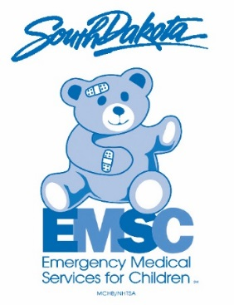
Pediatric Emergency Care Coordinator (PECC)

*Please complete the below information and return to Corolla Lauck by January 15th, 2020.
You may return via e-mail to Corolla.Lauck@usd.edu or by mail to:
SD EMS for Children
Corolla Lauck
1400 West 22nd Street
Route # 5679
Sioux Falls, SD 57105

Hospital Name: ______________________________________________
Street Address: ______________________________________________
City: _____ _________________________________________
State: _________ Zip Code: _________
Hospital Phone Number: _____________________________

Designated PECC: __________________________________________
PECC Cell Number: __________________________________________
PECC E-mail Address: __________________________________________
Printed Name of Person
Completing Form: ________________________Title_______________
Signature of Person
Completing Form: ___________________________________________
Date: _____________

