Cumbria Youth Alliance Training Opportunities
Thanks to Cumbria County Council through the Youth Infrastructure Contract
Are you working/volunteering with young people or supporting young people at home - aged 11 to 19 in Cumbria and having to deal with difficult behaviour - if the answer is yes this course is for you?
Dealing with Difficult and Challenging Behaviour
24th March 2020
Arrive 9.45 for a 10am start and 4pm finish
Delivered for us by CADAS
Venue: CADAS Offices 1 Fisher Street Carlisle CA3 8QT
This one day course will enable workers and volunteers to explore factors behind challenging behaviour and develop relevant strategies for supporting young people.
Learning Outcomes:
- To understand reasons for disruptive behaviour
- To explore factors that escalate conflict
- To recognise the physical signs and behavioural changes that lead to practical aggression
- To identify a range of interventions that de-escalate or help control conflict, aggressive or violent situations
- To focus on best ‘safe-touch’ practice and the legal parameters of using physical force to manage challenging behaviour and discharge your ‘duty of care’

You must complete the attached booking form to secure your place – book today as we anticipate this being fully booked
Cost £20 per person - this is heavily subsidised

There will be tea/coffee and biscuits served but participants should bring their own lunch (this helps us keep the cost of the training down and therefore we can offer more courses.
Please note there is no parking on site but parking is available in a number of pay and display car parks within easy walking distance To secure a place please: Complete the form on page 2 and return it by email to cath@cya.org.uk or by post to Cumbria Youth Alliance, Town Hall Community Hub, Oxford Street, Workington, CA14 2RS.
For enquiries contact Cath: 01900 603131 or download information from www.cya.org.uk
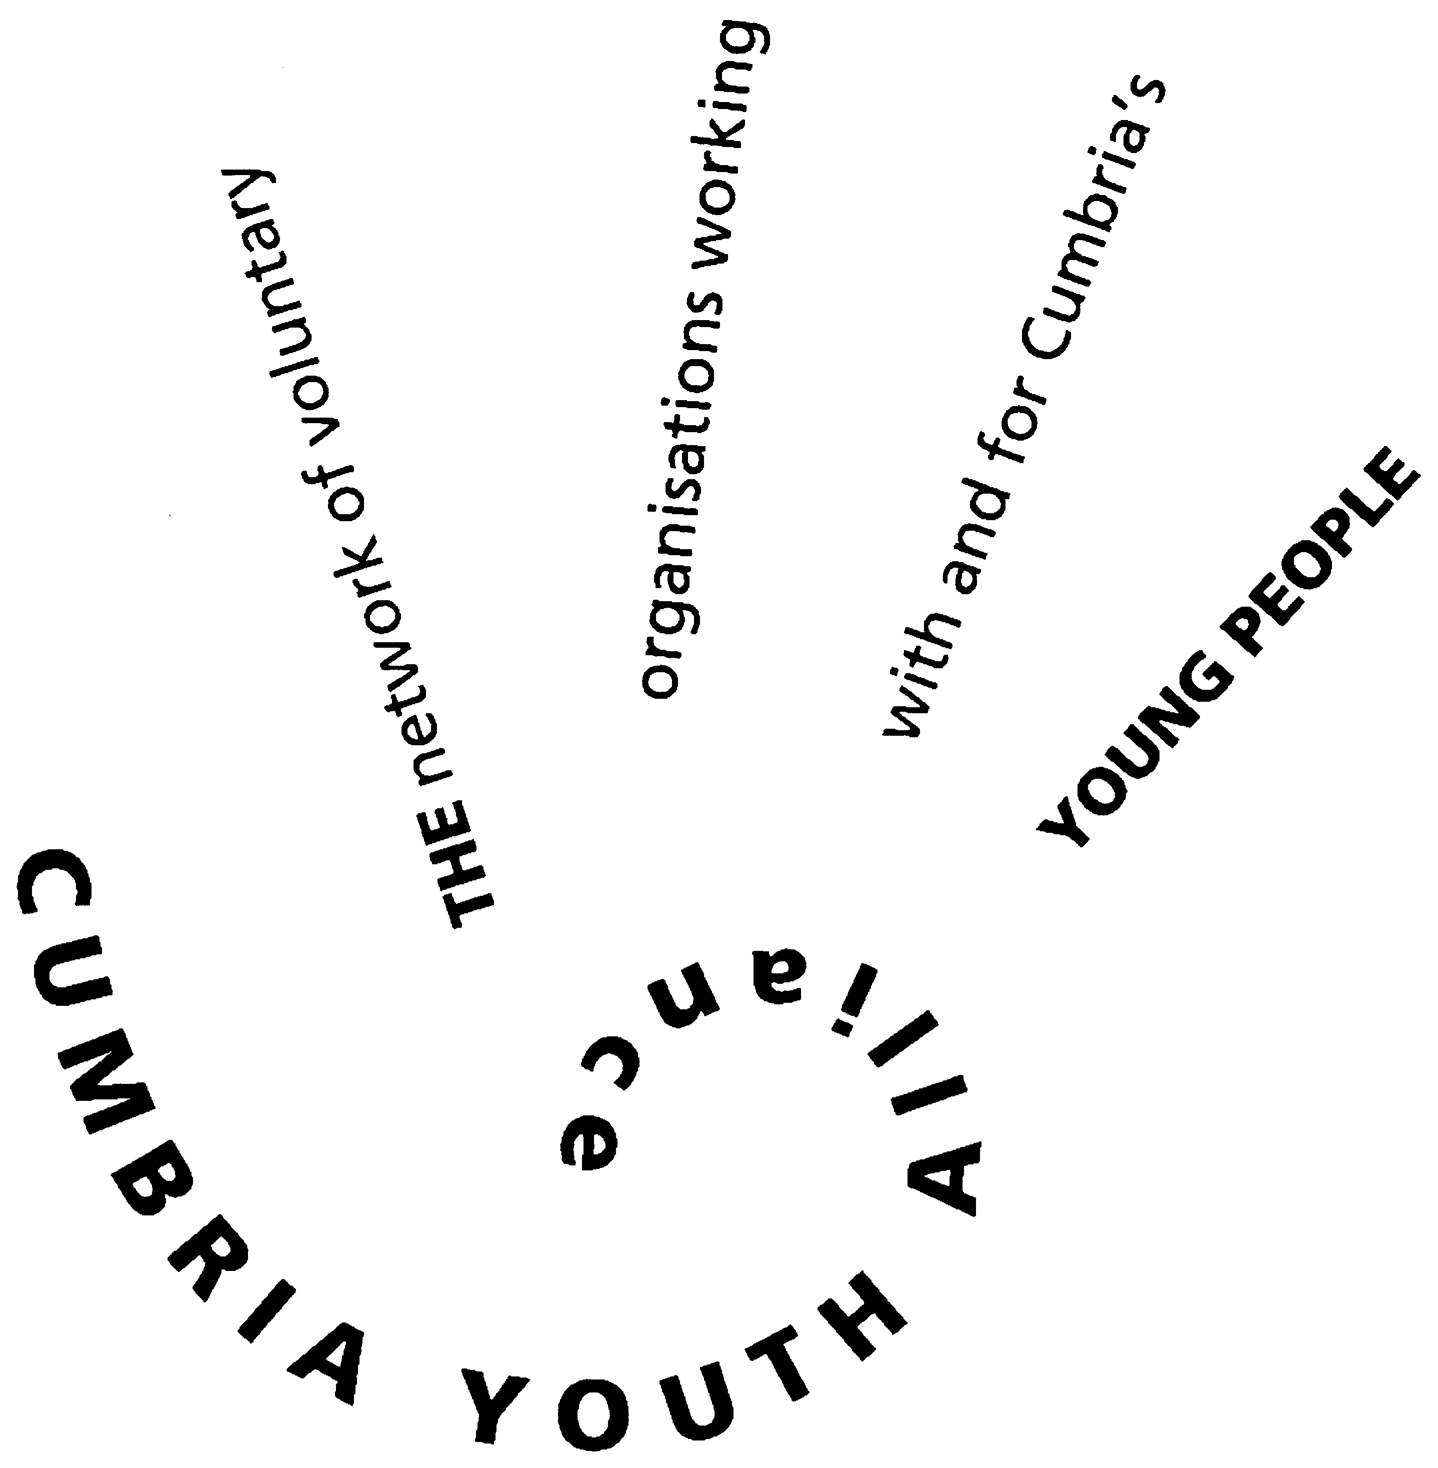
Cumbria Youth Alliance Booking Form
(one form per person)
Dealing with Difficult and Challenging Behaviour
CADAS Offices 1 Fisher Street Carlisle CA3 8QT
24th March 2020
Start time 9.45am for a 10am start finish 4pm
Delivered for us by CADAS team

Participant Details
Name
Organisation
Contact Address
Email Address
Telephone number(s)
Participant Declaration (indicate with a tick in the appropriate box)
 |  |  | Yes | No
I confirm that I am supporting/working with young people 11-19
I consent to having my data stored by Cumbria Youth Alliance and used to contact me by email
I consent to having my data stored by Cumbria Youth Alliance and used to contact me by telephone
I consent to having my data stored by Cumbria Youth Alliance and used to contact me by post
I consent to having my details shared with funders who have supported this scheme/project
I consent to having my details shared with the course trainer
I confirm I am happy to be contracted about other training opportunities available to me and my organisation
I consent to having my photograph taken and used for CYA’s publicity purposes
I agree to pay the £20.00 course fee and will ensure the invoice is paid prior to commencement of the training
I agree the course fee is liable unless I cancel at least 7 days prior to commencement of the training
I confirm I wish to attend the Dealing with Difficult and Challenging Behaviour on the 24th of March 2020
The invoice should be sent to (if different from above and email address if possible):
Do you have any support requirements? If so please give details
Signed: |  | Dated:

