Cumbria Youth Alliance

Youth Mental Health First Aid (YMHFA)
Awareness certified training

Free training for foster parents/parents/volunteers
and others from the Third Sector supporting young people

Venue: Mintbridge, Kendal Rugby Club
Shap Road, Kendal, The Lake District, LA9 6NY
Wednesday 29th April 2020
9.45am registration for a 10.00am start - 1.00pm finish
Refreshments are available on arrival

Delivered for us by Street Games (approved Youth Mental Health England Trainers)

Free training only possible thanks to funding from
James Cropper PLC who are supporting the delivery of this programme

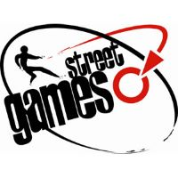
Content:
This introductory three hour session is designed to raise awareness of
young people’s mental health and the issues that can affect this age group
Who it's for:
Foster Parents/Parent Carers/Parents or Staff and Volunteers supporting
teenagers in and around the Kendal area
What you will learn:
* Some of the common mental health issues affecting young people, including
depression, anxiety, eating disorders and psychosis
* Skills to work more effectively with young people living with mental health issues
* Ways to support young people with a mental health issue and relate to their experiences
Format:
* Half day face to face session
* Learning takes place through a mix of presentations, group discussions and workshop activities
* Numbers limited to 25 people per course so that the instructor can keep people safe and supported
while they learn
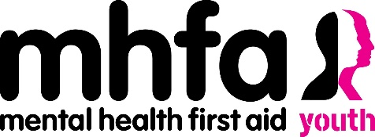
Takeaways
* A certificate to say you are Youth Mental Health Aware
* A manual to keep and refer to whenever you need it
You will be given resources to take home after the course to
support you at home or in your workplace

To book a place please complete the attached booking form and return
to cath@cya.org.uk. Early booking is advised as places are limited to 25 per course.
Phone if you require further information: 01900 603131

Cumbria youth Alliance is please to offer
FREE
Youth Mental Health First Aid delivered by Street Games
Wednesday 29th April 2019
9.45am for a 10am start 1pm finish
Venue: Mintbridge, Kendal Rugby Club
Shap Road, Kendal, The Lake District, LA9 6NY

Name of person attending
Organisation if working or volunteering
Contact Address
Email Address
Telephone number(s)
Participant Declaration (indicate with a tick in the appropriate box)
 |  |  | Yes | No
I confirm I am a parent/foster parent/parent/carer of a teenager or I am working within the third sector and supporting young people in or around Kendal
I consent to having my data stored by Cumbria Youth Alliance and used to contact me by email, post or phone (so we can communicate with you regarding your training)
I consent to having my details shared with funders who have supported this training and with the trainers who are delivering the training so certificates can be provided for you
I consent to my photograph being taken at the event
I confirm I wish to attend the Youth Mental Health First Aid Lite in Kendal and understand I must inform you if I am not going to attend the training so the place can be reallocated
I confirm I am happy to be contacted about other training opportunities available to me and/or my organisation
Do you have any support requirements? If so please give details - accessibility or learning support needs?
Signed: |  | Dated:

Return this form to Cath@cya.org.uk
Or mail it to Cumbria Youth Alliance Community, Town Hall Community Hub, Oxford Street, Workington CA14 2RS
This training is offered free but if you book and fail to turn up you have deprived somebody of attending this training and have wasted resources which other families could have benefited from - if you book please turn up or you will be refused places on any future courses

