Cumbria Youth Alliance Training 2020
Are you working/volunteering with young people aged 11 to 19 in Cumbria?
Need to understand more about how adverse childhood experiences impact on the lives of young people? If yes this is the course for you
Working with ACEs -Understanding Adverse Childhood experiences
delivered by www.collegeoflife.co.uk
(Certificate of attendance only)
Wednesday 15th of April 2020
The Rydal Room -The Forum Barrow in Furness LA14 1HH
Cumbria Youth Alliance Big Lottery Emotional Resilience Project/Cumbria County Council and with support from the John Gilpin Charitable Trust
This course is FOR STAFF/volunteers supporting young people
you will understand more about adverse childhood experiences and the impact it has upon lives
only £20.00 per person for voluntary sector staff and volunteers
only £30.00 per person for those working in statutory sector organisations
as places are limited - early booking will be essential
Understanding Adverse Childhood Experiences
Learning Outcomes: By attending the course you will have a greater understanding of how adverse childhood experiences impact upon the potential mental, physical health outcomes and behaviours. At the end the course you will:
- know what can be done to prevent ACEs
- know who should be screening for ACEs
- know how to build resilience
- understand the basics of Trauma-Informed Practice
- understand the basics of Neuroplasticity
Anybody who is working with or volunteering with young people from statutory or third sector service can attend this course

There will be tea/coffee and biscuits served but participants should bring their own lunch (this helps us keep the cost of the training down and therefore we can offer more courses) There is no parking at the venue but there are town centre car parks nearby on . Complete the form on page 2 and return it by email to cath@cya.org.uk or by post to Cumbria Youth Alliance, Town Hall Community Hub, Oxford Street, Workington, CA14 2RS.
For enquiries contact Cath: 01900 603131- places are allocated on a first come basis and no bookings accepted until forms are returned to us.
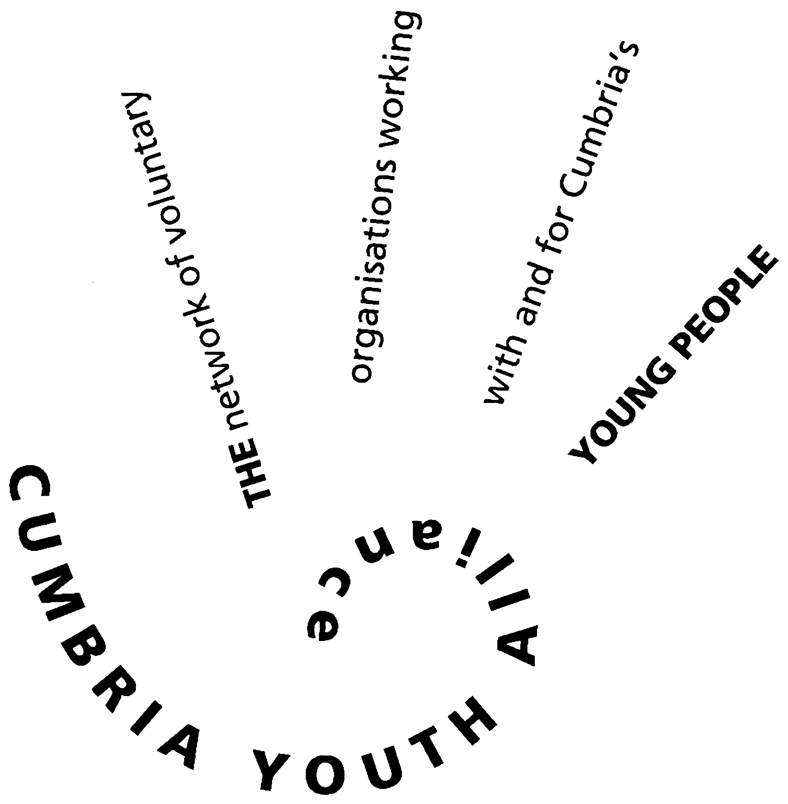
Cumbria Youth Alliance Booking
Working with ACEs
Understanding Adverse Childhood Experiences
Wednesday 15th of April 2020
Rydal Room – The Forum Barrow in Furness LA14 1HH
Arrive 8.45am for 9am start finish by 4pm
Certificate of attendance from College of Life
Thanks to support from the John Gilpin Charitable Trust
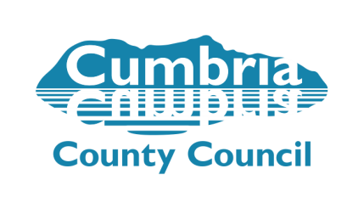

Participant Details
Name
Organisation
Contact Address
Email Address
Telephone number(s)
Participant Declaration (indicate with a tick in the appropriate box)
 |  |  | Yes | No
I confirm that I am supporting/working with young people 11-19 in Cumbria
I confirm that I am working or volunteering in the third sector in Cumbria and cost is £20.00 per person
I confirm that I am an employee of a statutory sector employer in Cumbria and the cost is £30.00 per person
The invoice should be sent to (if different from above and email address if possible):
Please note that all invoices must be paid at least 7 days prior to training
Failure to the pay the invoice will result in your place being cancelled and reallocated
Invoice address:
I consent to having my data stored by Cumbria Youth Alliance and used to contact me by email
I consent to having my data stored by Cumbria Youth Alliance and used to contact me by telephone
I consent to having my data stored by Cumbria Youth Alliance and used to contact me by post
I consent to having my details shared with funders who have supported this scheme/project
I consent to having my details shared with the course trainer
I consent to having my photograph taken and used for CYA’s publicity purposes
I confirm I wish to attend the Working with ACEs – Understanding Adverse Childhood Experiences in Barrow in Furness
Do you have any support requirements? If so, please give details
Signed: |  | Dated:

