Noosa lions Football club

  - partnership opportunities

the club
  - partnership opportunities
  - 2021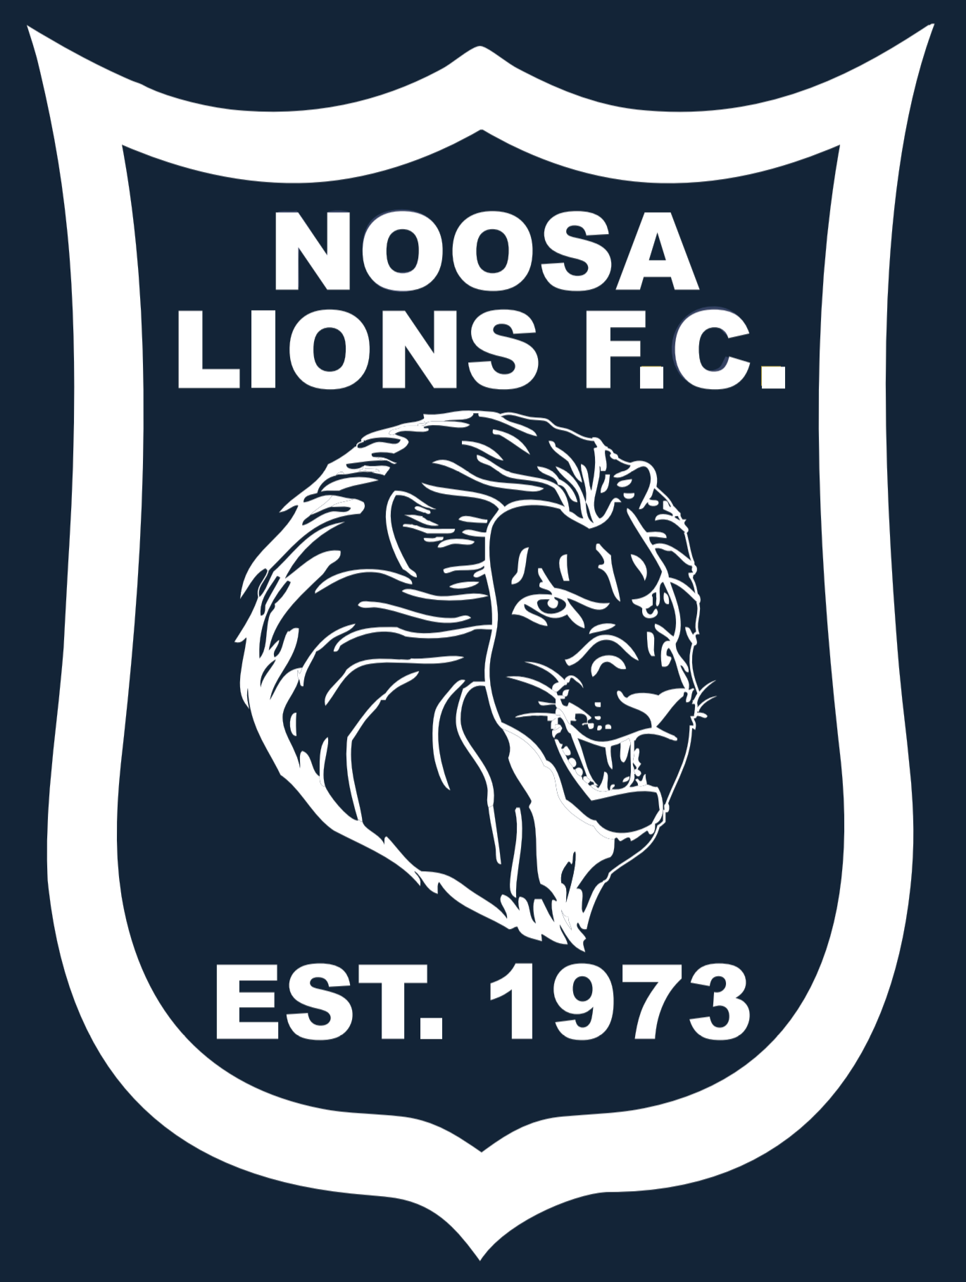
700 members
550 junior members from 5-18 years
150 senior member
2 x Womens Teams
6 x Mens Teams
65 x Junior teams
FFA Level 1 accreditation
Good Food Good Sports Level 3 accreditation
Established in 1973, Noosa Lions Football Club has grown to be the largest football club on the Sunshine Coast. In 2019 there were 698 registered players, competing in 74 teams, with both male and female members aged from 5 to 80+ years old.
In 2013, the club moved to its new, award winning home at Girraween Sports Complex, situated just five minutes drive from the famous beaches at Noosa Heads and Sunshine Beach. The complex boasts state-of-the-art fields, large, licenced club house, commercial kitchen and modern change rooms and officials area.
In 2021 the club again partners with Technical/Academy Director and Senior Men Coach Kevin Aherne-Evans who will be heading up the Academy program which will offer our junior members the opportunity to receive additional training in both and development and elite programs.
On a weekly basis the club welcome teams from all over the Sunshine Coast from as far afield as Bribie Island to Maleny to Gympie.
In 2021 we envisage our club to grow to 720 members. Your brand exposure and ability to reach thousands of Sunshine Coast residents each week is without a doubt one of the best investments you could make for your business. Packages can be adjusted dependent on needs and tailored to budget.

  - platinum Sponsorship
  - investment $5,500
- Front position on Noosa Lions Football Club Training shirt – 5500 junior members
- One 2000x950 sign in full colour including front fence along field 2
- Front page banner on Noosa Lions Website www.noosalionsfc.com

- Direct logo link on fortnightly newsletters
- Sponsorship recognition at all home games at half time – ground announcements.
- Invitation to Season Launch and Sponsors night at Noosa Lions Football Club including catering and drinks for 2 adults.
- Invitation to all Home Games at Noosa Lions Football
- Free entry to Final series hosted by Noosa Lions Football Club for 4 adults.

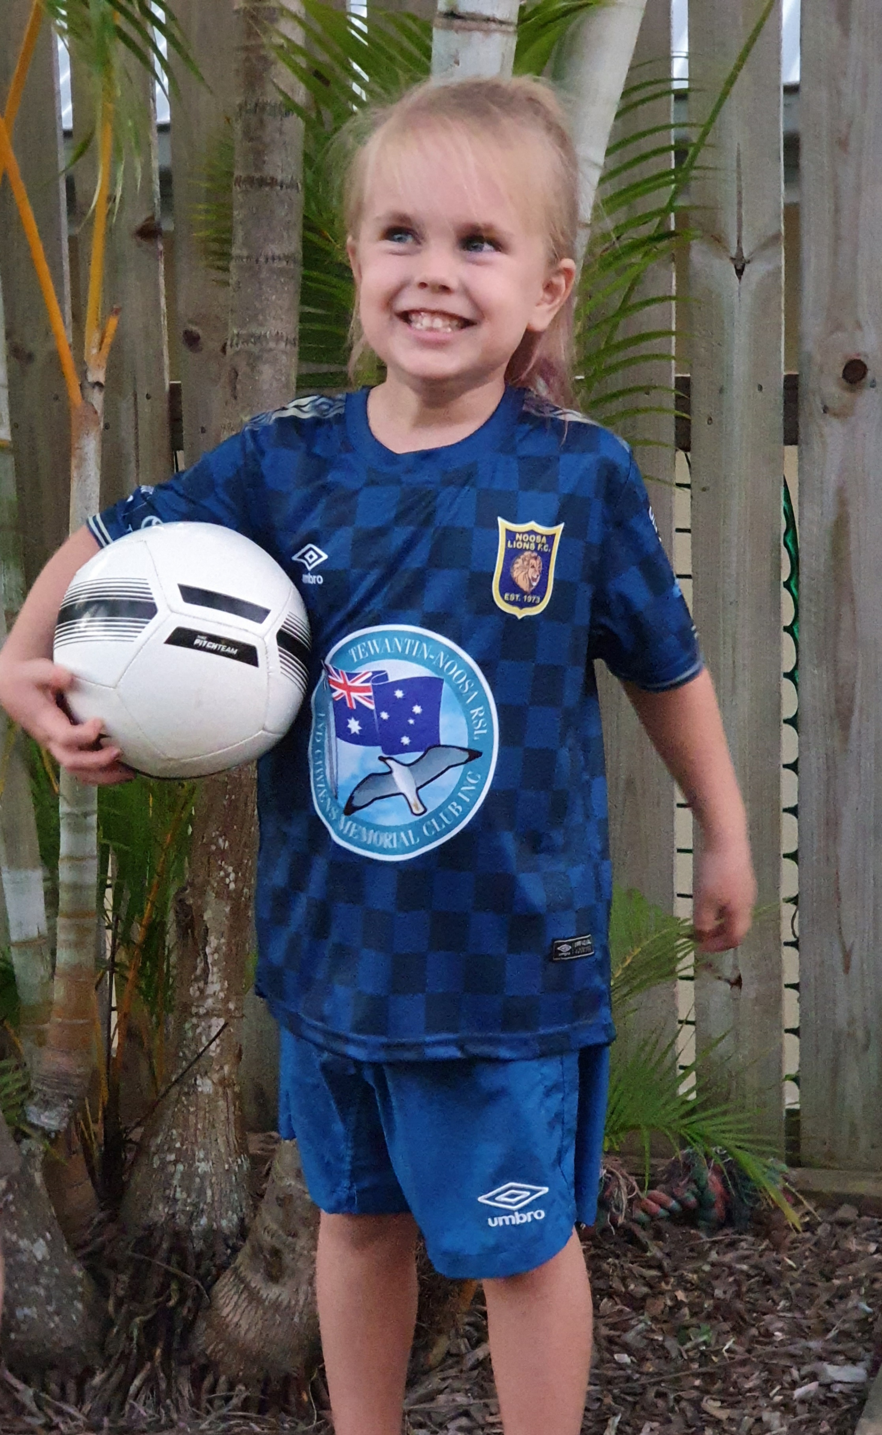
gold Sponsorship
investment $4500
- Business Logo on back of training shirts of junior members – approximately 700 shirts
- Business Logo on front of 1 x Junior and 1 senior Team jerseys (not including Premier Men)
- Two (2) 2000x950 signs in full colour including front fence along field 2
- Front page banner on Noosa Lions Website www.noosalionsfc.com
- Direct logo link on fortnightly newsletters

- Sponsorship recognition at all home games at half time – ground announcements.
- Invitation to Season Launch and Sponsors night at Noosa Lions Football Club including catering and drinks for 2 adults.
- Invitation to all Home Games at Noosa Lions Football
- Free entry to Final series hosted by Noosa Lions Football Club for 4 adults.

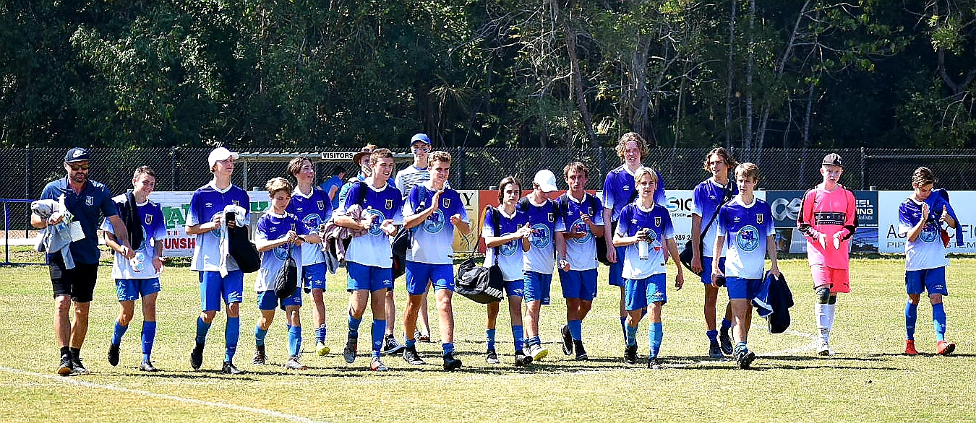

silver Sponsorship
investment $2500
- Business Logo on back of training shirts of junior members – approximately 700 shirts
- 1 X 2000mm x 900mm field sign in full colour
- Direct logo link on fortnightly newsletters sent to date base of members (+700members)
- Logo on Noosa Lions FC website with hyperlink to business.
- Sponsorship recognition at all home games at half time – ground announcements.
- Invitation to Sponsors night at Noosa Lions Football Club including catering and drinks for 2 adults.
- Invitation to all Home Games at Noosa Lions Football Club

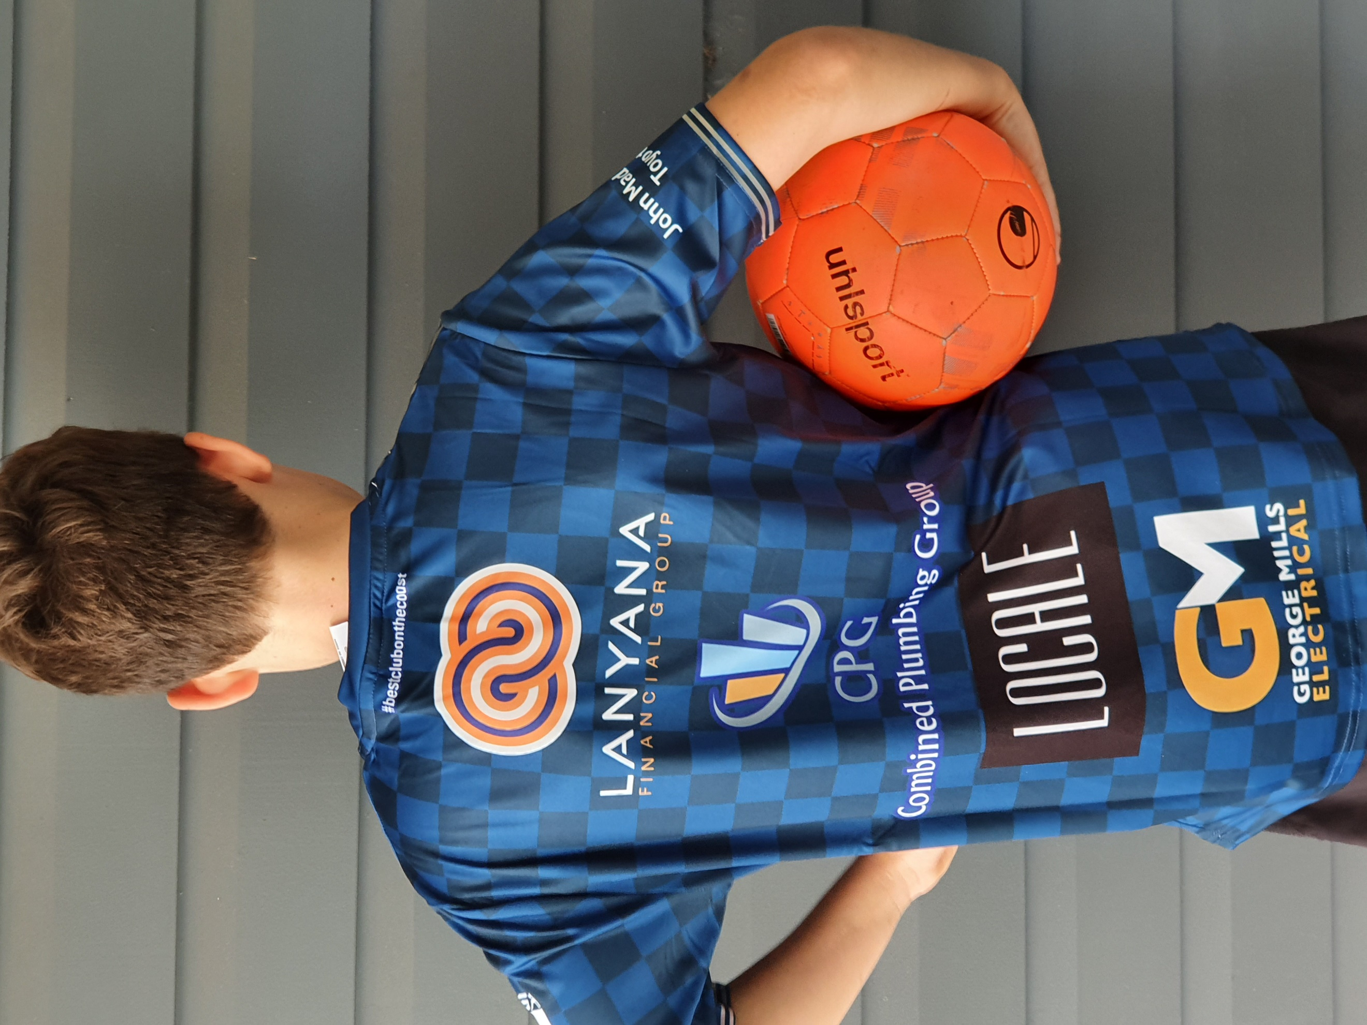

bronze Sponsorship
investment $2000
- Business Logo on front of 1 x Senior Men’s Team jerseys (Not including Premier Men)
- Business Logo on front of 1 x Junior Boys Team jerseys
- Prominent sign on Field 2 in front of club house – 2000mm x 900mm
- (Including sign and artwork).
- Logo on all newsletters sent to data base of members (+700 members)
- Logo on Noosa Lions FC website with hyperlink to business.
- Ability to put company tear drop banners at all home games every Saturday (approx. x 20 weeks)
- Sponsorship recognition at all home games at half time – ground announcements.
- Invitation to Sponsors night at Noosa Lions Football Club including catering and drinks for 2 adults.
- Invitation to all Home Games at Noosa Lions Football
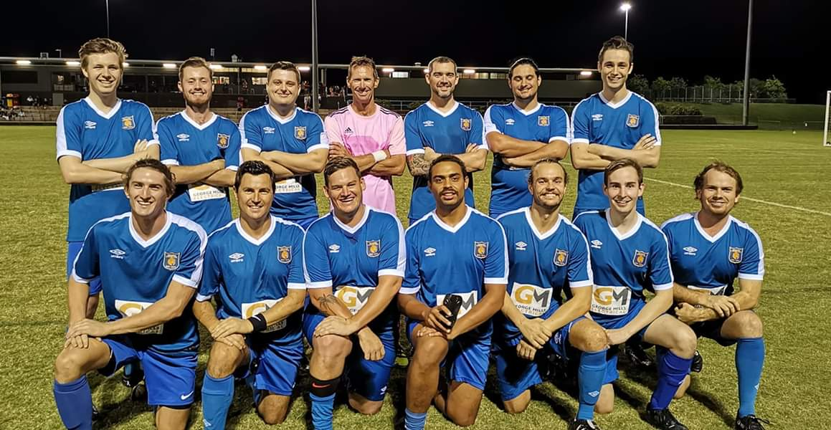

  - blue Sponsorship
  - investment $1,200

- Business Logo on front of 1 x Junior Team jerseys (boys teams)
- Prominent sign on Field 2 in front of club house – 2000mm x 900mm
- Logo on all newsletters sent to data base of members (+700 members)
- Logo on Noosa Lions FC website with hyperlink to business.
- Ability to put company tear drop banners at all home games every Saturday (approx. x 20 weeks)
- Invitation to Sponsors night at Noosa Lions Football Club including catering and drinks for 2 adults.
- Invitation to all Home Games at Noosa Lions Football
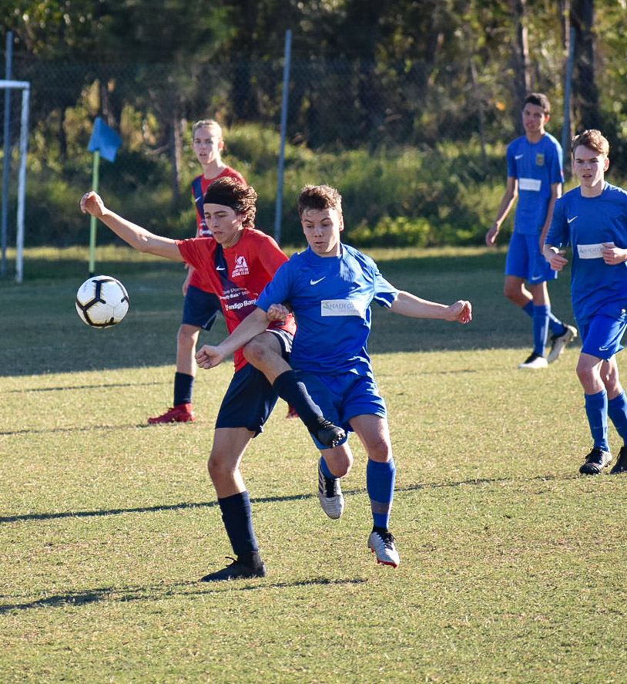

  - white Sponsorship
  - investment $500
- Business Logo on front of 1 x Mini Roos (under 6-10) Team jerseys
- Logo on all newsletters sent to data base of members (+700 members)
- Logo on Noosa Lions FC website with hyperlink to business.
- Ability to put company tear drop banners at all home games every Saturday (approx. x 20 weeks)

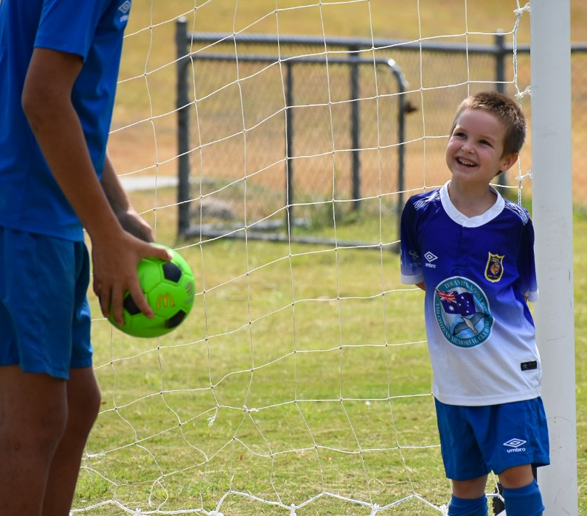

  - signage only Sponsorship
  - investment $700

- Prominent sign on Field 2 in front of club house – 2000mm x 900mm (including sign and artwork).
- Signage remains on field during 2021 season

For any questions please contact Secretary – Bec Whisker or email secretary@noosalionsfc.com

