ECONOMICS UNITS 3 & 4
2019

TRIAL EXAM A

SUGGESTED SOLUTIONS/RESPONSES

Multiple-choice Answers

1 | A | B | C | D
2 | A | B | C | D
3 | A | B | C | D
4 | A | B | C | D
5 | A | B | C | D
6 | A | B | C | D
7 | A | B | C | D
8 | A | B | C | D
9 | A | B | C | D
10 | A | B | C | D
11 | A | B | C | D
12 | A | B | C | D
13 | A | B | C | D
14 | A | B | C | D
15 | A | B | C | D

Question 1

Which one of the following will cause the supply curve for a good to increase?

- increase in government taxes
- increase in the level of income
- increase in worker productivity
- a decrease in the price of a substitute good

REASONING:

An increase in supply implies a shift to the right for supply (more willing and able to produce). A rise in taxes increases costs and has the opposite effect, income is related to demand effects as is answer D, as prices of substitutes effects changes to the demand for a good. C is the correct answer.

Figure 1.1 – Market for Fitbit Watch

Question 2

Which of the following does not explain the change in the market for Fitbit watches?

- consumers preference for Fitbit watches decreased
- the price of sports running shoes fell by 20%
- the price of Garmin fitness watches fell by 20%
- disposable income fell on average by 10%

REASONING:

Figure 1.1 shows a demand curve shifting to the left D1 to D2; representing a decrease in demand for ‘fitbit watches’. The question asks for the response that does not explain the decrease and answer A, C, D all would result in a decrease in demand. Running shoes are assumed to be a complementary good to fitness watches, so if the price of complementary good falls the demand for the ‘Fitbit watches’ should increase, thus answer B is correct.

Question 3

Market failure is likely to occur in a market when

  - Resources are allocated to those areas that maximize society’s wellbeing
  - It is possible to make someone better off without making someone else worse off
  - Firms use resources in the most efficient manner
  - There are no adverse spillovers from production or consumption

REASONING:

Market failure is where the market system results in outcomes that undermine economic well-being. Market failure is unlikely to occur when; society’s wellbeing is maximized, resources are used in the most efficient way and no adverse spillovers onto third parties occur. Answers A, C & D are not correct. Pareto efficiency states that with the current allocation of resources ‘it is not possible to make someone better off without making someone else worse off’, when an economy is operating outside this condition, it is more likely market failure is occurring, hence answer B is the best response.

Question 4

Which of the following is not a characteristic of a perfectly competitive market?

- firms are price makers
- homogenous goods that are sold
- ease of entry and exit from the market
- perfect knowledge is shared between sellers and buyers

REASONING:

A perfectly competitive market exhibits all the characteristics in answers B, C, D. ‘Firms are price makers’ is characteristic of an oligopolistic or monopoly market, firms are ‘price takers’ in perfectly competitive markets. Answer A is the correct response.

Question 5

Which of the following best describes an economy experiencing a contraction in economic activity?

- Unemployment is increasing, GDP is falling and inflation is rising
- Unemployment is decreasing, GDP is rising and inflation is rising
- Unemployment is increasing, GDP is falling and inflation is declining
- Unemployment is decreasing GDP is rising and inflation is declining

REASONING:

Unit 3 AOS 2 requires the students to understand the nature and causes of the business cycle. A contraction in the business cycle implies a slowdown in economic activity. It causes unemployment to rise (ruling out answers B and D), economic growth (GDP growth) to decline and inflationary pressures to fall. Making the correct response C.

Question 6

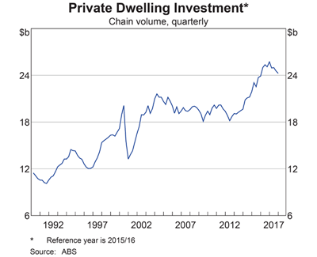
Graph 1.1 – Private Dwelling Investment

Which of the following best describes the trend in private dwelling investment since 2002?

- the trend was increasing from approximately $12b to around $24b
- the trend was decreasing from around $18b to approximately $12b
- the trend was increasing from approximately $18b to around $24b
- the trend was increasing from $20b to around $26b

REASONING:

ADVICE: draw a line from the beginning of 2002 and mark the chart, mark the chart at the end of 2017. Draw a line of ‘best fit’ from 2002 – 2017.
NOTE: when reading the RBA graphs the 12 months of data is directly above the year listed e.g. 2017 depicts January to December directly above it on the chart.
The current study design requires students to ‘explain trend and patterns… in economic data’.
Answer A beginning at $12b is too low, whilst the trend is increasing so answer B is not correct. Answer D finishing at $26b is too high, according to the finishing position of the data series. Answer C is the most correct because it best describes the trend since 2002.

Question 7

Which of the following is not directly related to the measurement of Non Material Living Standards (NMLS) in Australia?

- the amount of leisure time people have
- the quantity of goods and services produced
- the level of crime rates in capital cities
- the level of family breakdown and divorce rates

REASONING:

NMLS relates to the quality aspects of life. Material Living Standards directly relates to the quantity of goods and services available to be consumed. Leisure time, crime and divorce rates all are aspects of NMLS. The correct answer is B, as it does not directly relate to NMLS.

Question 8

Which of the following combinations is not likely to increase the level of economic growth?

- higher levels of business confidence and decreased interest rates
- lower levels of personal income taxes and a higher labour force participation rate
- strong rates of growth in Japan and an increase in productivity
- lower levels of consumer confidence and appreciating Australian dollar

REASONING:

In answers A, B and C, respectively ‘higher business confidence’, ‘lower personal income taxes and ‘strong growth rates in Japan’ all will increase the level of AD and are likely to increase the rate of economic growth. Answer D has the combination of ‘lower levels of consumer confidence’(decline consumption spending) and ‘appreciating Australian dollar’(decline in export income) which will both decrease economic growth, hence is the correct response.

Question 9

International trade allows the living standards of countries to increase. Which of the following would be an argument that contradicts this statement?

- The degree of choice and wider range of goods and services available through international trade assists in improving the non-material living standards of a nation.
- Free trade agreements mean Australian firms encounter stronger competition from overseas, resulting in businesses needing to improve efficiency. Structural adjustment makes some workers redundant and better off.
- Free trade agreements, like Australia’s FTA with Chile, provide greater access to overseas markets and support stronger rates of real GDP in Australia. Increased employment from rising production levels improve material and non-material living standards.
- Comparative cost advantage, the theorem developed by David Ricardo, encourages greater specialisation in trade and forces resources to be more efficiently allocated, improving material living standards.

REASONING:

Answers A, C and D all refer to ways international trade and aspects associated with international trade improve material living standards and non-material living standards. Answer B explains the way international trade and accompanying Free Trade Agreements can undermine living standards, by causing structural unemployment as Australian firms who are uncompetitive close in the face of stiffer competition from overseas producers.

Question 10

Which of the following is unlikely to improve Australia’s international competitiveness?

- falling labour productivity overseas
- a depreciation in the value of the Australian dollar
- an increase in union protests and strikes across the labour market
- a fall in Australia’s inflation rate

REASONING:

Falling productivity overseas makes Australian firms/producers relatively more competitive, so improves international competitiveness- ruling out answer A. A depreciating Australian dollar makes Australian producers more competitive, as it makes exports relatively cheaper in international markets, it is not B. A lower inflation rate improves the competiveness of Australian exporters so the answer is not D. The correct answer is C, labour market disruption, such as protests and strikes adds to producer costs and in the short-term reduces productivity, weakening Australia’s international competitiveness.

Question 11

In relation to Australia’s Net Foreign Debt (NFD), which of the following statements is incorrect?

- Australia’s NFD as a percentage of GDP is above 50%
- NFD and Net Foreign Equities(NFE) combine to produce Australia’s Net Foreign Liabilities
- NFD makes up a smaller percentage of Australia’s Net Foreign Liabilities than NFE
- The government sector’s share of NFD is smaller than the private sector’s share of NFD

REASONING:

The correct answer is C, because Net Foreign Debt typically makes up the largest proportion of Australia’s Net Foreign Liabilities, Australia’s Net Foreign Equities currently has a negligible effect on NFL. Answers A, B and D are all correct, as NFD in 2019 sits at 59.5 % of GDP, as of March 2019, NFD + NFE = NFL and The private sector holds the majority of Australia’s NFD.

Question 12

Which of the following is not considered to be an aggregate supply policy?

- expansionary monetary policy
- reforms to the tax system
- provision of subsidies for consumers
- grants for research and development

REASONING:

A quick reference to the Economics Study Design Section Unit 4 AOS 2 Key Knowledge dot point 3; budgetary policies that have aggregate supply effects include subsidies and research and development grants. In dot point 4, it also refers to tax reform policies. Meaning answers B, C & D are all AS policies. Answer A is correct because Monetary policy is considered to be ONLY an aggregate demand policy.

Question 13

One main weakness of using immigration policy to influence aggregate supply

- operates to simultaneously achieve the 3 key macroeconomic goals
- can boost both the quality and quantity of the labour force reducing the level of skill shortages
- boosts Australia’s productive capacity and extends Australia’s sustainable level of economic growth
- political effects can undermine the decision-making because of the desire to be re-elected

REASONING:

Answer D is correct because with any government political agenda (seeking votes to be re-elected) can undermine the economics of the decision-making. Strengths of immigration policy include; simultaneously supports 3 key domestic goals, increases both quantity and quality of labour force, and extends Australia’s productive capacity. Hence answers A,B & C are incorrect.

Question 14

Which of the following is likely to assist with restoring the budget surplus in the coming years?

- Bracket creep (fiscal drag)
- Lower iron ore prices
- Slower growth in China
- Deflation

REASONING:

Lower iron ore prices globally will negatively affect the profits of Australian exporting companies, diminishing the level of company tax collected, so answer B is incorrect. China’s economy slowing, decreases demand for Australia’s exports, once again reducing Australian exporting companies’ profits and lowering the amount of tax collected, so answer C is incorrect. Deflation reduces the level of GST collected, and the level of income tax collected falls because of a trough in economic activity, answer D is not correct. Answer A is correct as bracket creep (wage inflation pushing workers into higher marginal tax brackets) will increase the level of income tax collected and contribute towards the budget being in surplus.

Question 15

Proposed changes to Progressive Income Tax System
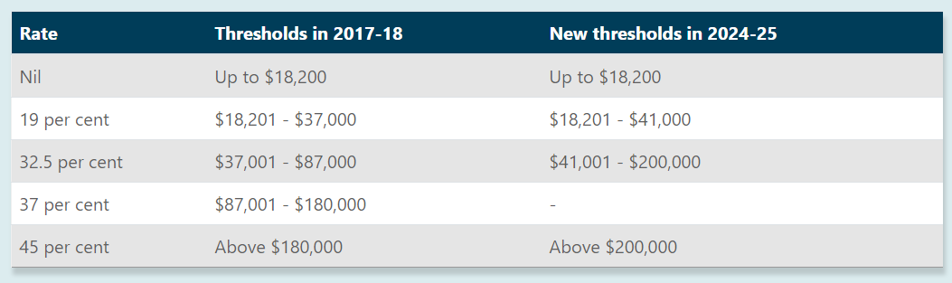
Table 1.1 – Progressive Income Tax System

In reference to the information provided in Table 1.1, which of the following statements is most correct?

- The proposed changes will have an adverse effect those earning between $100,000 - $150,000
- The tax free threshold will change between 2017 and 2025
- The proposed changes will increase the level of disposable income for those earning between $100,000 - $150, 000
- The marginal tax rate is 45 cents in every dollar earnt above $180, 000 in 2025

REASONING:

Answer C is ‘most correct’ as from 2017-18 to 2024-25 those earning between $100,000 and $150,000 will increase their level of disposable (after tax income). Answer A is incorrect because the proposed changes will have the opposite effect; as income earners up to $150, 000 will be better off paying only 32.5% tax on income earnt from $87,000 to $150, 000 instead of 37%, and therefore disposable income (income available after tax has been paid and welfare has been received). B is incorrect because the tax free threshold does not change and answer D is incorrect – in 2025 from $180,000 to $200,000, PAYG income earners will pay a tax of 32.5 cents for each dollar earnt within this bracket, not 45 cents.

END OF SECTION A
SECTION B – Written responses
Instructions for Section B

Answer all questions in the spaces provided

Mar-2017 | 2.2
Jun-2017 | 2.3
Sep-2017 | 2.5
Dec-2017 | 2.8
Mar-2018 | 3.0
Jun-2018 | 3.0
Sep-2018 | 2.7
Dec-2018 | 2.2
Mar-2019 | 1.7

Table 1.1 - Gross domestic product: Chain volume measures (%)
(ABS Series: 5206.0 - Australian National Accounts: National Income, Expenditure and Product)

Question 1 (17 marks)
- Describe the trend in real Gross Domestic product since 2018. (2 marks)

Advice
- Unit 3 AOS 1 Key Skill dot point 3 advises students they must be able to, ‘interpret and analyse statistical data’
- Read the question carefully, noting where the description of the trend begins and ends. In this case, the beginning of 2018 is March and shows a figure of 3% GDP.

Suggested solution
The table depicts a decreasing trend in real GDP since 2018 (1 mark). From the first quarter of 2018 the real GDP rate was at 3% and has since fallen to 1.7% in the March quarter for 2019 (1 mark)

Marking Guide
1 mark for correctly identifying the trend
1 mark for using data from the table/graph to support the interpretation

- Describe how a downturn(contraction) in the business cycle might impact aggregate demand.
(4 marks)

Advice
- Unit 3 AOS 2 Key Knowledge dot point 4 requires students to understand the nature and causes of the business cycle and the Key Skills requires students to define key concepts …using them correctly.
- Past examiners reports have advised that it is not necessary to define the key terms, rather students are encouraged to answer the question and weave the meaning of the terms ‘business cycle’, ‘contraction’ and ‘aggregate demand’ into the answer.
.

Suggested solution
A contraction in the business cycle will adversely affect the level of AD in the Australian economy (1 mark). The downturn in the business cycle indicates that unemployment is rising, production and GDP growth is slowing and that inflation will be falling. The household sector faced with greater uncertainty regarding employment will reduce the level of consumption spending, whilst weakening business confidence in the economy, will result in cut backs on investment expenditure (2 marks). Ultimately, the total level of spending (AD= C+ I + G1 + G2 + X – M) on goods and services will fall and slow the level of AD within the economy (1 mark).

Marking Guide

1 mark for stating a downturn will negatively affect aggregate demand (AD)
2 marks for discussing how a downturn impacts household spending and business investment
1 mark for linking to the level of AD and showing knowledge of the meaning of AD.

- Examine how a depreciating Australian dollar could affect the level of economic growth in Australia. (4 marks)

Advice
- Unit 3 AOS 3 students are asked to ‘discuss the effects of the changing currency values on the achievement of the domestic macroeconomic goals’, or in this case the level of economic growth
- It is accepted in economic theory that currency changes have a direct and strong relationship with the level of exports demanded. However, import effects can occur that will also impact on economic growth

Suggested solution
The value of the Australian dollar falling in international currency markets will result in an improvement in economic growth (1 mark). A depreciation of the $AUD causes an increase in demand for Australia’s key exports, such as minerals, agricultural produce and tourism. The depreciation makes Australia’s exports relatively cheaper to overseas buyers. Simultaneously, it will slow the level of importing and boost domestic production for firms competing with imports (2 marks). The economic activity in the export sector will speed up and production levels will begin to increase, in turn having a positive effect on the rate of GDP growth in Australia (1 mark).

Alternative response

It is possible to refer to the depreciation having a negative effect on Australian firms reliant on imports for production. Firms needing inputs from overseas (refined fuels, technology, machinery) will see production costs rise and cause a slowdown in the willingness to supply and cause production levels to slow.

NOTE: This type of response would need to be counter-balanced with the positive effect of an increase in exporting to receive full marks.

Marking Guide

1 mark for stating that $AUD depreciating has a positive effect on economic growth
2 marks for examining why it has a positive effect
1 mark for the correct use of terms and definitions of economic growth and a depreciating Australian dollar

- Select one of the following:

- Downturn(contraction) in the business cycle
- Depreciating Australian dollar

Describe how the economic event chosen is likely to impact Australia’s current account deficit (CAD). (3 marks)

Advice
- Unit 3 AO3 Key Knowledge dot point 3; refers to ‘causes of Australia’s current account deficit including cyclical and structural factors’ and students are required to explain the relationship between the factors and the CAD.
- In the 2018 examiners report students were encouraged to answer questions ‘directly and precisely’. Students should practise writing responses that get to the answer directly, rather than repeat the question or regurgitate definitions.

Suggested solution 1
A contraction in the economic cycle is likely to have a positive effect on Australia’s current account deficit (1 mark). The decline in economic activity will slow the level of economic activity, with unemployment rising. The household sector will cut back on spending and thus the level of import spending will fall (assuming exporting levels remain unchanged), resulting in a fall in the size of the cyclical CAD, possibly causing a net export income surplus (2 marks)

Suggested solution 2
A depreciating Australian dollar will assist in lowering Australia’s current account deficit (1 mark). The consequence of the Australian dollar falling in value, is it makes exports relatively cheaper in international markets, and demand for Australian exports increases. However, the demand for imports will decline as they become more expensive. The rise in net export income (X-M) will have a positive effect on the balance of trade and reduce the size of CAD (2 marks)

Marking Guide
1 mark for correctly identifying what effect the event has the CAD
2 marks for the description of how the factor relates to the CAD, in having this effect

Question 2
- Distinguish between government current expenditure and government capital expenditure (Use examples in your response). (4 marks)

Advice
- Unit 4 AOS1 Key Knowledge dot point 3 and Key Skill dot point 1; advises students to have key knowledge about ‘government current and capital expenditure’ and be able to ‘define and use key economic concepts’
- The 2018 examiners report when referencing written responses 1a a ‘distinguishing’ question, advises students to provide a distinguishing feature to show how the concepts are different, meaning correct examples will not be enough to attain full marks.
.

Suggested solution
Government current expenditure (G1) refers to spending on the day-to-day running of government departments and has economic benefits in the period it is spent. Current expenditure includes spending on consumables such as; travel expenses and stationary (2 marks). Whereas, government capital expenditure (G2) includes spending on public assets such as roads and hospitals. These public assets having economic benefits for many years after the initial spending is made. (2 marks)

Marking Guide
1 mark for stating current expenditure benefit in the short-term and is spent on government consumables
1 mark for a correct example (travel expenses, stationary, staff expenses)
1 mark for outlining social and economic infrastructure has on-going economic benefits
1 mark for a correct example (roads, hospitals, railway lines, bridges, schools)

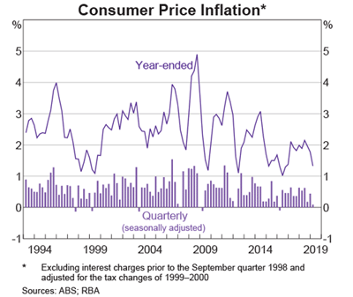

Graph 1.1 – Inflation Rate 1994 through to 2019 (Source: RBA Chart Pack 2019)

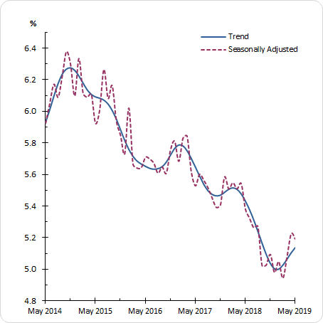
Graph 1.2 – Australia’s Unemployment Rate

(in answer b. refer to Graph 1.1 and Graph 1.2)

- Analyse how the recent movements (past 2 years) in the inflation rate and unemployment rate may have influenced the setting of budgetary policy in 2019-2020. (8 marks)

Advice
- This question will be marked globally (without a strict idea of what is an 8 out of 8 response) A sustained and appropriate evaluation of the indicators and budgetary policy will attain full marks.
- The study design in Unit 4 AOS1 Key Knowledge dot point 1 and dot point 10 refer to; need for AD policies to stablise the business cycle (indicators influenced by the business cycle: inflation and unemployment) and the stance of budgetary policy. Further, key Skills dot point 3 the need to be able to discuss and analyse the effect of contemporary factors on the setting of AD policies.
.

Suggested solution

The trend in the inflation rate of decreasing from around 2% to approx. 1.3% over the past 2 years, suggests there is weakness in economic activity. In contradiction, Graph 1.2 reveals economic activity picking up with the rate of unemployment falling from 5.6 % to be at approximately 5.2% in 2019 (2 marks)

If only considering the inflationary weakness, it is likely the Federal government would have aimed for an increase in the size of the deficit of 2018-19 of $4.1 billion. A budgetary policy that has an expansionary effect on spending, production and has the effect of building inflationary pressures within the economy. However, should the government use budgetary policy to moderate economic activity, the budget deficit would be reduced or the deficit would be reversed and a surplus budget would be targeted. (2 marks)

The budget is predicted to change from a $4.1b (2018-19) deficit to a surplus of $7 billion in 2019-20. In effect, this means the government is seeking to have a more contractionary effect on the economic activity. It appears, the unemployment rate falling has had a more significant effect on the setting of budgetary policy, than the trend in the inflation rate. (2 marks)

Although, the budgetary policy setting is influenced by more than just the inflation rate and the unemployment rate. In recent years, the government aim for fiscal consolidation has seen the deficit reduced, the government seeking to achieve a surplus budget outcome over the long-term. In addition, Monetary policy’s current expansionary setting is having a positive effect on AD and affects the decision to use a macroeconomic policy mix (combination of fiscal and monetary policies) that provide stability for other objectives such as economic growth and the quality of life measures (2 marks).

Marking Guide
2 marks for analysing and describing the trends in inflation and unemployment
2 marks for the effect of setting budgetary policy to be either expansionary or contractionary
2 marks for describing the current setting of contractionary $7b surplus and theorizing its effect
2 marks for elaborating on why not only the inflation rate and the unemployment rate is relevant when setting BP

- Outline how automatic stabilisers could affect the budget outcome in 2019-2020. (3 marks)

Advice
- Unit 4 AOS 1 Key Skill dot point 1 advises students to, ‘use key economic terms relating to the Australian Government’s aggregate demand policies’
- To attain full marks for this question students will need to refer to the recent movements in the level of unemployment, subsequent effect on welfare outlays against PAYG income tax collections or other government outlays/receipts that are strongly influenced by the business cycle
.

Suggested solution

Automatic stabilsers are budgetary measures that come into effect to smooth out the business cycle without the treasurer deliberately changing tax levels or spending initiatives (1 mark). Unemployment benefits, in the form of the Newstart allowance is paid to those persons who are unemployed and seeking work. As the unemployment rate is falling the amount of welfare paid is reduced and decreases government outlays. The fall in outlays will contribute to a smaller deficit and be one of the reasons for a predicted budget surplus in 2019-2020. (2 marks)

Marking Guide
1 mark for describing how automatic stabilisers operate
2 marks for outlining how one contemporary economic factor could be influencing government expenditure or revenue

“At its meeting today, the Board decided to lower the cash rate by 25 basis points to 1.25 per cent” (RBA press Release 4th June 2019)

- Describe how the change to the cash rate is intended to influence the cash flow transmission mechanism of monetary policy. (3 marks)

Advice
- The examiner’s report in 2018 in reference to Question 2b that required students to ‘explain how two transmission mechanisms might operate to affect the level of AD’ it states the highest scoring responses when describing the ‘cash flow channel’ used the following term; ‘repayments’ ‘discretionary income’ and ‘consumption’ and ‘investment’ spending.

Suggested solution

Lowering the cash rate by 25 basis points (0.25%) will theoretically stimulate the economy through cash flow channel (1 mark). Households with existing mortgages will experience a reduction in the monthly repayments on their home, and will retain a larger proportion of their discretionary income. The relative increase in the level of discretionary income will increase householder’s propensity to consume and support stronger levels of AD within the economy (2 marks).

Marking Guide
1 mark for stating it will stimulate the cash flow channel and in turn AD
2 marks for describing the relationship between reduced repayments, discretionary income and consumption or business investment

Question 3
- Discuss how aggregate supply policies are designed to improve Australia’s international competitiveness. (4 marks)

Advice
- The VCAA examiners reports from 2017 question 1d. refers to how increased budgetary spending could influence aggregate supply. In the suggested solution it is highlighted that ‘aggregate supply’ and ‘productive capacity’ are seen as similar in meaning. Note: it refers to labour productivity resulting in average costs of production falling

.

Suggested solution
Aggregate supply policies aim to improve the efficiency of resource allocation, boost productivity levels and enhance the quality and quantity of resources available for production (1 mark). By targeting productivity improvement through spending on education and training, the technical efficiency of the labour force improves. The relative increase in outputs from a similar amount of inputs, lowers the production costs of firms and allows Australia’s exports to be more competitive in international markets (2 marks). The improved price competitiveness results in Australia’s export and import competing firms growing the size of their market share in global and domestic markets (1 mark).

Marking Guide
1 mark for stating the 1-2 aims of aggregate supply policies
2 marks for explaining how AS policies operate to have a positive effect on efficiency, productivity or quantity and quality of resources
1 mark for knowledge of and linking back to international competitiveness

- Examine the way tax reform policies can operate to have a positive effect on an efficient allocation of resources. (4 marks)

Advice
- Unit 4 AOS 2 Key Knowledge dot point 4 and Key Skill dot point 4 advises students they must be able to, ‘explain how tax reform policies are designed to influence living standards and analyse the effect of aggregate supply policies on living standards
- ‘Living standards’ both material and non-material are significantly affected by how well an economy achieves allocative, technical, intertemporal and dynamic efficiency.
.

Suggested solution
A Morrison government tax reform has been to lower the company tax rate for smaller companies from 30% to 25% by 2021-22 (1 mark). The increase in companies retained profits can be used to invest in new technology and capital equipment. Business investment in new machinery and computerised technology prompts firms to adopt the lowest cost method of production and improve the level of technical efficiency achieved across the economy (2 marks). The gains achieved in technical efficiency underpin a more efficient allocation of resources and support the aim of maximising the level of material and non-material economic wellbeing of the nation (1 mark).

Marking Guide
1 mark for referring to a real or hypothetical tax reform policy that could have a positive effect on the efficiency in resource allocation
2 marks for explaining the operation of the policy and how it changes the efficiency of resource allocation
1 mark for relating to what an efficient allocation of resources means

- Select one of the following aggregate supply policies

- Subsidies
- Investment in infrastructure
- Welfare reform policy

Outline one strength and one weakness of using the policy to achieve domestic macroeconomic goals. (4 marks)

Advice
- Unit 4 AOS2 key knowledge dot point 6 advises students to understand the strengths and weaknesses of using aggregate supply policies to achieve the Australian Governments’ domestic macroeconomic goals.
- The VCAA examiners report from 2017 highlighted in Question 3c. it is essential that students don’t fall for the trap of just explaining how the policy works i.e. improves AS, rather students must articulate specific strengths and weaknesses of the AS policy

Suggested solution

Investment in infrastructure projects such as new roads, rail and ports can support the simultaneous achievement of the three key macroeconomic goals of full employment, strong and sustainable economic growth and low inflation. This strength of investment in infrastructure cannot be achieved through AD policies (2 marks). However, a weakness of using investment in infrastructure is the impact lags and delayed effects in terms of supporting productivity and efficiency improvements. Some major road and rail projects taking up to 5-10 years to complete, undermining the short-term benefits of such infrastructure projects (2 marks)

Alternate response

Subsidies can support the domestic economic goals by targeting particular areas of slow growth or industries adversely affected by erratic weather events. For instance, during the drought farmers could receive targeted subsidies, enabling industry to survive beyond the period of drought emergency (2 marks). However, a weakness of using subsidies is the short-term benefits can lead to longer-term net losses, in terms of firms charging higher prices. Propping up underperforming industries can lead to an inefficient use of economic resources, force individuals to pay higher prices for goods (meats and farm produce) and undermine material living standards in the long-term (2 marks).

Marking Guide
2 marks for outlining an appropriate strength for the policy chosen
2 marks for outlining an appropriate weakness for the policy chosen

- Explain how immigration policy can be used to boost the labour force participation rate and achieve the goal of low inflation. (6 marks)

Advice
- Unit 4 AOS 2 Key Knowledge dot point 5 advises students to understand the effect of immigration policies on the labour market and aggregate supply and the way this influences the achievement of the domestic macroeconomic goals
- The examiner’s report from 2018 question 3c. addresses the relationship between skilled migration and the labour market. Noting, that the labour market relates to the ‘demand for, and the supply of workers’ and that a change to supply will either tighten the labour market (reduction in skilled migration) or reduce wage pressure (rise in skilled migration)

Suggested solution

Immigration policy involves the annual intake of approximately 130, 000 skilled migrants, most already qualified and of working age. Directly this intake, increases the size of Australia’ labour force, with the majority of skilled migrants immediately entering the workforce. (2 marks)
The labour force participation rate in Australia has typically been around 65%; that is 65% of persons 15 years and over either engaged in employment or actively seeking work. The net effect of skilled migration helps the labour force participation rate rise above 65% as the migrants level of participation is above 90% (2 marks)

The rise in the size and skill level of the labour force contributes to the aggregate supply shifting out to right, enabling an increase in Australia’s productive capacity. The growth in quantity and quality of labour enhances the ability of firms to produce whilst keeping the general labour costs in check. Cost-side pressures are diminished and assist the government in achieving an inflation rate of between 2-3% on average over the course of the business cycle (2 marks).

Marking Guide
2 marks for describing immigration policy
2 marks for explaining how immigration policy can increase aggregate supply
2 marks for explaining how immigration policy can have a positive effect on the goal of low inflation

Question 4

- On the graph below, draw the demand curve for a good that exhibits a price elasticity of demand that is inelastic. (Illustrate why it is inelastic) (3 marks)

Solution
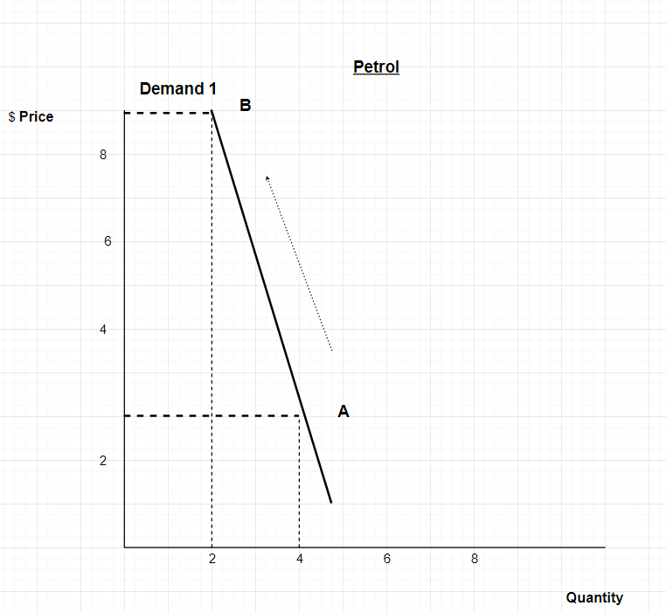
From point A to point B the proportional change is higher in the change in price than the resultant change in quantity demanded

Advice
- The Examiners report in 2017 Q2a. acknowledges that students need to apply the skill of ‘constructing’ and ‘interpreting’ demand and supply diagrams.
- Unit 3 AOS 1 Key Knowledge dot point 9 advises students to understand; the meaning and significance of price elasticity of demand and supply.

Suggested solution
See graph drawn above for solution.

Marking Guide
1 mark for correctly labelling the horizontal as quantity and the vertical as price
1 mark for correctly drawing the demand curve (back slash) at an angle greater than 45 degrees (closer to 90 degrees, but not beyond)
1 mark for illustrating the reason why this is an inelastic demand curve (naming, working exercise illustrated)

- Outline why the production period affects the price elasticity of supply. (3 marks)

Advice
- The 2014 Examiners report identified a weakness in student’s knowledge of factors that affect the price elasticity of supply. The new Study Design requires students be able to explain factors that affect PES.
.

Suggested solution
The production period is the time it takes to produce/make a good or service (1 mark). Some products take a long time to produce, for example cereal crops or fruit crops. Whereas some products can be produced very quickly, a milkshake or cup of coffee (assuming spare capacity exists) (1 mark). The price elasticity of supply (PES) relates to the level of responsiveness in the change in the quantity supplied given a change to the price of a good or service. It follows that, products such as cereal crops with long production periods have an inelastic PES and products with a short production period have an elastic PES (1 mark).

Marking Guide
1 mark accurately addressing what ‘production period’ means
1 mark for surface level explanation of why production period affects the PES
1 mark for detailed explanation/possibly with examples illustrating the effects of different production periods

- Explain how resources are allocated in a perfectly competitive market. (4 marks)

Advice
- Unit 3 AOS 1 Key Knowledge dot point 2 and dot point 8; students are advised to know the nature of and conditions for a perfectly competitive market and explain the role of relative prices in the allocation of resources.

Suggested solution
A perfectly competitive market exists when there is large number of sellers, firms are price takers and homogenous products are sold (1 mark). In these market the price mechanism and relative prices operate to allocate economic resources. The forces of supply and demand and consumer sovereignty determine the relative prices of goods, which form the price signals producers will follow (1 mark). Price signals indicate to producers where the greatest amount of profits can be attained (1 mark). Given that firms aim to maximise profits, scarce economic resources (labour, capital and natural) will be directed to areas of production where the highest relative profitability for the firms is achievable (1 mark)

Marking Guide
1 mark for detail of a perfectly competitive market
1 mark for stating the price mechanism and consumer sovereignty set relative prices
1 mark for linking the idea that price signals indicate to producers where the greatest profits can be made
1 mark for indicating that scarce resources will be allocated by producers to where the highest relative profits can be achieved.

- Compare the way indirect taxation and government advertising operate to address the problems caused by market failure. (6 marks)

Advice
- The command word ‘compare’ implies that both a similarity and a difference must be made between ‘indirect taxation’ and ‘government advertising’
- A market failure refers to a situation where there is an over-allocation of resources or under-allocation of resources. It can be made clear through theoretical discussion or the use of example as to how market failure is addressed by each of these policies.
.

Suggested solution

Indirect taxation is a tax applied to a good or service when purchased and is simply added to the price of the purchase for instance the fuel excise levy on petrol. Whereas, government advertising involves increasing public awareness on social, health and policy based issues, via television advertising, print, or social media publications (2 marks).

Both indirect taxation and government advertising are similar in the effect they can have on decision making mitigating the negative effects of market failure on the economic wellbeing of society. Both methods of addressing market failure by successfully reducing the level of production and consumption of goods and services that undermines economic wellbeing. Redirecting resources to areas of production that assists in maximising material and non-material living standards (2 marks).

However, the reasons why indirect taxation and government advertising change consumer’s decision-making is different. An indirect tax, say an excise tax on cigarettes increases the cost of purchasing the good that causes negative externalities, deterring consumers from purchasing the good. Whereas, a public awareness campaign, such as QUIT campaign increases consumers’ awareness of the health risks associated with smoking and influencing consumers to demand less cigarettes to avoid health cost in the short-term and into the future (2 marks).

Marking Guide
2 marks for outlining the way the policies operate
2 marks for providing a similarity between indirect taxation and government advertising
2 marks for providing a point of difference of why consumers and producers decision- making changes to address market failure

The material is the property of prime.edu © and is subject to the copyright laws of Australia. Disclaimer: This resource has been written by the author for use with students of VCE Economics. This does not imply that it has been endorsed by the Victorian Curriculum and Assessment Authority (VCAA). The current VCE Economics Study Design (2017–2021) can be accessed directly via the VCAA website. VCE is a registered trademark of VCAA. While every care is taken, PRIME.EDU accepts no responsibility for the accuracy of information or advice contained in the exam. Teachers are advised to preview and evaluate all PRIME.EDU resources before using them or distributing them to students.

