Letter
STUDENT
NUMBER

ECONOMICS UNITS 3 & 4
2019

TRIAL EXAM A
Reading time: 15 minutes
Writing time: 2 hours

QUESTION AND ANSWER BOOK

Structure of book
Students are NOT permitted to bring mobile phones and/or any other unauthorised electronic devices into the examination room

- Students are permitted to bring into the practice examination: pens, pencils, highlighters, erasers, sharpeners and rulers.
- Students are NOT permitted to bring into the examination room: blank sheets of paper and/or white out liquid/tape.
- No calculator is allowed in this examination
Materials supplied
- Question and answer book of 23 pages.
- Answer sheet for multiple choice questions.
- Additional space is available at the end of the book if you need extra paper to complete an answer
Instructions
- Write your student number and name in the space provided above on this page.
- Check that your name and student number are written on your multiple choice answer sheet.
- All written responses must be in English.
At the end of this examination
- Place the answer sheet for multiple-choice questions inside the front cover of this book.

Section | Number of questions | Number of questions to be answered | Number of marks
A | 15 | 15 | 15
B | 4 | 4 | 65
 |  |  | Total 80

Instructions for Section A
Choose the response that is correct or that best answers the question.
A correct answer scores 1, an incorrect answer scores 0.
Marks will not be deducted for incorrect answers.
No marks will be given if more than one answer is completed for any question

Question 1
Which one of the following will cause the supply curve for a good to increase?

- increase in government taxes
- increase in the level of income
- increase in worker productivity
- a decrease in the price of a substitute good

Question 2
Figure 1.1 – Market for Fitbit Watch

Which of the following does not explain the change in the market for Fitbit watches?

- consumers preference for Fitbit watches decreased
- the price of sports running shoes fell by 20%
- the price of Garmin fitness watches fell by 20%
- disposable income fell on average by 10%

Question 3
Market failure is likely to occur in a market when

  - resources are allocated to those areas that maximize society’s wellbeing
  - it is possible to make someone better off without making someone else worse off
  - firms use resources in the most efficient manner
  - there are no spillovers from production or consumption
SECTION A – continued
TURN OVER
Question 4
Which of the following is not a characteristic of a perfectly competitive market?

- firms are price makers
- homogenous goods that are sold
- ease of entry and exit from the market
- perfect knowledge is shared between sellers and buyers

Question 5
Which of the following best describes an economy experiencing a contraction in economic activity?

- Unemployment is increasing, GDP is falling and inflation is rising
- Unemployment is decreasing, GDP is rising and inflation is rising
- Unemployment is increasing, GDP is falling and inflation is declining
- Unemployment is decreasing GDP is rising and inflation is declining

Question 6

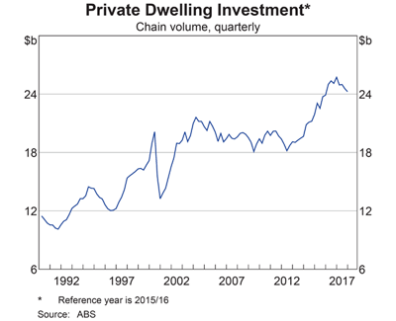
Graph 1.1 – Private Dwelling Investment

Which of the following best describes the trend in private dwelling investment since 2002?

- the trend was increasing from approximately $12b to around $24b
- the trend was decreasing from around $18b to approximately $12b
- the trend was increasing from approximately $18b to around $24b
- the trend was increasing from $20b to around $26b

SECTION A – continued
TURN OVER
Question 7

Which of the following is not directly related to the measurement of Non Material Living Standards (NMLS) in Australia?

- the amount of leisure time people have
- the quantity of goods and services produced
- the level of crime rates in capital cities
- the level of family breakdown and divorce rates

Question 8

Which of the following combinations is not likely to increase the level of economic growth?

- higher levels of business confidence and decreased interest rates
- lower levels of personal income taxes and a higher labour force participation rate
- strong rates of growth in Japan and an increase in productivity
- lower levels of consumer confidence and appreciating Australian dollar

Question 9

International trade allows the living standards of countries to increase. Which of the following would be an argument that contradicts this statement?

- The degree of choice and wider range of goods and services available through international trade assists in improving the non-material living standards of a nation.
- Free trade agreements mean Australian firms encounter stronger competition from overseas, resulting in businesses needing to improve efficiency. Structural adjustment makes some workers redundant and better off.
- Free trade agreements, like Australia’s FTA with Chile, provide greater access to overseas markets and support stronger rates of real GDP in Australia. Increased employment from rising production levels improve material and non-material living standards.
- Comparative cost advantage, the theorem developed by David Ricardo, encourages greater specialisation in trade and forces resources to be more efficiently allocated, improving material living standards.

Question 10

Which of the following is unlikely to improve Australia’s international competitiveness?

- falling labour productivity overseas
- a depreciation in the value of the Australian dollar
- an increase in union protests and strikes across the labour market
- a fall in Australia’s inflation rate

SECTION A – continued
TURN OVER
Question 11
In relation to Australia’s Net Foreign Debt (NFD), which of the following statements is incorrect?

- Australia’s NFD as a percentage of GDP is above 50%
- NFD and Net Foreign Equities(NFE) combine to produce Australia’s Net Foreign Liabilities
- NFD makes up a smaller percentage of Australia’s Net Foreign Liabilities than NFE
- The government sector’s share of NFD is smaller than the private sector’s share of NFD

Question 12
Which of the following is not considered to be an aggregate supply policy?

- expansionary monetary policy
- reforms to the tax system
- provision of subsidies for consumers
- grants for research and development

Question 13
One main weakness of using immigration policy to influence aggregate supply

- operates to simultaneously achieve the 3 key macroeconomic goals
- can boost both the quality and quantity of the labour force reducing the level of skill shortages
- boosts Australia’s productive capacity and extends Australia’s sustainable level of economic growth
- political effects can undermine the decision-making because of the desire to be re-elected

Question 14
Which of the following is likely to assist with restoring the budget surplus in the coming years?

- bracket creep (fiscal drag)
- lower Iron Ore prices
- slower growth in China
- deflation

SECTION A – continued
TURN OVER

Question 15

Proposed changes to Progressive Income Tax System
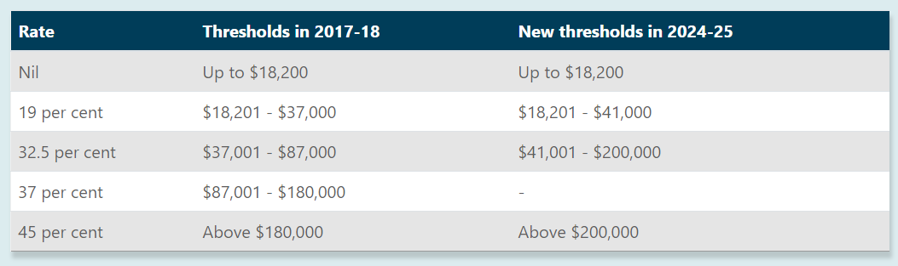
Table 1.1 – Progressive Income Tax System

In reference to the information provided in Table 1.1, which of the following statements is most correct?

- The proposed changes will have an adverse effect those earning between $100,000 - $150,000
- The tax free threshold will change between 2017 and 2025
- The proposed changes will increase the level of disposable income for those earning between $100,000 - $150, 000
- The marginal tax rate is 45 cents in every dollar earnt above $180, 000 in 2025

END OF SECTION A
TURN OVER

SECTION B – Written responses
Instructions for Section B

Answer all questions in the spaces provided

Mar-2017 | 2.2
Jun-2017 | 2.3
Sep-2017 | 2.5
Dec-2017 | 2.8
Mar-2018 | 3.0
Jun-2018 | 3.0
Sep-2018 | 2.7
Dec-2018 | 2.2
Mar-2019 | 1.7

Table 1.1 - Gross domestic product: Chain volume measures(%)
(ABS Series: 5206.0 - Australian National Accounts: National Income, Expenditure and Product)

Question 1 (13 marks)
- Describe the trend in real Gross Domestic product since 2018. (2 marks)

____________________________________________________________________________

____________________________________________________________________________

____________________________________________________________________________

____________________________________________________________________________

____________________________________________________________________________

____________________________________________________________________________

____________________________________________________________________________

____________________________________________________________________________

- Describe how a downturn(contraction) in the business cycle might impact aggregate demand. (4 marks)

____________________________________________________________________________

____________________________________________________________________________

____________________________________________________________________________

____________________________________________________________________________

____________________________________________________________________________

____________________________________________________________________________

____________________________________________________________________________

____________________________________________________________________________

____________________________________________________________________________

____________________________________________________________________________

____________________________________________________________________________

____________________________________________________________________________

____________________________________________________________________________

____________________________________________________________________________

____________________________________________________________________________

____________________________________________________________________________

- Examine how a depreciating Australian dollar could affect the level of economic growth in Australia. (4 marks)

____________________________________________________________________________

____________________________________________________________________________

____________________________________________________________________________

____________________________________________________________________________

____________________________________________________________________________

____________________________________________________________________________

____________________________________________________________________________

____________________________________________________________________________

____________________________________________________________________________

____________________________________________________________________________

____________________________________________________________________________

____________________________________________________________________________

____________________________________________________________________________

____________________________________________________________________________

____________________________________________________________________________

____________________________________________________________________________

- Select one of the following:

- Downturn(contraction) in the business cycle
- Depreciating Australian dollar

Describe how the economic event chosen is likely to impact Australia’s current account deficit (CAD). (3 marks)

____________________________________________________________________________

____________________________________________________________________________

____________________________________________________________________________

____________________________________________________________________________

____________________________________________________________________________

____________________________________________________________________________

____________________________________________________________________________

____________________________________________________________________________

____________________________________________________________________________

____________________________________________________________________________

____________________________________________________________________________

____________________________________________________________________________

Question 2 (18 marks)

- Distinguish between government current expenditure and government capital expenditure (Use examples in your response). (4 marks)

____________________________________________________________________________

____________________________________________________________________________

____________________________________________________________________________

____________________________________________________________________________

____________________________________________________________________________

____________________________________________________________________________

____________________________________________________________________________

____________________________________________________________________________

____________________________________________________________________________

____________________________________________________________________________

____________________________________________________________________________

____________________________________________________________________________

____________________________________________________________________________

____________________________________________________________________________

____________________________________________________________________________

____________________________________________________________________________

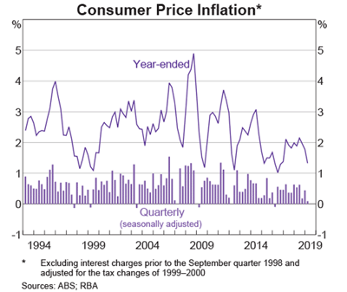

Graph 1.1 – Inflation Rate 1994 through to 2019 (Source: RBA Chart Pack 2019)

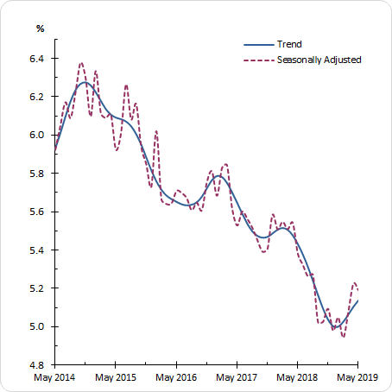
Graph 1.2 – Australia’s Unemployment Rate

(in answer b. refer to Graph 1.1 and Graph 1.2)

- Analyse how the recent movements (past 2 years) in the inflation rate and unemployment rate may have influenced the setting of budgetary policy in 2019-2020. (8 marks)

____________________________________________________________________________

____________________________________________________________________________

____________________________________________________________________________

____________________________________________________________________________

____________________________________________________________________________

____________________________________________________________________________

____________________________________________________________________________

____________________________________________________________________________

____________________________________________________________________________

____________________________________________________________________________

____________________________________________________________________________

____________________________________________________________________________

____________________________________________________________________________

____________________________________________________________________________

____________________________________________________________________________

____________________________________________________________________________

____________________________________________________________________________

____________________________________________________________________________

____________________________________________________________________________

____________________________________________________________________________

____________________________________________________________________________

____________________________________________________________________________

____________________________________________________________________________

____________________________________________________________________________

____________________________________________________________________________

____________________________________________________________________________

____________________________________________________________________________

____________________________________________________________________________

____________________________________________________________________________

____________________________________________________________________________

____________________________________________________________________________

____________________________________________________________________________

- Outline how automatic stabilisers could affect the budget outcome in 2019-2020. (3 marks)

____________________________________________________________________________

____________________________________________________________________________

____________________________________________________________________________

____________________________________________________________________________

____________________________________________________________________________

____________________________________________________________________________

____________________________________________________________________________

____________________________________________________________________________

____________________________________________________________________________

____________________________________________________________________________

____________________________________________________________________________

____________________________________________________________________________

“At its meeting today, the Board decided to lower the cash rate by 25 basis points to 1.25 per cent” (RBA press Release 4th June 2019)

- Describe how the change to the cash rate is intended to influence the cash flow transmission mechanism of monetary policy. (3 marks)

____________________________________________________________________________

____________________________________________________________________________

____________________________________________________________________________

____________________________________________________________________________

____________________________________________________________________________

____________________________________________________________________________

____________________________________________________________________________

____________________________________________________________________________

____________________________________________________________________________

____________________________________________________________________________

____________________________________________________________________________

____________________________________________________________________________

Question 3 (18 marks)

- Discuss how aggregate supply policies are designed to improve Australia’s international competitiveness. (4 marks)

____________________________________________________________________________

____________________________________________________________________________

____________________________________________________________________________

____________________________________________________________________________

____________________________________________________________________________

____________________________________________________________________________

____________________________________________________________________________

____________________________________________________________________________

____________________________________________________________________________

____________________________________________________________________________

____________________________________________________________________________

____________________________________________________________________________

____________________________________________________________________________

____________________________________________________________________________

____________________________________________________________________________

____________________________________________________________________________

- Examine the way tax reform policies can operate to have a positive effect on an efficient allocation of resources. (4 marks)

____________________________________________________________________________

____________________________________________________________________________

____________________________________________________________________________

____________________________________________________________________________

____________________________________________________________________________

____________________________________________________________________________

____________________________________________________________________________

____________________________________________________________________________

____________________________________________________________________________

____________________________________________________________________________

____________________________________________________________________________

____________________________________________________________________________

____________________________________________________________________________

____________________________________________________________________________

____________________________________________________________________________

____________________________________________________________________________

- Select one of the following aggregate supply policies

- Subsidies
- Investment in infrastructure
- Welfare reform policy

Outline one strength and one weakness of using the policy to achieve domestic macroeconomic goals. (4 marks)

____________________________________________________________________________

____________________________________________________________________________

____________________________________________________________________________

____________________________________________________________________________

____________________________________________________________________________

____________________________________________________________________________

____________________________________________________________________________

____________________________________________________________________________

____________________________________________________________________________

____________________________________________________________________________

____________________________________________________________________________

____________________________________________________________________________

____________________________________________________________________________

____________________________________________________________________________

____________________________________________________________________________

____________________________________________________________________________

- Explain how immigration policy can be used to boost the labour force participation rate and achieve the goal of low inflation. (6 marks)

____________________________________________________________________________

____________________________________________________________________________

____________________________________________________________________________

____________________________________________________________________________

____________________________________________________________________________

____________________________________________________________________________

____________________________________________________________________________

____________________________________________________________________________

____________________________________________________________________________

____________________________________________________________________________

____________________________________________________________________________

____________________________________________________________________________

____________________________________________________________________________

____________________________________________________________________________

____________________________________________________________________________

____________________________________________________________________________

____________________________________________________________________________

____________________________________________________________________________

____________________________________________________________________________

____________________________________________________________________________

____________________________________________________________________________

____________________________________________________________________________

____________________________________________________________________________

____________________________________________________________________________

____________________________________________________________________________

____________________________________________________________________________

Question 4 (16 marks)

- On the graph below, draw the demand curve for a good that exhibits a price elasticity of demand that is inelastic. (Illustrate why it is inelastic) (3 marks)

- Outline why the production period affects the price elasticity of supply. (3 marks)

____________________________________________________________________________

____________________________________________________________________________

____________________________________________________________________________

____________________________________________________________________________

____________________________________________________________________________

____________________________________________________________________________

____________________________________________________________________________

____________________________________________________________________________

____________________________________________________________________________

____________________________________________________________________________

____________________________________________________________________________

____________________________________________________________________________

- Explain how resources are allocated in a perfectly competitive market. (4 marks)

____________________________________________________________________________

____________________________________________________________________________

____________________________________________________________________________

____________________________________________________________________________

____________________________________________________________________________

____________________________________________________________________________

____________________________________________________________________________

____________________________________________________________________________

____________________________________________________________________________

____________________________________________________________________________

____________________________________________________________________________

____________________________________________________________________________

____________________________________________________________________________

____________________________________________________________________________

____________________________________________________________________________

____________________________________________________________________________

- Compare the way indirect taxation and government advertising operate to address the problems caused by market failure. (6 marks)

____________________________________________________________________________

____________________________________________________________________________

____________________________________________________________________________

____________________________________________________________________________

____________________________________________________________________________

____________________________________________________________________________

____________________________________________________________________________

____________________________________________________________________________

____________________________________________________________________________

____________________________________________________________________________

____________________________________________________________________________

____________________________________________________________________________

____________________________________________________________________________

____________________________________________________________________________

____________________________________________________________________________

____________________________________________________________________________

____________________________________________________________________________

____________________________________________________________________________

____________________________________________________________________________

____________________________________________________________________________

____________________________________________________________________________

____________________________________________________________________________

____________________________________________________________________________

____________________________________________________________________________

END OF QUESTION AND ANSWER BOOK

Extra space for responses

Clearly number all responses in this space

____________________________________________________________________________

____________________________________________________________________________

____________________________________________________________________________

____________________________________________________________________________

____________________________________________________________________________

____________________________________________________________________________

____________________________________________________________________________

____________________________________________________________________________

____________________________________________________________________________

____________________________________________________________________________

____________________________________________________________________________

____________________________________________________________________________

____________________________________________________________________________

____________________________________________________________________________

____________________________________________________________________________

____________________________________________________________________________

____________________________________________________________________________

____________________________________________________________________________

____________________________________________________________________________

____________________________________________________________________________

____________________________________________________________________________

____________________________________________________________________________

____________________________________________________________________________

____________________________________________________________________________

____________________________________________________________________________

____________________________________________________________________________

____________________________________________________________________________

____________________________________________________________________________

____________________________________________________________________________

____________________________________________________________________________

____________________________________________________________________________

____________________________________________________________________________

____________________________________________________________________________

____________________________________________________________________________

____________________________________________________________________________

____________________________________________________________________________

____________________________________________________________________________

____________________________________________________________________________

____________________________________________________________________________

____________________________________________________________________________

____________________________________________________________________________

____________________________________________________________________________

____________________________________________________________________________

____________________________________________________________________________

____________________________________________________________________________
The material is the property of prime.edu © and is subject to the copyright laws of Australia. Disclaimer: This resource has been written by the author for use with students of VCE Economics. This does not imply that it has been endorsed by the Victorian Curriculum and Assessment Authority (VCAA). The current VCE Economics Study Design (2017–2021) can be accessed directly via the VCAA website. VCE is a registered trademark of VCAA. While every care is taken, PRIME.EDU accepts no responsibility for the accuracy of information or advice contained in the exam. Teachers are advised to preview and evaluate all PRIME.EDU resources before using them or distributing them to students.

