South
American
Spanish
Lithuanian
Greek
Romanian
100,00%

80,00%

60,00%

40,00%

20,00%

0,00%

2.- Whom are you living?

0,00%
6,67%
0,00%
Both parents
20,00%
73,33%
Just one parent
Grandparents Relatives
Orphanage

3.- Which is your parent's level of education?
A
B C D
33,33%
53,33%
6,67%
6,67%

A: none of the parents graduated secondary school
B: at least one parent graduated secondary school
C: at least one parent graduated high school
D: at least one parent has university studies

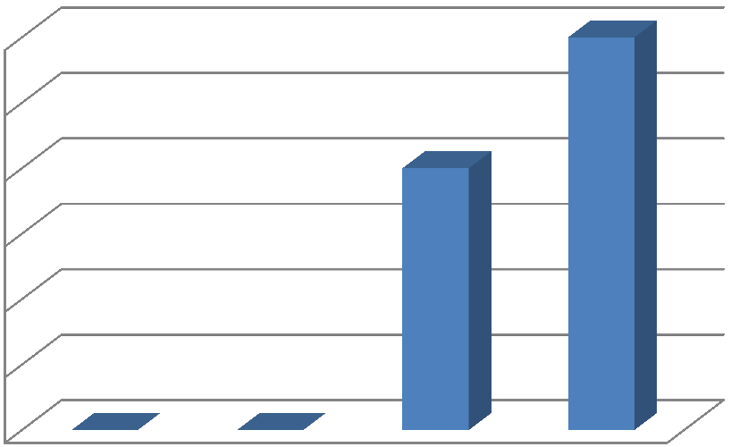
> 1000 €
500-1000 €
300-500 €
< 300 €
60,00%

50,00%

40,00%

30,00%

20,00%

10,00%

0,00%

5.- Do you have your own room at home?
NO
53,33%
YES
46,67%

6.- From your point of view how important is school in order to be successful in life?
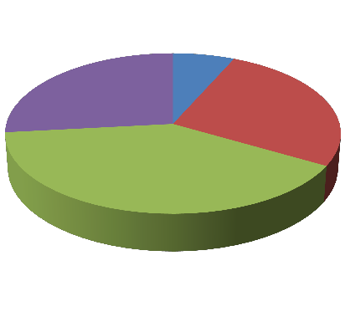
very important
important
less important
not important
40,00%
26,67%
26,67%
6,67%

very much
much less help
not at all
33,33%
53,33%
0,00%
13,33%

8.- Who helps you with the lessons?

school none of parents both parents my father
my mother

0,00% 10,00% 20,00% 30,00% 40,00% 50,00% 60,00% 70,00%

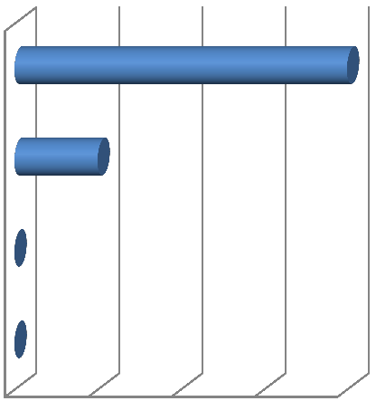9.- How often do your parents come to school to talk to teachers?

never when they are asked to come at parents' conselling meetings
often

0,00% 20,00% 40,00% 60,00% 80,00%

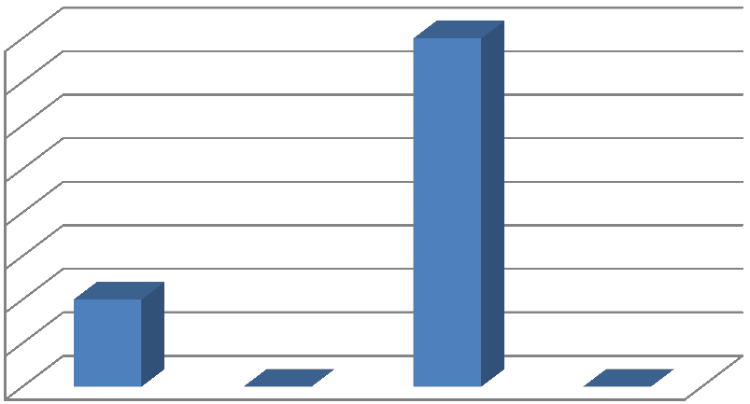
influence of conflicts with
friends school or classmates
health
problems
family
problems
80,00%
70,00%
60,00%
50,00%
40,00%
30,00%
20,00%
10,00%
0,00%

11.- When you skip classes where do you go?

13,33%
at home
33,33%
I walk in the park, I go around the town
meeting my friends

at work
53,33%

12.- What would make you not to skip classes anymore?
classmates' support teachers' support
family's support
120,00%

100,00%

80,00%

60,00%

40,00%

20,00%

0,00%

YES

100,00%

14.- How do you spend your free time with your friends?
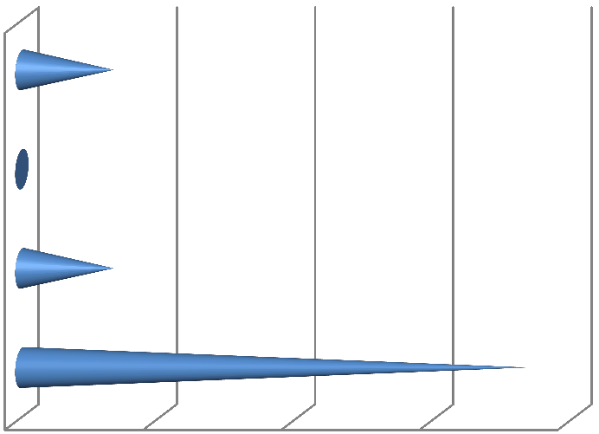
80,00%
60,00%
40,00%
20,00%
0,00%
73,33%
talking
13,33%
practising sports
walking
13,33%
smoking

15.- Would you give up studying for a walk with your friends?
NO

100,00%

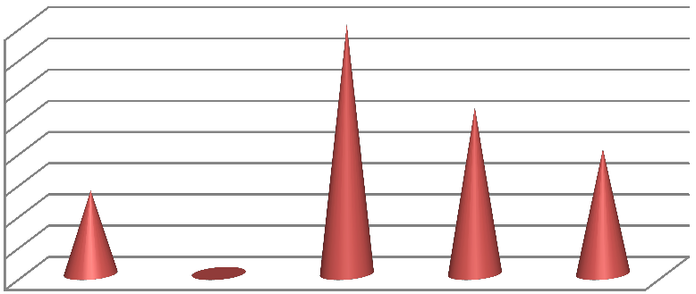
13,33%
20,00%
20,00%
15,00%
10,00%
5,00%
0,00%
26,67%
40,00%
40,00%
35,00%
30,00%
25,00%

17.- Do you think if you changed your group of friends you would have better results at school?
20,00%
YES
NO
80,00%

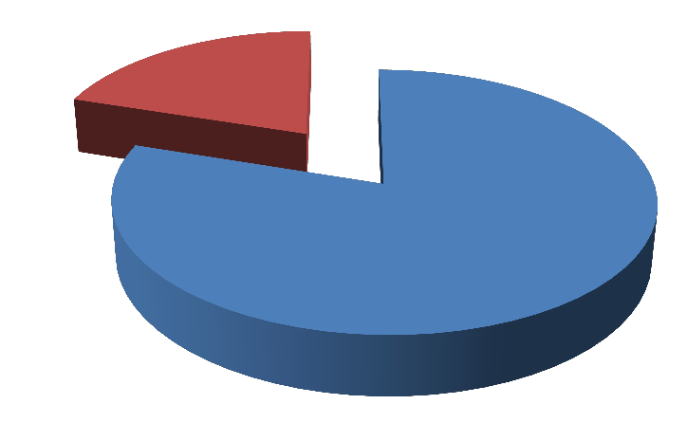18.- Have you ever felt discriminated on ethnic grounds in your school?

20,00%

NO
YES
80,00%

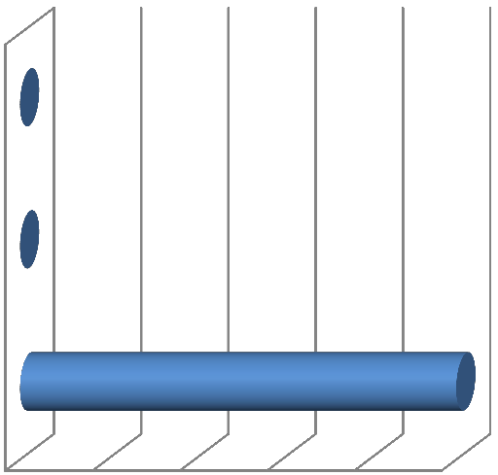

I was not allowed to participate in extracurricular activities

I was not paid attention

I was offended

0% 20% 40% 60% 80% 100%

20.- What should be done not to feel discriminated anymore?
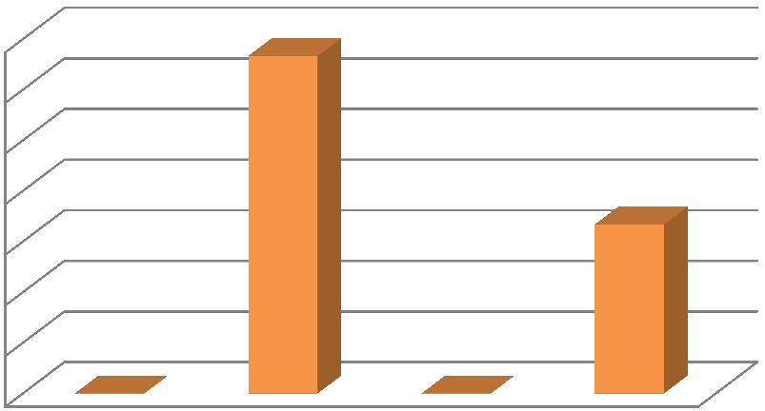
in activities
together
a group
to be a part of to be involved
not to be
offended
my opinion to
be listened
20,00%
10,00%
0,00%
33,33%
50,00%
40,00%
30,00%
66,67%
70,00%
60,00%

DEMOGRAPHIC DATA
AGE | GENDER |  | CLASS
 | MALE | FEMALE
12 | X |  | 1 ESO
13 | X |  | 1 ESO
13 |  | X | 1 ESO
13 |  | X | 1 ESO
13 | X |  | 1 ESO
14 | X |  | 2 ESO
14 | X |  | 2 ESO
14 |  | X | 2 ESO
14 |  | X | 2 ESO
14 | X |  | 2 ESO
14 |  | X | 2 ESO
15 | X |  | 2 ESO
15 |  | X | 2 ESO
15 |  | X | 2 ESO
15 |  | X | 3 ESO

