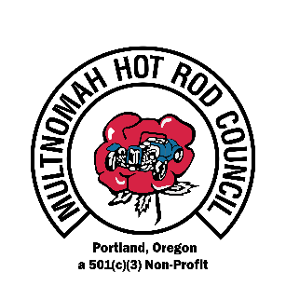
9th ANNUAL

SALUTE TO VETERANS CAR & MOTORCYCLE SHOW
WASHINGTON COUNTY FAIR COMPLEX AUGUST 15th, 2020
SPONSOR REGISTRATION FORM

Company Name___________________________________ Contact Name_________________________
Phone____________________________Email________________________________________________________
Address__________________________________City___________________________St_________Zip__________
501 (c) 3 # 83-2091271
SPONSORSHIP LEVELS
Included Benefits |  | Sponsorship Levels
 | Lieutenant | Captain | Major | Colonel | General
 | $50-99 | $100-299 | $300-499 | $500-1499 | $1500 +
Recognition by DJ at Car Show Event |  |  |  |  | X
Name on Car Show Flyer & 17x11 Business Window Poster |  |  |  |  | X
Flyer in 10K Portland Roadster Show Programs |  |  |  |  | X
Recognition on Website with Link to Sponsor Site |  |  |  | X | X
Framed Certificate of Appreciation |  |  |  | X | X
Booth at Car Show – up to 10x20 |  |  | X | X | X
Name on Sponsor Thank You Banners at Car Show |  | X | X | X | X
TROPHY in Sponsor’s Name & Choice of Best in Show Vehicle |  | X | X | X | X
Sponsor’s Banner/Signs May be Set up at Car Show Event | X | X | X | X | X
Name listed on Event Spectator Program | X | X | X | X | X

- SPONSORSHIP AMOUNT: $____________ SIGNATURE: ___________________________ DATE: ________
Mail completed form & your check by August 1, 2020, to 4931 SW 76th Ave. #151 Portland 97225
Checks must be made payable to VETERANS CAR SHOW.
We also accept credit cards
Card Name ______________________________Card#___________________________Exp._______CVC______Zip______
2. TROPHY INSCRIPTION: _____________________________________________________________________
3. BOOTH REQUIREMENT: Free with $300 or more sponsorship No Charge to the military
Informational Booth: 5x5 ($25)____10x10 ($40) ____ 10x20 ($50) ____
Retail Booth: 5x5 ($50) ____ 10x10 ($75) ____ 10x20 ($85) ____
Please include your payment in your sponsorship amount above.
4. RAFFLE DONATION: Would you like to donate an item or gift certificate? Yes ___ No ___ Raffle/Certificate Item_________________________________________ VALUE________________
Detailed trophy/booth/raffle information sent upon receipt of this form. Questions: Lynn at lynnkirwan1@comcast.net 503 780 4679, or at Veterans Car & Motorcycled Show, MHRC, & PDX Car Culture websites

