

**Supplementary Echo Acquisition Protocol for**

*Congenitally Corrected Transposition of the Great Arteries*

***The following protocol for echo in adult congenital heart patients with congenitally corrected transposition of the great arteries (ccTGA) is a guide for performing a comprehensive assessment of this group of patients. It is intended as a supplementary guide to the ISACHD echo protocol and sequential analysis and all regular measurements should be included. It highlights areas of interest in each view specific to ccTGA patients.***

**Background**

Congenitally or “physiologically corrected” transposition of the great arteries is a congenital heart condition characterized by discordant atrioventricular and ventriculo-arterial connections. It is also known as double discordance, levo-TGA and cc-TGA. It is a very uncommon congenital heart defect (0.5% of congenital heart defects). The RV is the subaortic ventricle supporting the systemic circulation and the LV is the subpulmonary ventricle supporting the pulmonary circulation. The systemic AV valve is the morphologically tricuspid valve.



**Diagram**. ccTGA: discordant atrioventricular and ventriculo-arterial connections

*Diagram from Popelova et al*

**Common associations**

VSD

Tricuspid valve (systemic AV valve) abnormalities e.g. Ebstein-like malformation  
Tricuspid regurgitation   
Aortic regurgitation

Systemic right ventricular dysfunction

Subvalvular pulmonary stenosis

Malalignment of the atrial septum and inlet part of the IVS in usual arragement in the atria (reversed crux).

Heart block

Mesocardia, dextrocardia.

**Imaging protocol for cc-TGA**

|  |  |
| --- | --- |
| View | Area of interest |
| Subcostal view | * Establish abdominal and atrial situs, cardiac position & direction of apex * Assess IVC size & collapse to assess RA pressure * Systemic RV function assessment (visual) * Systemic RV wall thickness assessment * Tricuspid valve morphology, mechanism and severity of TR * Retrograde flow abdominal aorta (in cases where > moderate AR present) |
| Parasternal views | * In ccTGA, initial images can be confusing. No standardized parasternal long axis views are possible * Use short axis views to establish the spatial relationship of aorta and pulmonary artery. The aorta is typically anterior and leftward of the pulmonary artery. * Use multiple nonconventional planes to visualize additional defects, valve morphology and function |
| Apical views | * Detailed systemic RV size and function assessment. RV is identified by moderator band, apical displacement and septal attachments of it’s AV valve. * Assess LV size and function (usually crescent-shaped/compressed by systemic RV) * Atrioventricular connection RV: * Assessment of tricuspid valve morphology, inflow and regurgitation * Pulmonary vein Doppler when regurgitation is moderate to severe * Atrioventricular connection LV: * assess mitral regurgitation * CW mitral regurgitation for LV systolic pressure (representing pulmonary systolic pressure only when pulmonary stenosis is absent) * Ventriculo-arterial connection (normally aorta is positioned leftward and anterior to the PA however, there is a wide variability in the spatial relationship between the great vessels) * Apical 5 chamber view superior tilting for LV- LVOT- PA connection * Apical 5 chamber view extensive superior tilting for RV-RVOT-Ao connection * Pulmonary/LV outflow: * assess for gradient (sub-valvular and valvular) * assess pressures from pulmonary regurgitation velocity * Aorta/RVOT: * assessment of aortic valve function * assessment aortic regurgitation * LA and RA size |
| Suprasternal views | * Retrograde diastolic flow in descending aorta |

**ccTGA Reports**

Key points to include in transthoracic echo report:

* Systemic RV size (serial comparison) and systolic function
* Systemic tricuspid valve anatomy and function
* Aortic valve function
* Sub pulmonary ventricular size & function
* Sub pulmonary outflow anatomy, especially for subvalvular pulmonary stenosis.

Key views for ccTGA

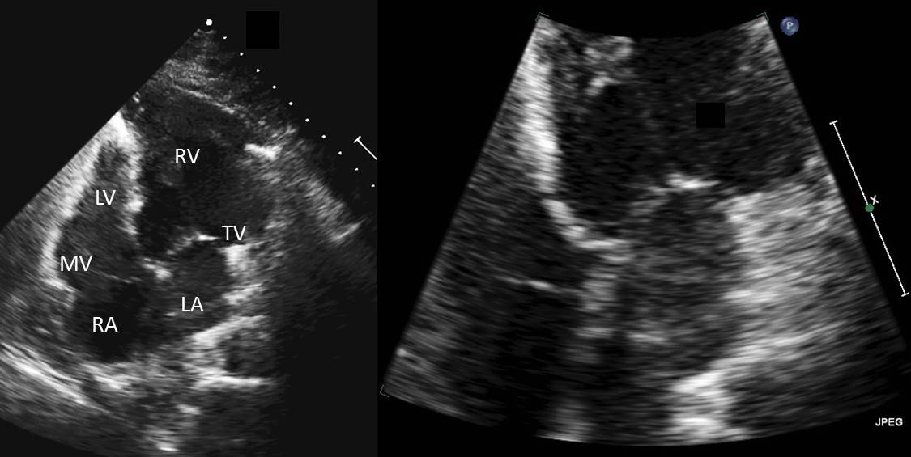

Figure 1: Apical 4 chamber view – for assessment of the cardiac crux & ventricular morphology. (Left) AV discordance, (right) zoomed in view of the cardiac crux showing reversed offset

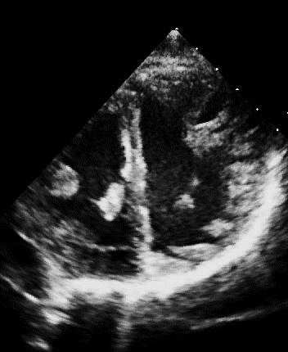

LV

RV

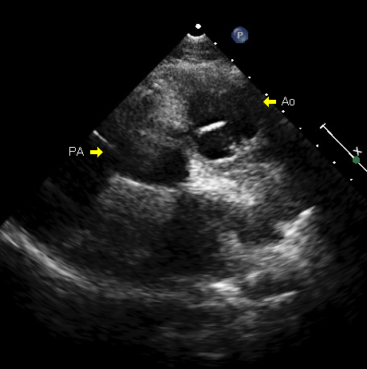

Figure 2: PSAX view. (left) side by side orientation commonly seen in ccTGA, (right) both great arteries are seen in short axis, with the aorta anterior and to the left of the pulmonary artery

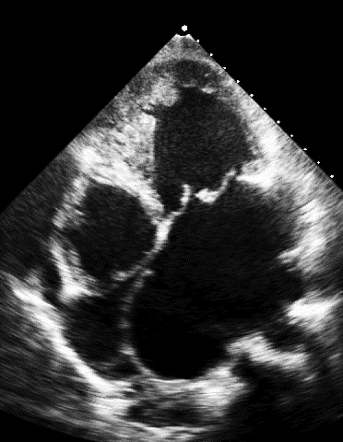

Figure 3: Ebstein-like tricuspid valve seen in ccTGA