2 Feathers Innovations Tarping Station

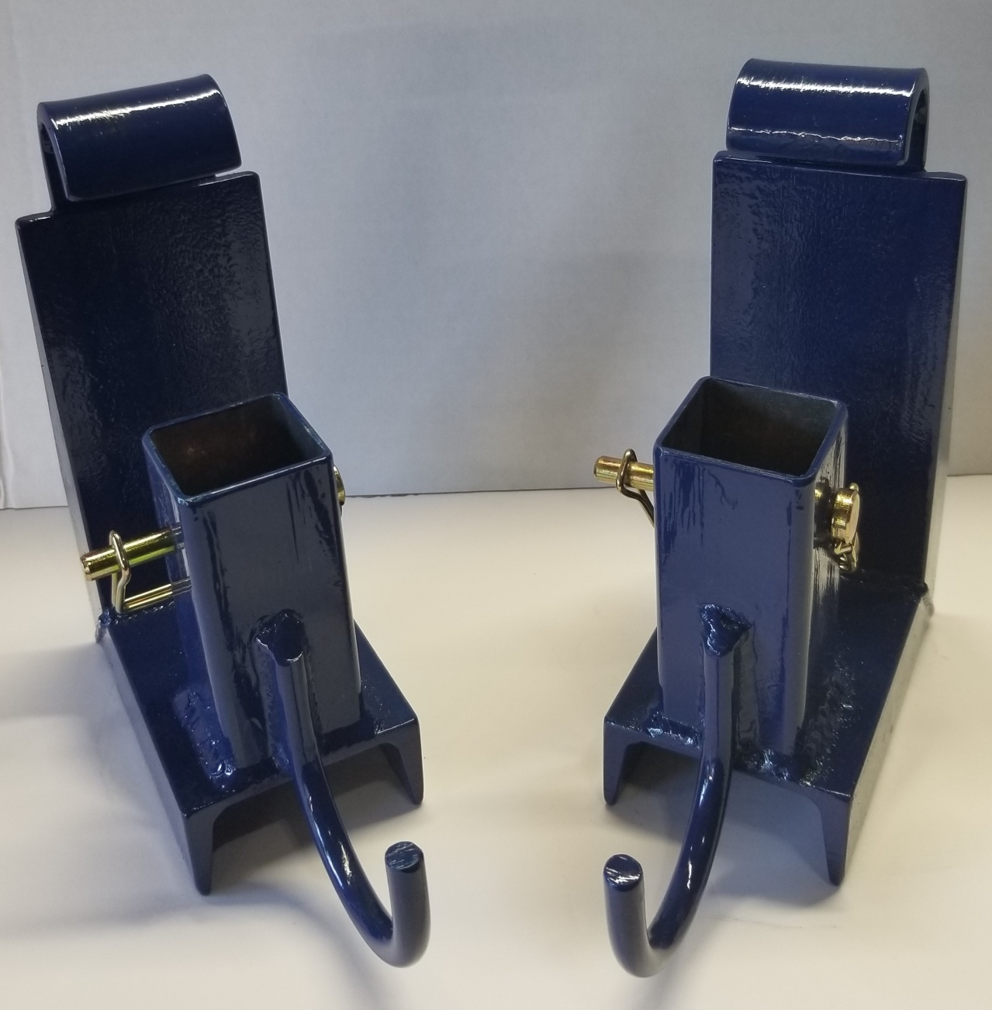
Below are pictures of each segment of the Tarping Station, showing all components. We will be posting a video showing how the components are pieced together and how the Tarping Station works later this week.

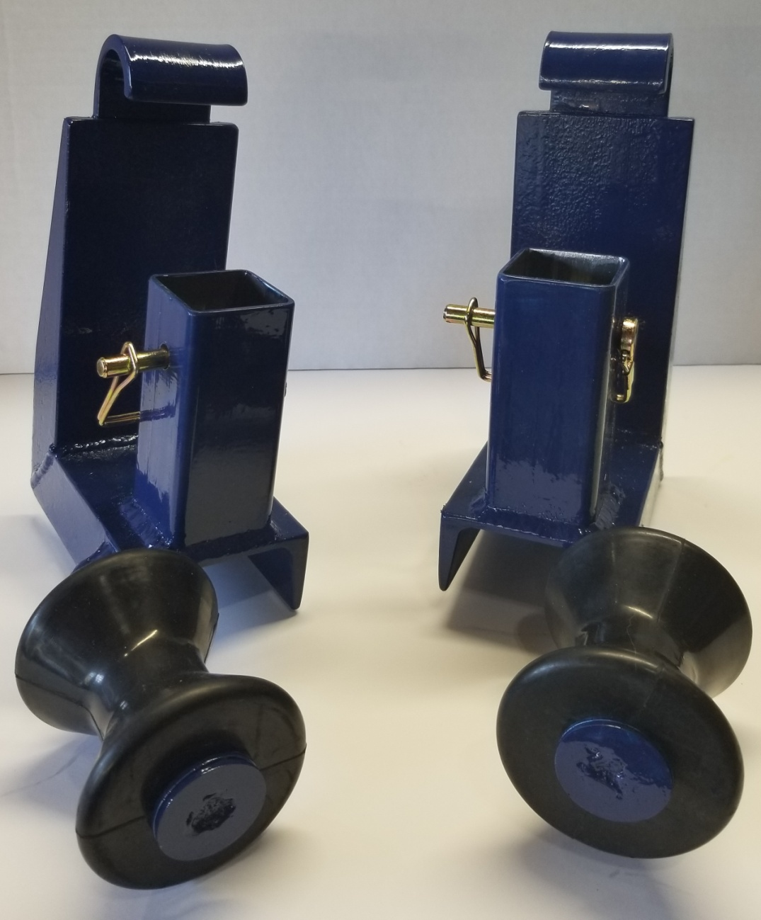

2 Pocket Mounts With Rollers

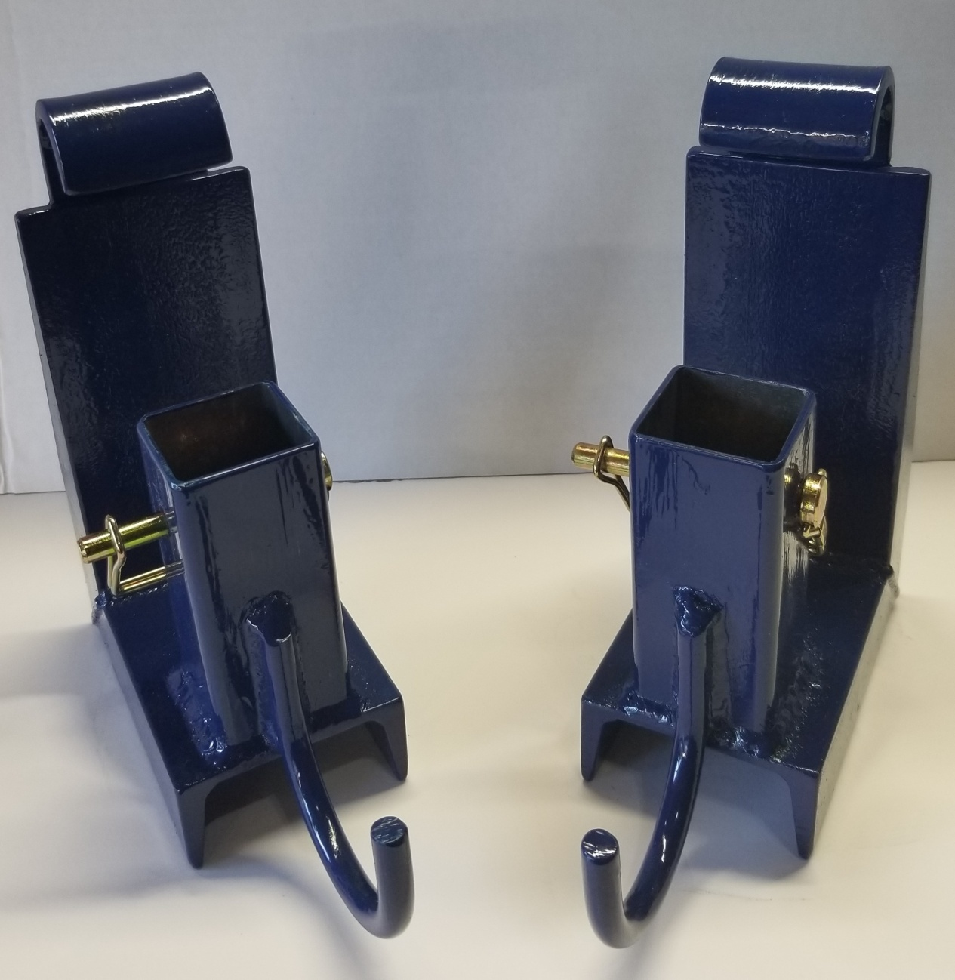

2 Pocket Mounts With Hooks
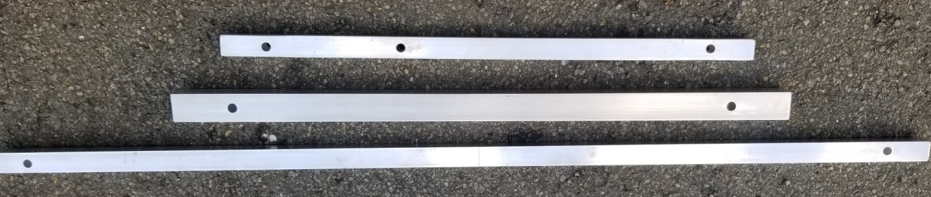

3 uprights X 4
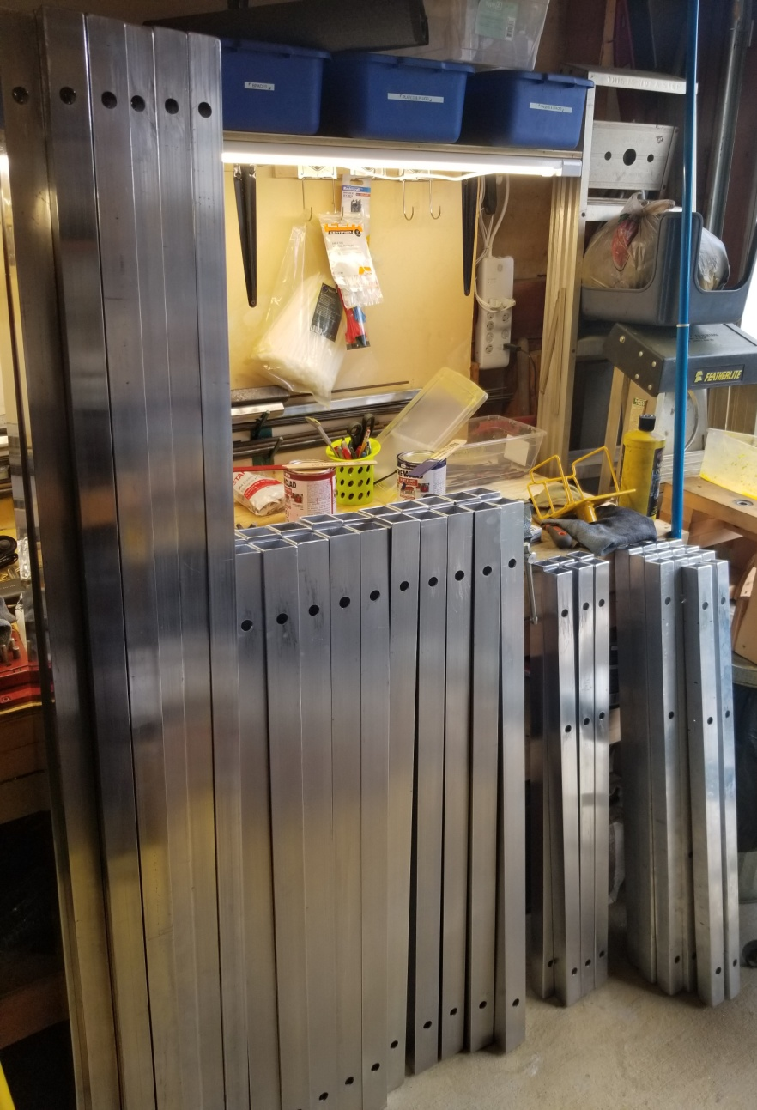

Completed Uprights For 5 Tarping Stations
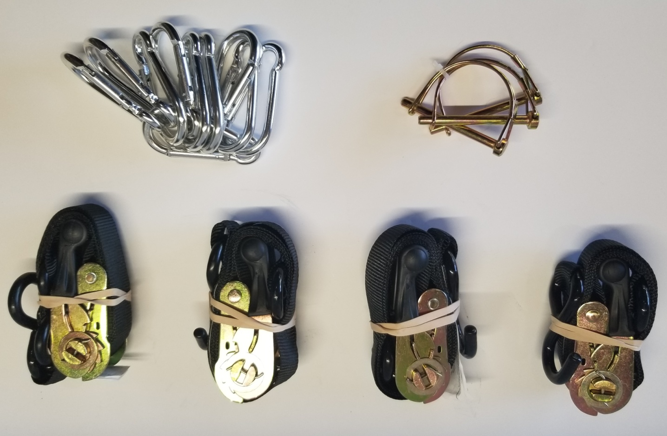

Snap Connectors, Locking Pins and Ratchets
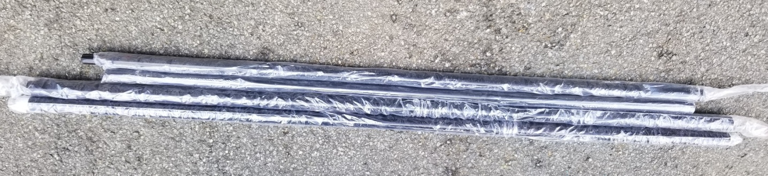

Tarp Support Rods

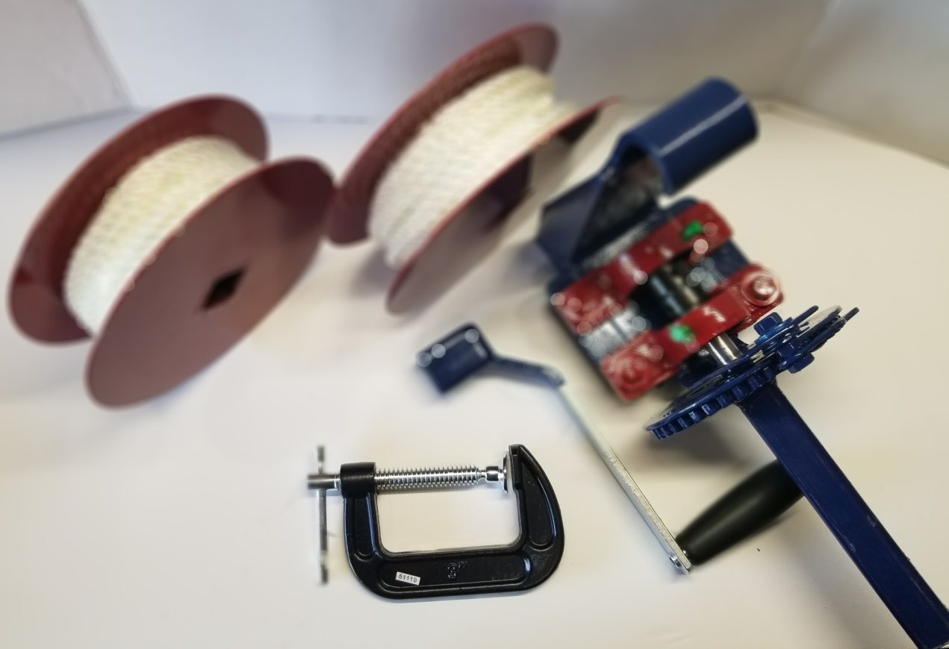

Dismantled Central Crank
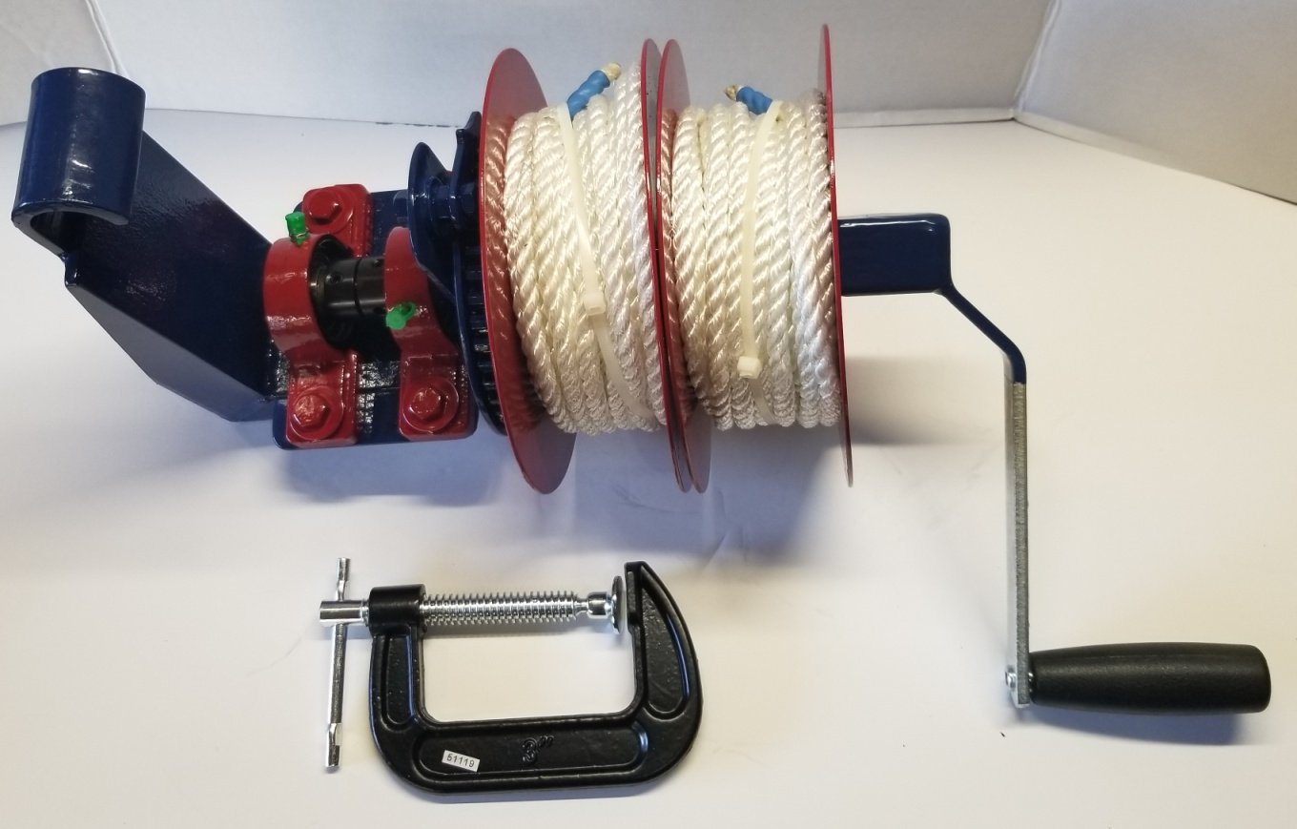

Assembled Central Crank

1 Pocket Mount, 1 Upright and 1 Roller Assembled

